PERFORMANCE BASED FIRE SAFETY DESIGN : PREDICTION OF UNTENABILITY CONDITIONS IN ASSEMBLY HALL AND CORRIDOR USING ZONE AND CFD MODELLING

Shorab Jain, M. P. Singh, A. A. Ansari
Scientists, Fire Research
CSIR - Central Building Research Institute, Roorkee, Uttarakhand – 247667
E mail: shorab@yahoo.com

ABSTRACT

The concept of performance based fire safety design is becoming increasingly popular and often supplements designs based on prescriptive codes. Under performance based concept, specifically defined fire safety goals are set and analysis is carried out to identify the design that achieve these goals in most efficient and cost effective manner. Simply put, performance based design implies use of fire safety engineering for design purposes. During last two decades, two different approaches to fire modelling have emerged, known as zone and field modelling. In the present paper, two case studies have been presented, one involving a zone model and other involving CFD model for simulating fire environment inside two different types of building enclosures_an assembly hall and a long corridor. Attempts have been made to predict untenability conditions and calculate ‘Available Safe Egress Time (ASET)’ values. These calculations are essential for carrying out performance based fire safety design analysis for a fire scenario involving safety of occupants. The first case study pertains to simulation of a fire inside a hall using CFAST _a multi room zone model. The second case study pertains to simulation of a fire inside a long corridor using CFX._a CFD modelling technique.

INTRODUCTION

In India, Fire protection measures are incorporated in the buildings based on National Building Code Part IV. The requirements given in the code prescribes minimum fire protection measures to be adopted in a given type of occupancy to minimize hazard from the fire. The code does not cover all aspects of general fire prevention, for example, sources of ignition. It does not consider the activities pursued by the occupants into account while assessing the hazard. Also the Fire Protection measures have to be based on the fire behaviour characteristics of different materials and structural elements of buildings. The nature of buildings constructed today and variety of building materials used today makes the building
more complex. Prescriptive guidelines of NBC Part IV (initially developed in 1983) alone cannot suffice for specifically defined fire safety goals in a big building. The code itself recognizes the fact that the requirements given in the code should act as a guide and an engineering design approach should be adopted for ensuring specific fire safety design goals sets for a given occupancy.

Now days, internationally, engineering approach to fire safety design is increasingly applied in large projects. The focus is thus on performance based codes. The most typical applications of performance based design are evacuation calculations, smoke control, and structural fire safe engineering (i.e. load bearing capacity of building elements). In many countries now, performance based guidelines are being applied in most building projects involving large or complex buildings. However, in India, the performance based approach to fire protection is yet to be promoted.
For life safety considerations the performance based methodology involves calculation and comparison between the times available for occupants to reach a safe place, ASET (Available Safe Egress Time i.e the time at which tenability criteria are exceeded in a specific space) and the time occupants take to reach a safe place, RSET (Required Safe Egress Time). RSET includes detection time, response time and travel times. The acceptance criteria for a proper fire safety design of a building is thus RSET < ASET. Fire protection professionals rely on fire models for design analysis of fire safety features in a building. Performance based fire safety design, therefore, requires validated fire modelling tools to justify equivalent safety when compared to prescriptive code requirements. However, the mathematical modelling of fire growth and smoke movement is difficult because the physical processes such as turbulence, buoyancy, convection, radiative transfer, and combustion are difficult to model. Also the variables such as the location of the fire, the external wind conditions, and the available ventilation also affect the outcome.

FIRE MODELLING

Last two decades have seen the development of two different approaches to Fire Modelling. One is known as Zone Modelling and another one as Field Modelling.

Zone Models

Zone models are one-dimensional models that divide each room into a small number of volumes, such as upper hot layer, the lower cold layer, the fire plume and the compartment boundary. Each of these volumes is assumed to be uniform. That is, the temperature, smoke and gas concentrations within each layer are assumed to be exactly the same at every point. Heat and mass transfer between the two layers are processed through the plume. Equations describing the conservation of mass, momentum and enthalpy are solved numerically together with previously developed empirical equations derived from experiments such as plume models, vent flow equations, ceiling jet correlations, radiation and combustion models. However, the models neglect the momentum equation within a zone, because they assume that flow within a layer is quiescent. A simple form of the momentum equation, Bernoulli's Law, is used though to compute vent flow between compartments, using pressure differences. Zone fire models predict the interface height and gas temperatures between the two layers remarkably well because of the tendency of hot gases to stratify due to buoyancy. A comprehensive discussion of this type of model may be found in reviews [1,2].

Numerous zone models with varying scopes and proposes have been developed over the years. However there is no single zone model that can cover all aspects related to fire growth and smoke spread. For example Simple "room filling" models such as the Available Safe Egress Time (ASET) model [3] predicts fire in a single compartment. COMPF2 [4] calculates post-flashover room temperatures and LAVENT [5] includes the interaction of ceiling jets with fusible links in a room containing ceiling vents and draft curtains. Very detailed models like the HARVARD 5 code [6] or FIRST [7] predict the burning behaviour of multiple items in a room. In addition to single room models there are small number of multi room models available such as BRI transport model [8], the models developed by NIST like HARVARD 6 code [9] (which is a multi room version of HARVARD 5), FAST [10], CCFM [11], and CFAST [12]. Jones [13] of NIST studied modelling of smoke movement in compartmented structures. Charters et al [14] developed a three-layer zone model, Fire Growth and Smoke Movement in Tunnel- FASIT to simulate fire growth movement in tunnels.

CFD Models

The limitation of the zone models is that they approximate the entire upper layer with just one temperature. This approximation works remarkably well but breaks down for complicated flows or geometries. For such cases, computational fluid dynamics (CFD) techniques are required. Computational Fluid Dynamics (CFD) [15, 16] is the recent technique to study the behavior of fire. CFD Models predict smoke and/or hot air flow movement caused by fire, wind, ventilation systems, and other factors in three-dimensions, for steady state and time-dependent applications by solving numerically the fundamental equations governing fluid flow, commonly known as the Navier-Stokes equations. These are partial differential equations, which have no known general analytical solution but have to be solved numerically. The governing equations for the flow field used in any CFD code expressed as partial differential equations [17] are as follows:

Mass conservation $\frac{∂ρ}{∂t} + \frac{∂}{∂x_{j}}\left(ρ u_{j}\right) = 0$ (1)
Momentum conservation $\frac{∂}{∂t}\left(ρ u_{i}\right) + \frac{∂}{∂x_{j}}\left(ρ u_{j} u_{i}\right) = −\frac{∂p}{∂x_{i}} + \frac{∂τ_{\text{ij}}}{∂x_{j}} + ρ B_{i}$ (2)
Energy conservation $\frac{∂}{∂t}\left(ρh\right) + \frac{∂}{∂x_{j}}\left({ρu}_{j}h\right) = \frac{∂p}{∂t} + \frac{∂}{∂x_{j}}\left(\frac{λ}{c_{p}} \frac{∂h}{∂x_{j}} − {\overset{˙}{q}}_{j}^{R}\right)$ (3)
Species conservation $\frac{∂}{∂t}\left({ρY}_{α}\right) + \frac{∂}{∂x_{j}}\left(ρ u_{j} Y_{α}\right) = \frac{∂}{∂x_{j}}\left(ρD\frac{∂Y_{α}}{∂x_{j}}\right) + S_{α}$ (4)

Equation of state $P = ρ R T$ (5)

Where
ρ represents density, u_{i} represents gas velocity in x_{i} direction, τ_{ij} represents stress tensor, B_{i} represents body forces in x_{i} direction, h represents enthalpy, λ represents heat conductivity, c_{p} represents specific heat capacity at constant pressure, ${\overset{˙}{q}}_{j}^{R}$ represents heat flux due to thermal radiation, Y_{α} represents mole fraction of species α, and S_{α} represents source term in chemical species conservation term.

Using field modeling, a domain space is first defined where simulation is to be carried out. This domain is divided into a large number of small control volumes. In field modeling complex partial differential equations describing conservation of mass, momentum, energy and concentration of species are solved for each control volume. At the moment field models must also include certain assumptions because there exist certain gaps in understanding of turbulence, kinetics and other important physical processes. The accuracy of the CFD modeling thus depends on the accuracy of these physical models employed in the CFD codes. For example, sub-models of combustion, turbulence, radiative heat transfer, buoyancy, compressibility, and thermal radiation are required to describe an enclosure fire phenomenon.

Apart from general-purpose CFD codes available like CFX, Phoneics, Flow3D, Fluent applicable to variety of problems, codes like FDS[18] developed by NIST, USA, SOFIE[19], and JASMINE are specially made for fire related problems. The most common and extensively used amongst them is JASMINE (Analysis of Smoke Movement In Enclosures) developed at the Fire Research Station U.K. Kumar and Cox [20,21] has validated the application of JASMINE CFD code to road tunnel fire problems. Almost all general-purpose codes have been validated for fires inside enclosures. For example, Woodburn and Britter [23, 24] have conducted sensitivity studies of CFD simulations of a fire in a tunnel using FLOW3D. Sinai [25] has validated CFX 5 using results of Steckler Fire experiment.

In the present work, two case studies are presented one involving a zone model and other using CFD model for simulating fire environment inside a building enclosure. Efforts have been made to determine the onset and further development of untenable conditions which may lead to calculation of available safe egress time values. This available safe egress time is essential for carrying out performance based fire safety design analysis for the building enclosure. Quantitative determination of RSET is beyond the scope of this paper. The first case study pertains to simulation of a fire inside a hall using a multi room zone model, CFAST (Consolidated Model of Fire Growth and Smoke Transport). For predicting thermal environment inside the hall (describe below), multi-cell zone modelling approach has been applied where entire compartment is divided into number of sub compartments and the walls of the compartments are replaced by equal size vents (26, 27, and 28). The second case study pertains to simulation of a fire inside a building corridor using ANSYS CFX, a CFD code.

FIRE INSIDE AN ASSEMBLY HALL: A CASE STUDY USING ZONE MODEL, CFAST

The fire inside a building hall is simulated using a zone model, CFAST (Consolidated Model of Fire Growth and Smoke Transport) developed by National Institute of Standard and Technology (NIST) to predict the thermal environment inside the hall. This is a multi room zone model which divides the entire compartment into two zones and performs energy and mass balances for both the zones.

The hall considered is of size 28.6 m×26.6 m×4 m. The ceiling of the hall is not uniform. There are 0.5 m deep rectangular obstructions projecting downward from the ceiling. There are four exits from the hall, two to outside open space and two exits to connecting built space. The maximum heat release rate in this work is assumed to be 9MW which indicates a large fire. Heat release rate reaches its maximum value at 900 seconds assuming a medium growth fire.
Because the built space considered is of large size, therefore multi cell concept (26, 27, 28) is used for better accuracy. In multi cell concept, the entire compartment is divided into a number of sub compartments and walls of each compartment are replaced by equal size vent. For simulation, the compartment was divided into 21 unequal sized sub compartments as shown in figure 1.
28.6 m
26.6 m
Exit to outside
Exit to outside outsideatmosphere

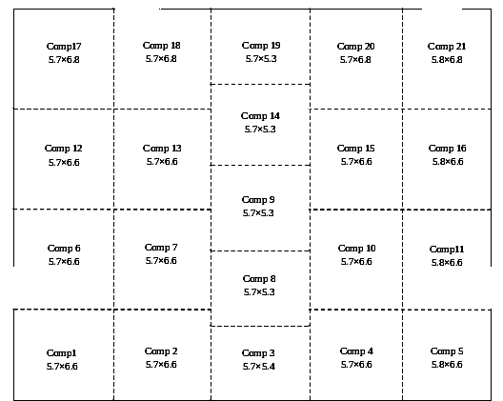

Figure -1. Hall divided into 21 divisions

Figure 1 Assembly Hall divided into sub compartments

For simulation, initial temperature inside the building was assumed to be 25⁰C and pressure 101.3 kPa. Walls of the building were assumed to be made of concrete. Maximum heat release rate of fire was taken to be 9 MW located at the centre of the hall (compartment 9). For tenability analysis in the hall, tenability parameters like upper smoke layer temperature, smoke layer interface height, radiant heat flux from fire are plotted against time at selected location of the hall (Figure 2). Since the hall is symmetric along centre, so the condition for tenability parameters are shown for the compartments which are located left to and along the fire compartment.

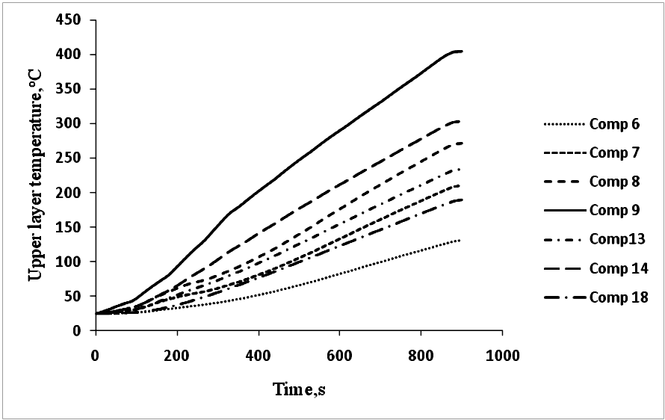

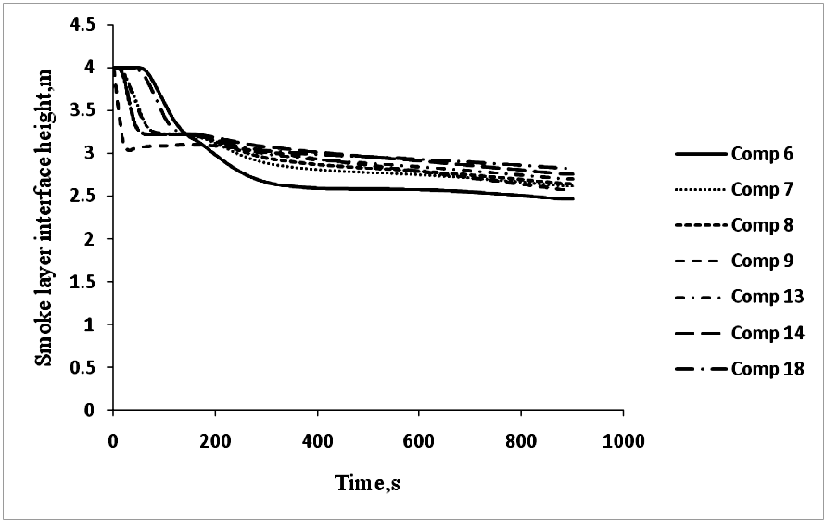

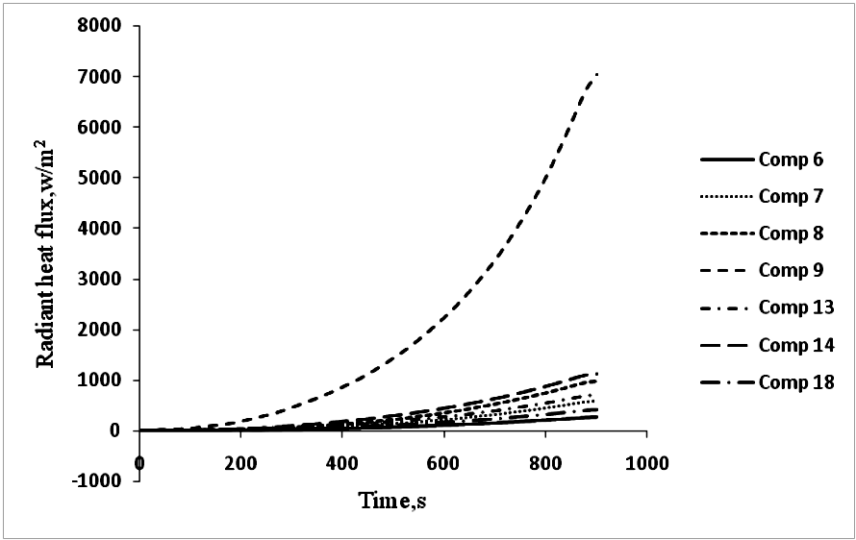

Figure 2. Predicted condition inside hall for 21 compartment division for medium fire growth (a) upper layer temperature (K) v/s time (s), (b) smoke layer interface height (m) v/s time (s) , (c) Radiant heat flux (W/m²) v/s time (s).

Smoke layer temperature, for both the cases of fire growth, changes in a similar manner as the heat release rate increases. It is seen from the ‘height of smoke layer interface v/s time’ plot that the smoke layer interface descended very quickly in the sub compartments connected to the wall of the hall especially in the corner compartments. But occupants will rarely go through those corner compartments during their egress. So for estimation of available safe egress time descending of smoke layer in the sub compartments attached to the wall of the hall are not considered, only sub compartments (near the wall) connecting the exits are considered.

Upper layer temperature and radiant heat flux increases very fast in the fire sub compartment compared to the other sub compartments because of the presence of the fire source. But smoke layer interface does not fall very quickly in the fire sub compartment because smoke gases are pushed radially outward along the ceiling because of pumping of the plume. So for estimation of onset of untenable environment or estimation of available safe egress time upper layer temperature and radiant heat flux in the fire compartment would give conservative value and hence smoke layer interface height of any sub compartment except the one attached to the hall wall is considered. The values of time to reach critical tenability limits in terms of parameters like smoke layer interface height, radiant heat flux and upper smoke layer temperature are determined and are shown in Table-1.

Table-1. Values of time to reach critical tenability limits

Tenability parameter | Tenability limit | Time to reach critical value
Smoke layer interface height | 2 m | Never attained
Radiant heat flux | 2.5kw/m² | 630 Seconds
Upper smoke layer Temp. | 200ºC | 400 Seconds

FIRE INSIDE A CORRIDOR: A CASE STUDY USING CFD MODEL

The corridor considered is 100 m long, 6 m wide and 9 m high. All walls are assumed to be smooth, adiabatic and gray. For all simulations, a fire with a constant heat release rate of 4000 kW is used to represent fire source. The fire source is represented by a solid block whose base area is assumed to be square of side 3.53 m (12.5 m² in area) and located at the middle of the corridor. The fire source is kept 0.5 m above the floor level. The volumetric heat source height is taken as 2.5 m. Both the ends of corridors are open and assumed to be at atmospheric conditions. A view of the computational domain of modelled section is shown in Figure 3.
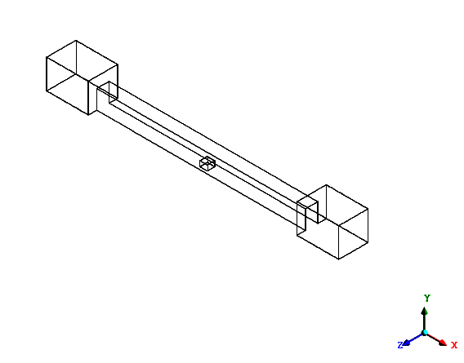
Figure-3. Computational domain of corridor with extended domain

Numerical Simulations

The computations have been done using CFX on a Compaq PIV 1.83 GHz, 1GB RAM machine. CFX uses finite volume technique to solve these equations. The full length of corridor was modelled using 1, 25,693 control volumes with turbulence and radiation sub models. Fire is represented as a volumetric heat source model (VHS). The volumetric heat source representation of the fire source is simply modelled as a volumetric source term in the governing equation for enthalpy. It only considers heat and mass transfer caused by fire. VHSM uses a volumetric energy source for the heat release rate. The CFD model input conditions are given in Table-2.

Table- 2.CFD Model Input Conditions
Domain | Tunnel and an extension of connected space outside the door. Extended domain - 20 m x 14 m x 12 m
Nodes  Tetrahedron elements | 1,25,321  5,93,566
Turbulence | standard k-ε model with buoyancy modification
Radiation | P1 model / six flux model
Heat source | VHSM model
Ref. temp. | 300 K
B.C | Walls-smooth, adiabatic and gray, emissivity of walls – 0.9, emissivity of ceiling and floor – 0.5, extended domain boundary – Free Pressure Boundary
Domain material | Air
Density | 1.185 [kg m⁻³]
Viscosity | 1.831E-05 [kg m⁻¹ s⁻¹]
Specific heat | 1.0044E+03 [J kg⁻¹ K⁻¹]
Conductivity | 2.61E-02 [W m⁻¹ K⁻¹]

Observations
The most significant effect of fire inside a long corridor is the buoyant effect caused by the difference of density between smoke and fresh air. This effect tends to create a layer of hot smoke and gases flowing away from the fire near the crown of the corridor, while air supporting combustion moves towards the fire beneath the smoke layer. This can be observed from Figure 4 which shows predicted temperature distribution on the vertical central plane through the fire source and ends of corridor at various times. It can be seen from the Figure 4 that the smoke moves symmetrically along the crown in both directions and cool entrained air from bottom of ends of corridor move towards the fire source.

Time = 10 s

Time = 20 s

Time = 30 s

Figure -4. Temperature Distribution along central plane in the tunnel at various times (a) 10s, (b) 20s and (c) 30 s

It was found that on upstream side, temperatures remained around 300 K up to 3 m height from the bottom of corridor and at a distance up to 45 m from the inlet of the corridor. The velocities were found to lie in between 2.3 and 3.70 m/s, low enough for the people to walk in case of emergencies. This implies that tenable conditions exist and people can safely escape from the place of fire and fire-fighters can approach the location of fire.

CONCLUSIONS

The paper discusses two different approaches namely simpler zone modelling and more complex CFD modelling to simulate smoke movement and predict thermal environment in two types of building enclosures assembly hall and corridor. The fire environment inside the assembly hall has been simulated by a zone model CFAST while the fire environment inside the corridor has been simulated by a CFD model, ANSYS CFX. In CFAST, the maximum number of compartments that can be simulated is thirty, though a case of only twenty one compartments is shown. The CFAST simulations run very fast and provide results in few minutes. However, CFAST can only provide global view in terms of two layers; it may not provide temperature profiles at selected locations. It has been shown that the fire modelling, especially CFD, is capable of reproducing the thermal characteristics (smoke and heat transport) of fires in corridors. The tenability conditions inside the corridor are studied using CFD. Though a CFD simulation takes days to run, however their use should be encouraged, as huge computation power is now available even at desktops.

Depending upon the complexity of the problem and accuracy of results required, the above two approaches can be used for predicting fire environment inside an enclosure under different fire scenarios. The time to reach critical tenability limits can be determined which may be used to determine available safe egress time values necessary for carrying out performance based design analysis. CFD modelling approach may complement zone models and can be used to conduct parametric studies that would be too expensive to undertake by full-scale experiments.

REFERENCES

- Cox G. 1995. “Compartment Fire Modelling”. In: Cox G, editor. Combustion fundamentals of fire. London: Academic Press, p. 329-404.

- Budnik, E.K. and Walton, W.D. 1990 “Computer Fire Models”. In: Cotte, A.E., editor. Fire Protection Handbook, 1990, sixteenth edition section 21, chapter 4, p. 21-25.
- Cooper, L.Y. 1982. “A Mathematical Model for Estimating Available Safe Egress Time in Fires”. Fire and Materials. 1982, 6(4), 135-144.
- Babrauskas, V. 1979. “COMPF2 – A program for calculating post-flashover fire temperatures”. NBS Tech Note 991, NIST, Gaithersburg, MD, USA.
- Davis, W.D. and Cooper, L.Y. 1991. “Computer Model for Estimating the Response of Sprinkler Links to Compartment Fires with Draft Curtains and Fusible Link-Actuated Ceiling Vents”. Fire Technology, 27(2), 113-127.
- Mitler, H.E. and Emmons, H.W. 1981. “Documentation for CFCV, the Fifth Harvard Computer Fire Code” NBSGCR 81-344, 187 p., NIST, Gaithersburg, MD, USA.
- Mitler, H.E. and Emmons, H.W. 1987. “A User Guide for FIRST, A Comprehensive Single Room Fire Model” NBSIR 87-3595, NIST, Gaithersburg, MD, USA.
- Tanaka, T. 1983. “A Model of Multi-room Fire Spread” NBSIR 83-2718, NIST, Gaithersburg, MD, USA.
- Rockett, J.A. 1990. “Using the HARVARD / NIST Mark VI fire Simulation” NISTIR 4464, NIST, Gaithersburg, MD, USA.
- Jones, W. W. 1985. “A Multicompartment Model for the Spread of Fire, Smoke and Toxic Gases”. Fire Safety Journal, 9, 55.
- Forney, G. P. and Cooper, L.Y. 1990. “The Consolidated Compartment Fire Model (CCFM) Computer Application CCFM.VENTS – Part – II: Software Reference Guide”. NISTIR 90 – 4343, NIST, Gaithersburg, MD, USA.
- Jones, W. W. and Forney, G. P. 1990. "A programmer's reference manual for CFAST, the useful model of fire growth and smoke transport." NISTTN-1283 NIST, Gaithersburg, Md., U.S.A.
- Jones, W. W.1993. Modelling Smoke Movement through compartmented Structures. Journal of Fire Sciences, Vol 11, No 2, 172-183.
- Charters, D.A., Gray, W.A., and Maclntosh, A.C. 1994. “A Computer Model to Assess Fire Hazards in Tunnels (FASIT)”. Fire Technology, Vol 30 (1), First Quarter 1994.
- Carlsson, J. 1999. “Fire Modelling using CFD – An introduction for Fire Safety Engineers” Report 5025, Deptt. of Fire Safety Engineering, Lund Institute of Technology, Lund University.
- Grant, G.B., Jagger, S.F. and Lea, C.J. 1998. “Fires in tunnels “. The Royal Society, 356, 2873 – 2906.
- AEA Technology, CFX 5.5.1 User Manual, 2002.

- McGrattan, K.B. and Forney, G.P. 2000. “Fire Dynamics Simulator – user’s manual”. NISTIR-6469, NIST, Gaithersburg, MD, USA.
- Rubini, P.A. 1997. “SOFIE – Simulation of Fires in Enclosures”. Fire Safety Science- Proceedings of the 5th International Symposium.
- Kumar, S. and Cox, G. 1985. Mathematical modelling of fires in road tunnels. Fifth Int. Symp. on the Aerodynamics and Ventilation of Vehicle Tunnels- BHRA, 61.
- Cox, G. and Kumar, S. 1987. Field Modelling of Fire in Forced Ventilated Enclosures. Combustion Science and Technology, 52, 7 – 23.
- Mcgrattan, K. and Hammins, A. 2001. “Numerical Simulation of the Horward Street Tunnel Fire, Baltimore, Maryland”, NISTIR 6902, NIST, Gaithersburg, MD, USA
- Woodburn, P.J. Britter, R.E., 1996. “CFD Simulations of a Tunnel Fire – Part I”. Fire Safety Journal, 26, 35-62.
- Woodburn, P.J. Britter, R.E., 1996. “CFD Simulations of a Tunnel Fire – Part II”. Fire Safety Journal, 26, 63-90.
- Sinai, Y. Validation of CFX-5 against a Steckler Fire experiment. AEA Technology CFX Validation Report, CFX-VAL15/0103.
- Chow, W.K. (1996). Multi-cell concept for simulating fires in big enclosures using a zone model. Journal of Fire Science, 14, No 3:186–198.
- Hu, L.H., Li, Y.Z., Huo, R., and Wang, H. B. (2005). Smoke Filling Simulation in a Boarding–Arrival Passage of an Airport Terminal using Multicell Concept. Journal of Fire Sciences, vol. 23, 1: pp. 31-53.
- Jain, S., Kumar, S., Kumar, S., Sharma, T.P. (2008). Numerical simulation of fire in a tunnel: Comparative study of CFAST and CFX predictions. Tunnelling and Underground Space Technology, 11:221-236.

