EFFECT OF FIRE EXPOSURE TO A SEMI-INFINITE PLATE ON UNEXPOSED SURFACE TEMPERATURE
B. M. Suman* and Sandeep Kumar*
*CSIR - Central Building Research Institute,
Roorkee -247667, U.K, India
E mail:bs_ashishh@rediffmail.com

ABSTRACT
The success of fire design depends upon the accurate prediction of temperature level of fire. The temperature at unexposed surface depends upon the temperature of fire at exposed surface, Response factor, duration of time and thermo-physical properties of the plate. The Study has been carried out for transient heat flow in semi-infinite slab by assuming the fire at 800ºC at exposed surface of 10 cm thick Autoclave aerated concrete and result of the study states that after thirty minutes of fire exposure, the temperature of unexposed surface rises from 20ºC to 50ºC.
INTRODUCTION
The heat flow takes place from one surface to other surface of a plate due to fire exposure at high temperature may be known as transient heat flow, where heat flow is instantaneous. Similar study has been carried out by some researchers previously. Tailor¹ has determined heat transfer coefficient of the semi-infinite body surface. This paper describes the method of determination of unexposed surface temperature of a semi-infinite plate subjected to fire at other surface. This method may be applied for any homogenous material to predict temperature of unexposed surface. The theoretical study is based on Gauss’s integral formula of error function. In this study the thermal resistance (R) and thermal capacitance(C) of the material and response factor are very important to fire design of building components. The response factor is defined as the ratio of difference of fire temperature and temperature of unexposed surface at time t, to the difference of fire temperature and the initial temperature before fire takes place. This study can be extended for prediction of thermal response subjected to fire or elevated temperature and also for extremely low temperature like Cryogenics.
Similar study has been made by the author to find the time temperature history due to transient heat flow caused by exposure of high temperature at a surface of infinite plate. The longer wall of a building has been considered as infinite plate in the study.
The computational technique of temperature history inside semi-infinite plate due to fire exposure is quite simple and less time consuming. By utilizing this study, warning may be given to save life and property when there is fire accident in a building.
Most of the heat transfer measurements consist of monitoring of the temperature of a body at selected points and then relating that temperature history to one of the heat transfer rates. If the temperature of the slab does not change during a process, the temperature distribution near the surface is identical to that in an infinitely thick slab. This type of plate falls into the category of semi-infinite plate.
Study on transient heat flow in semi-infinite plate has been made by some researchers previously. The R-C value is an important factor on which prediction of temperature or time duration is fully dependent. The computation technique of temperature history inside the semi-infinite body is simple and less time consuming, although the data analysis relatively complicated. But with the help of RC value of some sections and illustrations, it has been made further easier.
GOVERNING EQUATION
Consider an infinitely thick plate, that is, a plate bounded by the y-z plane only and extending to infinity in the positive x- direction. Such a plate is called a semi-infinite plate. The initial temperature distribution in the plate is given by
t = t₁(x). At time t =0, the temperature of the surface x = 0 is suddenly changed to and held at t_{s for all t > 0}
If we defined T = (t - t_{s} ) as before, the governing general equation becomes:
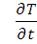 = --- --- (1)
With the conditions
T = T₁ (x) at t = 0; 0 ≤ x ≤ ∞ --- --- (2)
T = 0 at x = 0; t > 0 --- --- (3)
It is the general solution of eq. (1) for this case of semi-infinite plate. Consider the special case of uniform initial temperature where t₁ (x) = t₁ or T1 (x) = T₁
Let µ= 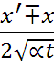 --- --- --- (4)
Then x’ = 2√ αt µ ± x
dx’ = 2√ αt dµ
Hence, for x’ = 0
µ = 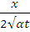 --- --- --- (5)
For x’ = ∞, µ = ∞
T_{(x,t)} T_{i =} ( 1- F(µ)) --- --- (6)
T_{(exp)} ⁻ T_{i}

The value of µ gives the value of Error function F (µ) by using a curve drawn between µ and F (µ) as the curve is depicted in Figure 1. The left side of equation (6) is the response factor.

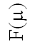
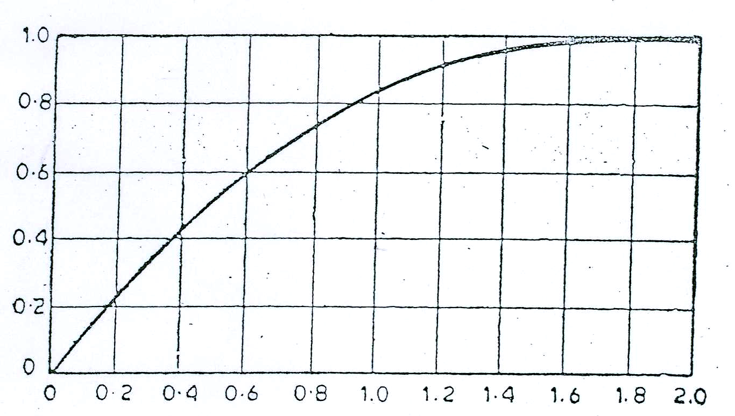 µ
Figure 1. The Error function F (µ) for corresponding Value of µ

DETERMINATION OF UNEXPOSED SURFACE TEMPERATURE
The computation of temperature of unexposed surface of aerated autoclave concrete (semi-infinite plate) has been carried out when fire was exposed at other surface and the fire temperature was considered at 800 º C. It is also assumed that temperature at exposed surface remains same for an hour. The temperature was determined by computing response factor for the given thermo-physical properties of the material. The response factor gives the value of temperature at unexposed surface at the interval of 15 minutes, 30 minutes, 45 minutes and one hour has been determined and shown in Fig. 2.

Modelling
The computation procedure has been described step by step here below:
Let us consider the temperature of fire at exposed surface is T_{exp} and initial temperature of the plate before fire is T_{i} . Let the temperature at unexposed surface after time t (hour) is T_{o} which is to be determined. The thermo-physical properties, thermal conductivity, k, density, ρ, specific heat, C, and thickness of the plate, d may be expressed in meter. By putting these values of the plate’s material in equation (5), we get the value of µ.

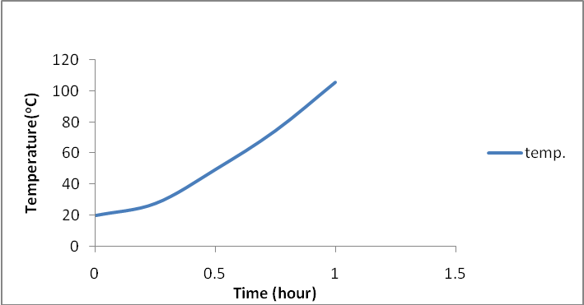
Figure 2. Temperature of unexposed surface of Autoclaved aerated concrete after time t of fire exposure at other surface
Now from figure 1, find the value of the function F (µ) for the corresponding µ.
The equation (6) can be written in the form,
T_{(x,t)} = (T_{i} + (T_{exp} - T_{i} )) (1- F(µ)) --- --- --- (7)
The temperature at unexposed surface of the plate after different duration of time is determined from equation (7) by putting the value of F (µ) for the corresponding µ.

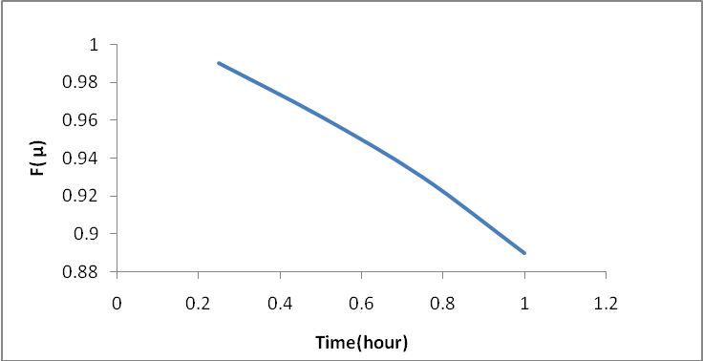
Figure 3. Value of Error function F (µ) with duration of time
Temperature of unexposed surface of aerated autoclave concrete for 800º C temperature of fire at exposed surface is computed up to one hour duration as shown in Figure 2.

DISCUSSION

Figure 1 has been used to find Error function F (µ) for the computation of µ and the value of µ is determined by knowing the value of thickness, density, thermal conductivity and specific heat of the slab for any duration of time. It is found from this figure that as value of µ increases, the F (µ) also increases rapidly but after the 1.5 µ, the increasing of F (µ) is less. As F(µ) is increasing the exposed surface temperature is decreasing, whereas for higher value of K, the µ is found to be lower. It can be seen from equation 5 that µ is inversely proportional to the reciprocal of square of diffusivity. The temperature at unexposed surface of autoclaved aerated concrete was determined at different time interval after exposure of fire at other surface of the slab. It can be observed from Figure 2 that temperature of unexposed surface is rising with time, but the rate of increase in temperature during first quarter of the hour is lower and after that the rate of increase in temperature is much higher. During first fifteen minutes the temperature of unexposed surface is rising for 20 ⁰C to 27.8 ⁰C and after thirty minute temperature goes at to 51⁰C whereas just after one hour it rises to 105 ⁰C when exposure temperature of fire is 800º C at one surface of the slab. This methodology can be applied to design of slab property (i.e. thickness, thermal resistance) for particular duration of time and vice-versa. Semi-infinite plate can be designed for fire by making additional layer, i.e., a composite multilayered slab to increase the time before damage of the unexposed surface.

Figure 3 consists of a curve between Error function and the time. Since we know that as error function is increasing the exposed surface temperature is reducing. Therefore slab in the form of building section can be designed for lower error function to get maximum time duration. From the curve depicted in fig 3, it is observed that initially the slope of F (µ) with time is higher and after half an hour duration µ slope is lower. The rate of decrease in error function is higher initially and the rate is reduced thereafter. It is concluded from this study that, we need low error function for the plate to get higher duration of time to save property & life. The high value of µ will give higher value of error function at for higher value of µ and to get higher µ, the thickness of the material should be higher, thermal conductivity as well as diffusivity of the material should be as low as possible.

CONCLUSION
From the above study, it is concluded that fire design of building component can be made for desired duration of time to save life & the property.
The response factor is depending upon the Error function F (µ) and F (µ) depends on the value of µ. The lower value of µ leads to higher duration of time.
The value of µ is proportional to be thickness of the slab and inversely proportional to the square of its thermal diffusivity.
To get higher duration of time to reach particular temperature of unexposed surface when fire is exposed at other surface, high thickness of the slab and low thermal conductivity as well as diffusivity is desirable.

ACKNOWLEDGEMENT

The paper forms part of regular R & D work done at Central Building Research Institute (CBRI) Roorkee. The paper is sent for publication with permission of the Director, CBRI Roorkee.

REFERENCES

- Taler J. D. (1996), “Determination of heat transfer co-efficient of the surface of semi-infinite Bodies” Journal of Heat & Mass Transfer, V.39, N.17
- Suman B. M. and Verma V. V. (2000), “A new computational strategy for transient temperature distribution in infinite material slab” presented at National Conference on Computational Material Science (NCCMS-2000) organized by BARC at multipurpose hall, BARC training school hostel, Anushaktinagar, Mumbai during July 27-29, 2000.

