A MODEL FOR DETERMINING OPTIMAL REQUIRED SAFE EVACUATION TIME OF A BUILDING DURING FIRE

Pradeep Kumar Yadav, Rajeev Kumar Sharma, Sunil K Sharma, Rajiv Kumar
CSIR- Central Building Research Institute, Roorkee
E mail: prd_yadav@rediffmail.com

ABSTRACT

An emergency evacuation is a rapid mass removal of occupants from a dangerous environment to a safer space in a minimum possible time during fire. Such events can also occur, during religious gatherings, music concerts, cinema hall and other similar assemblies. Adequate numbers of escape routes of sufficient size are a prior requirement for an efficient movement and rapid evacuation of a building. Inadequate sizes of routes create bottlenecks and backtracking that may result stampede, crushing and trampling. Therefore, it is essential to examine the building design with respect to number and size of exits, stairwells and other physical features of the building egress plan. The complexity of the evacuation process is associated with the flow of occupants through various paths available inside the building. Width of these components plays a key role during an emergency evacuation. Required Safe Evacuation Time [RSET] is an important factor while evacuating the any building during emergency. During evacuation process RSET must be less than Available Safe Egress Time [ASET]. In building fires ASET is defined as the time between fire detection and the onset of conditions which are hazardous to continue human occupancy. In this paper a methodology has been discussed to determine the optimal value of RSET.

INTRODUCTION

When people rush to exit during fire a push force may act on a person that may control the movement of the people. Such crowd may lead to serious injuries or even death to the people due to crushing or trampling. Such events can also occur, during sports events, religious gatherings, music concerts, cinema hall and similar assemblies. Examples of tragic consequences such as in Uphar Cinema fire on June 13, 1997 59 people were died, on April 10, 2006 in Meerut, fare fire in which more than 50 people were killed and more than 100 were injured in Kumbakonam on 16th July 2004, 83 children killed in school fire and on 3rd February 2004, Srirangam wedding tragedy, which cost 62 lives because of fire
accident in the marriage hall, on 22nd May 2005, bomb explosions rocked two cinema halls in Delhi injuring at least 40 people are closely linked with the flow of people with jams and congestion. In order to investigate such dangerous situation, efficient movement and rapid evacuation of a building with sufficient number of escape-routes is the prior requirement. Flow of occupants through various paths available inside the building is directly associated with the complexity of the evacuation process. In literature several methods are now available to analyze the problem related to evacuation.

The pedestrian behaviors is modeled by use of many theories such as automaton theory by Iki [2], potential theory by Yokoyama [3], magnetic theory by Okazaki [4], flow theory by Togawa [5], and dynamics theory by Hirai and Nishida [6]. Chalmet, Francis & Sanders, [7] have reported a Network Models for Building Evacuation. A lot of work have been carried out by the researches in this area and published various technical reports. In 1984 a research report on the evacuation problem by applying a negative exponential was published by Francis, R. L., and Chalmet, L. G. [8]. A computer program to determine optimal building evacuation plans, EVACNET+ has been developed by Kisko, T. M., and R.L. Francis [9]. Roytman [10] has prepared the fire safety standards for building construction. In the Soviet Union; Predtetschenski and Milinski [11] explored the same evacuation problems related to civilian facilities. Gupta A.K. & Yadav, P.K. [12] have developed a Model SAFE-R to study the evacuation profile of a Building during an emergency. Gupta, A.K. Yadav, P.K. & Sharma, R.K. [13] have developed an evacuation model for evacuation management in high rise building. Francis, R. L. and Chalmet, L.G. [14, 15] have designed a prototype primer software system for building evacuation using the network modeling technique. Software for the fire protection community was published in NFPA Journal by Pucci, W. E. [16]. Fahy [17] presented EXIT89 model to study the evacuation process in high-rise buildings. EXIT89 also requires network description of the building in the form of nodes and arcs. Thompson and Marchant [18-20] developed a model SIMULEX to evaluate the potential evacuation process of a complex building with a high degree of accuracy. In the development of SIMULEX, the authors have attempted to minimize user inputs while increasing the complexity of the algorithm in the program. The program incorporates route-finding techniques so that travel distance can be calculated automatically. Hagiwara and Tanaka [21] have investigated the existing provisions of means of escape in various countries. It is noted that the maximum limit of 2.5 minute of escape time has no engineering or scientific basis, so is the case of maximum travel distance between 40-60 m. Berlin et al. [22] also presented a methodology for estimating the evacuation time from group houses.

The model discussed in this paper is to determine the systematic scheduling for exit of person without congestion, backtracking and circling to minimize the loss of life. The model requires the Network descriptions of the building to identify various routes available to the occupants for movement. The proposed methodology is useful to plan the minimum number of escape routes, their capacities, travel distances and for determining the optimum value of RSET.

DETERMINING THE OPTIMAL VALUE OF RSET OF A BUILDING

Determining the optimal value of RSET of a building is generally concerned with the exiting flow of occupants inside a building in case an emergency. Therefore, systematic flow of occupants inside a building is the fundamental requirement for determining the optimal value of RSET. There are several components involved related to get the optimal value of RSET, are primarily converted with the adequacy of the number of exits, their capacity and sizes requiring minimum possible RSET. The proposed methodology includes:

- Determination of the service rate and service time for each edge
- Calculation of Node Capacity (NC) of each Node
- Determination of Dynamic Capacities (DC) of each edge
- Calculation of total Traversal Time Step (TTS) of each edge
- Identification of available paths for each source node
- Identification of activated paths and their capacity
- Determination of optimal value of RSET for a building

MATHEMATICAL MODEL

The proposed model requires the network description of the building plan having a set of “n” nodes. Nodes are used to define the building spaces, such as rooms, corridors, stairs, halls, etc. connecting “m” edges. An edge is the passageway through which occupants traverse. A graph matrix G(i,j), i= 1,2,….m and j = 1,2…4 has been formulated. Each edge has its own weights (c,t) where “c” represent the DC and “t” represent the number of Traversal Time (TT) steps required to pass the flow capacity “c” through the m^{th} edge. The service rate of each edge “μ_{m}” will be the ratio of “t” and “c” and the service time will be the reciprocal of “μ_{m}” for the m^{th} edge. The total number of available paths have been computed by applying “depth and breathe search technique” of graph theory. “CSR_{i}” and “MFC_{i}” of each i^{th} path has been calculated using equation (1) and (2).

${\text{CSR}}_{i}=\sum{\left\{\left(μ_{m}\right):m^{\text{th}}{\text{ edge belong to t}}^{\text{th}}\text{path}\right\}}$ (1)
${\text{MFC}}_{i}=\text{min}\left\{\text{ c:} c \text{is} \text{the} \text{DC} \text{of} \text{the} m^{\text{th}} \text{edge} \text{of} \text{the} i^{\text{th}} \text{path}\right\}$ (2)

Where CSR is the Cumulative Service Rate and MFC is the Minimum Flow Capacity

The paths are arranged in ascending order for their CSR assuming that all the paths are activated initially and store them in a linear array P_{path}( ). Select the first path (say p_{i}) from P_{path}( ) and select MFC_{i} to path p_{i} and store this in a linear array C_{assign}( ) and Store the path p_{i} in a linear array P_{act}( ). Modify the MFC_{i} for remaining paths having at least on common edge with path p_{i} by subtracting the MFC_{i}. Modify P_{path}( ) by removing the path P_{i}. Select paths whose MFC_{i} becomes zero and remove from P_{path}( ). This process will continue until P_{path} ( ) = { }. If “T” is the optimal value of RSET required for evacuating the N occupants from the j^{th} source node and if there are “k” number of activated paths in the j^{th} source node then the number of evacuees moving through each i^{th} activated path say “p_{i}” may be calculated using equation (3)

$p_{i}={\text{MFC}}_{i}\left[T−\left(\sum{{\text{TTS}}_{i}−1}\right)\right]$ i=1, 2, 3…….k (3)

Where, $\sum{{\text{TTS}}_{i}}$is the activation time of i^{th} path say “p_{i}”

Since “N” number of evacuees shall have to evacuate through “k” activated paths of the j^{th} source node therefore, we can represent this relation as equation (4).

$\sum_{i=1}^{k}{p_{i}}=N$ (4)

Solving equations (3) and (4), we will get the value of p_{i} and T.

RESULT & DISCUSSION

To justify the application and usefulness of the present model, an example of a single storey public building which may be control room in an industry, a court room, a bank or a similar mercantile building, a cinema hall or similar entertainment hall, or even a religious congregation depicted in Figure 1. It is assumed that 95 people are assembled in the building. Three people are present in Manager’s room and two are using the toilet, remaining ninety persons are working in the hall. In the lobby, chairs are provided for the waiting people. There is a main entrance/exit and one
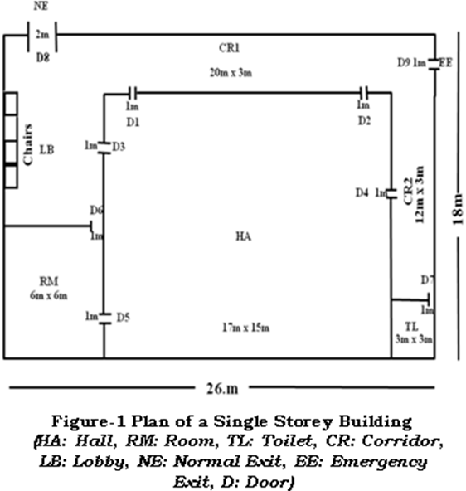
emergency exit. Sizes of various locations within the building are are shown on in the figure 1. The NC is the product of number of persons/m² “n” and usable floor area U_{fa} the value of n=2 is assumed while determining the NC. The Initial Content (IC), i.e. the number of persons present at the node. The obtained value is given in Table-1.

Table 1

Sl. No. | Node Name | Total Floor Area (m²) | Usable Floor Area (U_{fa}) (m²) | Node Capacity (NC) (Persons) | Initial Content (IC)
1 | HALL (HA) | 255.00 | 76.50 | 153 | 90
2 | Lobby (LO) | 72.00 | 50.40 | 100
3 | Corridor-1 (CR1) | 60.00 | 42.00 | 84
4 | Corridor-2 (CR2) | 36.00 | 25.20 | 50
5 | Room (RM) | 36.00 | 10.80 | 21 | 3
6 | Toilet (TL) | 9.00 | 6.30 | 12 | 2
Total Number of Occupants |  |  |  |  | 95

The DC is the product Discharge Rate (DR) and Time Period (TP), where DR is the product of Discharge Time (DT) of a person in 1m width and effective width while computing the DC. The DT of persons is assumed as 0.867 based on 52 person discharges in 1 m width in 60 seconds and 1 TP = 5 seconds is assumed. The TTS for each edge has been calculated on the by dividing the total travel distance with average speed and TP. The results are given in Table 2.
Table 2

Branch | Effective Width | Factor P/sec | DC | Travel Distance | Average Speed m/sec | Total Time taken | TTS
HA→CR2 | 0.70 | 0.61 | 3 | 10.00 | 1.10 | 9.09 | 2
HA→LO | 0.70 | 0.61 | 3 | 15.20 | 1.10 | 13.82 | 3
HA→CR1 | 1.40 | 1.22 | 6 | 14.80 | 1.10 | 13.45 | 3
RM→HA | 0.70 | 0.61 | 3 | 14.50 | 1.10 | 13.18 | 3
RM→LO | 1.70 | 1.48 | 7 | 9.00 | 1.20 | 7.50 | 2
LO→NE | 1.70 | 1.48 | 7 | 6.00 | 1.20 | 5.00 | 1
CR1→EE | 0.70 | 0.61 | 3 | 6.50 | 1.10 | 5.91 | 1
CR1→LO | 2.60 | 2.26 | 11 | 9.50 | 1.10 | 8.64 | 2
CR2→CR1 | 2.60 | 2.26 | 11 | 9.50 | 1.10 | 8.64 | 2
TL→CR2 | 0.70 | 0.61 | 3 | 8.50 | 1.10 | 7.73 | 2

The service time and the service rate for each edge have been calculated and are given in Table-3. The data will work as input for the model while determining the optimal value of RSET.

Table 3 Input data for model

Branch | Node-1 | Node-2 | Type of Node | DC | TTS | Service Time | Service Rate
1 | 1 | 4 | 1 | 6 | 3 | 2.00 | 0.50
2 | 5 | 1 | 1 | 3 | 3 | 1.00 | 1.00
3 | 1 | 2 | 1 | 3 | 2 | 1.50 | 0.67
4 | 1 | 3 | 1 | 3 | 3 | 1.00 | 1.00
5 | 6 | 2 | 1 | 3 | 2 | 1.50 | 0.67
6 | 2 | 4 | 1 | 11 | 2 | 5.50 | 0.18
7 | 4 | 3 | 1 | 11 | 2 | 5.50 | 0.18
8 | 5 | 3 | 1 | 7 | 2 | 3.50 | 0.29
9 | 4 | 7 | 1 | 3 | 1 | 3.00 | 0.33
10 | 3 | 7 | 1 | 7 | 1 | 7.00 | 0.14
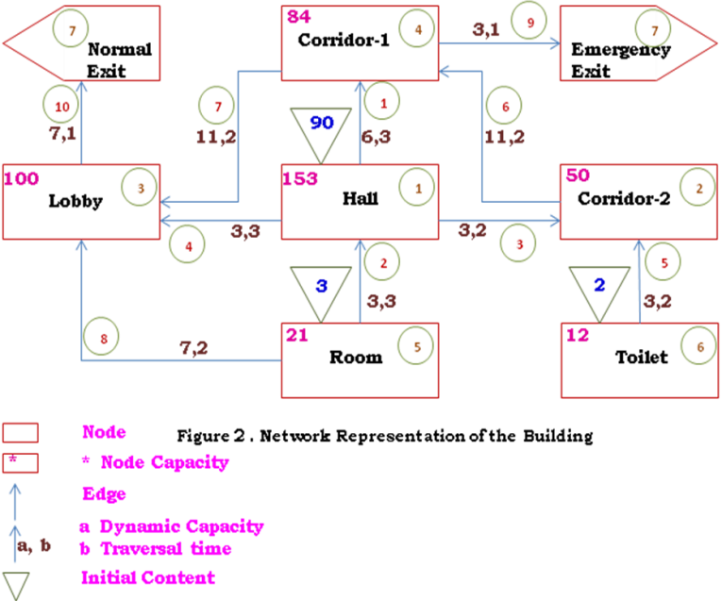
Figure 2 shows a network representation of the building. The network comprises OF 8 nodes and 10 arcs. Dynamic Capacity (DC) and the Traversal Time (TT), of an arc represented by “a” and “b” respectively. DC is defined as the number of persons moving through an arc per unit time. TT is the time to traverse the passage represented by an arc. Node capacity (NC) represents the maximum capacity of a node. Triangle represents the number of persons present at the node before evacuation process is initiated. The temperature variation and depth of the hot gas layer, assuming a heat release rate of 1500 KW has been determine with the help of CALFIRE software. The ASET has been calculated on the basis of upper layer interface reaches to head, say, 2.0 m level or its temperature reaches to 108ºC - whichever comes first, It is found that the both the conditions comes after 110 seconds. After applying the model the total available and activated paths for the occupants have been computed and given in Table-4 and 5 respectively. The optimal value of RSET and flow of occupant through the various paths has been calculated by using the equation (3) and (4) assuming the all the doors of the building are open which is also shown in Table-5.

Table – 4 Identified Path for each Sources Node when all the doors are open

Source node : 1
Total no. of simple path : 5
Node wise | Branch wise |  |  | CSR |  | Time of activation.
Path - 1: 1 2 4 3 7 | Path - 1: 3 6 7 10 |  |  | 4.810 |  | 7.000
Path - 2: 1 2 4 7 | Path - 2: 3 6 9 |  |  | 3.000 |  | 5.000
Path - 3: 1 3 7 | Path - 3: 4 10 |  |  | 1.143 |  | 4.000
Path - 4: 1 4 3 7 | Path - 4: 1 7 10 |  |  | 2.643 |  | 6.000
Path - 5: 1 4 7 | Path - 5: 1 9 |  |  | 0.833 |  | 4.000
Source node : 5
Total no. of simple path : 6
Node wise | Branch wise |  |  |  | CSR |  |  | Time of activation
Path - 6: 5 1 2 4 3 7 | Path - 6: 2 3 6 7 10 |  |  |  | 5.810 |  |  | 10.000
Path - 7: 5 1 2 4 7 | Path - 7: 2 3 6 9 |  |  |  | 4.000 |  |  | 8.000
Path - 8: 5 1 3 7 | Path - 8: 2 4 10 |  |  |  | 2.143 |  |  | 7.000
Path - 9: 5 1 4 3 7 | Path - 9: 2 1 7 10 |  |  |  | 3.643 |  |  | 9.000
Path - 10: 5 1 4 7 | Path - 10: 2 1 9 |  |  |  | 1.833 |  |  | 7.000
Path - 11: 5 3 7 | Path - 11: 8 3 10 |  |  |  | 1.095 |  |  | 5.000
Source node : 6
Total no. of simple path : 2
Node wise |  | Branch wise |  |  | CSR |  | Time of activation
Path - 12: 6 2 4 3 7 | Path - 12: 5 6 7 10 |  |  | 5.143 |  | 8.000
Path - 13: 6 2 4 7 | Path - 13: 5 6 9 |  |  | 3.333 |  | 6.000

Table -5 Activated paths for each Sources Node

Source node : 1
Activated Paths : 3
Node wise | Minimum Capacity |  | CSR |  | Time of activation |  | Persons moving through the path | Required TTS | RSET
Path -  5: 1 4 7 | 3 |  | 0.833 |  | 4.000 |  | 33
Path -  3: 1 3 7 | 3 |  | 1.143 |  | 4.000 |  | 33 | 14 | 14x5 =70
Path -  1: 1 2 4 3 7 | 3 |  | 4.810 |  | 7.000 |  | 24
Source node : 5
Activated Paths : 2
Node wise |  | Minimum Capacity |  | CSR |  | Time of activation
Path -  11: 5 3 7 |  | 2 |  | 1.095 |  | 5.000 | 3 | 02
Path -  10: 5 1 4 7 |  | 3 |  | 1.833 |  | 7.000 | 0
Source node : 6
Activated Paths : 1
Node wise |  | Minimum Capacity |  | CSR |  | Time of activation
Path -  13: 6 2 4 7 |  | 3 |  | 3.333 |  | 6.000 | 2 | 01

Calculations have been performed to determine the RSET for 12 various cases of door opening. A comparison RSET and ASET for 12 different case have been shown in Table-6 and also shown in figure-3 and it is clear from that in most of the cases the calculated optimal value of RSET < ASET expects cases 1 to 4.

Table-6: Comparison of Evacuation Time and Safe Egress Time for a Building in Different Cases

Case | Doors Closed | RSET (Sec) | ASET (Sec) | Desirable/ Undesirable
Case-1 | D1,D3,D4 and D9 | 185 | 110 | Undesirable
Case-2 | D2,D3,D4 and D9 | 180 | 110 | Undesirable
Case-3 | D2,D3 and D9 | 115 | 110 | Undesirable
Case-4 | D3,D4 and D9 | 110 | 110 | Undesirable
Case-5 | D1,D3 and D9 | 105 | 110 | Desirable
Case-6 | D3 and D9 | 90 | 110 | Desirable
Case-7 | D1, D4 and D9 | 90 | 110 | Desirable
Case-8 | D2,D4 and D9 | 90 | 110 | Desirable
Case-9 | D1,D2 and D9 | 90 | 110 | Desirable
Case-10 | D4 and D9 | 85 | 110 | Desirable
Case-11 | D9 | 80 | 110 | Desirable
Case-12 | NIL | 70 | 110 | Desirable

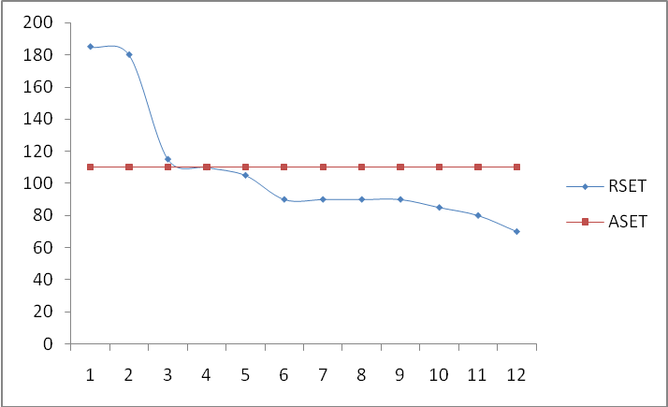

Figure-3 Comparison of RSET and ASET for a Building in Different Cases

ACKNOWLEDGEMENT

Authors are thankful to Director, CBRI, for his Roorkee for his kind permission to publish this paper. This paper is published as the part of R&D work carried out at this Institute with kind permission of Director CBRI, Roorkee.

REFERENCES

- Iki, K., "Study on network-automata model for architectural planning", Trans. of A.I.J., No.298, pp 89-97, 1980

- Yokoyama, H., Meguro K., and Katayama T., "Simulation method of human behavior at an underground shopping center", Papers of the Annual Conf. of the Inst. of Social Safety Science, No3, pp 160-164, 1993
- Okazaki, S., "A study of pedestrian movement in architectural space" Trans. of A.I.J, No.285, pp 111-117, 1979
- Togawa, K., "About the calculation for crowd flow of evacuees", Kenchiku-zasshi, No.4, pp 15-190, 1954
- Hirai, K. and Nisida, M. "A simulation of behavior of a pedestrian", Proc. of Human Engineering, No. 13(4) pp 185-188, 1977
- Furin I., Pedestrian planning and design, Metropolitan association of urban designers and environmental planners, New York, 1971
- Chalmet, L. G., Francis, R. L., and Saunders, P. B., "Network Models For Building Evacuation", Management Science, Vol. 28, No. 1, pp. 86-105, January, 1982.
- Francis, R. L., and Chalmet, L. G., "A Negative Exponential Solution To An Evacuation Problem", Research Report No. 84-86, National Bureau of Standards, Center for Fire Research, Washington DC, 20234, October, 1984.
- Kisko, T. M., and R.L. Francis, "EVACNET+: A Computer Program to Determine Optimal Building Evacuation Plans", Fire Safety Journal, 9:211-222, 1985.
- Roytman, M. Y., Principles of Fire Safety Standards for Building Construction, published for the National Bureau of Standards, Washington, DC By Amerind Publishing Co., Pvt. Ltd. New Delhi, India, 1975.
- Predtechenskii V.M., and Milinskii A.I., Planning for foot traffic flow in buildings., New Delhi, Amerind publishing co. pvt. Ltd., 1978.
- A.K. Gupta & P.K. Yadav, “SAFE-R: A New Model to Study the Evacuation Profile of a Building”, Fire Safety Journal Vol 29(7) pp 539-556, 2004
- A.K. Gupta, P.K.Yadav, & R.K. Sharma, “Evacuation Management in High Rise Buildings“ Presented and published in national seminar on High Rise Buildings: Material and Practices Organised by Indian Society for Construction Material and Structures, IIT Campus Roorkee, held at Le MEDRIEN Hotel Delhi ,pp. 473-482, 2006
- Francis, R. L., and Chalmet, L. G., "Network Models for Building Evacuation: A Prototype Primer", NBS-GCR-81-316, National Bureau of Standards, Center for Fire Research, Washington DC, 20234, March, 1981.
- Francis, R. L., and Chalmet, L.G., "Network Models for Building Evacuation: Development of Software System", NBS-GCR-84-457, National Bureau of Standards, Center for Fire Research, Washington DC, 20234, May, 1984.
- Pucci, W. E., "Hot Software for the Fire Protection Community", NFPA Journal, pp. 51-56, January/February, 1997.
- Fahy F.R., Exit89 -An evacuation model for high-rise buildings -model description and example applications, Fire Safety Science -Proceedings of the fourth international symposium 1994, p. 657-668.
- Thompson P. A., and Marchant E.W., SIMULEX; Developing new computer modelling techniques for evaluation, Fire Safety Science -Proceedings of the fourth international symposium 1994, p. 613-624.
- Thompson P. A., and Marchant E.W., A Computer Model for the evacuation of Large Building Populations, Fire Safety Journal, 1994; 24: p. 131-148.
- Thompson P. A., and Marchant EW., Testing and Application of the Computer Model SIMULEX, Fire Safety Journal, 1994; 24: p. 149-166.
- Hagiwara I., and Tanaka T., International Comparison of Fire Safety Provision for Means of Escape, Fire Safety Science -Proceedings of the fourth international symposium 1994, p. 633-644.
- Berlin G.N., and Dutt A, Gupta S.M., “Modeling emergency evacuation from group homes” Fire Technology 1982; 18: 38

