PERFORMANCE BASED FIRE SAFETY DESIGN: ESTIMATION OF MOVEMENT TIME FOR EVACUATION USING EVACNET-4
Jawad Farooquiª, Shorab Jain^{b}, Shashiª, Surendra Kumarª, M. P. Singh^{b}
- Department of Chemical Engineering, I.I.T-Roorkee, Roorkee
- CSIR-Central Building Research Institute, Roorkee
E mail: shorab122@yahoo.com

ABSTRACT
Evacuation system in a building is very important for life safety during fire emergency. It is important that safe egress routes are available to building occupants so that they are able to move to safe locations before untenablity conditions are reached. Engineering (performance based) approach to fire safety design warrants that evacuation system of a building is properly analyzed and both-Available Safe Egress Time (ASET) as well as Required Safe Egress Time (RSET) are quantitatively estimated to verify that design objectives have been achieved. Both ASET and RSET depend upon several variables involving different building characteristics and occupants’ characteristics. As such, estimation of ASET and RSET is a challenging task before fire protection analysts. Several researchers have investigated problem of evacuation during an emergency and have proposed different evacuation models. This paper discusses Movement Time of occupants and attempts to estimate it for a G+2 storey building using Hydraulic Model, EVACNET-4.

INTRODUCTION
The primary concern during fire emergency is to evacuate persons to a safe location to reduce casualties, especially group casualties. Successful evacuation of all occupants from a building depends on several factors like_ number of exits, maximum width and length of the escape routes, signage & lighting system, maximum time for evacuation, managerial strategies to keep escape routes available & safe etc. Uncertainty of safe egress time is an inherent problem during performance-based fire safety design. Providing a proper method of egress time estimation and improving accuracy of calculations is very useful. During performance-based fire design, calculation of required safe egress time involves judgment of the safety factors and uncertainty.
Generally, safe egress time is sum of three time components-detection time, pre-movement time and time taken to move to safe location. Characteristics of buildings and occupants and several other factors play important part in the estimation of safe egress time. The pre-movement time can be calculated from the building attributes using methodologies given by Sime and MacLennan [1,2,3]. While calculating the movement time, the relevant factors to be considered include: occupant density, occupant walking speed, specific flow and egress width etc. The uncertainty factors will directly influence the accuracy of egress time calculation. Also the building characteristics and the occupant characteristics have their impact on the pre-movement and movement time.
The casualties in building fires are not just due to burn but also due to exposure to smoke/toxic gases and reduction in oxygen concentration etc. These factors are all responsible for untenable conditions [4,5,6,7]. For example, it is difficult to tolerate beyond few minutes a heat exposure > 3kW/m², temperature >70 ºC and oxygen depletion below 14% in atmosphere. Also, escape becomes difficult if Optical Density of smoke in escape routes increases beyond 3.0 dB/m. It is, therefore, necessary that evacuation is complete before untenability conditions are reached.
Evacuation
The main objective of the evacuation is life safety in case of any emergency situation like building fire. All persons in the building are expected to be evacuated to a safe location so that the casualties from the accident will be as low as possible. To achieve this objective, we need to reduce the required safe egress time (RSET) for a building below the available safe egress time (ASET). The difference between ASET and RSET is the margin of safety. The larger the difference, the higher is the safety of the occupants.
AVAILABE AND REQUIRED SAFE EGRESS TIME
Available Safe Egress Time (ASET) starts at the ignition of fire and ends when the conditions in building enclosure become untenable because of presence of smoke/toxic combustion gasses/heat. ASET depends upon the fire growth and consequent build-up of untenability conditions in escape routes of occupants. Calculation of the ASET requires a detailed study of the fire, right from its ignition to complete development.
Required Safe Egress Time (RSET) depends upon the alertness, mobility and other factors influencing the time taken for occupants to leave the building. The required safe egress time contains three main time phases:
Detection Time, (t_{d}). It is the time taken from ignition of fire to the detection of fire and involves occupants’ characteristics, building characteristics and characteristics of fire/fire alarm system.
Pre-Movement Time, (t_{pm}). Pre-movement time starts at the moment when the occupants are alerted or notified about the fire and ends when till they finally begin to start their movement towards the exit point.
Movement Time, (t_{m}). It is the time from the start of actual movement of occupants towards safe location and ends with successful evacuation of occupants.
Therefore,
RSET = t_{d} + t_{pm} + t_{m} (1)
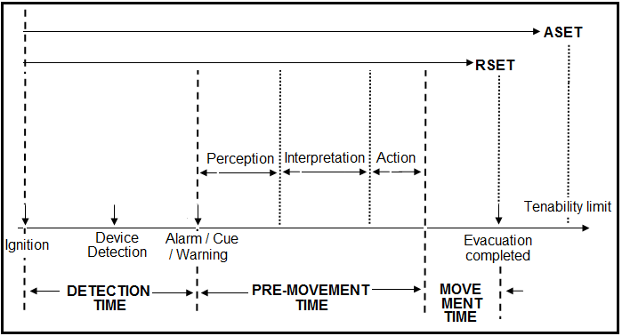
Figure-1: Sequence of occupant response to fire
Figure-1 gives a clear picture all components of the egress time. Since the pre-movement time involves perception, interpretation and action; different aspects of human behaviour are involved.
MOVEMEMT TIME FOR EVACUATION
The movement time starts when the occupants start moving towards a safe location. Movement time should be calculated from the flow time through various elements of the egress system and the travel time to move along an egress route. The elements of emergency evacuation are to be taken into consideration while calculating the movement time.
Important Elements of Emergency Movement
The two important elements of emergency movement that must be considered are apparent evacuation efficiency and effective width.
Apparent evacuation efficiency
Apparent evacuation efficiency defines the difference between the modeled evacuation time and actual evacuation time as
(2)
Where,
=modeled evacuation time (s)
= actual evacuation time (s)
e = apparent evacuation efficiency
The apparent evacuation efficiency is a function of various elements that causes delay in the evacuation time. Some of these elements are:
- Decisions. To take any action to evacuate, the occupants need to make a decision and this involves some time delay. Levin has investigated the subject further [8].
- Investigation time. An occupant investigates about the location of the fire, its occurrence, the condition of the exit routes etc. Investigating time, though increases the evacuation time, but also increases the evacuation efficiency.
- Way finding. Even if the number of occupants is low in the building, the way finding is important, particularly in situations where the occupants are not familiar with the exit system used in emergencies. Locations where occupants may face way finding problems may include hotels, multi-office building, multi-storey buildings where people rarely uses the staircase [9].
- Merging conflicts. This occurs where the occupants enter an area that is already occupied by the occupants entering from other areas in the building. Since a particular area has a limited capacity, the moving speed of the people decreases at the merger points and thus decreases the evacuation efficiency.
- Self regulation. Often in the high density buildings, some occupants stop moving till the density is reduced. Such self induced delays cause a decrease in the evacuation efficiency.
- Uneven use of exit facilities. Some exit routes are used more often and some very rarely in case of emergencies. The uneven use of the exit facilities causes a decrease in egress efficiency. The impact of this uneven use of exit routes on evacuation time is significant.
- Wardens. It is helpful to have a warden system where the occupants are not trained about the evacuation procedures.
- Other actions. Not every action taken in emergency situation contributed to speedy evacuation. Some actions do not contribute to the evacuation but to the safety or mistakes. However all actions taken have some impact on the evacuation efficiency. Figure-2 shows various actions [10].
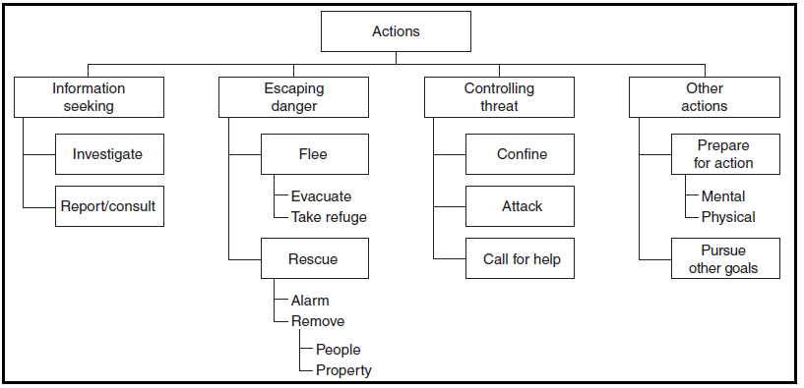
Figure-2. Types of action taken in emergency situation
Effective width
The effective width of any part of an exit route is the clear width of a given portion of an exit route and is obtained by subtracting width of boundary layers from normal width of that portion. This boundary layer clearance is maintained by the occupants moving through the egress routes.
(3)
Where,
= effective width of any portion (m)
= total or normal width of that portion (m)
, = width of the boundary layers on either side of the portion (m)

In any building, clear width is measured
- From wall to wall in corridors or hallways
- As the width of the treads in stairways
- As the actual passage width of a door in its opposition
- As the space between the seats along the aisles of assembly arrangement
- As the space between the most intruding portions of the seats in a row of seats in an assembly arrangement.
These measurements for stairs is shown in figure-3,

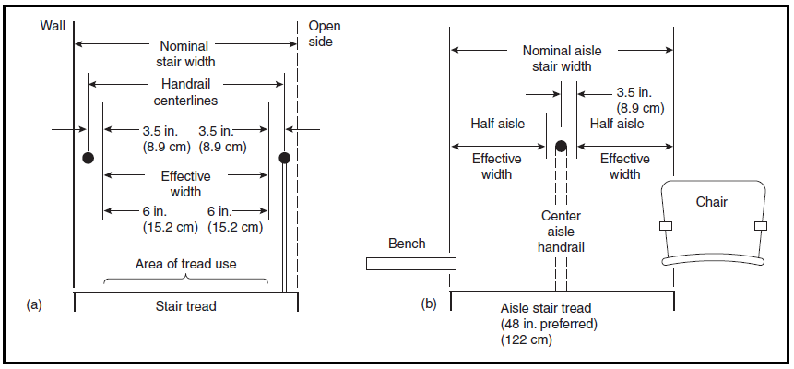

Figure-3. Measurements of effective width of stairs in relation to walls, handrails and seating

HYDRAULIC MODEL FOR ESTIMATING MOVEMENT TIME
To estimate the evacuation time for a building, different approaches have been used by the researchers. Hydraulic Approach – Simulating Occupants as Fluid Particles is one of the popular approaches to estimate movement time. Most of the methods for predicting the flow of groups of persons in emergency are research based. Lot of work on this topic has been done by Milinskii [11], Fruin [12] and Paul [13,14]. This approach is referred as the hydraulic model of emergency egress. The main assumptions of this model are:
- All persons will start to evacuate at the same instant.
- No interruptions will be caused on the occupants flow by the decisions of the individuals.
- Most of the occupants in the building are significantly free of disabilities and keep up with the movement of the group.
The main parameters used in this model are-density, speed, specific flow, transitions and time for passage.
- Density
Density is the ratio of the number of occupants in a group and the total area occupied by this group. Total area also includes the void spaces between the occupants. It is the measurement of the degree of the crowdedness in an egress route.
(4)
Where,
= population in a group (persons)
= Area occupied by this group (m² or ft²)
= Density (persons/m² or persons/ft²)
- Movement Speed
From the experimental studies it has been observed that the velocity is a function of the density, type of egress component and the mobility capabilities of the occupants [11,12,13].
For densities less than 0.55 person/m², the occupants do not interfere with the movement speed of an individual. But if the density in the limit of 0.55 and 3.8 persons/m², then the speed is given as the linear function of density as
(5)
Where,
= movement speed (m/s or ft/min)
= Density (persons/m² or persons/ft²)
= velocity factor (m/s or ft/min)
= constant = 0.266 (if speed is in m/s), k=k₂
= 2.86 (if speed is in ft/min), k=k₁
The k values to be used are given in table-1
Figure-4 shows the relation between the movement speed and the population density at corridor, ramp, doorway and stairs with different riser and tread sizes.

Table-1. Velocity factors used for speed calculations
Exit route element |  | k₁ | k₂
Corridor, aisle, ramp, doorway |  | 275 | 1.40
Stairs
Riser (in.) | Tread (in.)
7.5 | 10 | 196 | 1.00
7.0 | 11 | 212 | 1.08
6.5 | 12 | 229 | 1.16
6.5 | 13 | 242 | 1.23

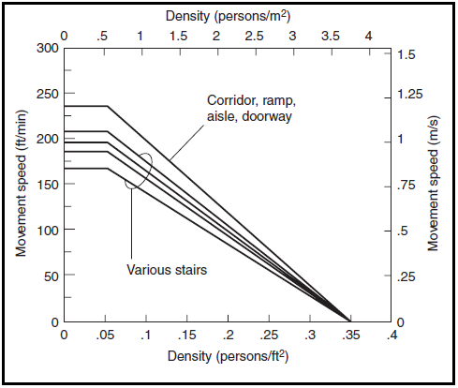
Figure-4. Movement speed shown as a function of density
The maximum unimpeded flow speeds from this experiments is given in table-2.
Table-2. Maximum flow speed
Exit route element |  | Speed
 |  | m/s | ft/min
Corridor, aisle, ramp, doorway |  | 1.19 | 235
Stairs
Riser (in.) | Tread (in.)
7.5 | 10 | 0.85 | 167
7.0 | 11 | 0.95 | 187
6.5 | 12 | 1.00 | 196
6.5 | 13 | 1.05 | 207

- Specific Flow
It is defined as the flow of evacuating persons past a point in the exit route per unit time per unit effective width of the route. Expressed in persons/(m.s) or persons/(ft.min), specific flow is mathematically represented as the product of density and the movement speed.
(6)
Where,
= specific flow (persons/(m.s)) or (persons/(ft.min))
(7)
Consideration of effective width has some effect on the specific flow of the occupants. For this a predicted flow is defined as the flow of persons passing through a particular egress point in unit time.
(9)
(8)
= calculated flow (persons/s) or (persons/min)
Figure-5 shows the graphical relation between the specific flow and the density at corridor, ramp, doorway and stairs with different riser and tread sizes
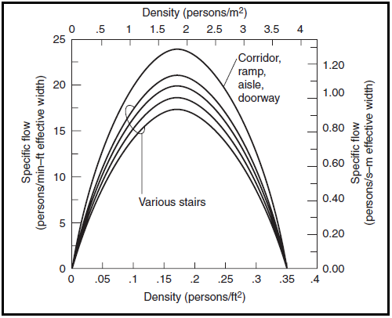
Figure-5. Specific flow as a function of density
The maximum specific flows used are given in table-3
Table-3. Maximum specific flows
Exit route element |  | Specific Flow
 |  | person/m.s | persons/ft.s
Corridor, aisle, ramp, doorway |  | 1.32 | 24
Stairs
Riser (in.) | Tread (in.)
7.5 | 10 | 0.94 | 17.1
7.0 | 11 | 1.01 | 18.5
6.5 | 12 | 1.09 | 20.5
6.5 | 13 | 1.16 | 21.2
- Transitions
Any point in the egress system where the dimensions or the character of the route changes or the route merges is called transition. Some of the transition points are
- Exit route becomes narrower or wider. Example, a corridor width reduces due to presence of some intruding object.
- Tow transitions occurs where a corridor is connected to a stairway. One is from corridor to doorway and other is from doorway to corridor.
- Point where two or more exit routes merges. Like a stairway connected to different floors.

- Time for Passage
It is the time taken by a group of persons to pass through a point in an egress route. It can be expressed as
(10)
= time for passage (s) or (min)
= calculated flow (persons/s) or (persons/min)
= population (persons)
(11)
Occupant characteristics are important for evacuation time. Characteristics like familiarity, responsibility, social affiliation, commitment, alertness and physical limitation plays important part. Similarly, building characteristics important for evacuation time includes: type of warning system, building layout and way-finding, visual access, focal point and training.
EVACUATION MODELS
There have been four generations of the evacuation models, most of which are used even now. These are described below.
- 1st generation models: Involves manual calculations applying main prescriptive assumptions
- 2nd generation models: Employs computer based flow or hydraulic calculations
- 3rd generation models: Uses more sophisticated computers to solve flow or hydraulic calculations.
- 4th generation models: These are the actual state of the art models that consider several factors such as
- The spatial configuration of the building (number of exits, exit width, travel distances, etc)
- The procedures (training, knowledge, signage, etc)
- The environment (smoke, toxic gases, debris, etc)
- The human behavior (response time, travel speeds, route finding, etc)
Classification of Models Based on Movement and Behavior
There are primarily three classes of evacuation models, described below and shown in figure-6,
- Movement Models. These models calculate only the movement time in an evacuation procedure. The accountability for the human behavior and its effect on the pre-movement time is not considered.
- Models with Movement and Partially Accounting the Behavior of Occupants. These are used to calculate both the movement time and the pre-movement time and sometimes, all the other components of the egress time as both the movement and human behavior are considered in these models.
- Models Completely Based on the Behavior of Occupants. These behavior models calculate only those components of time that are affected by the human behavior.
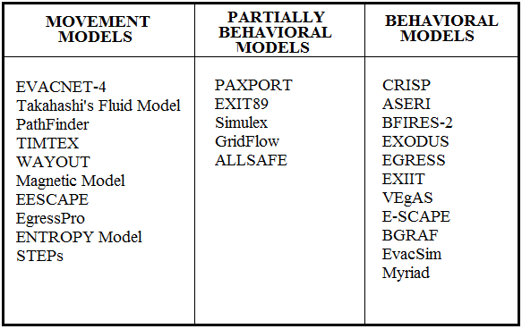
Figure-6. Classification of various available evacuation models based on movement and behavior
MODEL: EVACNET-4
The EVACNET-4 model to estimate the evacuation time in different types of buildings is one of the popular model. Based on this model, movement time has been estimated for a G+2 building (Chemical Engineering Department building of Indian Institute of Technology Roorkee).
In this model, the network is represented by nodes and arcs. The nodes are any component of the building where people are working or moving during evacuation. The node specifications includes-node type (which may be workplace (WP), hallway or corridor (HA), landing (LA), stairwell (SW), lobby (LO), elevator (EL), escalator (ES), destination (DS)). Node specification requires-node number, floor number, node capacity and initial capacity of the node. These all are given as integers. The node defined as, WP2.3,180,20 means a workplace number 2 on the third floor with a node capacity of 180 and initial capacity of 20 persons.
An arc is any visible passageway between the two defined nodes. In network model, the arc is shown as an arrow between two nodes. The arc specification includes-from node, to node, dynamic capacity of an arc and traverse time taken to move through an arc in user-defined time periods. An arc, defined as WP4.2-HA1.2,27,4, indicates an arc from a workplace to a hallway requiring 4 time periods to complete the movement with dynamic capacity of 27 persons/time period. Dynamic capacity and time periods should be inputted as integers.
The chemical Engineering Department building, with 400 occupants in the building, has been modeled. Of these 400 persons, 172 persons are on ground floor and first floor each and remaining 56 persons are on the second floor when the evacuation started. The building is modeled with 48 nodes and 47 arcs. 4 destination points (DS) are allotted to the building. Two of the DS are in the open space outside and other two are inside the building. The effective width, boundary layers and floor loading is also taken into consideration to calculate the node capacity. A time period of 10 seconds is fixed in all the calculations. The average speed of 120 ft/minute at stairs and 230 ft/min at all other nodes are fixed to calculate the dynamic capacity and traverse time. The network model of the building is shown in figure-7.
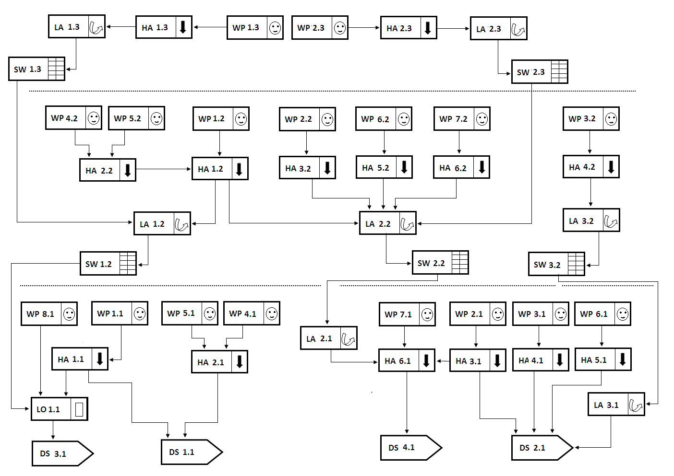
Figure-7. Graphical network model for Chemical Engineering Department building
RESULTS AND CONCLUSIONS
The components of the safe egress time have been discussed and attempt has been made to calculate movement time in the G+2 storey building. The main factors that affect movement time such as evacuation efficiency, effective width, density, speed, specific flow etc. have been described. The basis of classification of evacuation models has also been given. The estimation of movement time, as a component of RSET, has been done for the G+2 storey building using EVACNET-4. The output for main parameters has been obtained.
The results for main parameters estimated as as under:
- 31 time periods (310 seconds) are required to successfully evacuate all the 400 persons from the building.
- 11 time periods (110) are required for uncongested building evacuation.
- 103 persons are evacuated into the open spaces inside the building and 297 persons are evacuated outside the building.
- 6 bottleneck arcs are identified
- It takes 24 time period for third floor, 27 time periods for second floor and 31 time periods for ground floor to evacuate completely.
- Most number of persons (65 persons) are evacuated in third time period.
- Other results included total arc movement, node clearing times, identification of bottleneck arcs, uncongested node evacuation times, building evacuation profiles by time period, number of evacuees reaching the final destination at each time period, number of persons waiting at the end of time period.
It has been found that for the whole building movement time is 31 time periods (310 seconds).
REFERENCES
1. J.D. Sime, “Escape from Building Fires: Panic or Affiliation?,” Ph.D. Dissertation, University of Surrey, UK (1984).
2. H.A. Maclennan, “Towards an Integrated Egress/Evacuation Model Using an Open System Approach, Fire Safety Science,” in Proceedings of the First International Symposium, Hemisphere Publishing Corporation, Washington, DC (1986).
3. R. Marchant, Some discussions on egress calculations - time to move, International Journal on Engineering Performance-Based Fire Codes, Volume 1, Number 2, p.81-95, 1999
4. P.G. Wood, Fire Research Note 953, Building Research Establishment, Borehamwood, United Kingdom (1972).
5. J.L. Bryan, Smoke as a Determinant of Human Behavior in Fire Situation, University of Maryland, College Park (1977).
6. Human factors: life safety strategies – occupant evacuation, behaviour and condition, PD 7947-6:2004
7. www.usfa.fema.gov, FA-246/ February 2003

8. B.M. Levin, “Design as a Function of Response to Fire Cues,” in Proceedings of American Institute of Architects “Research and Design 85: Architectural Applications of Design and Technology Research,” Los Angeles (1985).
9. F. Ozel, Way Finding and Route Selection in Fires, New Jersey Institute of Technology, Newark, NJ (1986).
10. SFPE: Handbook of Fire Protection Engineering, Third Edition.
11. V.M. Predtechenskii and A.I. Milinskii, Planning for Foot Traffic in Buildings (translated from the Russian), Stroizdat Publishers, Moscow (1969). English translation published for the National Bureau of Standards and the National Science Foundation, Amerind Publishing Co., New Delhi, India (1978).
12. J.J. Fruin, Pedestrian Planning Design, Metropolitan Association of Urban Designers and Environmental Planners, Inc., New York (1971).
13. J.L. Pauls, “Effective-Width Model for Evacuation Flow in Buildings,” in Proceedings, Engineering Applications Workshop, Society of Fire Protection Engineers, Boston (1980).
14. J.L. Pauls, “Calculating Evacuation Time for Tall Buildings,” in SFPE Symposium: Quantitative Methods for Life Safety Analysis, Society of Fire Protection Engineers, Boston (1986).

