STUDY ON DETERIORATION OF VISIBILITY DUE TO SMOKE FOR SOME MATERIALS USED IN RAILWAY INDUSTRIES

A. A. Ansari, M. P. Singh, Sourabh Jain and Rakesh Kumar
Fire Research Laboratory
CSIR-Central Building Research Institute, Roorkee

E –mail: aaansari@cbri.res.in

ABSTRACT

The term ‘visibility’ is variously defined, but generally indicates the distance to which human visual perception is limited by atmospheric conditions. The physical mechanisms that influence visual perception during the night in distinguishing lights differ from those in the day time in distinguishing objects illuminated by daylight. Basically, however, visibility describes the transparency of the air in the horizontal direction and represents the maximum distance that one can see in the atmosphere at any given time. The Materials to be used in railways are needed to evaluate according to standard test such as Deterioration of visibility due to smoke The paper deals with the study of deterioration of visibility due to smoke released on the combustion of some of materials commonly used in Indian Railway Industries.

INTRODUCTION

A fire produces copious smoke right in its initial stage of development. Rising smoke concentration leads to increasing hazard for building occupants. The smoke causes Loss of Visibility, making escape and evacution difficult. Occupants feel disoriented,irritated & panicked and are often unable to find their wayout for escaping from smoke filled locations.They are trapped once visibility falls below certain threshhold and exit routes become smoke logged
Passenger train fires are rare, but can lead to serious consequences as was seen in recent fire incidences in Gujrat and other places in India. Fire safety is an important element of overall system safety for conventional rail and new high-speed train technologies. A systems approach to passenger train fire safety requires that the effects of vehicle design, material selection, detection and suppression systems, and emergency egress, as well as their interaction, be considered.

DETERIORATION OF VISIBILITY DUE TO SMOKE

Deterioration of visibility due to smoke released on the combustion of materials in a sealed chamber is assessed by the attenuation of a light beam passing the chamber vertically. It gives information about smoke production and available time for safe escape. The study is carried out as per procedure described in UIC 564-2-OR: App.15.

Experimental

The apparatus consists of a chamber constructed of heat resistant material having internal dimensions 1000 ± 5 mm (H) x 750 mm ± 5 mm (W) x 750mm ± 5 mm (D) and a door with seals ensuring smoke tight chamber. The chamber has one circular glazed opening in the ceiling positioned at a distance of 250 mm ± 2 mm from nearest sidewalls and a glazed opening in the floor positioned centrally on the vertical line passing through the centre of the opening in the ceiling.
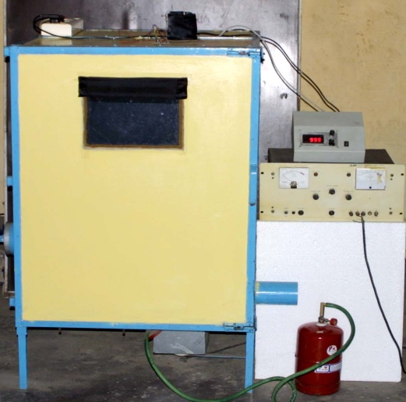
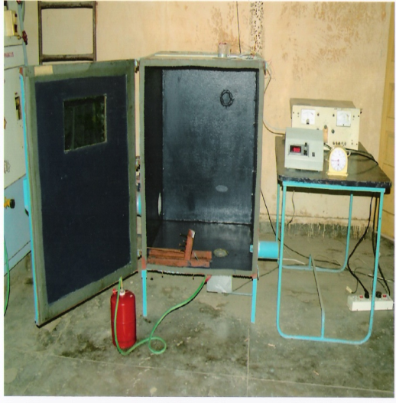
It has opening to introduce the burner, which permits the burner to be tilted at an angle of 45⁰ to the horizontal. It has light bulb holder approximately 215mm from bottom edge, positioned on vertical line through centre of floor opening. The bulb (220V, 100W) is placed vertically in the holder giving constant light intensity throughout the evaluation. It has two openings with sealing shutter to facilitate smoke expulsion one in each sidewall. On the glazed ceiling opening a light meter having two measuring scales 0-100 lux and 0-10 lux is provided. The chamber is placed so that stray light should not enter into the chamber. The apparatus has a specimen holder which hold the specimen, non-combustible insulating backing board and 2 mm

Front view Inside view
Fig.1: Deterioration of visibility due to smoke release apparatus as per UIC 564-2-OR: App.15

thick stainless steel plate firmly at an angle of 20 ⁰ to the vertical. The specimen holder frame has an opening of 100 mm x 50 mm at the front which allows the burner flame to impinge on the exposed surface of the specimen when it is adjusted at a required distance by a device provided with the specimen holder frame. The apparatus is shown in fig.1.

Specimens

The specimens (minimum 3 nos.) representative of the material are required in the dimensions 120 mm x 100 mm and of the thickness of the material actually used. Before evaluation the specimens shall be conditioned to equilibrium with air at 20-24 ºC and 50-65% relative humidity.

Method

The specimen frame with the specimen and the burner (unlit) be introduced into the smoke chamber and close the door, shutter of smoke discharge pipe and shutter of air-intake opening. The light meter cell then is placed at glazed opening in the ceiling. Cover the cell and other glazed openings with a black cloth so that in the most sensitive measuring scale the light meter indicate less than 0.3 lux. Adjust the meter to zero. Switch on the electric light bulb and adjust the current flow to obtain an illumination intensity of 100 lux.. Open the door and the air intake opening. Light the burner. Close the door and then the air intake opening after insuring that the burner has not extinguished. Complete all these operations in 5 seconds. Note the illumination intensity E at regular intervals. Change the measuring scale to greater accuracy when the reading of illumination intensity falls below 10 lux. Extinguish the burner as soon as illumination intensity falls below 1 lux or, if it does not occur, then after 5 minutes.

Before starting evaluation with next specimen remove soot particles from the glazed openings in the ceiling and at the floor. Clean the inner walls at regular intervals. Three evaluations shall be carried out for each material.

Observations

Observations are taken of the illumination intensity as a function of time (individual values for the each specimen and arithmetic mean).

Expression of results

A curve is drawn for the material by entering the time on the x-axis and the arithmetic mean of corresponding illumination intensity (lux) on the y-axis. From the curve the value of E ₄ , illumination intensity at the 4th minute is obtained. The light volume (lux. minutes) is obtained for the first 4 minutes by calculating the area between the coordinate axes and the curve E = f (t), and the classification is done based on the values of E ₄ and T in accordance with the table specified in the standard.

RESULTS & DISCUSSION

During the assessment of some of the materials for deterioration of visibility due to smoke evaluation, the illumination intensity (Lux) was recorded with respect to time for each specimen. The curve for the same is plotted in fig.2. The table -1 shows the classification of materials on the basis of their E ₄ and T values. From the curves of different materials, the value of E ₄, illumination intensity at the 4th minute and value of T, light. volume for the first 4 minutes were computed and are summarized in Table-2.

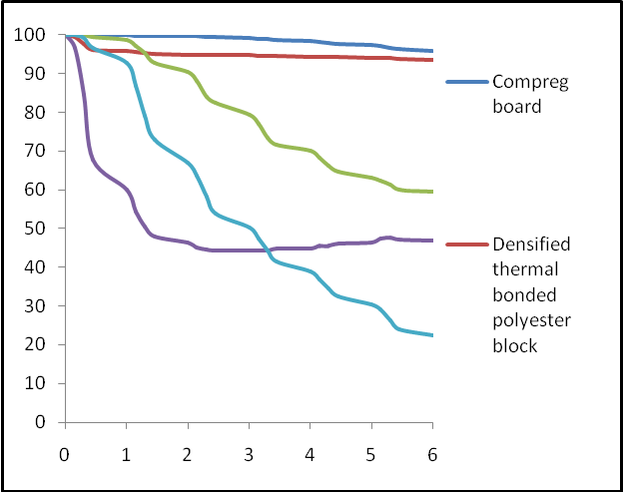
Illumination intensity, Lux
Time, min

Fig. 2: Time – illumination intensity curve for some materials

The illumination intensity (Lux) is found in the range of 94 to 98 in case of Compreg Board and Densified Thermal Bonded Polyester Block which in turn the least deterioration of visibility due smoke generated by these products in case of fire. These are on the basis of computed results under the area of the curve are classified as Class – A.

The illumination intensity (Lux) is found in the range of 70 in case of Non-asbestos Limpet Sheet & the area of the curve is found to be 350 Lux. Minute, hence it is also classified as Class – A.

The illumination intensity (Lux) is found in the range of 35 to 45 in case of Fire Retardant Rubber Sheets for Vestibules and Vinyl Leather Cloth Polyester Block which shows significant deterioration of visibility due smoke generated by these products in case of fire. These are on the basis of computed results under the area of the curve and the values of E ₄ are classified as Class – B.

Table 1: Classification of materials graded into classes A, B and C on the values of E ₄ and T

E ₄ (Lux)  T ( Lux . Minute) | E ₄ ≥ 50 | 20 ≤ E ₄ ≤ 50 | E ₄ < 20
T ≥ 300 | A | B | B
150 ≤ T < 300 | B | B | C
T < 150 | C | C | C

Table 2 : Results of deterioration of visibility due to smoke released on combustion of some materials used in railway industries

Material | Illumination Intensity (Lux) : E ₄ | Light Volume  ( Lux . Minute): T | Classification
‘Densified Thermal Bonded Polyester Block’ | 94 | 380 | Class - A
‘Non-asbestos Limpet Sheet’ | 70 | 350 | Class - A
‘ Compreg Board ’ | 98 | 398 | Class - A
Fire Retardant Rubber Sheets  for Vestibules | 39 | 215 | Class - B
‘Vinyl Leather Cloth’ | 45 | 280 | Class - B

CONCLUSIONS

Fire performance characteristics of materials used in railway industries is of considerable significance from the life and property safety point of view. The concept of deterioration due to smoke can be used to identify the likely fire hazard of materials in terms of their tendency to generate dense smoke which cause reduction in visibility.

The comparison of deterioration of visibility due smoke generated by different materials, it is possible to identify the safer material in order to avoid fire incidences as well as rescue operation on the basis of their deterioration of visibility and for maintaining desired level of fire safety in railway industries.

REFERENCES

- Test method for determining deterioration of visibility due smoke released on the combustion of materials, UIC Designation UIC-564-OR-APPENDIX 15, (International Union of Railways, France), (2006), 97-117.

- Standard test method for Specific Optical Density of Smoke generated by Solid Materials, ASTM Designation E 662 - 1983. 1988 Annual Book of ASTM Standard (American Society of testing and materials, Philadelphia) 14 (04.07) (1988). 523-544.

