VISIBILITY OF PHOTOLUMINESCENT FIRE EXIT SIGNS: AN EXPERIMENTAL STUDY

M. P. Singh, A. A. Ansari, Shorab Jain, N.S.Tyagi, Sushil Kumar, and Rakesh Kumar
Fire Research, CSIR-Central Building Research Institute, Roorkee
E mail: mahipal_fire@rediffmail.com

ABSTRACT

Now-a-days, one of the application of photoluminescent materials is in making of ‘self after-glowing type of fire exit/escaping signs’. In this application, because of property of self glow during dark conditions, fire exit signs based on a photolumiscent material are coming up as newer type and are often used as an alternative to conventional (electrically illuminated) type of exit signs. However, visibility of photolumiscent type of fire exit signs is a serious issue warranting experimental investigations of their efficacy/suitability in smoky environment. It is important to quantitatively assess visibility of these signs and examine whether they remain visible from sufficeint distance in smoky conditions. In this experimental study, Fire Exit Signs of both the types were installed in long corridor to measure their visibility and compare them in terms of visibility and other aspects relevant to exit in fire emergency. Small fires were created in the corridor to achieve conditions of increasing smoke concentration.

INTRODUCTION

Smoke emitted during fire incident presents serious fire hazard to building occupants and fire fighters. Its early detection and control are crucial factors in building’s fire safety management. A fire produces copious smoke right in its initial stage of development. Rising smoke concentration leads to increasing hazard for building occupants. The smoke causes loss of visibility, making escape/evacution/rescue operations difficult. Occupants feel disoriented, irritated and panicked. They are often unable to find their wayout for escaping from smoke filled locations.They are trapped once visibility falls below certain threshhold and exit routes become smoke logged. Efficient (and conspicously installed) FIRE EXIT SIGNS help in wayfinding in smoky conditions and are necessary for safe escape & evacution of occupants during fire emergency.
Visibility is the minimum distance from which a Sign (or an Object) is visible and information from it discernable. In a large & complex building, an efficient wayfinding Signage System helps occupants not only in emergency situation but also in normal circulation funtions. Effectiveness/efficacy of Fire Exit Signs depends on several factors such as size & brightness, ambient light conditions, observation angle, familiarty of occupants with building and their ability to interpret a sign or symbol, etc.

Conventional Fire Exit Signs use electric power to light-up. A conventional type of Fire Exit Sign, being electrically illuminated, has the advantage that its brightness (and so its visibility) is adjustable by simply changing wattage of the light source. Brightness affects visibility of a Sign in normal as well as dark/smoky conditions. However, dependence on electricity is a disadvantage as well because normal power supply may fail when a building is afire. Now a days, newer type of Signs are also being introduced into market which are based on Photoluminescent materials, making use of self-glowing property of these materials in dark/smoky conditions. Photoluminescent Signs are energized to maximum brightness from ambient light itself. Once energized, these Signs keep on glowing for some time that is critical for escape / evacuation of occupants during fire emergency. These can be termed as photoluminescent Fire Exit Signs. But, Visibility of these Signs remains a concern to researchers. Experiments were conducted in long corridor to measure visibility of photolumininecent and conventional types of FIRE EXIT SIGNS. The experimental arrangements are described below.

SMOKE- NATURE AND MEASUREMENT

Visiblity in fog has been a subjecct of extensive research. However, there has been little research work in the area of visibility of different types of Fire Exit Signs in fire smoke. Fire smoke represent an unstable medium as far as shape and size of particle are concern. Physical properties depends on the material involved in combustion and the condition of burning. These properties are also greatly influnced by surounding flow and temperature fields and vary with time. The unstable nature of smoke present difficulties in study of visibility of Fire Exit Signage Systems in fire smoke. Further complexities are caused by the fact that fire smoke is irritating to eyes and occupants of a building are under stress during a fire emergency effecting visibility of Signage System provided inside a building.

Smoke attenuates light and obscure vision. Extent of attenuation / obscuration is releated to smoke concentration (i.e. density of smoke). The phenomenon of attenuation of a plane parrallel monocromatic light beam ( passing through a stable, uniform & homogeneous attenuating medium such as fog) is well understood and provides basis for quantitative measurement of smoke concentration / density. The attenuation is described by Lambart – Beer releation:

Extinction Coefficient = 1/L log (I₀/I), having units of Bel / metre
or
C= 10 / L log (I₀/I), in units of deci-Bel / metre

where
L= Length between light source and light sensor (observer) in metres
I₀=Intensity of incident light

I= Intensity of transmited light.
C = Extiction/absorbance index

In fire research, deci-Bel per meter (dB/m) is preferred unit (and has been used here). Extinction / absorbance index (C) is termed as Optical Density / metre, expressed in the unit of dB/m.

SIZE AND COLOUR CONTRAST OF EXIT SIGNS

Size of Photoluminescent Exit Sign was 40 cm long x 15 cm wide and height of its letters was 10.8 cm. it has a white border strip of 1.0 cm width. Colour of letters was a little yellowish while the background was green in this type of Exit Sign. Size of conventional Exit Sign was 31 cm long x 11.2 cm wide x 8.0 cm deep. It has white border strip around perimeter of 2.5 cm width. It operated on electrical mains supply. Height of its letters was 10.2 cm. Color of its letters was white while its background was again green. These get energized from ambient light and keep on glowing for some times even after all lights are switched off. Thus both types of Exit Signs were essentially similar and comparable as far as size and colour contrast are concerned. Both types of Fire Exit Signs were installed in the corridor. As shown in the Photos (Fig.-2), word EXIT is same for both. However, photoluminescent type has an arrow (pointing left) and pictogram of a man walking in the direction of the arrow.

EXPERIMENTAL SET-UP

A long corridor (20.5 m in length x 2.2 m in width x 2.38 m in height) available in the mock–up building of the Institute was used for this experimental study. The experimental set up is shown in Figure-1.
Figure 1: Experimental Set-Up in the Corridor
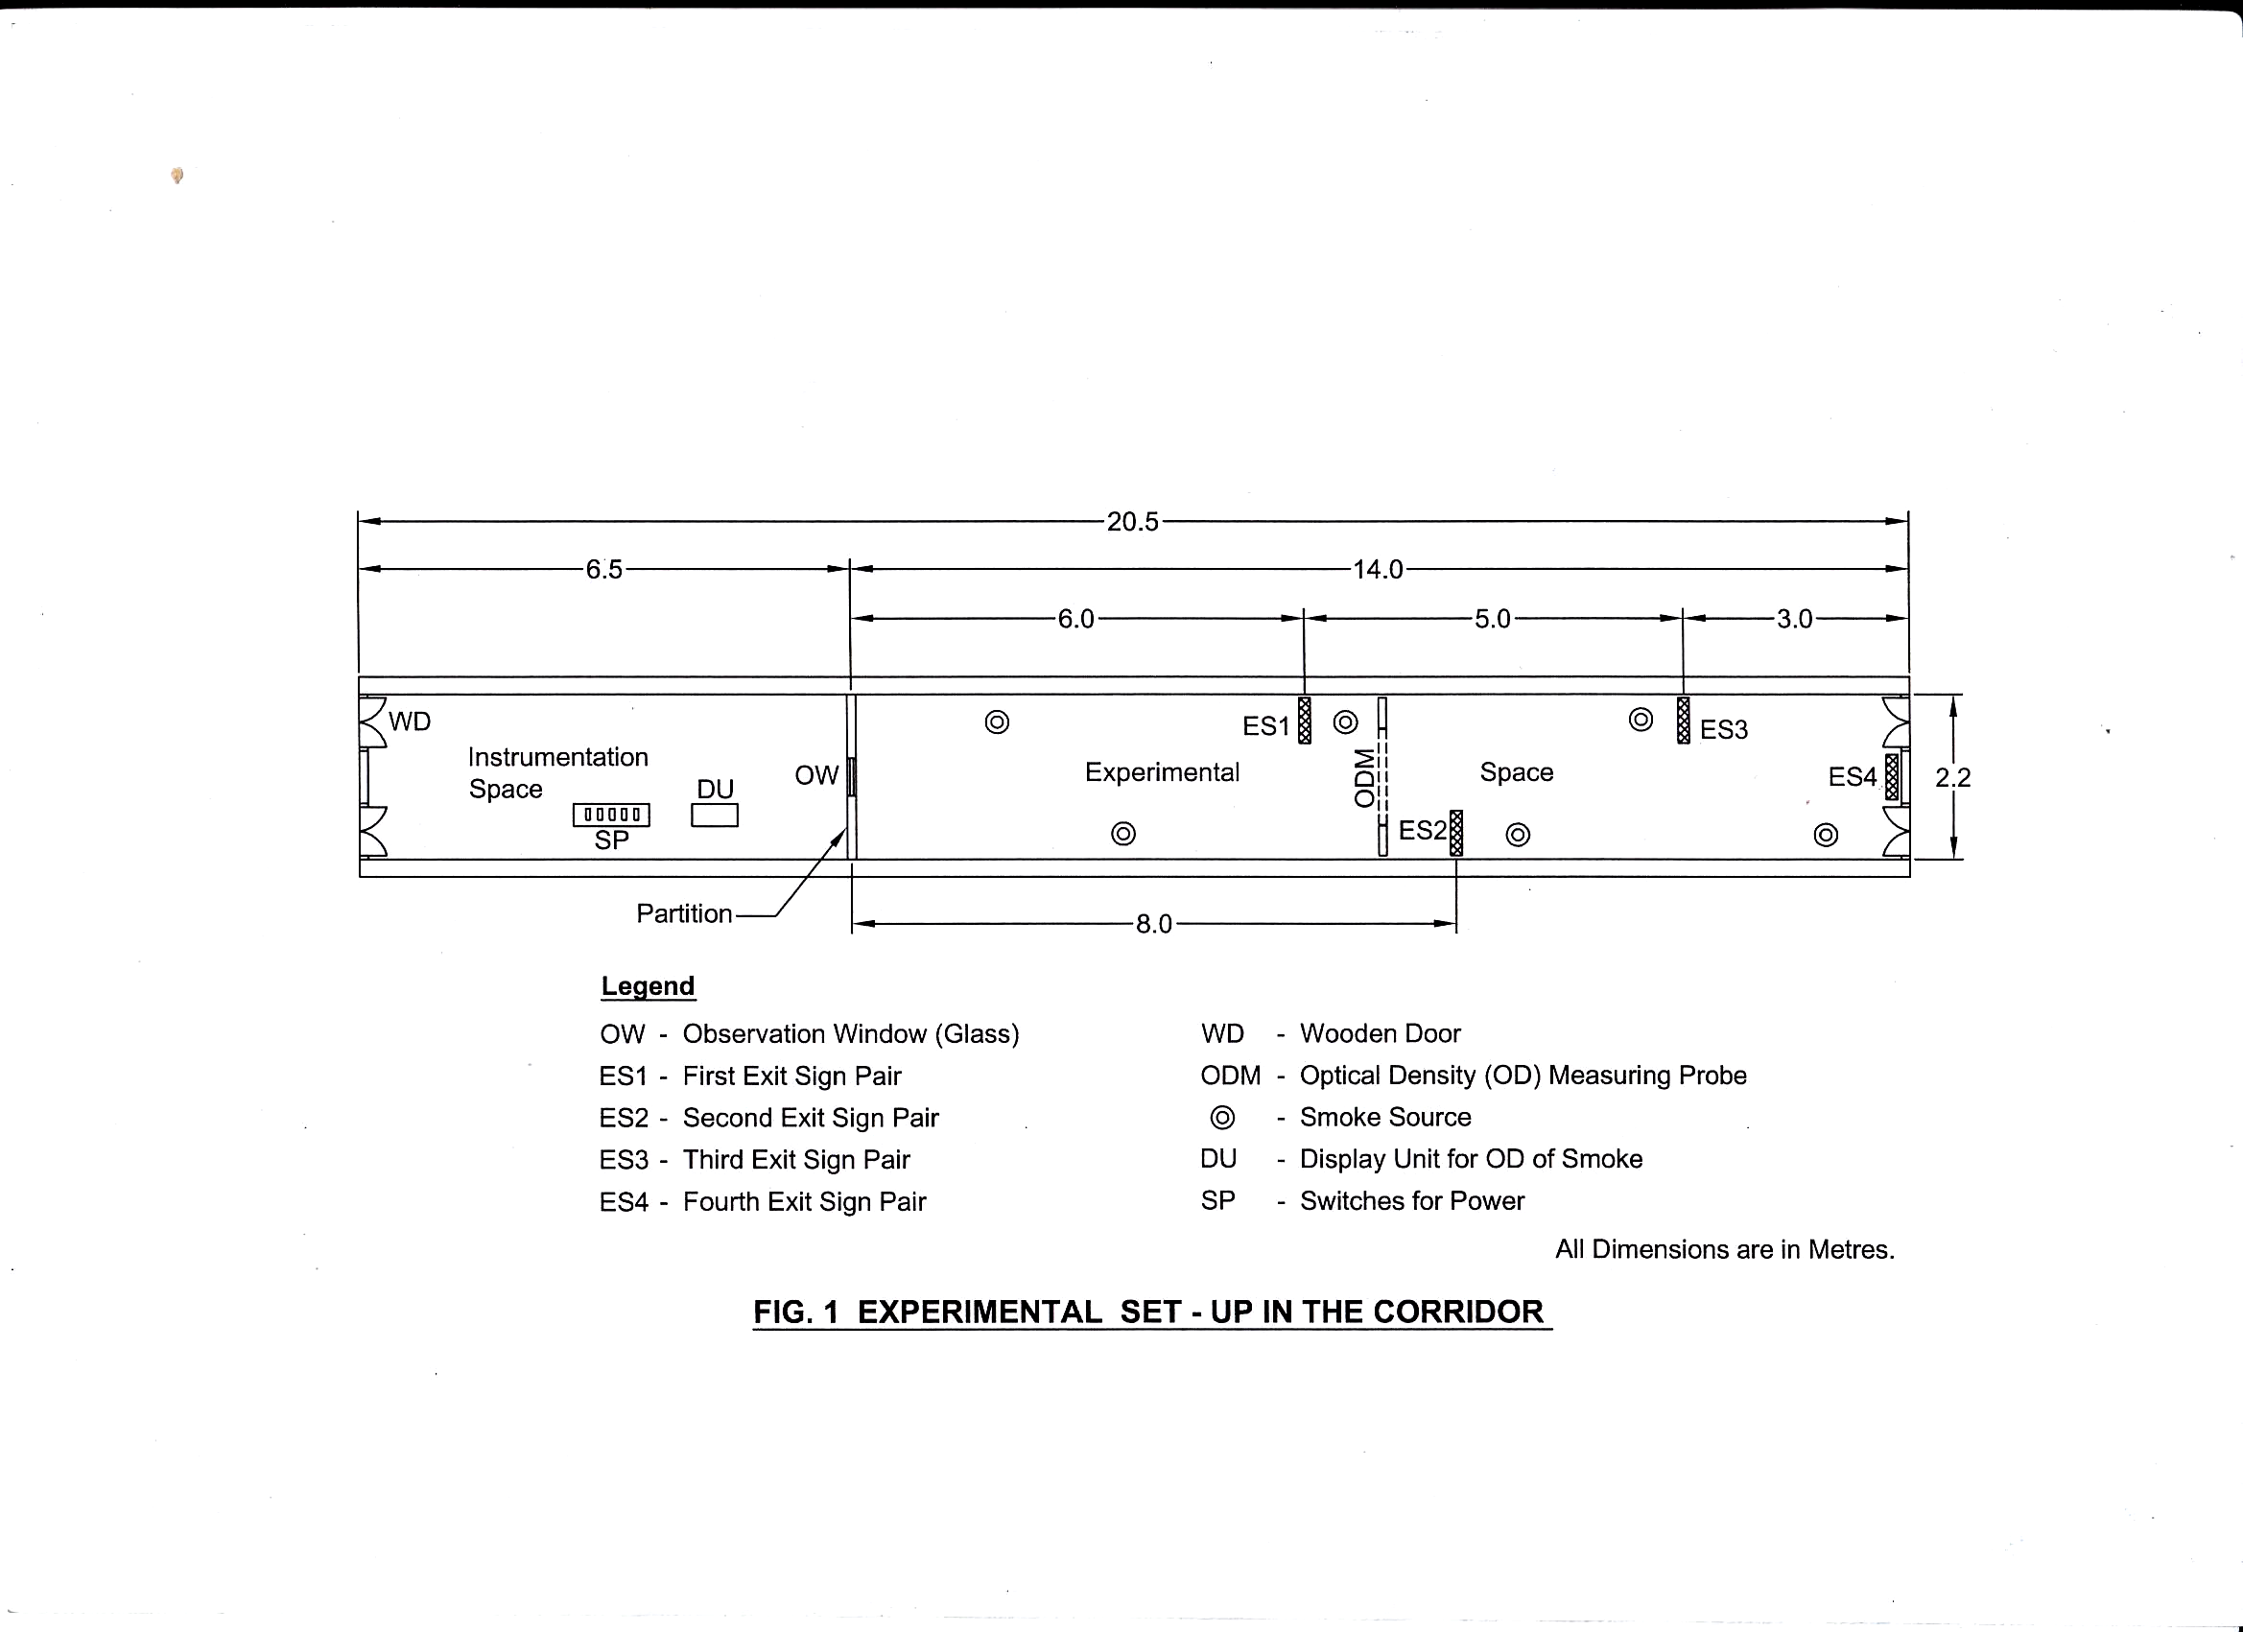
Arrangement inside the Corridor

A wooden partition was put up that (lengthwise) divided the corridor into two parts (or two spaces) – Experimental Space (measuring 14.0 m in length) and Instrumentation Space (measuring 6.5 m in length), as shown in Fig. 1. Exit Signs were installed and smoke was generated in Experimental Space. Optical Density (OD) measuring probe was also installed in the Experimental Space. An observation window (OW) of glass was provided in the wooden partition at a height of about 1.65 m through which Exit Signs and other objects in the Experimental Space could be seen. Observers remained in Instrumentation Space and observed visibility of Exit Signs through OW. End of the Experimental Space, opposite to OW, was kept closed (i.e. door at this end of the corridor was kept closed). Display Unit for displaying Optical Density (OD) of smoke and switches for controlling lighting in the corridor (as well as in conventional types of Exit Signs) were also kept in Instrumentation Space. There was provision of Interior lighting in the corridor for normal lighting purposes. However, in most of the experiment interior lighting was kept off in view of the fact that, in fire emergency, interior lighting from mains supply may not be available. Optical Density (OD) measuring probe was provided in the corridor at a distance of 7.0 m from OW (i.e. approximately at the middle of experimental space).

Smoke Generation in the Experimental Space

Smoke was generated in the Experimental Space. Three types of smokes were generated from kerosene, diesel and cotton-wicks. Kerosene and diesel in small quantity were kept in small containers. Cotton wicks were also thin in diameter and were 50 cm long. Diesel produced black smoke while cotton-wicks (as well as kerosene) produced grey smoke. For generating smoke, small fuel quantity was taken as small source of smoke. For each experiment, 6 smoke sources were take and were placed at 6 different locations as shown in Figure –1 (3 locations along each of the side walls of the experimental space). Smoke was generated at a very slow rate from all the 6 sources. Slow generation and proper mixing ensured that the experimental space is filled with smoke uniformly / homogenously without significant density gradients below the ceiling. This means that the Optical Density (OD) remains essentially uniform along layer touching the ceiling at a given time during an experiment. As more and more smoke is generated, smoke layer below the ceiling become thicker and thicker. Optical Density goes on increasing and Exit Signs becomes obscure.

Distances of Exit Signs from Observation Window

A Conventional type of Exit Sign and a Photoluminescent type of Exit Sign were paired together (one over the other) so that a particular pair could be placed at a defined distance from OW. Four pairs were taken and installed in the Experimental Space at four different distances from OW. Measuring from OW, nearest (first) pair of Exit Signs was at a distance of 6.0 m from the observer. Second and third pairs were at distances of 8.0 m and 11.0 m respectively from the observer. The fourth pair was farthest, at the distance of 14.0 m from the observer (i.e. at the corridor end). Exit Signs were installed vertical to the side walls of the corridor so that the observer could see them straight on. Height of pairs from floor level remained about 1.93 m.

EXPERIMENTAL OBSERVATIONS

Experiments have been conducted using kerosene, diesel and cotton wicks as fuels to generate smoke in the experimental space. With these fuels, both black and grey smokes could be obtained.

Both types of Fire Exit Signs were installed in the experimental space and their visibility observed from Observation Window (OW) as smoke filled the experimental space. Optical Densities were noted when a Sign became invisible. Exit signs (of photoluminescent as well as conventional) types were at distances of 14m, 11m, 8m and 6m respectively from the Observation Window (OW) or observers.

Visibility Table (Visibility V/s Optical Density)

Visibility  (in meters) | Photoluminescent Type mean  Avg. OD(in dB/m) at which the sign becomes invisible | Conventional Type mean  Avg. OD(in dB/m) at which the sign becomes invisible
Kerosene smoke
14 m | 0.153 | 2.759
11 m | 0.437 | 3.476
8 m | 0.514 | 4.595
6 m | 1.044 | 6.509
Diesel smoke
14 m | 0.346 | 2.607
11 m | 0.595 | 3.376
8 m | 0.915 | 4.807
6 m | 1.535 | 6.665
Cotton wicks smoke
14 m | 0.252 | 2.541
11 m | 0.389 | 3.382
8 m | 0.963 | 4.471
6 m | 0.978 | 6.746

Mean value (based on four trials) of Optical Density (OD) per meter at which Fire Exit Signs (both types) became invisible to the observers are given in the following Visibility Table.

CONCLUSIONS

Visibility of both - photoluminescent as well as conventional, types of FIRE EXIT SIGNS has been assessed. In terms of comparison between the two types, the above values of OD show that the visibility of photoluminescent type of Fire Exit Signs is very less than the visibility of conventional (electrically illuminated) type of Fire Exit Signs. In other words, at a given smoke density, conventional type of Fire Exit Signs would be visible from a far greater distance than photoluminescent type. This leads to the conclusion that brightness of the photoluminescent material is a serious limitation as far as application of these materials in making Fire Exit Signs is concerned. Unless photoluminescence itself is improved, visibility will remain poor in comparison to the conventional type of Fire Exit Signs. Visibility versus OD of smoke relationship (linear best fit) curves have been obtained for both types of ‘Fire Exit Signs’ and are given in figure -3. Irritation due to smoke has not been considered here, however it will adversely effect the visibility.

The results in the above table also show that in the black smoke from diesel, visibility of photoluminescent type of Fire Exit Signs is somewhat more than the visibility of these Signs in grey smoke from cotton wicks (or kerosene).
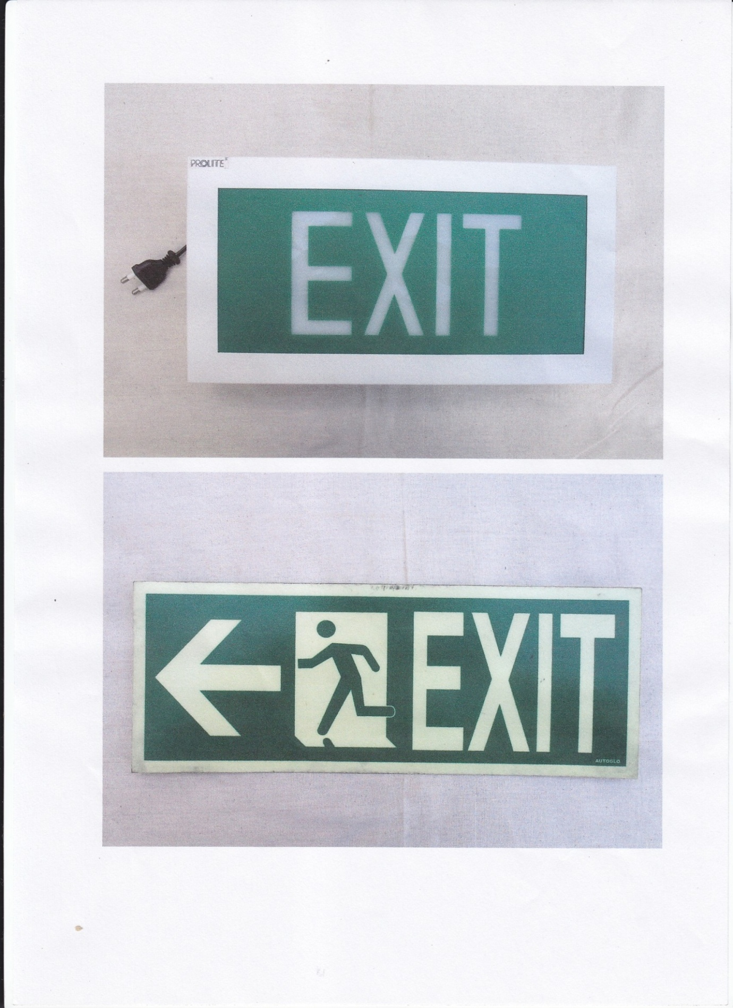
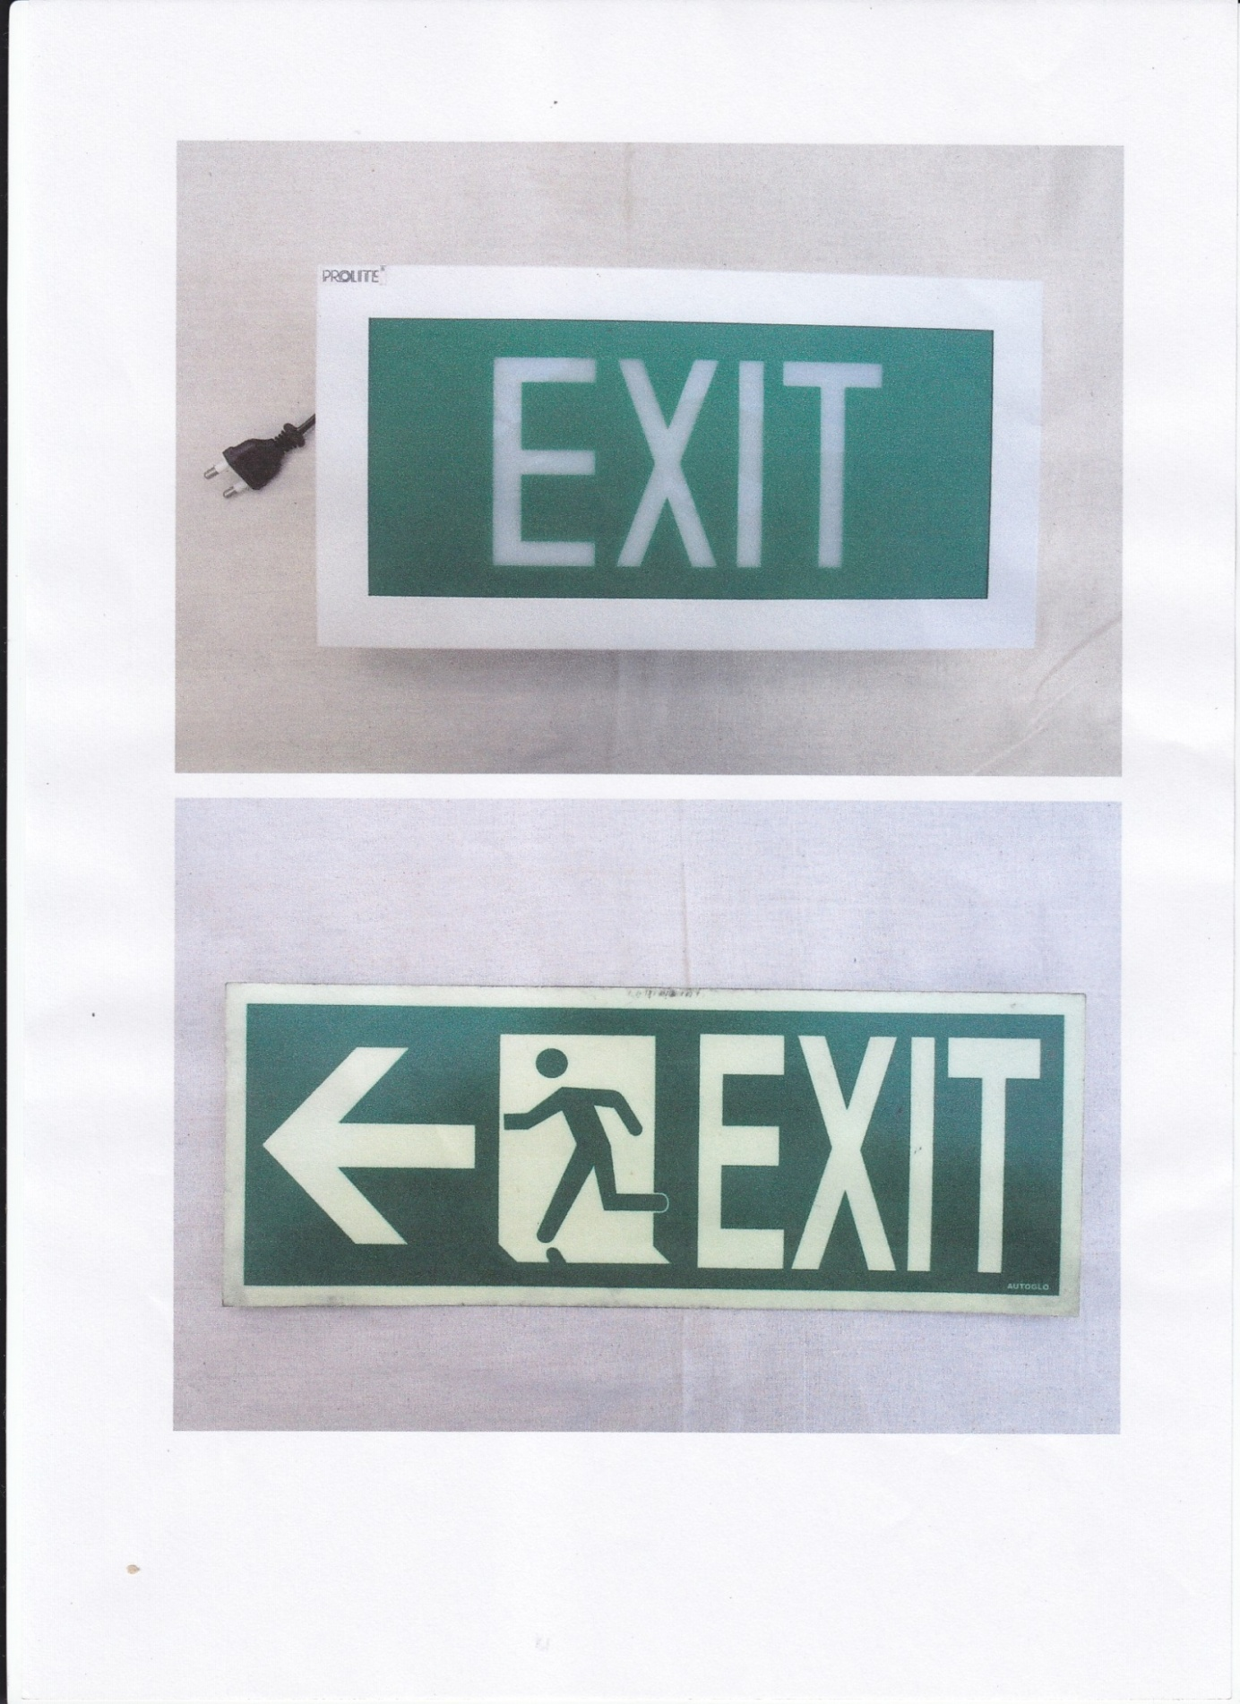
(a) Photoluminescent Type
(b) Conventional Type
Figure-2 Two types of Exit Signs
Fig.-3: Visibility V/s Optical Density Relations

Figure- 3 Relationship between Visibility and Smoke

