FIRE PROPAGATION INDEX & HEAT RELEASE STUDIES OF PLYWOOD TREATED WITH CHEMICAL SURFACE BARRIER
- A. Ansari, Sunil K. Sharma, Harpal Singh and Rakesh Kumar
Fire Research Laboratory
CSIR- Central Building Research Institute, Roorkee (India)
E mail: aaansari1311@yahoo.com

ABSTRACT
Generally wood and wood based materials are combustible, easily ignitable, can propagate heat and flame spread, produce dense smoke in fires. These materials can be used in buildings as lining materials in spite of their inferior behaviour in fire.

To render them flame retardant, we studied & prepared a new chemical surface barrier which not only improves the flame redundancy of these materials but also makes them fire safe.

The paper uniquely focuses on the study of an effective chemical surface barrier / fire retardant after treatment and appropriate curing. It should provide better “reaction to fire” characteristics to Plywood in a building fire. Reaction to fire characteristics include: Fire Propagation Index and Heat release. An attempt is made here to compare the effectiveness of Heat release over fire propagation index.

INTRODUCTION
Statistics show that generally between 10 and 20 fire deaths per 1,000,000 inhabitants are reported in the major industrial countries of the world. The number of severely injured people is estimated at ten times this figure, i.e. 100 to 200 per 1,000,000 inhabitants per year. About 80% of all fire deaths occur in residential buildings. The people most at risk are the very young and the elderly because they are least able to escape in the event of a fire.

The most common cause of death in fires is to be overcome by gas or smoke: In the UK, around 50% of people die this way, while 25% of deaths are due to burns and 20% are attributed to both burns and being overcome by gas or smoke. 5% of fire deaths cannot be specified. Accidental fires in the home have far higher casualty levels than any other location.
A fire can basically be split into three phases, the initiating fire, the fully developed fire and the decreasing fire. The fire starts with an ignition source setting combustible material on fire. The fire spreads, heats up the surroundings and once the materials in the room have formed enough flammable gases and are sufficiently hot, flashover takes place and the whole room is engulfed in the fire. This is the start of the fully developed fire. The fire will later decrease as the available fire load is consumed by the fire or if the fire occurs in a totally closed room the fire can decay because of oxygen deficiency.

The fundamental parameters governing a fire are:

- Combustibility: Will a material burn?
- Ignitability: If it is easily ignitable, how and when will it ignite?
- Spread of flame: Once ignited, how quickly will the flames spread over the surface?
- Heat release/ Fire Propagation Index: What will be the rate and total amount of heat released or how much is contribution of heat towards development and propagation of fire in terms of Fire Propagation Index?
- Smoke generation: Smoke development and visibility reduction which hinders escape in case of smoke filled fire.

CHEMICAL SURFACE BARRIER / FLAME RETARDANT

Chemical surface barriers / flame retardants are chemicals which are added to combustible materials to render them more resistant to ignition. They are designed to minimize the risk of a fire starting in case of contact with a small ignition source. If the flame retarded material or an adjacent material has ignited, the flame retardant will slow down combustion and often prevent the fire from spreading to other items. Flame retardants are necessary to ensure the fire safety of a wide range of materials including wood products. These materials are e.g. used in parts of buildings as false ceiling, wall linings, partitions and building components.
Both our homes and offices contain an increasing potential “fire load” of combustible materials because of of rising levels of comfort. Chemical surface barriers / flame retardants protect modern materials such as building components, from igniting and from spreading a fire. Once a fire starts in a room of a house, it can develop rapidly, if it spreads to items other than that first ignited. Once a number of items are burning, the temperature in the room will rise, and may reach “flash over” point, when hot burning gases cause effectively the whole room to catch light, often violently. Once this occurs, escape from the room is impossible, and spread of the fire to other rooms is very likely. Chemical surface barriers / flame retardants act both by preventing the initial start of a fire by impeding ignition and by delaying the spread of the fire, thus increasing escape time, and perhaps preventing “flash over.
Chemical surface barriers / flame retardants can be applied to many different combustible materials to prevent a fire or to delay its start and propagation by interrupting or hindering the combustion process. They thus protect lives, property and the environment.
Chemical surface barriers / flame retardants contribute to meeting high fire safety requirements for combustible materials and finished products prescribed in regulations and tests.
By chemical and/or physical action, flame retardants will inhibit or even suppress the combustion process. They interfere with combustion during a particular stage of this process, e.g. during heating, decomposition, ignition or flame spread. The amount of flame retardant one has to add to achieve the desired level of fire safety can range from less than one per cent for highly effective flame retardant up to more than 50 per cent for inorganic fillers. Typical ranges are 5 to 20 per cent by weight.
The most effective chemical action may take place by:
- Reaction in the gas phase: The radical gas phase combustion process is interrupted by the flame retardant, resulting in cooling of the system, reducing and eventually suppressing the supply of flammable gases.
- Reaction in the solid phase: The flame retardant builds up a char layer and shields the material against oxygen and provides a barrier against the heat source (flame).
The less effective physical action may take place by:
- Cooling: Energy absorbing (Endothermic) processes triggered by additives and/or the chemical release of water cool the substrate to a temperature below that required for sustaining the combustion process.
- Formation of a protective layer (coating): The material is shielded with a solid or gaseous protective layer and protected from heat and oxygen necessary for the combustion process.
- Dilution: Inert substances (fillers) and additives evolving non-combustible gases dilute the fuel in the solid and gaseous phases.

CHEMICAL SURFACE BARRIERS
Wood and wood based lining materials, has a wide range of applications as a construction material as it is or in the form of Plywood, medium density fibre board, pulp board, paper board, fiber board, chip board, wood wool board etc .Among the wood based boards, plywood are considered to be the “combustible” boards mainly due to their low density. Untreated insulating plywood do not fulfill the requirement of minimum fire safe requirements for these boards in wall and ceiling applications. The cutting edges and perforation seriously affects the flame spread classification and fire propagation index.
A chemical surface barrier is prepared using Melamine, Dicyandiamide, phosphoric acid and Formaldehyde solution in certain molar ratio. First of all the Formaldehyde solution was mixed with specific molar ratio with water and pH of this solution was adjusted to approximately 8 by adding NaOH solution. Then a mixture of melamine and dicyandiamide in the required proportion was added to this solution and the contents were refluxed at 80⁰C in a round bottom flask with a condenser fitted at its top for specific duration.
After refluxing, the solution was cooled to room temperature and then phosphoric acid in a certain molar ratio was mixed slowly in this solution keeping the temperature close to ambient. This phosphatised MDF solution is stored at 4⁰C temperature. The phosphatised MDF solution was diluted with water .The solution to water ratio is 65:35 and the resultant solution is our chemical surface barrier, also stored at a temperature of 4⁰C . The bulk density of the solution as measured was 1.16 g/ ml. The resultant solution in the said ratio was found promising for treating the specimens.
The specimens samples of 12 mm thick Plywood were coated by brush on the surface and cured at 60⁰C in an oven and finally in the sun light to characterize them for Fire Propagation Index and Heat release evaluations. The formulation gives a clear finish after treatment and curing and provides a shine to the surface. The dry loading after the treatment was 3.429 Kg/m² for 12 mm thick Plywood.
FIRE PROPAGATION INDEX (BS: 476: PART-6)
The Fire Propagation Index of materials can be used to identify the likely fire hazard of lining materials in terms of their tendency to contribute to the growth of fire inside buildings. A material of higher Fire Propagation Index is considered to contribute more towards the growth of fire than the one of a lower Fire Propagation index. Thus by comparison of Fire Propagation Indices of different materials for the interior of a building, it is possible to identify safer materials and the performance of different materials can be ascertained relative to each other.
Fire Propagation Index is determined using Fire Propagation Apparatus and by following the procedure specified in the British Standard, BS 476: Part 6 (figure 1). A specimen of the material is 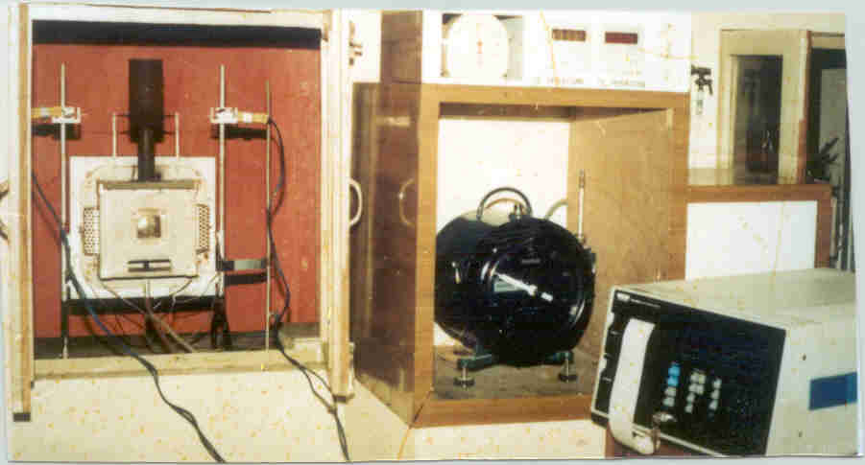
Fig.1: Fire propagation index apparatus
exposed to radiant heat and flames and temperatures of the combustion products are recorded in the stack. From these temperatures, three sub-indices are computed for different intervals of test duration. The fire propagation index is the sum of these three sub indices and is calculated as follows:
I = i1 + i2 + i3
I = Fire Propagation Index
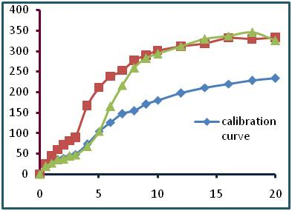
i1 = Sub-index calculated at 0.5 min intervals over the period 0.5 to 3.0 min interval.
i2 = Sub-index calculated at 1 min intervals over period 4 min to 10 min.
i3 = Sub-index calculated at 2 min intervals over period 12 min to 20 min.

Fig. 2 : Time (min) – temperature (deg C) curves for calibration, untreated Plywood and Plywood treated with chemical surface barrier on Fire Propagation Index experiments
Results are expressed as the Fire Propagation Index and the first sub-index. Higher the value of the sub-index or the Fire Propagation Index, higher is the likely contribution of the material to fire.
The specimens of Untreated Plywood and Plywood treated with chemical surface barrier are exposed to fire propagation index apparatus as per standard condition including the calibration. The time –temperature curves for calibration, untreated Plywood and specimens of Plywood treated with chemical surface barrier are shown in fig-1, while the computed mean results for Fire Propagation Indices are given in Table 1.
Type of specimens | Indices |  |  | Fire Propagation index,  I
 | i1 | i2 | i3
Untreated Plywood | 8.15 | 11.91 | 3.49 | 23.55
Plywood treated with chemical surface barrier | 0.13 | 5.29 | 3.64 | 9.00

Table 1: Fire Propagation Index for Plywood & Plywood treated with chemical surface barrier
HEAT RELEASE (ISO: 5660)
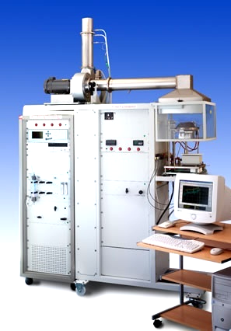
Heat Release studies carried out on untreated Plywood specimens and Plywood treated with chemical surface barrier by using Dual Cone Calorimeter as shown in Figure 3.
Oxygen-consumption-principle-based cone calorimeter testing is a useful small-scale test capable of determining most of the important parameters for identifying fire hazard. In this study, tests were conducted on the cone calorimeter according to the ISO5660 standard Fig. 3- Dual Cone Calorimeter test method. The specimens of untreated Plywood and Plywood treated with chemical surface barrier were exposed to an incident radiant flux of 50kW/m2. The measured parameters include HRR (heat release rate), MLR (mass loss rate), time of ignition, mass loss rate, smoke release rate, effective heat of combustion, rate of release of toxic gases (Carbon monoxide, Carbon dioxide).

Table 2: Dual cone calorimeter data for specimens of untreated Plywood and Plywood treated with chemical surface barrier
DATA | Plywood  12 mm | Plywood  (Treated)  12 mm
Heat Release Rate (kW/m²) | 142.4 | 102.6
Total Heat Release, MJ | 76.9 | 73.4
Effective Heat of Combustion(MJ/kg) | 13.1 | 15.1
Time to ignition, s | 17 | 37
Duration of flame, s | 560 | 755
Mass loss rate, g/s | 0.108 | 0.068
Specific extinction area, m²/kg | 58.7 | 87.9
Carbon monoxide yield (kg/kg) | 0.016 | 0.0364
Carbon dioxide yield (kg/kg) | 1.13 | 1.64
Total smoke release,  NF mode (m²/m²) | 0.3 | 16.9
Total smoke release,  F mode (m²/m²) | 345.6 | 432.6
Total smoke release (m²/ m²) | 345.9 | 449.5

The time -heat release rate curves for untreated Plywood and specimens of Plywood treated with chemical surface barrier are shown in fig-4.

The curves of time – specific extinction area, time – mass loss rate, time - % CO generated and time - % CO₂ generated for untreated Plywood and specimens of Plywood treated with chemical surface barrier are shown in fig. 5-8.

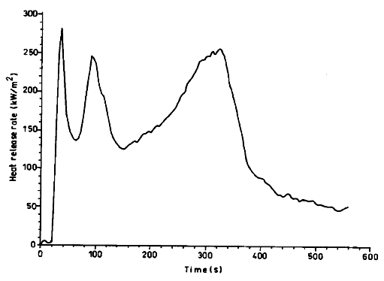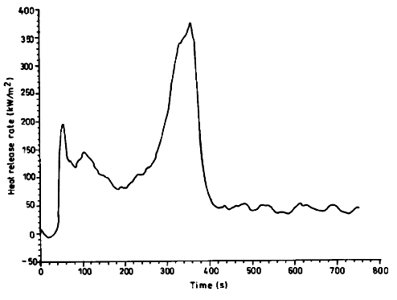
Plywood Plywood with CSB
Fig 4: HRR curves for untreated Plywood and specimens of Plywood treated with chemical surface barrier
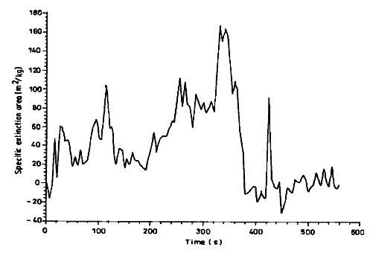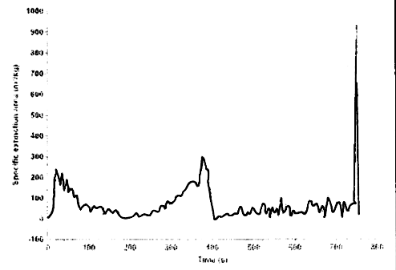
Fig 5: Specific extinction area for untreated Plywood and specimens of Plywood treated with chemical surface barrier

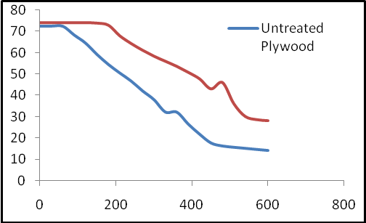
Mass, g
Time, s

Fig 6: Mass loss rate for untreated Plywood and specimens of Plywood treated with chemical surface barrier
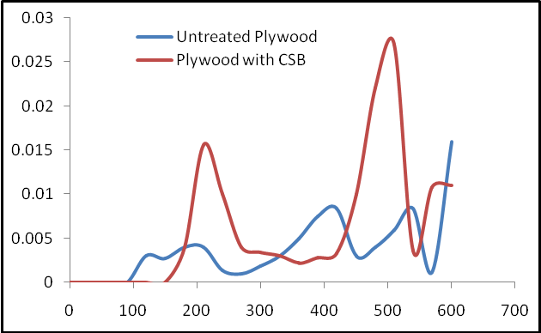
CO %
Time, s

Fig 7: Curves for % CO generated during heat release experiments on untreated Plywood and specimens of Plywood treated with chemical surface barrier
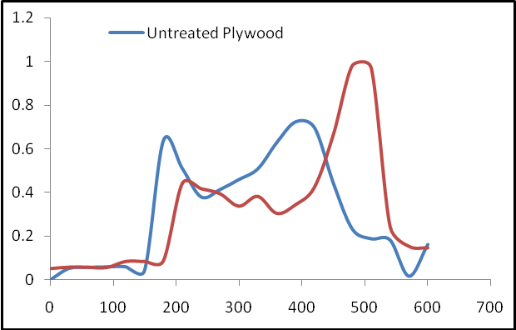
CO₂ %
Time, s

Fig 8: Curves for % CO₂ generated during heat release experiments on untreated Plywood and specimens
RESULTS AND DISCUSSION
Fire propagation index
The results obtained during experimental investigations on Fire Propagation Index of Plywood and Plywood treated with chemical surface barrier are summarized in Tables 1.
Fire propagation indices i_{1,} i2, i3 and I for untreated Plywood are 8.15, 11.91, 3.49 and 23.55 while these values for Plywood treated with chemical surface barrier are 0.13, 5.29, 3.64 and 9.00 respectively. The first sub-index which is the measure of flammability and period to pre-flash over has come down to nearly 2 %, while Fire propagation index I has shown reduction to 62 %. The time-temperature curve for Untreated Plywood shows higher rate of increase in temperatures from ignition of fire to the ‘flash –over’, then these increases gradually in fully –developed’ fire, while it becomes steady for the ‘deceased fire ‘period.
Plywood treated with chemical surface barrier shows very less or almost no increase in temperatures during first stage of fire and ‘flash-over’, the result is very much promising. During fully developed fire stage, temperatures are on lower side for this composition as compared to those for untreated specimen. During the final or decay period of fire, the temperatures for all the specimens becomes steady.
Heat release
Dual Cone calorimeter tests were carried out on the specimens of untreated Plywood and Plywood treated with chemical surface barrier and the fire hazard assessment based on these tests are given below. The data generated during heat release experiments are given in table-2.
DATA | Plywood  12 mm | Plywood  (Treated)  12 mm
Heat Release Rate (kW/m²) | 142.4 | 102.6
Total Heat Release, MJ/m² | 76.9 | 73.4
Effective Heat of Combustion(MJ/kg) | 13.1 | 15.1
Time to ignition, s | 17 | 37
Duration of flame, s | 560 | 755
Mass loss rate, g/s | 0.108 | 0.068
Specific extinction area, m²/kg | 58.7 | 87.9
Carbon monoxide yield (kg/kg) | 0.016 | 0.0364
Carbon dioxide yield (kg/kg) | 1.13 | 1.64
Total smoke release,  NF mode (m²/m²) | 0.3 | 16.9
Total smoke release,  F mode (m²/m²) | 345.6 | 432.6
Total smoke release (m²/ m²) | 345.9 | 449.5

Table 2: Dual cone calorimeter data for specimens of untreated Plywood and Plywood treated with chemical surface barrier

Ignition and Extinction Characteristics
Ignitability is the ignition ability of the volatiles released when a material is heated. The temperature of self-ignition, the ignition delay time in cone calorimeter test, the minimum radiant heat flux, and so on can all be used to assess the ignitability of the material. The higher the ignition temperature or flash point, the longer is the ignition time, or higher the minimum radiant heat flux, safer the material is.
The time to ignition for the specimens of untreated Plywood obtained is 17 s while for Plywood treated with chemical surface barrier it is 37 s, which shows that the ignition delay at peak fire irradiance level is 217 % more than that for untreated Plywood, hence the chemical surface barrier applied to Plywood is significantly effective in the initial period of fire growth.

Heat Release Rate
Cone calorimeter is based on the principle of oxygen consumption that is, for most combustibles; about 13.1MJ heat is released per kilogram of oxygen consumed. Thus, by measuring the variation of oxygen concentration prior to and after combustion and the corresponding gas flow rate, the rate of heat release can be calculated. Cone calorimeter has been widely adopted for evaluating material or products’ fire safety in real fire cases because of its good correlation to full-scale fires. It has been claimed that the rate of heat released by a product is the most important property predicting hazard in a fire situation, based on the assumption that HRR is a measure of the intensity of burning.
The heat release rate (HRR) for the specimens of untreated Plywood obtained is 142.4 kW/m² while for Plywood treated with chemical surface barrier it is 102.6 kW/m², which shows that the reduction in heat generation is 72 % less than that for untreated Plywood, hence the chemical surface barrier applied to Plywood is effective in making the product of low heat release.
The Specific Extinction Area (SEA) and Production of CO/CO2
Non thermal parameters like obscuring effect of smoke and concentration of toxic or smothering gases, such as CO & CO2, are related to fire hazard as well, as we are informed that over 80% of casualties in fire are caused by CO toxicity. SEA and CO concentration are two frequently adopted smoke properties for fire hazard assessment.

The Specific Extinction Area (SEA) for the specimens of untreated Plywood obtained is 58.7 m² / kg while for Plywood treated with chemical surface barrier it is 87.9 m² / kg , which shows that the increase in SEA. The curves for time – specific extinction area shows steady results with the peak at the end of experiment for a very short duration.

The curves for time – mass loss rate during heat release experiments shows 63 % reduction in mass loss rate for Plywood treated with chemical surface barrier as compared to that for the specimens of untreated Plywood.

The curves for time – % CO generated and for time – % CO2 generated during heat release experiments shows slight increase but within the permissible limits.

The curves for time – mass loss rate during heat release experiments shows 63 % reduction in mass loss rate for Plywood treated with chemical surface barrier as compared to that for the specimens of untreated Plywood.

The overall experimental results for Fire propagation index and Heat release rate show the chemical surface barrier applied to Plywood is effective in making the product of low heat release & low Fire propagation index.

CONCLUSIONS
Reaction to fire characteristics of materials used in building industry is of considerable significance from the life safety point of view. The concept of reaction to fire characteristics can be used to identify the likely fire hazard of materials in terms of their tendency to ignite, to burn, to contribute to the growth of fire and spread of flame, to generate dense smoke and combustion products. Thus by comparison of ‘Reaction to fire characteristics’ of different materials it is possible to identify the fire safe material in order to avoid fire incidences and for maintaining desired level of fire safety in buildings.
A chemical surface barrier can improve the ‘reaction- to- fire’ characterstics of lining materials used in buildings by rendering them flame retardant.
The overall fire performance of Plywood treated with chemical surface barrier is much better than that of untreated Plywoodand hence the chemical surface barrier treatment is quite effective.
REFERENCES
- A.A. Ansari, "Fire Behaviour of Wood Substitutes", Journal of Scientific and Industrial Research, vol. 56, Mar. 1997, pp 149-158.
- Fire tests on building materials and structures, Part 5: Ignitability test for materials, Bs 476: Part 5 - 1968. (British Standard Institution, London) (1968).
- Fire tests on building materials and structures, Part 6: Method of Test for fire propagation of products, BS 476: Part 6 : 1981 (British Standard Institution, London) (1987).
- Fire tests on building materials and structures, Part 7: Method for classification of the surface spread of flame of products, BS 476 : Part 7 : 1987 (British Standard Institution, London) (1987)
- Standard test method for Specific Optical Density of Smoke generated by Solid Materials, ASTM Designation E 662 - 1983. 1988 Annual Book of ASTM Standard (American Society of testing and materials, Philadelphia) 14 (04.07) (1988). 523-544.
- M. V. Ranney,’Fire resistant and flame retardant polymers’, Noyes Dolen Corporation, London (1975)
- Menachem Lewin, Gerald S. Krishenbaum, ‘Flame retardancy of polymeric materials’, Vol.1, 1990.
- Shuqin He, Yuan Hu, Lei Song and Yong Tang, ‘Fire safety assessment of halogen-free flame retardant polypropylene based on cone calorimeter’, Journal of Fire Sciences, vol. 25, Mar 2007, pp 109-118.

