NOISE ABATEMENT IN HIGH RISE BUILDINGS

R.K.Srivastava, Sc.F & R.L.Dhabal, Sc.EII
Central Building Research Institute, Roorkee

Abstract

There is a visible problem of noise in high-rise buildings in metropolitan cities. Metropolis with their ever increasing vehicular population are becoming more and more noisy thereby exposing increasing number of people to noise menace. The expansion of high-rise buildings is taking place in vertical direction due to paucity of residential and commercial buildings. Noise is one of the environmental pollutants that is encountered by day-to-day life. Ever since people began to use high-rise buildings for offices, commercial business and residences, noise has been considered an unjustified interference in comfort, health, quality of life and communication to the occupants.

Two types of buildings have been chosen for the studies namely Residential and Office cum Commercials buildings. The noise levels in these buildings comprised mainly of internal noises such as office work, telephone talk and movements of furniture etc. and external noise such as traffic noise , AC plant or generator set noise etc. Measurements were conducted in horizontal and vertical direction in high rise buildings. These buildings accommodated large variety of activities. Variation of horizontal and vertical noise levels were recorded. The noise level varied between 68dB to 97dB. Measurements were also conducted inside the building to see the effect of outside noise entering the building and also the noise generated inside the buildings The data collected was analyzed in the laboratory to see the frequency contents and its effectiveness in annoyance to the occupants.

The paper deals with the planning and proper designing of the high rise buildings by sound insulating and by using acoustical materials and practices been highlighted

Introduction

Noise adversely affects the person in various ways. Depending upon the intensity and duration, the person exposed to continuous noise may suffer from a temporary or permanent loss of hearing. There is increasing evidence that noise exposer causes physiological disturbance namely changes in digestion system, blood circulation etc.

Studies reported by U.S National Institute of Occupation Safety and Health, International Standards Organization has accepted that 90 dBA for a duration of 8 hours per day as safe limit for permanent hearing loss.

In high rise buildings all the activities utilizing equipments, electrical appliances materials means and modes that produce pressure variation in the frequency range constitute a noise source. Transportation and Industrialization has caused considerable concern not only among apartment occupants and owners, but also among investors, real state owners and governmental agencies.

Due to large number of people it widely varying nature of work accommodated in different floors of a high rise buildings, the acoustic scenario in these building are different than the single storied or double storied conventional constructions.
Number of new sources of noise have been increased the overall noise levels to an undesirable limits causing annoyance and distraction in their day-to-day work.

There are number of reasons which contribute noisiness to our environment lead to growing number of complaints of inadequate sound insulation and sound absorption in high rise buildings. The few causes are given as under:

- Light weight-building structures.
- Poor acoustic design
- High population density apartments
- Mechanization
- Awareness towards noise
- Poor workmanship
- Transportation
- Domestic appliances

In order to know the noise levels in different places of metropolitan cities, two types of buildings were selected for survey under the study, that is commercial cum office buildings were located in heavily dense and noisy environment through cross roads or in busy market. Measurements were taken in high-rise building ranging from 8 stories and above. These building accommodated large number of activities varying largely ion terms of noise emission characteristic measurements were recorded in tape recorder using integrated sound level meter.

Noise levels were measured at the entrance of each high-rise building and on different floors of the building facing the busy roar. At the same time L_{max} and L_{min} levels were also measured in different time of the day and night. Variations of noise levels in horizontal plane as well as vertical plane at different floors were also recorded.

The data collected was analyzed in the laboratory to see the frequency contents available in the noise and its effectiveness in annoyance to the occupants.
Measurement of noise levels was conducted in the following buildings at Delhi.

1) Residential Building

- Scientist Apartment, Ashram Chowk.

2) Office cum Commercial buildings

- Hindustan Time buildings.
- State Trading Corporation buildings.
- Life Insurance Corporation buildings.

Residential Buildings
Measurements were conducted in Residential Complex to check the horizontal and vertical direction of noise levels. Noise levels were recorded at a distance of 1meter away from the roadside from morning to evening.
It was assumed that number of heavy vehicles as well as light vehicles remains the same. It was shown that levels decreased as we go away from the roadside in horizontal plane as shown in Table 1 and Figure 1.
It has been that about a distance of 3 meter the levels remains almost constant then there was fall of noise levels with distance. However near the building levels further increased due to reflections from the building walls.
In case of closed site the vertical observations the variation with height was not that significant. This may be due to multiple reflections of sound from the structures on one side of the road.
In case of semi open situation there was slight decreased with height. The measurements were shown in Table 2 and figure 2.
Windows are also seen to have quiet effective role of advantage of about 4-5dB.
Boundary wall about 4 m heights between the road and the residential complex act as a barrier. Floor wise Measurement was given in Table 3 and figure 3.

Office cum Commercial buildings
Commercial buildings were situated in a very busy locality. The main source of noise was traffic noise. The other sources were generators, A.C Plants etc. Although generators and A.C Plants were kept in the basement and the overall noise levels were recorded of the order of 97 dB and 90 dB respectively. When the generators and A.C. Plants were switched off the background noise was 70 dB. Few measurements are shown in Table 4 and fig 4.

Suggestive Measures

External noise Control
The prevailing noise levels on the roadside of external noise sources (Air craft, Vehicular traffic, rail transportation, Industrial plant operation etc.) were in the range of 80-100 dB.

- Building should be judiciously situated at a distance of 50- 100m away from the road
- Buffer zone between road and building should be provided with noise barriers, green belts, landscaping to achieve a noise reduction of 35-40 dB (shown in figs.1-6)
- Zoning, planning and orientation of building must be properly done to cut down the direct entry of noise (fig.7)
- Intermittent gaps in continuity of buildings along the road side may be provided in high rise buildings (fig.8)
- Use of heavy vehicles and honking of horns may be strictly regulated as per need
- Louvers/fenestration on building should be properly designed to restrict external noise entering the building
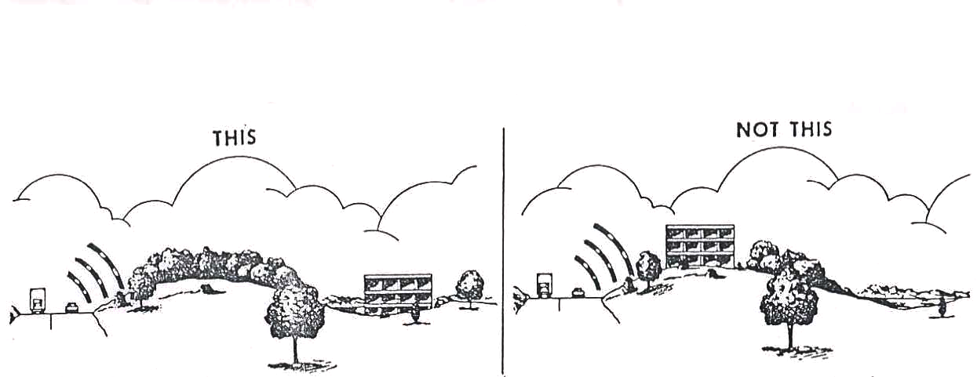

Fig 1: Natural noise barriers

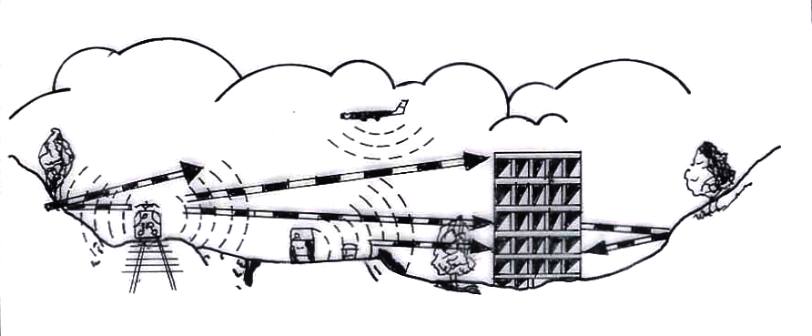
Fig 2: Poor building site
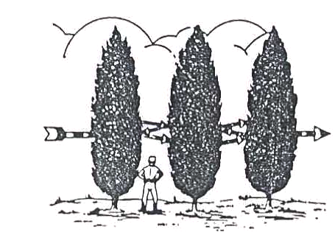
Fig 3: Noise reduction due to trees in a row (3-4dB).

Fig 4:Building sites near traffic Fig 5: Building sites near hilly

Junction. traffic areas.

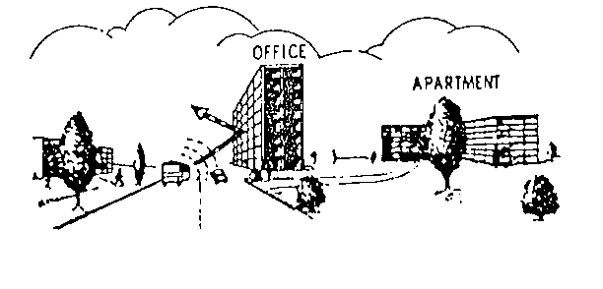

Fig 6: Use of buildings as noise barriers.

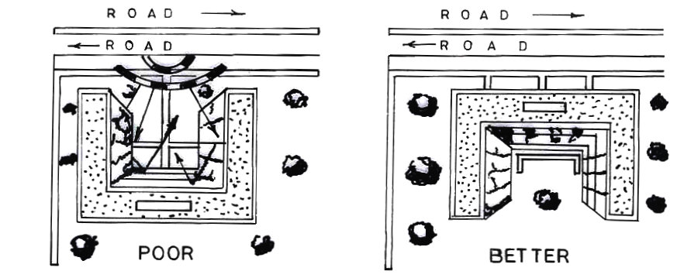
Fig. 7 Orientation of buildings

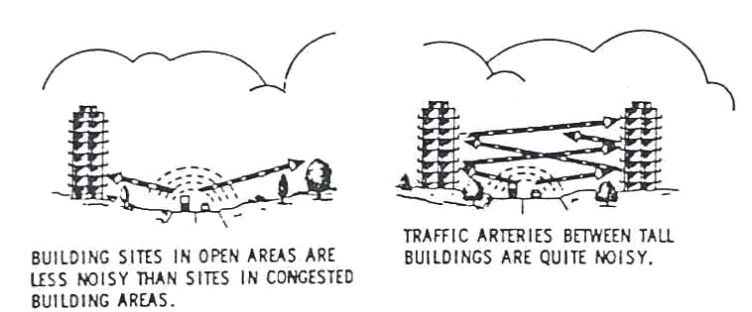
Fig. 8: Building sites near traffic junction and other buildings.

Internal noise control

- Recommended sound insulation between rooms and flats of the order of 35-40 dB should be strictly adhered to (figs.9-11)
- Acoustical treatment of ceiling, walls, AC plants, staircases and corridors should be provided
- Suitable vibration isolators or cushioning should be provided at the foot of domestic appliances or machineries
Windows and doors should be properly designed to achieve 4-5 db reduction of noise.

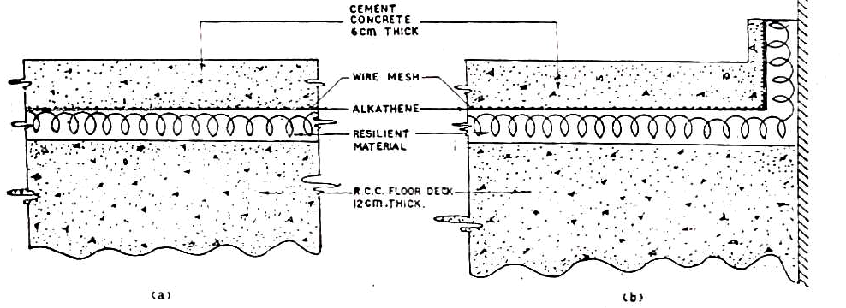
Fig.9: Construction of Resilient Floors

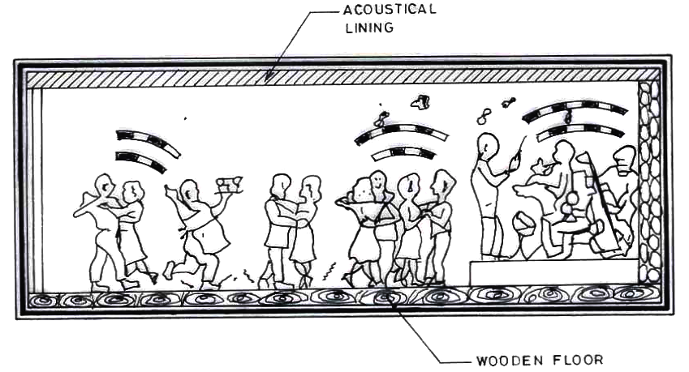 Fig. 10

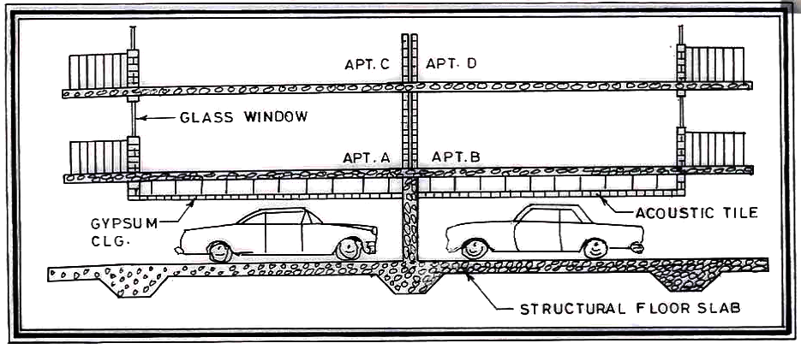
Fig. 11: Garage

In general in high-rise residential buildings main sources of outdoor noise were traffic, i.e., railways and roadways, children playing, services deliveries, blaring loud speakers etc. Inside noise sources were conservation of the occupants, foot step, banging of doors, shifting of furniture, operation of sistern, playing of music systems, Fitch emanates from the adjacent room of building.
Residential building should be constructed in a quiet area away from the noisy sources.

- Anon. 1991 : Noise levels in metropolitan cities , Part III Calcutta Report of CPCB, Delhi, Control of Urban Pollution Series , UPSS, 1-19
- Bjorkman, M., 1988 : Maximum noise levels in road traffic noise, Jour, Sound Vibration , 127 583-587
- Bottom, CG, Croome, D.J, 1969: Road traffic noise-its nuisance value, Appl. Acoust, 2, 279-296
- Bandopadhy ay, S.N., 1981: Recent developments in methods of controlling road traffic noise J.Inst. Engineers (India), 62(Ed.1).7
- Bhatnagar, N. Patwardhan, A, Rajagopalan, S, 1991 a : Evaluation of noise pollution in the home environment Ind. J. Environ , Protection , 11, 910 – 916.

- Bhatnagar , V.S. , Srinivas , M.S.N. , 1991: Analysis of noise levels in residential areas of chandigarh CSIO Communication , 18(1-2), 37-47

- Beranek, L.L., Noise Reduction (Mc Graw Hill Book Company inc., New York), 1960, 257.

- Chakrabarty D., Santra, S.C., Roy.B, 1998: Survey of community annoyance due to traffic noise-exposure in Calcutta metropolis. J. acoust .Soc India ,26 ,39-43

- Chhapgar, A.F., Mohanan,V.1984: Pilot noise survey in Delhi –1983 Tech. Rept. National Physical Laboratory, New Delhi, India

- Kumar, K., Jain , V.K. ,1994: A study of noise in various modes of transport in Delhi, Appl. Acoustic, 43,57-65

Naik, Neelima , S., 1998 : Noise study of two traffic junctions in Mumbai J.Acoust. Soc. India, 26, 15-20.

