CFD Modelling of Wind Flow around Buildings
for Wind Energy Conversion

A.K. Roy and P.K. Bhargava

CSIR-Central Building Research Institute, Roorkee 247667, India
Corresponding author; Email: amritworld@gmail.com

Abstract.

Wind energy conversion through wind turbine is so far well-established concept and very popular out of all available renewable energy sources. Research works are going on to optimize the efficiency of the energy extraction process by inventing advanced wind turbine replacing the old one. Wind speeds of more than 18 km/hr measured at a height of 10 mare sufficient enough for the functioning of wind turbine system. So the wind velocity at the sites is an important parameter for the development. Finding out wind velocities around closely spaced buildings with the help of codes is not possible. It requires extensive wind tunnel testing which is very expensive and time consuming. In this research work, CFD simulation of atmospheric boundary layer wind flow around high-rise urban buildings with different arrangements and wind incidence angles was carried out to observe the variation of wind velocity potential surrounding the buildings. It has been observed that on the leeward side formation of wake zone due to obstructing the flow results in low wind speeds which could be the reasons of poor efficiency of the installed wind turbine. The results are presented in the form of velocity magnitude and velocity vector around the buildings. It has also been observed that significant enhancement of velocity occurred at the roof top of the buildings. Although too many investigations are still required, here only a study has been carried out to explore some possibilities of enhancing the efficiency of wind energy conversion in high-rise urban buildings.

Keywords: Wind energy, velocity potential, wind turbine, CFD simulation, wind tunnel,

- Introduction

The main source of energy production i.e. oil, coal and gas are being used to a great extent with the advancement of the civilization and about to be finished in the next 30 years. Renewable energy sources i.e. hydro power, solar energy, geo thermal and wind energy are the next best choice for the survival of the civilization. Total wind energy available (1700 TW) all around the world is the second highest after solar energy (Solar PV 6500TW and Concentrated Solar Power 4600TW). It’s the current trend followed in developed countries to utilize the huge wind power with the help of building mounted wind turbine and fulfill the increased power demand. Wind energy conversion has reached a significant milestone with success of providing support to our increased electricity demand of our major cities around the world. Yet there are so many technology and invention left in this area so that this abundant source of wind energy can be utilized to produce electric energy.

In an urban area buildings are oriented haphazardly which influence the wind flow and wind velocity varies place to place around building. This variation can be observed by wind tunnel tests with the help of Laser Doppler Velocimetry (LDV) and Particle Image Velocimetry (PIV) or numerical calculations using CFD codes.

In recent years, there are significant progress in the application of CFD to evaluate wind loads on buildings and structures (e.g. [1-4]and others). Architectural Institute of Japan (AIJ) [5-6] and the European cooperation in the field of scientific and technical (COST) research[7] have established working groups to investigate the practical applicability of CFD and to develop recommendations for their use for wind resistant design of actual buildings and for assessing pedestrian level winds. AIJ has also provided methods for predicting wind loading on buildings by the Reynolds Averaged Navier Stokes equations (RANS) and LES.

Pedestrian level wind evaluation carried out by numbers of researchers, where only the mean wind speeds are required for evaluating pedestrian comfort. Computational studies on tall Buildings have been conducted by [3],[8] and others. The flow pattern and mean and rms pressure coefficient of the aerodynamics of Commonwealth Advisory Aeronautical Council (CAARC) building model is investigated by [9] and others. CAARC tall building is considered as one of the most extensively and systematically studied building model and popular in wind tunnel researcher community [10].

In this research work the main concerned area selected just to find out the velocity potential around the building so that wind turbine installation can be optimized to get the maximum power conversion. CFD simulation of the wind flow around tall building has been done to observe the variation of velocity potential. Wind tunnel experimental data has been used to validate the CFD results.

- Numerical simulation of wind flow on high-rise building

In the present study measurements of wind tunnel experiments on tall building [8] conducted at IIT Roorkee, India have been used. The wind tunnel experimental velocity profile and the turbulence intensity are considered here to simulate the boundary layer wind. This wind tunnel is an open circuit type boundary layer wind tunnel with no thermal stratification. It has a test section of 2.1m x 2m cross-section with 15m length. The present study assumes that the power law expression is valid for representing the wind velocity variation in the atmospheric boundary layer and a power law exponent (n) equal to 0.15 is used which corresponds to the open terrain category mentioned as category No.2 in the Indian Standard for wind loads [11]. Other wind standards [12-14] have also been used to validate the simulation study.

- Details of models used for the CFD simulation

The present research work aims at studying the effect of neighbouring buildings on mean wind velocity magnitude observed around the building. In selecting the model scale it is important to avoid the influence of the wind tunnel walls and an excessive blockage of the test section. Corrections are generally applied if the blockage by the model of the building and its immediate surroundings exceeds about 5% to 10%.Typical geometrical scales used in studies of wind flow on large buildings are about 1:300 to 1:600, and while for models of small buildings larger scales in the range of 1:100 may be used.

In the current study two setups of building models have been considered. The test setup 1 was the isolated building without any interfering building (Figure 1). Test Setup 2 and 3are two building model with 50 mm and 100mm (2×B) spacing respectively. Size of object building and interfering building was kept same with dimensions L × B × H = 50×50×400mm³. Wind incidence angle (β) has been varied from 0° to 180° with increment of 30° in anticlockwise direction as shown in Fig. 1.

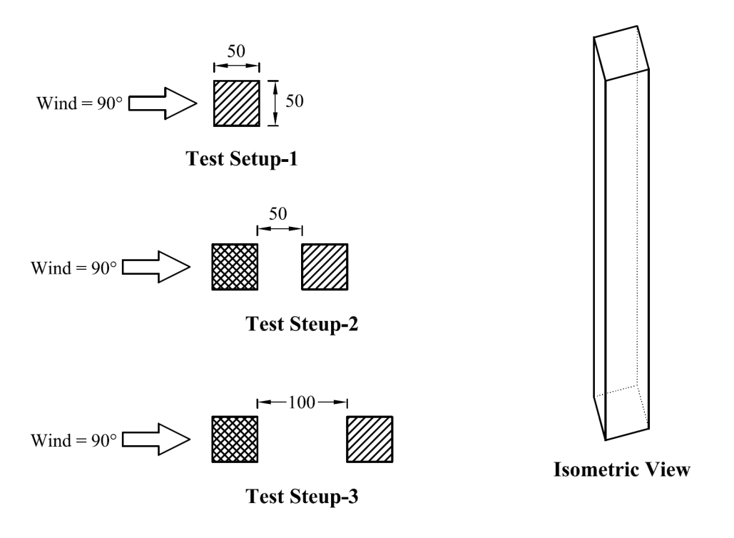
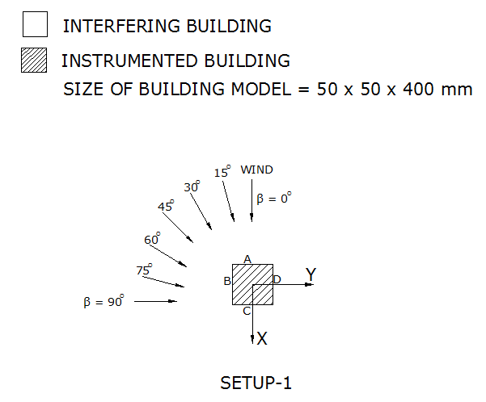
Wind Incident Angles

Figure 1.Test setup of buildings with wind direction angles considered for the study.

- Domains and meshes

Grid generation is one of the very important considerations during the pre-processing stage, the type of mesh chosen for a given flow problem can determine the success or failure in attainment of computational solution. The mesh should be sufficiently fine to provide an adequate resolution of the important flow features and geometrical structures. Generally for flow with bounded walls steep flow gradients within the viscous boundary layers are properly resolved through locally refining the mesh in the vicinity of wall boundaries. Accurate simulation of ABL flow in the computational domain is essential to obtain accurate and reliable predictions of the related atmospheric processes. To have the geometric similarity cross section of computational domain and model dimension was kept same as that of the wind tunnel study and the upstream/downstream length was kept as per the requirement [15-16]. The geometric scale of model of a building is chosen to maintain the equality of ratios of overall building dimensions to the inherent lengths of the generated model. The dimensions of the computational domain are i.e. L_{D} × B_{D} × H_{D} = 2.55 × 2.65 × 2 m³as shown schematically in Fig. 2, which shows the coordinate system used.

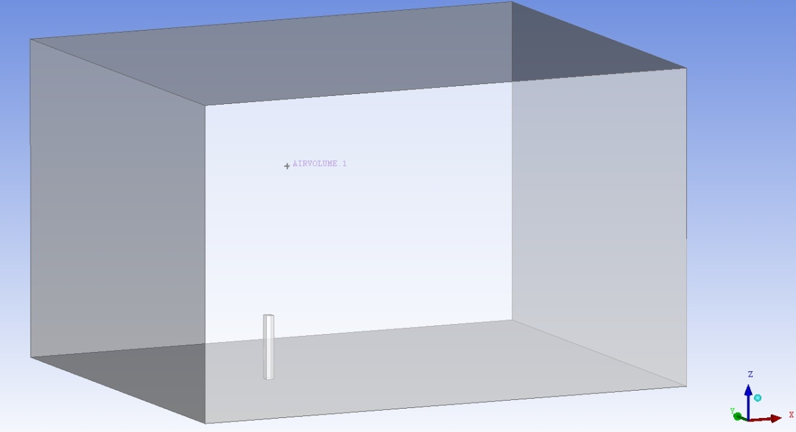
5H
26B
20B
30B
26B

Figure 2. Computational domain of the isolated building model used for CFD simulation.

The surface mesh close to the foot of the building shows the growth of the cells in the boundary layer next to the building. Clearly the aspect ratios of these boundary layer cells are very large, but as [17] indicates, there is no formal restriction on the size of cells in the wall-parallel direction in RANS simulations. However, Spalart (2000) is discussing streamlined bodies, not the complex detached flows seen with the bluff body under discussion here. At the leeward side of the building the mesh was more refined in the wake region relative to the more distant regions of the domain.
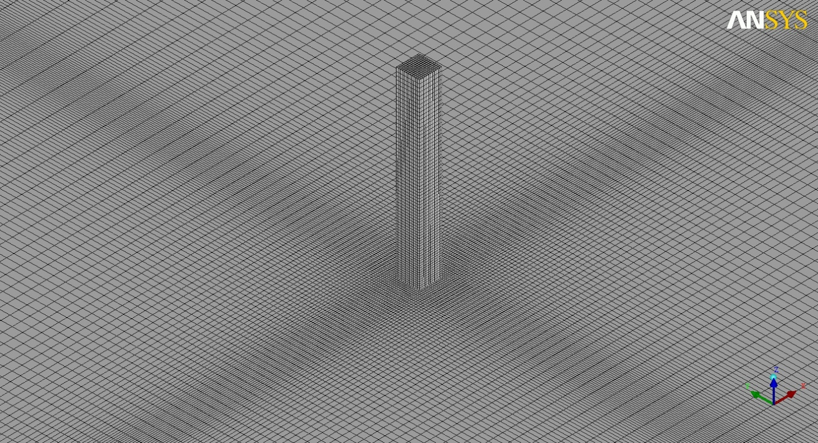
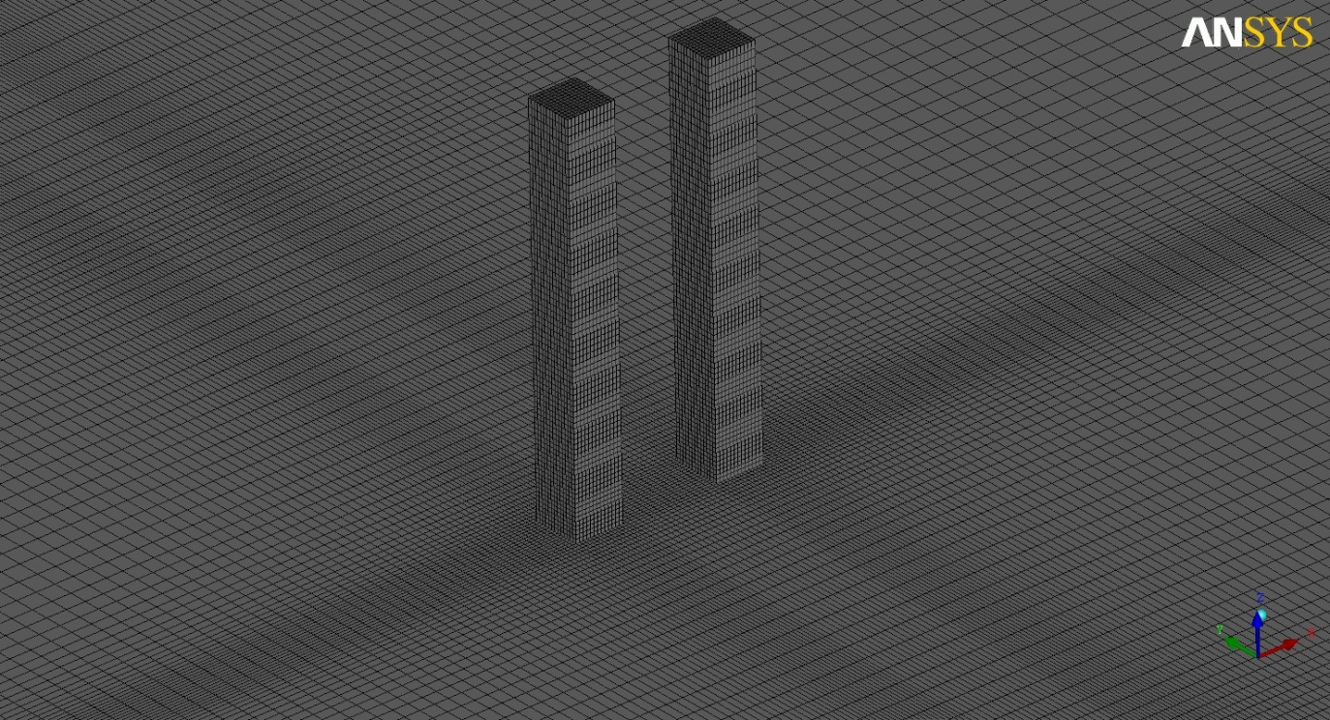
(a)
(b)

Fig. 3Surface meshes on the domain showing (a) isolated building model and (b) the two building model used for CFD simulation.
- Turbulence model

Researchers have already examined different turbulent models for their relative suitability for the atmospheric boundary layer airflow ([15] and [18]). It has been observed that for this kind of problem the realizable k-ε model [19] is most suitable. The commercial CFD code Ansys Fluent 13.0.0 [20] is used to solve the 3D Reynolds-averaged Navier–Stokes equations and the continuity equation using the control volume method. Closure is obtained using the realizable k-ε model (Shih). Pressure–velocity coupling is taken care of by the SIMPLE algorithm. Pressure interpolation is second order. Second-order discretization schemes are used for both the convection terms and the viscous terms of the governing equations.

- Boundary condition

For real physical representation of the fluid flow suitable boundary condition that actually simulate the real flow is required, there is always great difficulty in defining in detail the boundary conditions at the inlet and outlet of the flow domain that is required for accurate solution. At the upwind boundary, a velocity inlet was used with the following expressions for the along wind component of velocity, U which is similar to the experimental study.

Standard representation of the velocity profile in the ABL is as shown below.

In the present work the values are of the parameters m and m/s.
The measured longitudinal turbulence intensity () is converted to turbulent kinetic energy as input for the simulations using Eq. (10), assuming that and . It is observed that with a higher, a small discrepancy in the results in the order of a few percentages (<5%) in the magnitude of amplification factors.

The inlet turbulence dissipation rate profile ε from [21] is given by
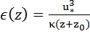(11)

where, is the height co-ordinate, the von Karman constant (~0:42), the scaled aerodynamic roughness length corresponding to a power-law exponent of 0.15 (here:) and the friction velocity related to a horizontally homogeneous (stable) ABL flow. The sides and the top of the computational domain are modelled as slip walls (zero normal velocity and zero normal gradients of all variables). At the outlet, zero static pressure is specified. The standard coefficients of the realizable k-ε model were used. The Reynolds number for the flow is 2.65 × 10⁶, using the building height, , and the velocity at as reference values. At the downwind boundary, a pressure outlet was used, with the relative pressure specified at and backflow conditions for and set to those of the inlet. In the domains, however, backflow was not observed because the downwind boundary was sufficiently far from the building.

On the bottom wall of the domain, a rough wall was specified to model the effect of the ground roughness. The values of and are needed as input. According to Blocken et al. (2007a), the roughness constant () in the law of the wall was specified as below

with taking its default value of 0.5. The walls of the building were specified as smooth. Eqs. (10) to (11) were used to specify the field variables throughout the domain as initial conditions at the start of the steady-state simulation.

The standard wall functions modified for roughness are employed. As already specified that for the chosen simulation scale (1/300) the value for and the reference wind speed taken from the wind tunnel experiments yields a suitable value of y+ for the use of wall functions (between 30 and 300). for the bottom of the computational domain ( representing the wind tunnel floor downstream of the roughness elements, including the turntable) is taken 3.33×10⁻⁷m (simulation scale) or 0.0001m (full scale), which is an estimate of the equivalent sand-grain roughness of the smooth floor. This value is smaller than (= 0.004 m, simulation scale) as required.

- Solver settings

Ansys Fluent uses the finite-volume method to solve underlying governing equations and associated problem-specific boundary conditions. A fundamental premise of using finite element procedure is that the body is sub divided into small discrete regions known as finite elements. These elements defined by nodes and interpolation functions. Governing equations are written for each element & these elements are assembled into a global matrix.

As mentioned in earlier the solutions were steady-state. Second-order differencing was used for the pressure, momentum and turbulence equations and the “coupled” pressure-velocity coupling approach due to its robustness for steady-state, single-phase flow problems.

The residuals fell below the commonly applied criteria of falling to 10⁻⁴ of their initial values after several hundred iterations. However, this was not the only test for convergence - the drag, lift and side forces and the moments acting on the building were monitored during the simulation and only when they achieved stationary values were the simulations deemed to have converged. Although the simulations were steady-state, there was some variation (< 1%) in the “steady” values of the various monitoring values.

- Numerical simulation and validation

The velocity profile obtained by fluent was compared with the velocity profile of the wind tunnel experimental study as shown in Fig. 4. It is observed that by incorporating all the consideration and boundary condition the inlet velocity profile are very much similar as it was in the experimental study.
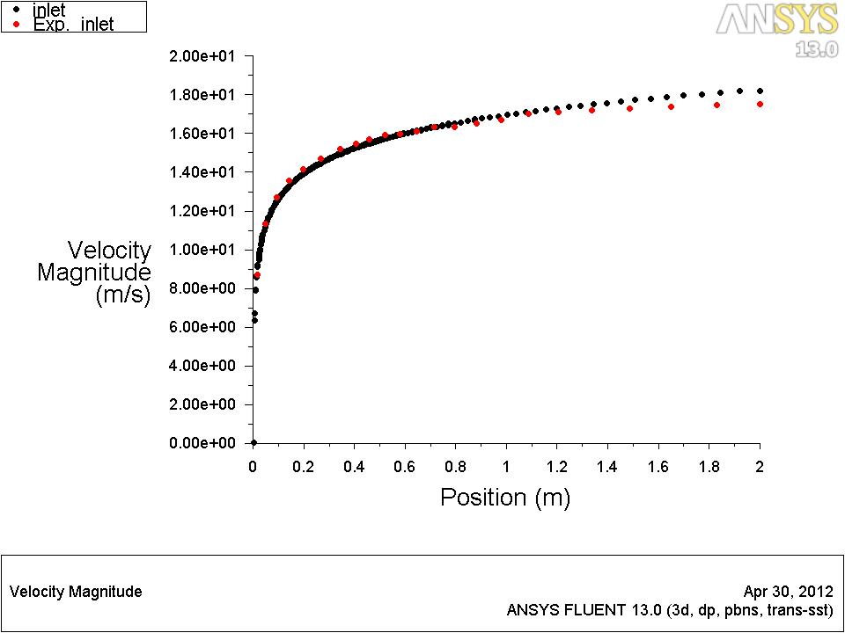

Figure 4. comparison of velocity profiles of wind tunnel experimental study and CFD simulation.
Results obtained through CFD simulation are fairly good and compared with experimental results [8] and wind standards available of different countries. Pressure coefficient for all four faces of isolated building (Setup-1) at 0° wind incidence angle (Fig. 5) is presented in tabular form as given in Table 1.

Table 1.Comparison of results obtained by CFD simulation with experimental results and wind standards of different countries for all four faces of object building (Setup-1) at 0° wind incidence angle

FACE | Average Face Pressure Coefficient (C_{p})
FACE | CFD  results | Wind Tunnel Exp. | BS 6399-2:1997 | ASCE 7-02 | AS/NZ 1170.2 | IS-875 Part-3
Face A | 0.906 | 0.83 | 0.85 | 0.80 | 0.80 | 0.95
Face B | -0.827 | -0.84 | -0.80 | -0.70 | -0.65 | -0.70
Face C | -0.508 | -0.71 | -0.50 | -0.50 | -0.50 | -1.25
Face D | -0.827 | -0.85 | -0.80 | -0.70 | -0.65 | -0.70
- Wind flow pattern for different combination of building model

CFD simulation of wind tunnel experiment was carried out to observe the variation of wind velocities around tall buildings with different arrangement and wind incidence angles. Few of the results are presented in the form of velocity magnitude around the buildings and mean pressure coefficients for different faces of buildings. It has been observed that the significant enhancement of velocity and pressure occurred in some case studies considered. With the help of these observations some possibilities have been explored to install domestic wind turbine in and around buildings to fulfil its electricity requirement along with the available power supply.

  - Setup-1 (Isolated building)

In this setup (Fig. 1) isolated building model has been considered and observed velocity potential around the building at different wind incidence angle i.e. 0° to 90° with an increment of 15° in anticlockwise direction.

The value of velocity magnitude varies significantly around the building for this wind incidence as shown in Fig. 5. In this case maximum wind velocity is observed near around the roof top corner of the building and a wake zone formed at the rare face of the building towards leeward side.

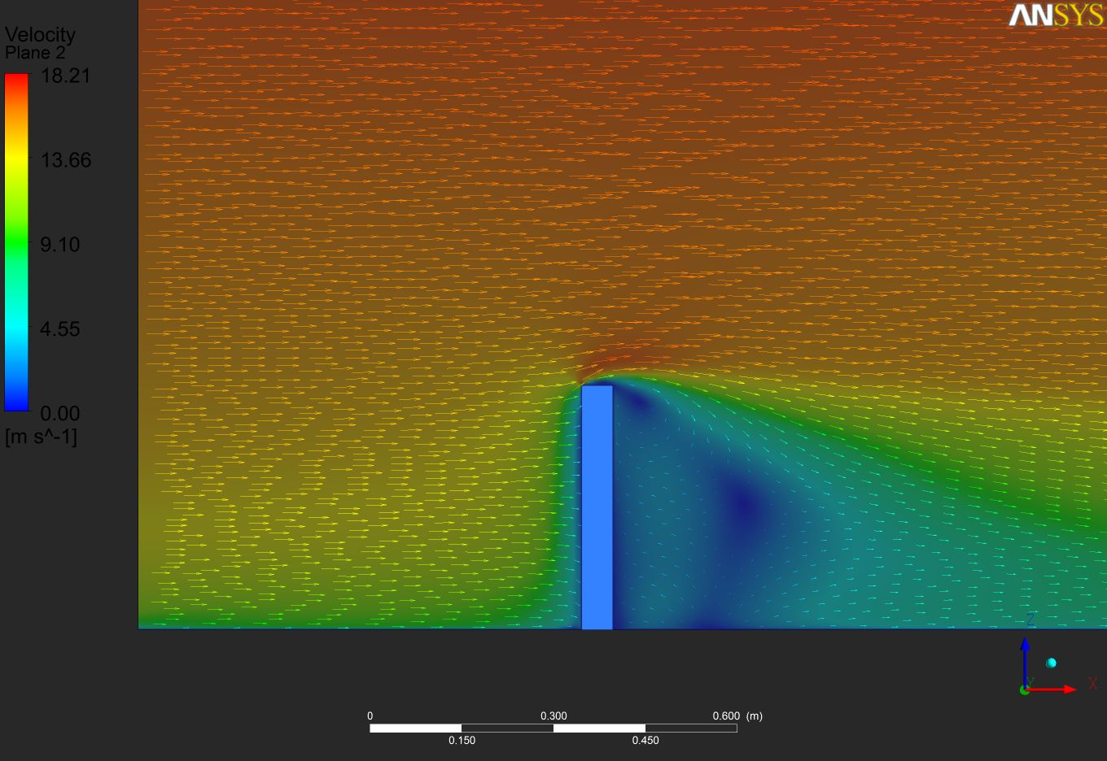

Figure 5. Velocity potential and vectors at vertical plane around the isolated model through CFD simulation

  - Setup-2 and 3 (Two building with 50mm and 100 mm spacing)

In this case two building models with a spacing of 50mm and 100mm (Fig. 1) are considered. It is observed that interfering building provide sheltering effect to the object building at 0° wind incidence angle and as the angle increases this sheltering effect vanishes. In figure 6 different cut planes has been shown where the velocity potential is measured to observe the variation of the flow field. The intensity of the wind flow i.e. the velocity varies significantly around the building and considerable wake zone with lesser velocity potential can be seen which is larger than it is for isolated building.
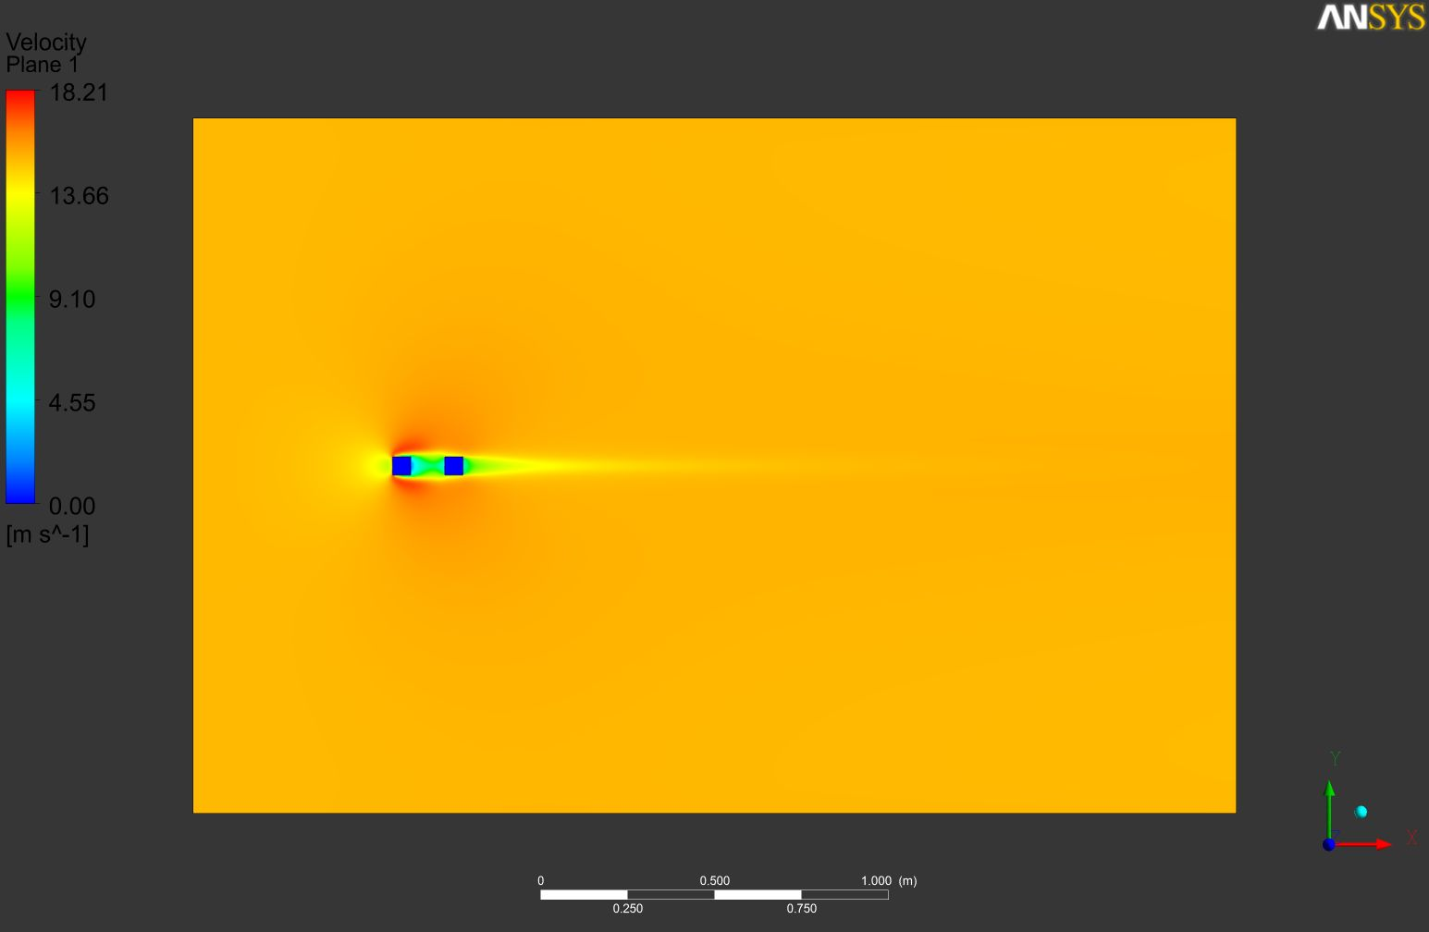
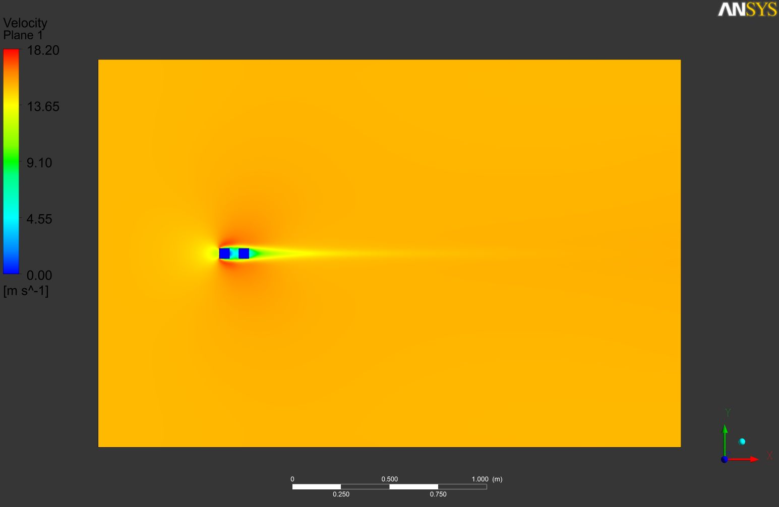
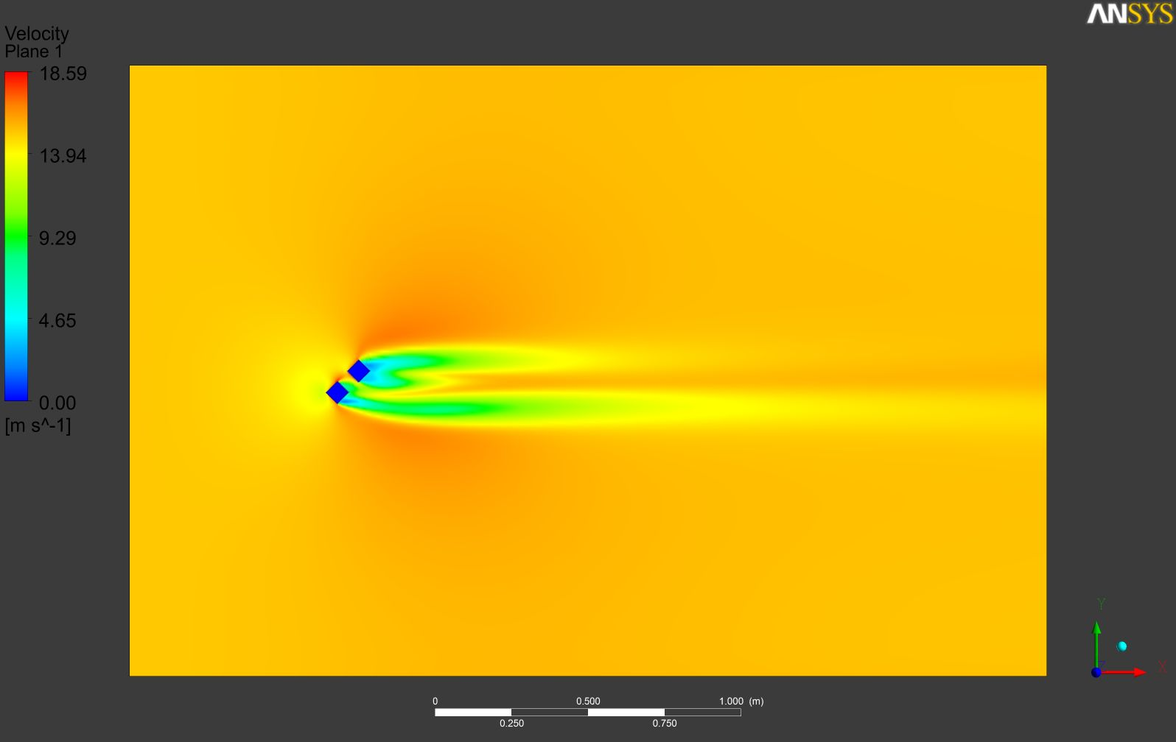
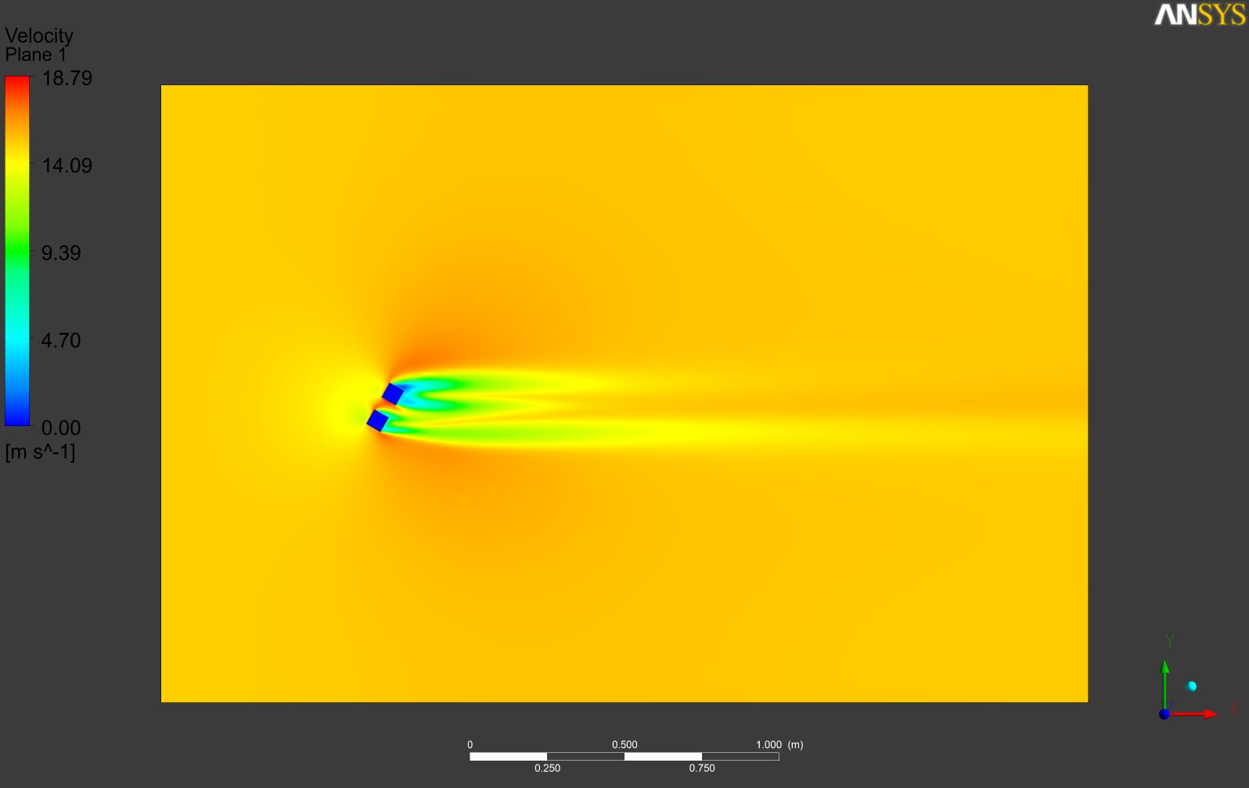
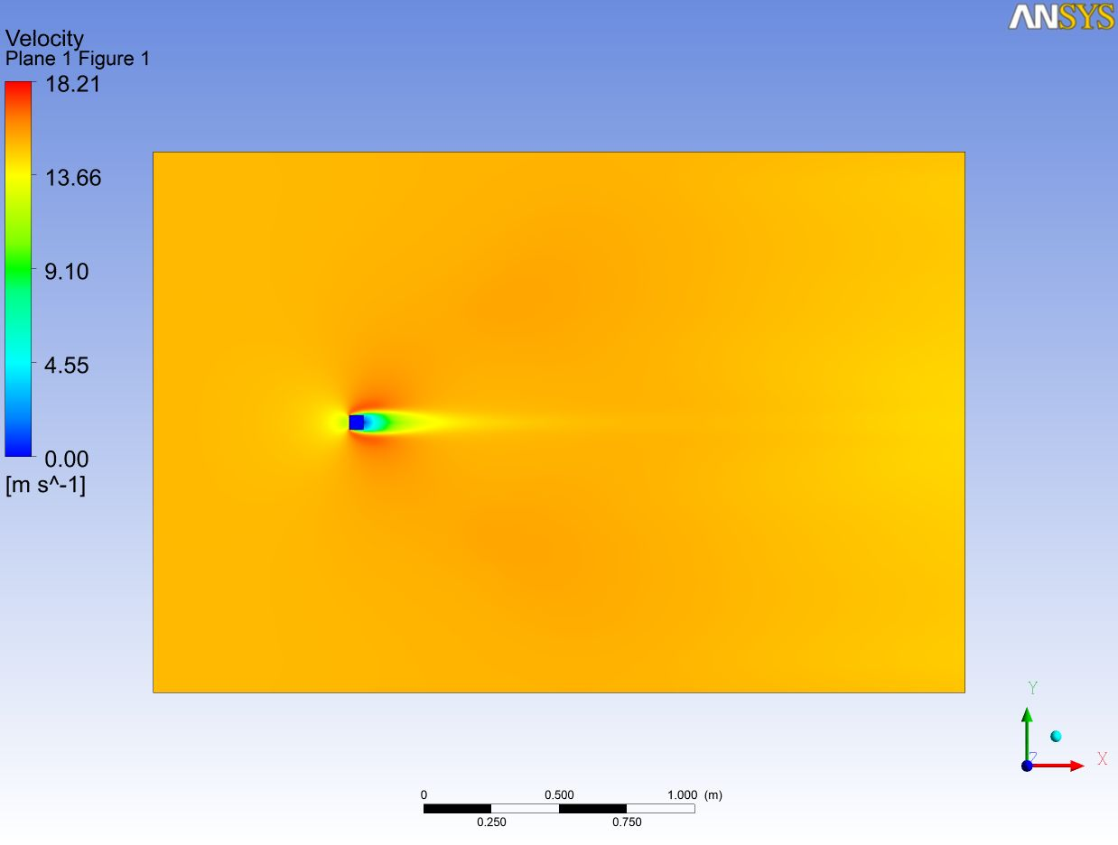
Figure 6. Variation of velocity potential around the two building model through CFD simulation
Setup 2: Spacing = 50mm, wind 0° Setup 3: Spacing = 100mm, wind 0°
Setup 2: Spacing = 50mm, wind 40° Spacing = 50mm, wind 60°

- Conclusion/Remark/ Discussion
The use of wind energy for domestic purpose there are numbers of possibilities that the performance and efficiency may get reduced due to the complex wind flow which is the consequence of having a haphazard building orientation in our urban areas. To find the solution of this complex flow field it is necessary to look into the wind flow pattern around building.CFD simulation and the experimental results are very much similar to the experimental study. The accuracy of results depend also on exactly the modeling according to the scale, proper meshing of the model geometry and defining the physical property values exactly as the realistic environment conditions.

Wind flow filed has been seen influenced significantly in presence of the building structure in a various pattern and extent which is responsible for increasing or decreasing the performance of the wind turbine installed in these areas.Wind incidence angle in all cases has shown a tremendous effect on wind flow around the buildings.In case of group of building extensive wind tunnel testing considering wind interference effect is required to accurately estimate before installing and designing the domestic wind turbine.Many complicated and complex model can be examined with the help of CFD analysis and the designing criteria of the wind turbine system at any flow field can be standardized. Apart from wind tunnel study, full scale model of physical problem need to be modelled and analyzed with this numerical simulation for better understanding of the wind flow field.
Reference

- Murakami, S. (1998), “Overview of turbulence models applied in CWE”, Jnl. of Wind Eng. Ind. Aerodyn. 74-76, 1-24.
- Stathopoulos, T. Wu, H. (2004), “Using Computational Fluid Dynamics (CFD) for pedestrian winds”, Proceedings of the 2004 Structures Congress, Nashville, TN.
- Tominaga, Y., Mochida, A., Murakami, S., and Sawaki, S. (2008a), “Comparison of various revised k–ε models and LES applied to flow around a high-rise building model with 1:1:2 shape placed within the surface boundary layer”, Jnl. of Wind Eng. Ind. Aerod., 96(4), 389-411.
- Costola, D., Blocken, B. and Hensen, J.L.M. (2009), “Overview of pressure coefficient data in building energy simulation and airflow network programs”, Building and Environment, 44 (10), 2027–2036.
- Tamura, T., Nozawa, K., and Kondo, K. (2008), “AIJ guide for numerical prediction of wind loads on buildings”, Jnl. of Wind Eng. Ind. Aerod., 96, 1974–1984.
- Tominaga, Y., Mochida, A., Yoshiec, R., Kataokad, H., Nozu,T., Masaru, Yoshikawa, M., Shirasawa, T. (2008b), “AIJ guidelines for practical applications of CFD to pedestrian wind environment around buildings”, Jnl. of Wind Eng. Ind. Aerod., 96.1.
- Franke, J., Hirsch, C., Jensen, A., Krus, H, Schatzmann, M., Westbury, P., Miles, S., Wisse, J. and Wright, N.G. (2004), Recommendations on the Use of CFD in Wind Engineering, In: van Beeck JPAJ (Ed.), COST Action C14, Impact of Wind and Storm on City Life and Built Environment, Saint-Genesius-Rode, Belgium, 5-7 May 2004.
- VermaSK,(2009)Wind effect on structurally coupled tall buildings. PhDthesis,IIT Roorkee.
- Braun, A.L. (2009), “Aerodynamicand aeroelastic analysesonthe CAARC standard tallbuilding model usingnumericalsimulation”, Computerand Structures87. 564-581.
- Wardlaw, R.L., Moss, G.F.(1970), “A standard tallbuilding modelforthecomparison ofsimulated naturalwindsin wind tunnels”,CAARC, C.C.662mTech;25January.
- IS: 875 (Part 3) – 1987, Code of practice for design loads (Other than earthquake for buildings and structures), Part 3- wind loads, BIS, New Delhi (India).
- AS/NZS 1170.2:2002, Australian/New Zeeland Standard - Structural Design Action, Part 2: Wind Action, Standards Australia International Ltd, Sydney.
- ASCE7-05, 2005, Minimizing design loads for building and other structures, Published by Structural Engineering Institute, Reston, VA.
- BSI BS 6399, 1997, Loadings for Buildings-Part2; Code of Practice for wind loads, British Standard Institution.
- Blocken, B., Carmeliet, J., Stathopoulos, T. (2007a), "CFD evaluation of wind speed conditions in passages between parallel buildings – effect of wall-function roughness modifications for the atmospheric boundary layer flow", Journal of Wind Engineering and Industrial Aerodynamics, Volume 95, Issues 9–11, Pages 941-962.
- Revuz J., Hargreaves D.M. and Owen J.S. (2012), "On the domain size for the steady-state CFD modelling of a tall building", Wind and Structures, 15(4), 313-329.
- Spalart, P.R. (2000), “Strategies for turbulence modelling and simulations”, International Journal of Heat and Fluid Flow, Volume 21, Issue 3, Pages 252-263.
- Blocken, B., Stathopoulos, T., Carmeliet, J. (2007b), “CFD simulation of the atmospheric boundary layer: wall function problems”, Atmos. Environ., 41, 238–252.
- Shih, T.H. et al. 1995. A new k-ϵ eddy-viscosity model for high Reynolds number turbulent flows—model development and validation. Comput. Fluids 24 (3), 227–238.
- ANSYS Ltd., 2010. Ansys Fluent solver, Release 13.0.0: Theory. Canonsburg.
- Richards, P.J., Hoxey, R.P. (1993), Appropriate boundary conditions for computational wind engineering models using the k-ε turbulence model, 46–47, Pages 145-153.

