Passive Design Features for Energy Conservation in Residential Buildings

P.K.Bhargava, Nagesh Babu Balam and A.K.Roy

CSIR- Central Building Research Institute, Roorkee
Corresponding Author, bhargavapk@rediffmail.com

Abstract.

Energy consumed in controlling environment in respect of temperature, air movement, humidity and hygienic condition inside buildings contributes a significant proportion towards the total energy consumed in the building sector. An increasing demand of electricity during the summer period due to extensive use of air-conditioning systems has necessitated evolution and incorporation of various passive techniques in design of buildings which can save a considerable part of conventional energy consumed in buildings for cooling and lighting. The three main aspects involved in the development of a passive system are (i) determination of the design climatic parameters at the building site (ii) knowledge of the desired environmental conditions indoors and (iii) application of basic principles of heat transfer in the evolution of appropriate passive system which on incorporation in the design of buildings may lead to the desired thermal environment indoors. Various investigations carried out at CSIR-CBRI covering these aspects to make residential buildings energy efficient have been reviewed. It is observed that passive cooling techniques have not yet reached the stage of established practice and constant efforts are being made world over to make advancement in the existing knowledge in this field.

Keywords: Passive feature, climatic zones, thermal comfort, ventilation, energy efficiency
and residential building.

1. Introduction

Comfort within buildings is primarily controlled by four major factors: air temperature, mean radiant temperature, humidity and air flow [1]. Lot of electrical energy is consumed in buildings to control these dominant factors. Natural renewable energies as substitute for conventional energies had been used earlier and many examples of ancient architecture have special design features to achieve comfortable indoor environment without the use of conventional energy. Present energy crisis and growing degradation in environment have again developed interest in design of modern buildings using passive cooling techniques. Passive cooling techniques means that enable the indoor temperatures of buildings to be lowered through the use of natural energy sources. The term passive does not exclude the use of mechanical devices such as fan and other electrical gadgets which may also be used together to enhance the performance further. A systematic approach is taken in the design of such buildings by the leading architect and few energy efficient buildings with passive features have come up. These techniques provide comfortable indoor environment mainly by natural means and minimizing consumption of conventional exhaustible energy sources.
Here, it would not be out of place to mention that the Bureau of Energy Efficiency constituted by the Govt. of India has launched in February 2009 a star rating programme that rates commercial buildings on the actual energy consumption in terms of kWh/sqm/ year. ECBC Codes launched in 2007 also sets minimum energy efficiency standards for new commercial buildings. The focus of these areas is directed towards improving energy efficiency in existing buildings and development of codes so that new buildings be designed and built with energy efficiency considerations having been incorporated right from the planning stage. Extensive studies covering the afore-said aspects have been carried out at Central Building Research Institute, Roorkee and elsewhere also. A few salient features of these studies are described in the present paper.

2. Climatic classification

Classification of climate in respect of building design means zoning the country into regions in such a way that the differences of climate from region to region are reflected in the building design, warranting some special provision for each region. Based on the following criteria, the country has been divided [2] into five major climatic zones, via, (i) Hot –Dry (ii) Warm –Humid (iii) Cold (iv) Temperate and (v) Composite as depicted in Table 1.
Table 1. Criteria for classification of climatic zone
Climatic Zone | Mean monthly maximum  Temperature ^{O}C | Mean monthly relative  Humidity %
Hot-Dry  Warm-Humid  Temperate  Cold  Composite | above 30  above 30  above 25  between 25-30  below 25  Criteria explained in the | below 55  above 55  above 75  below 75  all values  following paragraph

A given station is categorized under a particular zone if its climate conforms to that zone for six or more months, otherwise it falls under the composite zone. A map of India depicting various climatic zones is shown in figure1.

3. Thermal comfort

The amount of fresh air needed to maintain Carbon dioxide concentration of air within safe limits is only 6.3m³ / h / person whereas 2.2m³ / h /person is sufficient to provide necessary Oxygen for breathing. Comfort conditions depend upon air temperature, relative humidity, wind speed, as well as on clothing, acclimatization, age, sex, and type of activity of the people. Air motion has important influence on man’s thermal sensation as it can spell comfort or discomfort depending upon the climatic conditions. Air movement influences bodily heat balance by affecting the rate of convective heat transfer between skin and air, and the rate of bodily cooling through evaporation of skin moisture. Necessity of high rates of air motion for thermal comfort in tropics is an established fact. Studies on thermal comfort carried out in

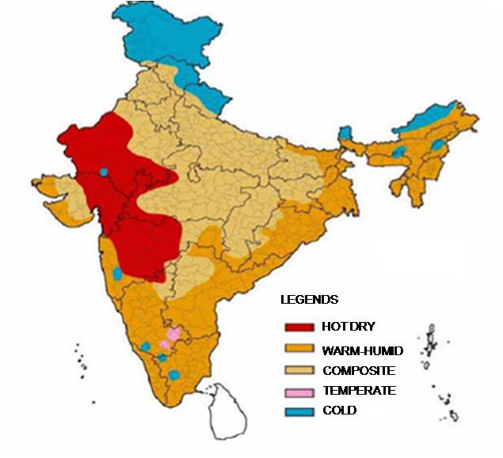
Figure 1. Climatic Map of India
this institute [3] yielded a Comfort Index, known as Tropical Summer Index (T.S.I). The TSI is defined as the temperature of calm air, at 50% relative humidity which imparts the some thermal sensation as the given environment. This index has been used for determining the minimum desirable wind speeds for thermal comfort under different conditions of temperature and humidity. These wind speeds may be calculated by the equation:

$$\text{TSI}=0\text{.}\text{745}t_{a}+0\text{.}\text{308}t_{w}−2\sqrt{v}+0\text{.}\text{841}$$

Where t_{a} = dry bulb (globe) temperature, ^{O}C.

t_{w} = wet bulb temperature ^{O}C

v = air speed in m/sec

The thermal comfort of people lies between TSI values of 25 ^{O}C and 30^{O}C with maximum per cent of people being comfortable at 27.5^{O}C.
Table 2. Desirable minimum wind speed (m/sec.) For thermal comfort
Dry Bulb Relative Humidity (Percentage)
Temperature

ºC 30 40 50 60 70 80 90

30 * * * 0.06 0.24 0.53 0.85
31 * 0.06 0.24 0.53 1.04 1.47 2.10
32 0.20 0.46 0.94 1.59 2.26 3.04 +
33 0.77 1.36 2.12 3.00 + + +
34 1.85 2.72 + + + + +
35 3.20 + + + + + +
* None, + Higher than those acceptable in practice

4. Design considerations for energy efficiency in buildings

Energy efficiency in buildings broadly implies three aspects; (i) obviating wastage in energy due to unwanted and non judicious use of electrically operated gadgets (ii) development of energy efficient appliances and (iii) optimum utilization of non conventional sources of energy through judicious planning and design of buildings. The aspects (i) and (ii) concern with the design, installation and operation of electrical appliances; whereas aspect (iii) is related to incorporation of appropriate passive features at the initial design stage of the buildings. Several theoretical and experimental studies [4] have demonstrated the usefulness of these techniques in respect of ameliorating thermal environment indoors. In context with cooling of buildings in hot dry and warm humid climates, the passive techniques mainly aim towards reduction in heat penetration through building envelope and provision of fenestration for inducing desired natural ventilation indoors. Few of these features are discussed below;

4.1 Site planning and landscaping

Sites in which the slope, elevation, orientation, vegetation and wind pattern act to increase summer cooling by wind and decrease radiation effects by shading should be used. Locations near large bodies of water may be preferable if cooling breezes can be directed into the building(s).

4.2 Building space & orientation

Buildings must be spaced to allow winds to reach the ventilation openings. In general, it is not desirable to site buildings within the wake of surrounding structures or landscaping. The terrain, surrounding vegetation and plans and layout of buildings may be used to "channelize the air flow” into the building. Buildings constructed on earth mounds or sloping sites of hills gets advantage of enhanced wind speeds. Air motion in a shielded building is less than that in an unobstructed building. To minimise shielding effect, the distance between the two rows should be about 8H for semidetached houses and 10H for a long rows houses. However, the shielding effect is diminished by raising the height of the shielded building.Orientation of a building plays an important role in governing the total amount of solar radiation incident on the building envelope. It is well known [5] that the amount of daily solar radiation incident per unit area on N and S facing walls is much less as compared to that on the walls facing other directions. Hence, for minimum solar heat gain by the building envelope, it is desired that the longer axis of building should lie along East-West direction. Further, the effect of orientation of a building on heat penetration through envelope also depends on the aspect ratio (length/breadth) of the building. For a building with square plan (aspect ratio 1:1) and glass area equally distributed on all the four walls, the effect of orientation is nil, while for a rectangular building with aspect ratio 2:1, the fabric load is reduced by 30 per cent due to change in orientation from worst to best. Data on the amount of solar radiation received by walls oriented in different directions at different latitudes are readily available in the Climatic Data Hand-Book [2]. Using these data, an optimum orientation that corresponds to the minimum value of total solar radiation can be easily worked out.

4.3 Landscaping

Plantation of trees can result in energy saving, reduction of noise and pollution, modification of temperatures and relative humidity and psychological benefits on humans. Hedges and shrubs deflect the air away from the inlet openings and cause a reduction in air motion indoors. These elements should not be planted at a distance of about 8 metre from the building because the induced air motion is reduced to minimum in that case. However, air motion in the leeward part of the building can be enhanced by planting a low hedge at a distance of 2 metre from the building. Trees with large foliage mass having trunk bare of branches up to the top level of window, deflect the outdoor wind downward and promote air motion in the occupancy zone inside the buildings. Trees can act complementary to window overhangs, as they are better for blocking low morning and afternoon sun, while overhangs are better barriers for high noon sunshine The cooling loads of a house can be reduced by 10%- 40% by appropriate tree plantation.

5. Building design for natural ventilation

The primary comfort requirements for buildings using natural ventilation are to protect occupants from the sun and rain without obstructing the airflow that cools both the occupants and the building structure. Minimizing heat gain and promoting maximum ventilation are of primary requirement for design of energy efficient buildings. Natural ventilation in buildings is produced by pressure differences between the inside and the outside of the building. The magnitude of the pressure difference and the resistance to flow across the openings in the envelope will determine the rate of airflow through the openings. The two main forces producing pressure differences are the wind force and the thermal force or stack effect.

5.1 Ventilation due to thermal forces

When a temperature difference exists between the outside and inside air of a building, a pressure gradient is developed along the vertical direction over the walls of the building. If the inside temperature is higher than that outside, the upper parts of the building will have excess pressure while the lower parts will have under pressure. When openings are provided in these regions, air enters through the lower openings and escapes through the upper. In case the indoor air temperature is lower than outside, the air flow will be reversed. This is exactly what happens when a building is ventilated by thermal forces, a process often referred to as the "Stack Effect". The rate of air flow induced by thermal forces is given by the equation,

$$Q=7A\sqrt{h\text{.}Δθ}$$
where
Q = Volume of air flow in m³ /min.
A = Free area of inlet opening in m²
h = Vertical distance between inlet and outlet in m
Δθ = Difference in temperature of indoor and outdoor air.

In buildings employing natural ventilation, the temperature difference between indoor and outdoor air is only a few degree Centigrade (say 2º C). Furthermore, the height between inlet and outlet openings in single storey houses with 3 m ceiling height is restricted to a maximum of , say , about 1.5 metre. Therefore, the maximum contribution of thermal force to ventilation will be given by

$Q=7×1×{\left(1\text{.}5×2\right)}^{0\text{.}5}$
= 12 m³ / min. / m ² of top or bottom openings.
This rate of air flow is too small to meet the requirements of comfort ventilation.

5.2 Ventilation due to wind force

When wind strikes a building , a region of excess pressure is created on windward wall , while the sides , leeward wall and roof are all subjected to reduced pressure . A pressure gradient is thereby created across the building in the direction of the incident wind. This pressure gradient causes the air to flow through the building from openings in the region of higher pressure to openings located in lower pressure zones . In the simple case of an isolated enclosure in which openings are provided in each of the two opposite walls, required area of ventilation openings may be calculated by the equation
$A=\frac{Q}{\text{KV}}$
where
A = Area of each opening in m²
Q = Desired rate of air flow m ³ / hr
V = Outside wind speed m / hr
K = Coefficient of effectiveness
( 0.6 for normally incident wind and 0.3 for obliquely incident wind )
In case the inlet and outlet openings are of different sizes, say A₁ and A₂, then the value of A can be worked out using the equation

$\frac{2}{A^{2}}=\frac{1}{A_{1}^{2}}+\frac{1}{A_{2}^{2}}$

5.3 Nocturnal ventilation

Theoretical as well as experimental studies on assessment of contribution of night ventilation towards cooling of buildings during the following day have been carried out by several investigators for different types of structures under different climatic conditions. In 1992 Givoni [6] derived following relationships for estimating the reduction caused in indoor minimum (eq.1) and maximum temperatures (eq.2) caused by the provision of night ventilation for medium and high mass buildings with light external colour and fully shaded windows,
T_{min unvent} - T_{min vent} = 0.5 ( T_{min unvent} - T_{min out side )} (1)
T_{max unvent} - T _{max vent} = 0.25 ( T_{max out side -} T _{max unvent} ) (2)
It is also reported that potential of night ventilation for lowering the day time temperature indoors below the outdoor temperature is proportional to the ambient diurnal temperature range. It was observed that night ventilation has only a very small effect on the indoor maxima of the low-mass buildings. However, it is very effective in lowering the indoor maximum temperature for high mass buildings below the outdoor maximum. In case of high mass building, the night ventilation at the rate of 45 ach lowered the indoor maximum temperature by 3.5⁰ C when outdoor maximum temperature was 38⁰C Extensive studies on the effect of these parameters on the availability of indoor air motion have been carried out in CBRI. Based on the findings of these studies simple design guidelines for design of airy buildings [7] have been prepared and included in BIS codes.

5.4 Non-conventional system of ventilation

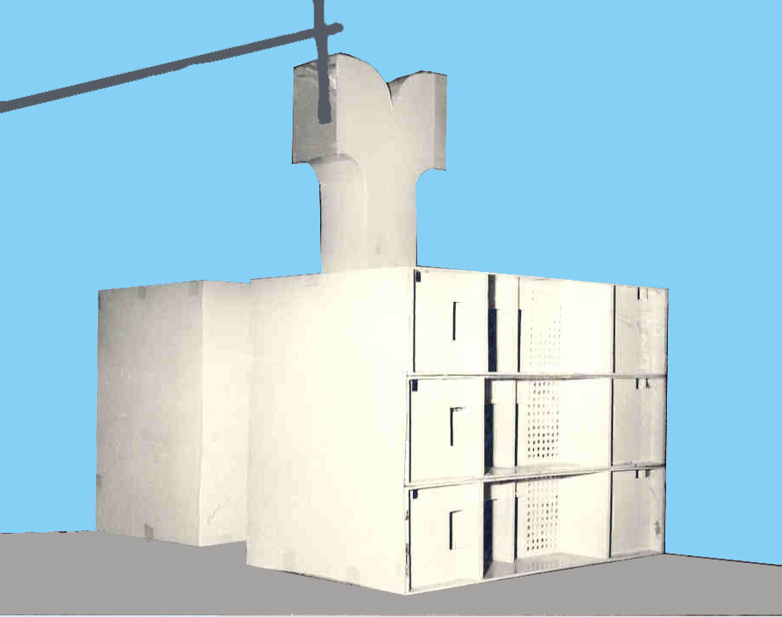
A non-conventional system of ventilation, commonly called as wind tower, help induce air motion in rooms devoid of windows on two exposed walls. The wind tower broadly consists of a vertical wind carrying shaft with a wind scooping attachment atop thereof. On its vertical sides, the shaft is provided with several openings, which connect the tower to the different rooms intended to be ventilated. Openings in rooms are also provided on walls other than the one facing the tower. Such an arrangement of openings facilitates cross ventilation in the rooms. The impingement of wind on the face of the tower causes development of positive pressure thereon. As the wind flows around the building, separation of flow takes place at the windward edges and negative pressure is created over all the leeward faces of the building.

Thus a pressure difference exists between the tower inlet and openings located on leeward sides of the rooms. Consequently flow of wind occurs from tower inlet to the room openings. In this process the wind entering through the wind tower sweeps room area and finally exits through the room opening. Thus the room gets ventilated with the help of the tower.
Figure.2 Model of Wind Tower placed at top of roof

6. Energy saving in buildings due to various passive systems
The studies carried out at CSIR-CBRI and other R&D organisations on different passive features incorporated in buildings revealed that considerable amount of energy may be saved. Few examples are reported in table given below.
Table3. Energy saving due to implementation of various passive features
Proper orientation (change) in longer axis from N-S to E-W) | 30 per cent reduction in solar radiation incident on walls.
Proper shading of windows | Over 10 per cent reduction in cooling load.
Painting of external surfaces of walls with minimum absorption of solar radiation and high emission in longer wave region | 40 to 50 per cent saving in electrical energy.
Application of high albedo coating on roofs. | 10 to 43 per cent saving in energy used to cool the buildings
Change in roof albedo from 0.18 to .81 | 69 per cent saving in cooling energy.
Shading of houses by nearby trees | 30per cent reduction in heat
Shading of walls by a row of trees. | 50 per cent reduction in heat-gain through the wall.
Growing a thick layer of vines on wall | 75 per cent reduction in heat gain through the wall
Covering the roof top with deciduous plants or creepers | Roof top temperature is reduced by 15°c. Heat flow of 200w/m² enters through un- covered roof whereas 10w/m² is transferred upward from inside the room.
Evaporative cooling of roof. | Cooling load is reduced by 40 per cent
Replacement of air within glazing by argon, krypton or xenon | U-value is reduced to 1.3w/m²k and 1w/m²k respectively.
Provision of cross ventilation | Contributes significantly towards ameliorating thermal environment indoors. Saving in energy varies from case to case.
Nocturnal ventilation | In low mass building indoor maxima is very close to outdoor maxima, but in high mass building the indoor maxima is reduced by 3.5°c.
Radiative cooling using metallic nocturnal radiator | The indoor air temperature is reduced by 4 to 6 °c
Earth air tunnel | The air is effectively cooled by 3°c as it passes through the earth coupled heat exchanger tube.
Use of renewable energy sources such as wind, solar etc. | Saving in energy varies from case to case.
Use of hollow clay tiles for roofs | Saving of 18% - 30% of cooling energy

7. Barriers in adopting energy efficiency in residential buildings

- Architects are neither fully aware of the energy situation of the country nor well-informed about energy efficient design features. They need more information and technical skills to design energy efficient buildings [8].
- The interior designers too are not aware of the energy efficient design features that the architect may have designed. They should be involved at initial stage of design.
- The different energy efficient features can only be implemented if the clients are prepared to pay the extra costs and compromise with reduced floor area. Residents need to be explained about the necessity of energy efficient buildings.
- The lifestyle of the higher income groups contradicts with the notion of energy efficiency. For example, using air conditioners in each and every room, latest and biggest appliances irrespective of their energy use and plenty of trendy lights such as spotlights, chandeliers in an interior decorated house is a matter of status symbol for the upper income groups.
- Flat owners do not always reside in the flats they buy. They rent the flats to tenants. The owners are therefore not interested in energy efficient design features as they are not the end users and would not bear the energy costs.

8. Conclusion

Design techniques for cooling of buildings have been described. It has been established that adoption of some simple passive features results in significant saving in the energy consumed in creating comfortable environment indoors. It is also observed that despite clinching shortage of conventional energy and well known benefits of use of non- conventional energies like solar and wind energy, the concept of passive systems could not find wide application in design of buildings. Further, the basic principles of various passive systems are well defined, but the technology of passive cooling is yet to reach the level of an established practice. Response of users of buildings provided with passive cooling systems to the private queries about the viability of the system also lacks consistency. More over efforts are continuously being made world over to make further advancement in knowledge in area of passive design of buildings. In this scenario hybrid passive system emerges a viable option that may provide greater reliability and attract wider application of passive techniques in the design of buildings in hot climate. Hence hybrid passive cooling is an important R & D area for functional and energy efficient design of buildings.

9. Acknowledgement

The study forms a part of the research programme of Central Building Research Institute, Roorkee and the paper is published with the kind permission of the Director.

References

- Sodha, M.S. et. al, (1986) “Solar passive buildings”, Pergamon Press page. 126.
- Chand, Ishwar and Bhargava, P.K. (1999), “The climatic data hand book, Tata McGraw Hill, New Delhi
- Sharma, M.R. and Ali, S. (1986) , “Tropical Summer Index- a study of thermal comfort of Indian Subjects”, Building and Environment, Vol.21.
- Kumar, Shree and Bhargava, P.K. (2009), “Studies on Thermal Environment in Enclosure Exposed on Single Side: A Case Study in Northern India, Architectural Science Review, Volume 52.1, pages 40-47.
- CBRI, Roorkee (1963), “Orientation of Buildings”, Building Digest no.74.
- Givoni, B. (1992) “Comfort, climate analysis and building design guidelines”, Energy and Buildings, 18, 11.
- CBRI, Roorkee (1976), “Guidelines for designing airy buildings”, Building Digest no.121.
- Department of Defence, United States of America (2004), “Cooling Buildings by Natural ventilation”, report No. ufc 3-440-06n.

