Energy Efficient Building Technologies
An Approach towards Sustainable Development

Yogesh P Kajale*, Jalaj Parashar** and Ajay Chourasia**

* BG Shirke Construction Technology Pvt. Ltd., Pune

** CSIR-Central Building Research Institute, Roorkee
Corresponding Author, Email: jalajp@rediffmail.com

Abstract.

With rapid growth in urbanization, sustainable development and utilization of resources is of paramount importance, which can be addressed by development of proven prefab system for mass housing construction. The developed system shall have edge in regards to safety, speed, serviceability. The paper attempts to highlight the features of one of the prefab system notably 3-S prefab building system. The sustainability aspect of building construction vis-à-vis the prefab system of industrialize housing construction is elaborated. The system describes use of prefab elements to a maximum possible extent with connections facilitated through certain level of cast-in-situ concrete at project sites. The building system has been evolved and perfected to cater to the seismic requirements as well as typical conditions prevailing in India.

Keywords: sustainable, mass housing, prefabrication, 3-S system, precast, reverse cyclic load, performance evaluation, and autoclaved lightweight cellular concrete.

1. Introduction

Construction industry is one of the largest consumers of natural resources such as water, sand, crushed rock, gravel, minerals, timber etc. The demand for housing units, energy, clean water & air, safe & rapid transport etc. is also increasing with the growing development. Construction Industry is primarily dependant on certain manufacturing industries such as cement, steel and aluminum; which are amongst the most energy intensive apart from major consumer of scares natural resources. This calls for adoption of energy efficient technologies for sustainable development in the construction leading to ‘Green Future’. Sustainable construction encompasses the process which caters needs of the present without compromising the ability of future generations. The sustainable technology of construction therefore requires maintaining the harmony of the earth’s eco-system. The concept of sustainable building construction is to incorporate technologies that result in environment protection, water conservation, energy efficiency, usages of recycled products and renewable energy. Such technology ensures that waste is minimized at every stage during construction and operation of the building, resulting in low costs.

The prerequisites for energy efficient sustainable construction are:

- Judicial use of construction materials there by requiring lesser materials i.e. products that conserve natural resources
- Use of energy efficient building materials and products that save energy or water i.e. the materials requiring low energy for their production as well as will consume lesser energy during life cycle of building
- Use of products that avoid toxic or other emissions
- Reduction in wastage of materials during construction of buildings& utilizing wastes to make construction materials
- Use of recycled aggregates in construction
- Reducing emissions during the production of construction materials
- Using more durable materials in buildings thereby requiring lesser maintenance cost
- Use of products that contribute to a safe, healthy built environment
- Use of construction system minimizing air, water and noise pollution during construction, at the same with higher level of safety and speed.

To meet out the prerequisites, Prefab building techniques with building components made-up of energy efficient technologies viz. AAC blocks/slabs, are the best proposition for building construction on mass scale. The paper attempts to illustrate the features of above technology with reference to energy saving.

2. Prefab technology – energy efficient proposition

2.1 The System

3-S prefab (Fig.1) solution for the housing sector includes following elements:

- Precast RCC dense cement concrete slabs or Autoclaved light-weight energy efficient cellular reinforced cement concrete slabs for floor and roof
- Autoclaved light-weight energy efficient cellular cement concrete building blocks
- Precast reinforced dense cement concrete structural components e.g. columns, beams,toilet slabs, stairs, etc.
- Galvanised powder coated press metal frames and shutters for doors / windows.
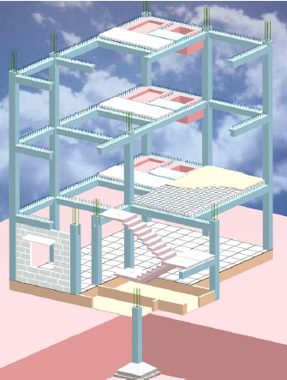

Figure1 View of 3-S Prefabricated
Building System

The technology makes use of the construction materials mainly precast RCC columns, beams, lightweight autoclaved cellular reinforced cement concrete slabs / precast RCC slabs, lightweight autoclaved cellular un-reinforced masonry blocks and galvanised powder coated press metal frames and shutters for doors / windows, thereby eliminating demand of timber and agricultural soilin construction. Moreover, due to factory manufacturing, lesser quantity of water consumption is reduced drastically since autoclaving is resorted for curing under controlled condition. Further, the prefabrication process yields very high repetition of form-work (i.e. steel moulds); thereby resulting into very minimal consumption of raw material for false work. Similarly, the construction raw material requirement is much less due to production of lesser density materials having high ratio of strength/weight i.e. having higher strength for lesser weight. The building elements of the system have low energy cost since these are concrete, cellular concrete, cement and steel. The energy consumed for various construction materials[1] for the present system is presented at Fig.2.

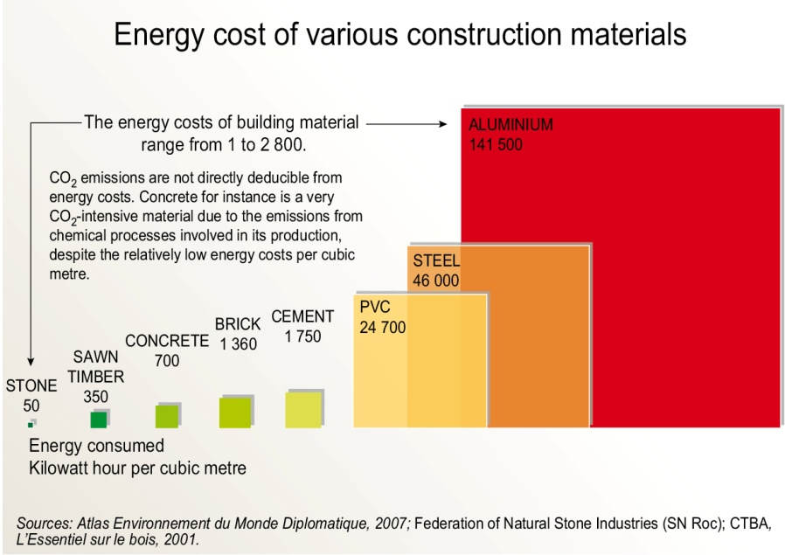

Figure 2. Embodied energy for various construction materials

Figure 3. Embodied energy for various masonry units
The system utilizes autoclaved aerated concrete (AAC) material for walling and floor / roof slabs; which has very low energy consumption in itsproduction [2] (Fig.3).

2.2 Indoor air quality

Due to high insulating properties of lightweight autoclaved cellular concrete masonry blocks and roof slabs, the solar heat transfer within the building is much less thereby making the inside spaces more comfortable^{[3]}. Fig.4 shows the inside temperature for AAC construction.

Figure 4. Outside Vs Inside temperature for AAC construction.

It can be seen from the Table-1that thermal efficiency of 125mm thick light weight autoclaved cellular ‘Siporex’ roof slab is three times more than that of conventional RCC cast in-situ roof slabs. This enables the end user to restrict the use of air-conditioning / fans to the minimum, thereby requiring lesser electrical energy. Similarly thermal efficiency of 150mm thick light weight autoclaved cellular ‘Siporex’ block masonry is two to three times more than that of conventional masonry units like bricks / concrete blocks. All building designs which have to take account of energy conservation need to consider the effect of the thermal capacity of the building cladding / roofing. Calculations which take into account only the thermal insulation of the fabric assume steady-state conditions which do not occur in practice. Autoclaved lightweight cellular concrete provides useful thermal capacity combined with good thermal insulation properties. This combination reduces the extremes of temperature experienced in the building, compared with buildings made of lighter structures (e.g. metal-framed which have minimum thermal capacity) or heavier structures (e.g. solid brickwork / concrete block work which provides less thermal insulation). During the warm season the thermal capacity of an autoclaved lightweight cellular concrete roof of normal thickness works in such a way that inside the building the rise of temperature due to solar radiation is delayed by approximately 5-6 hours, counted from the time of day when the effect of solar radiation is at its maximum. After this period, the effect of radiation decreases considerably. The roof then emits its accumulated heat during the cooler part of the day. This reduction in heating and cooling load requires less capacity from the heating or cooling equipment, wherever used. Thus, by use of autoclaved cellular concrete slabs and masonry blocks the air-conditioning load is reduced substantially thereby reducing the capital investment towards AC installation. The recurring cost of electricity bills are also considerably reduced for the buildings constructed using ‘3-S’ system.

Table 1. Thermal efficiency for roofs with different construction material [5]

THERMAL TRANSMITTANCE (U) in W/(m²K) FOR ROOF |  | Form-finish RCC roof slab | RCC roof slab with ceiling plaster | AACRoof slab
Thickness of slab in mm |  | 115 | 115 | 125
Thermal conductivity of slab material in W/(mK) |  | 1.58 | 1.58 | 0.188
Internal surface resistance  {Considering inside film coefficient at still air = 9.36 W/(m²K)} |  | 0.107 | 0.107 | 0.107
Outside surface resistance  {Considering outside film coefficient at an air velocity of 8.0km/h as 19.86W/(m²K)} |  | 0.050 | 0.050 | 0.050
Internal ceiling plaster resistance  {Considering thermal conductivity of 0.721W/(mK)} | Thk. in mm | 0 | 10 | 0
 | Resistance | 0.000 | 0.014 | 0.000
Brick bat coba resistance  {Considering thermal conductivity of 0.793W/(mK)} | Thk. in mm | 75 | 75 | 75
 | Resistance | 0.095 | 0.095 | 0.095
External CM treatment resistance  {Considering thermal conductivity of 0.721W/(mK)} | Thk. in mm | 25 | 25 | 25
 | Resistance | 0.035 | 0.035 | 0.035
RCC screed resistance  {Considering thermal conductivity of 1.58W/(mK)} | Thk. in mm | 0 | 0 | 30
 | Resistance | 0.000 | 0.000 | 0.019
Slab material resistance | Resistance | 0.073 | 0.073 | 0.665
Total resistance |  | 0.359 | 0.373 | 0.970
Thermal transmittance (U) in W/(m²K) |  | 2.78 | 2.68 | 1.03
Maximum permitted value of Thermal transmittance  (As per IS: 3792) |  | 2.33 for 'Hot Dry', 'Hot Humid' and 'Warm Humid' zones
Thermal efficiency  (Considering 100% for thermal transmittance of 2.33) |  | 84% | 87% | 226%

Table 2. Thermal efficiency for walls with different construction material [5]

THERMAL TRANSMITTANCE (U) in W/(m²K) FOR EXTERNAL WALL |  | Burnt brick wall |  | Solid concrete block wall |  | Autoclaved cellular concrete block wall
Thickness of walling unit in mm |  | 150 | 230 | 150 | 200 | 150 | 200
Thermal conductivity of walling material in W/(mK) |  | 0.811 | 0.811 | 1.155 | 1.155 | 0.188 | 0.188
Internal surface resistance {Considering inside film coefficient at still air = 9.36 W/(m²K)} |  | 0.107 | 0.107 | 0.107 | 0.107 | 0.107 | 0.107
Outside surface resistance {Considering outside film coefficient at an air velocity of 8.0km/h as 19.86W/(m²K)} |  | 0.050 | 0.050 | 0.050 | 0.050 | 0.050 | 0.050
Internal plaster resistance {Considering thermal conductivity of 0.721W/(mK)} | Thk. in mm | 12 | 12 | 12 | 12 | 12 | 12
 | Resistance | 0.017 | 0.017 | 0.017 | 0.017 | 0.017 | 0.017
External plaster resistance {Considering thermal conductivity of 0.721W/(mK)} | Thk. in mm | 22 | 22 | 22 | 22 | 22 | 22
 | Resistance | 0.031 | 0.031 | 0.031 | 0.031 | 0.031 | 0.031
Walling material resistance | Resistance | 0.185 | 0.284 | 0.130 | 0.173 | 0.798 | 1.064
Total resistance |  | 0.389 | 0.488 | 0.334 | 0.378 | 1.002 | 1.268
Thermal transmittance (U) in W/(m²K) |  | 2.57 | 2.05 | 2.99 | 2.65 | 1.00 | 0.79
Maximum permitted value of Thermal transmittance (As per IS: 3792) |  | 2.56 for 'Hot Dry', 'Hot Humid' zones and 2.91 for 'Warm Humid' zone
Thermal efficiency for 'Hot Dry' & 'Hot Humid' zones (Considering 100% for thermal transmittance of 2.56) |  | 100% | 125% | 86% | 97% | 257% | 325%
Thermal efficiency for 'Warm Humid' zones (Considering 100% for thermal transmittance of 2.91) |  | 113% | 142% | 97% | 110% | 292% | 369%

3. Energy consumption scenario for construction

The statistical study on energy consumption, projected demand and energy in transportation of few construction materials in India is highlighted at Table-3, 4 and 5 respectively.

Table 3. Volume and energy consumption of building materials in India (2003) [6]

Material | Production volume per annum (2000) | Thermal Energy  (MJ per kg) | Total Energy  (GJ)
Bricks | 150 x 10⁹Nos | 1.40 | 630 x 10⁶
Cement | 96 x 10⁶tonnes | 4.20 | 403 x 10⁶
Aluminium | 0.8 x 10⁶Nos | 236.8 | 189 x 10⁶
Structural steel | 11 x 10⁶Nos | 42.0 | 462 x 10⁶

Table 4. Projected demand for building Table 5. Energy in transportation of building
Material[13] material [6]

Material | 2020 |  | Material | Energy (MJ) for 100km transport
Bricks (Nos) | 246 x 10⁹ |  | Bricks (Cum) | 200
Cement (Tonne) | 255 x 10⁶ |  | Sand (Cum) | 175
Structural steel (Tonne) | 30 x 10⁶ |  | Cement (Tonne) | 100
Rebars (Tonne) | 15.3 x 10⁹ |  | Structural steel (Tonne) | 100

3.1 Need for switchover to sustainable alternatives

Steel, cement, glass, aluminium, plastics, bricks, etc. are energy-intensive materials, commonly used for building construction. Generally these materials are transported over great distances. Extensive use of these materials can drain the energy resources and adversely affect the environment. It is therefore essential to adopt energy efficient innovative materials and prefab technology to meet the ever-growing demand for buildings. There is an immediate need for optimum utilization of available energy resources and raw materials to produce simple, energy efficient, environment friendly and sustainable building alternatives and techniques to satisfy the increasing demand for buildings.

Some of the guiding principles in adopting the sustainable alternative building technologies can be summarized as follows: Energy conservation; Minimize the use of high energy materials; Concern for environment, environment-friendly technologies; Minimize transportation; Decentralized production and maximum use of local skills; Utilization of industrial and mine wastes for the production of building materials; Recycling of building wastes, and Use of renewable energy sources. Time-tested prefab building technologies like 3-S, meeting these principles could only be sustainable and will facilitate sharing the resources especially energy resources more efficiently, causing minimum damage to the environment.

3.2 Energy efficient: thermal mass benefits

High thermal mass of precast concrete enables it to absorb, store and later radiate heat. Also, using precast concrete in passive solar designs allows natural heating in winter and cooling in summer, thereby reducing the need to rely on artificial heating and cooling.

3.3 Improved internal building amenity

Use of precast concrete can even out internal diurnal building temperatures.3-S Prefab technology having light-weight cellular concrete elements for slabs and walling can improve indoor air quality, providing comfortable temperature inside the home.

3.4 Acoustic performance

The high thermal mass of precast concrete assists with sound insulation to reduce noise and absorb noise impact.

3.5 Environmental sustainability of Prefab

High thermal insulation results in achieving energy efficiency resulting in safe & durable Green building Construction

- Conclusion

The ‘Prefab technology for sustainable building’ movement is advancing at a rapid pace in other parts of the world and is yet to take accelerating mode in India. Considering the tremendous technological, energy efficiency and ecological benefits such prefab buildings systems can result a milestone for sustainable development. By adopting prefab building technology, using light weight building materials such as AAC to the extent possible, cement replacement materials such as fly ash in concrete, designing for durability as well as undertaking life cycle analysis of construction projects, it is possible to direct the construction industry, a more sustainable path with higher energy efficiency.

- Acknowledgment

The authors are grateful to Director, CBRI for granting permission to publish the paper.

References

- Atlas Environment du Monde Diplomatique (2007); Federation of Natural Stone Industries (SN Roc); CTBA, L, Essentielsur le bois (2001)
- W. Marmé and J. Seeberger; AAC data from Dr. Briesemann und Dr. Frey (1997)
- CEB (1987), “Autoclaved Aerated Concrete”, CEB Manual of Design and Technology, The Construction Press, Lancaster
- IS: 3792, “Guide for Heat Insulation of Non-Industrial Buildings”, BIS, New Delhi
- Jain R.K., Asthana K.K., Gupta Manorama (1989), “Evaluation of Anticorrosive Treatment on Steel Reinforcement in SIPOREX Concrete” Central Building Research Institute, Roorkee AND Sharma T.P., Lal B.B. (1997), “Fire Performance Evaluation and Upgradation of SIPOREX Slabs, Blocks and Panels” Central Building Research Institute, Roorkee
- Reddy Venkatarama B.V. (2004), “Sustainable building technologies” Current Science, Vol. 87, NO. 7
- National Buildings Organization (1990), “The Handbook of Housing Statistics Part – 1”, New Delhi, India

