Integration of Daylight and Artificial Lighting along with PV Conversion System for Energy Efficient Lighting of Buildings

B. K. Saxena* and Tushar Saxena**

*Former Dy. Director CBRI Roorkee & Coordinator IDMP
**TERI University, New Delhi
Corresponding Author, Email: tusharsaxena.8@gmail.com

Abstract.

Visible range of solar energy as daylight and sunlight provides an attractive and viable option of efficient lighting in buildings. Integration of energy efficient CFL and LED with day lighting can provide optimal solution to energy efficient lighting of buildings. Daylight data collated by Central Building Research Institute(CBRI) in India under International Daylight Measurement Program (IDMP) of CIE and WMO can be suitably used for computation of daylight availability indoors. This can be effectively utilized for judicious design of window glazing with appropriate glazing material, such as heat absorbing glass, heat reflecting glass, or double glazing. For this purpose Task-Ambient lighting approach satisfying task illuminance requirement along with desired ambient brightness provides a rational basis for day lighting and artificial lighting design as well as for integration of artificial light with day light. Also, possibility of photovoltaic conversion of sunlight for indoor artificial lighting need to be explored further for lighting applications in buildings. The paper presents rational approach for energy efficient lighting of buildings through utilization of IDMP data on daylight and conventional photovoltaic and organic photovoltaic conversion for artificial lighting.

1. Introduction

Solar energy radiated by sun contains a sizeable part of visible radiation within the range 400 to 700 nm. The peak sensitivity of human eye corresponds to 555 nm which tapers down to zero at lower and upper extremes of 400 nm and 700 nm respectively. Direct beam of sun is called direct solar radiation or beam radiation and the solar radiation scattered by the atmosphere is called diffuse radiation. Thus daylight comprises direct sunlight and diffuse sky light. Lighting is an essential requirement for performing the entire gamut of visual activities to be carried out in industrial, educational, institutional, commercial and office buildings. During day time hours the available daylight outdoors can be optimally utilized for indoor lighting in conjunction with artificial lighting. For use beyond daylight hours sunlight can be suitably converted by photovoltaic panels and stored in a system of batteries. Latest energy efficient light sources not only help in energy conservation in lighting of buildings but also enhance feasibility of use of photovoltaic conversion for artificial lighting using energy efficient light sources as well as for energy efficient integration of artificial lighting with daylight.Task-ambient lighting approach not only ensures satisfactory task illuminance but also well balanced visual surroundings, which can be achieved through optimal day lighting and its integration with artificial lighting.

2. Terms, Notations, Units and Definition

The International Commission on Illumination (CIE) has published [1] International Lighting Vocabulary (ILV). Some of these terms are as follows.

Solid Angle ω (Steradian)

It is the angle subtended by a surface at a point and is defined as the ratio of projected area of the surface to the square of its distance from the point in question. Thus 1 m² of the surface area of a sphere of 1m radius subtends unit solid angle (1 steradian) at the centre.

Intensity I (Candela)

Intensity of a light source in a given direction is the luminous power emitted per unit solid angle in that direction.

Luminous Flux Φ (lm or Lumen)

It is the light flux or luminous power. 1 lumen is the light flux emitted by a light source of 1 candela intensity within unit solid angle.

Luminance L (Candela/m²)

It is the brightness of a surface defined as the light intensity per unit projected area of the surface in a given direction.

Illuminance E (Lux)

It is the level of lighting at a point on a surface and is defined as light flux (lumen) incident on a square metre area of a surface around the point in question.Thus 1 LUX is 1 lumen per square metre.

Luminous efficiency η (Lumen/watt)

It is the light flux emitted by a light source per watt of electric power consumed.

Uniform diffuser

A matt surface diffusing light uniformly in all directions is called a uniform diffuser, such a large uniform diffuser or a hemispherical diffuser of 1 candela/ m² brightness produces
illuminance of π Lux on a parallel or a diametric plane. Another convenient unit of brightness for assessing the resulting illuminance is known as Apostilb where a large uniform diffuser of brightness 1 Apostilb produces illuminance of 1 Lux on a parallel plane or a diametric plane of hemispherical diffuser.

Sky factor (SF)

It is indoor illumininance on a plane (generally horizontal plane) due to uniform sky (i.e. having constant luminance throughout) expressed as percentage of the horizontal illuminance outdoors due to the entire sky.

Brightness factor (BF)

It is the ratio of mean sky luminance as seen from an indoor point through the window opening and equivalent uniform sky luminance corresponding to actual outdoor sky illuminance (or diffuse illuminance) on horizontal plane. Sky component is equal to the product of brightness factor and sky factor. Accordingly SC = BF x SF

Daylight factor (DF)

It is the sum of sky component (SC), inter-reflected component (IRC) and external reflected component (ERC) where the later are respectively the contribution of internal reflection and external reflection to the indoor illuminance expressed as percentage ratio of the outdoor sky illuminance (diffuse illuminance) on a horizontal plane due to the entire sky. Accordingly DF = SC + IRC + ERC. Thus Daylight Factor at an indoor point on a plane is the ratio of total daylight due to sky, inter-reflection and external reflection expressed as percentage of the outdoor sky illuminance (diffuse illuminance) on a horizontal plane due to the entire sky.

3. Fenestration percentage

It is the total area of window opening expressed as percentage of floor area.

3.1 IDMP Data

Saxena et al [2(a), (b)] have collated precise daylight data at several stations in India under International Daylight Measurement Program (IDMP) launched by International Commission on Illumination (CIE) and World Meteorological Organization (WMO). These include sky luminance distribution and horizontal diffuse illuminance and normal direct solar illuminance (sunlight) from which direct solar illuminance have been derived on horizontal and vertical surfaces. These data form basis for computation of daylight availability indoors and are of considerable significance in quantitative estimation of photovoltaic conversion of sunlight into electricity for lighting purposes.

3.2 Task-ambient lighting

Task-ambient lighting design approach emphasizes need of not only satisfying task illuminance [3] (e.g. required illuminance on horizontal work plane) but also ensures desirable ambient brightness. Ambient brightness [4]has been suggested as 100 Apostilb (32 Candela/m²). This value of illuminance or general illuminance of 100 lux can be obtained from multi reflection formula [5]
[M.E_{O}.F.A.R_{AV}] / [100.A_{r.}(1-R_{AV} )] = 100 (1)

Where,

E_{O} → Illuminance on window plane which is obtainable from IDMP data
A →Floor area of room
A_{r} →Total internal surface area of room
R_{AV}→Average reflectance of room
M →Reduction factor due to glass transmittance, maintenance and reduction due to
louvers and reduction due to area obstructed by window sashes.
F → Fenestration (window opening) as percentage odd floor area

Taking E_{O} as 6000 lux from IDMP data and for a room of 5m x 3m x 3m

A = 15
Ar = 78
R_{AV} = 0.6 (For a light finished interior)

M = 0.62 (For 3mm thick clear glass of transmittance as 0.85 and accounting for
reduction of 0.9 each due to maintenance, louvers and sashes)

F=[ 100 x 100 x Ar_{r}x (1-R_{AV})] / [M x E_{O} x A x R_{AV} ]= 9. (2)

It may be noted that if the interior finish is dull off-white of average reflectance as 0.5 instead of 0.6 as in the above example, the ambient brightness will be reduced by a factor of 1.5 resulting in general illuminance as 70 lux ( instead of 100 lux ).

For determination of total workplace illuminance Sky Factor (SF) protractor and Brightness Factor (BF) protractor (figures 1 , 2 ) have been provided which may be used on plan of room and elevation of window respectively for obtaining sky component [6] as follows

Sky Component = (BF) x (SF) (3)

Since sky component values will be obtained as percentage of outdoor horizontal sky illuminance (diffuse illuminance) therefore for outdoor diffuse illuminance of 8000 lux (8 klux) 1 %, 1.5% or 2% sky component will be 80, 120 or 160 lux indoor illuminance respectively due to sky.

Artificial lighting design utilizing energy efficient light sources can be based on conventional Lumen method for ensuring required task illuminance. However, for detailed analysis of distribution of workplace illuminance point by point method may be followed so as to ensure the task illuminance.

4. Energy efficiency of light sources

The development of fluorescent light sources have provided manifold energy efficient lamps as compared to incandescent lamps (10 – 18 lumen/watt). The latest CFL and LED lamps [7] have energy efficiency of 50-80 lumens/watt. Energy efficiency of various light sources are given in Table1. For energy efficient artificial lighting of buildings CFL and LED provide best options particularly for use with photovoltaic conversion. Mirror optic luminaires and semi-direct luminaires further boost up incident light on the working plane. Therefore, use of energy efficient light sources together with efficient luminaries and adequate provision of day light provide reliable solution of energy efficient lighting design of buildings.

5. Photovoltaic conversion of Sunlight

Solar photovoltaic technology enables the direct conversion of sunlight into electricity through semiconductor devices called solar cells without involving any moving part or causing environmental pollution. PV modules are presently crystalline silicon PV modules with minimum power output of 37W or 74W (depending upon configuration) at 16.4 V load voltage ( V_{ld}) and open circuit voltage (V_{OC}) as 21 V.

12 V flooded electrolyte type tabular plate low maintenance lead acid batteries of 40 or 75 Ah capacity depending on the configuration are deployed for storage. Sample testing and certification of the PV lighting systems is presently undertaken by Solar Energy Center (SEC) of the Ministry of New and Renewable Energy (MNRE) in the vicinity of Gurgaon (Haryana) and other authorized test centers are Central Power Research Institute (CPRI) Thiruvananthapuram, Electronics Regional Test Laboratory Kolkata and Electronics Test and Development Center (ETDC), Bangalore.

The next generation organic solar cells provide further possibilities of extended use in artificial lighting. The conventional (inorganic) silicon devices are called minority carrier materials, wherein the diffusion of carriers in the built in electric potential creates the photovoltaic current on excitation by sunlight. On the other hand, organic cells are majority carriers because the excitons dissodiate only at the interface so that holes exist primarily in one phase and electrons exist primarily in the other phase and their movement results directly in the flow of current

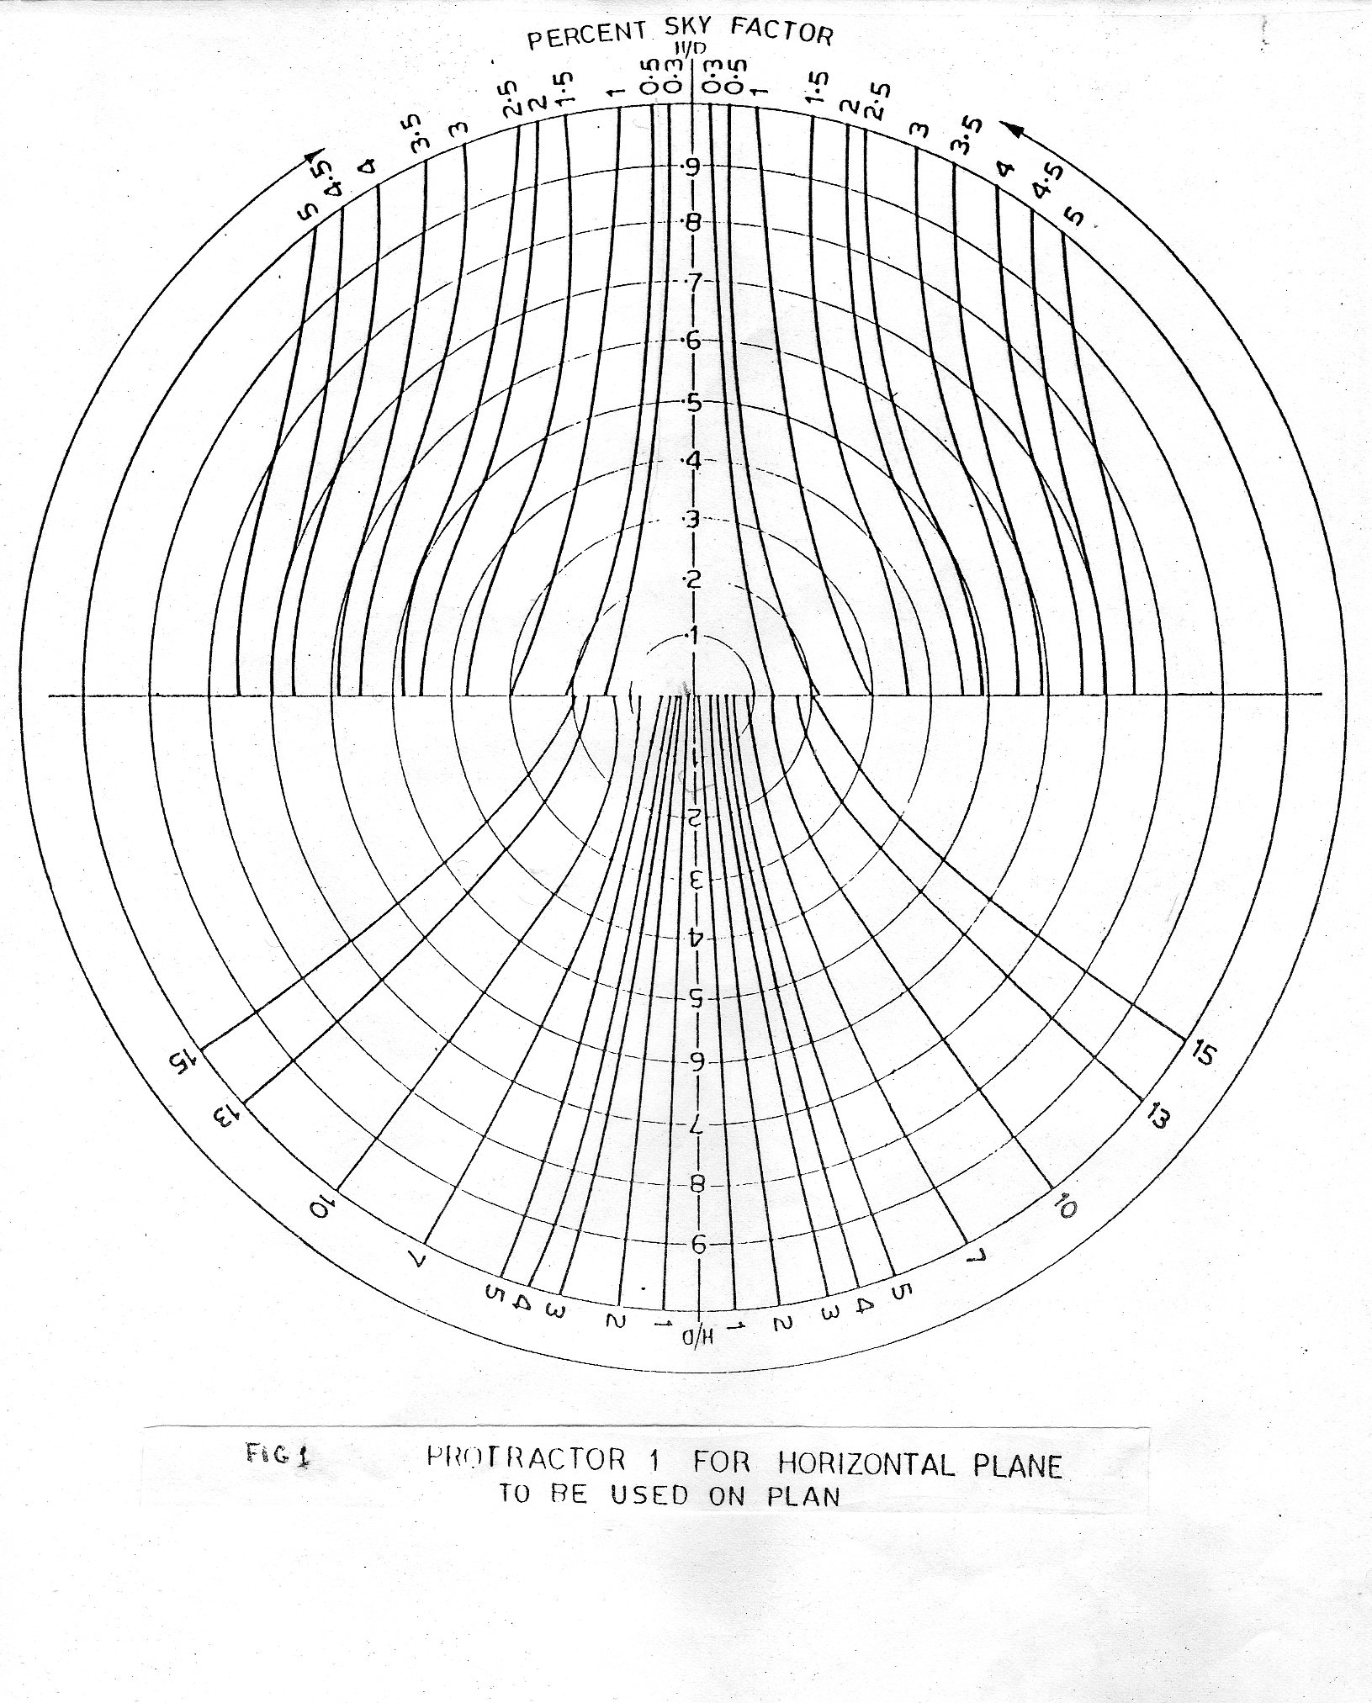
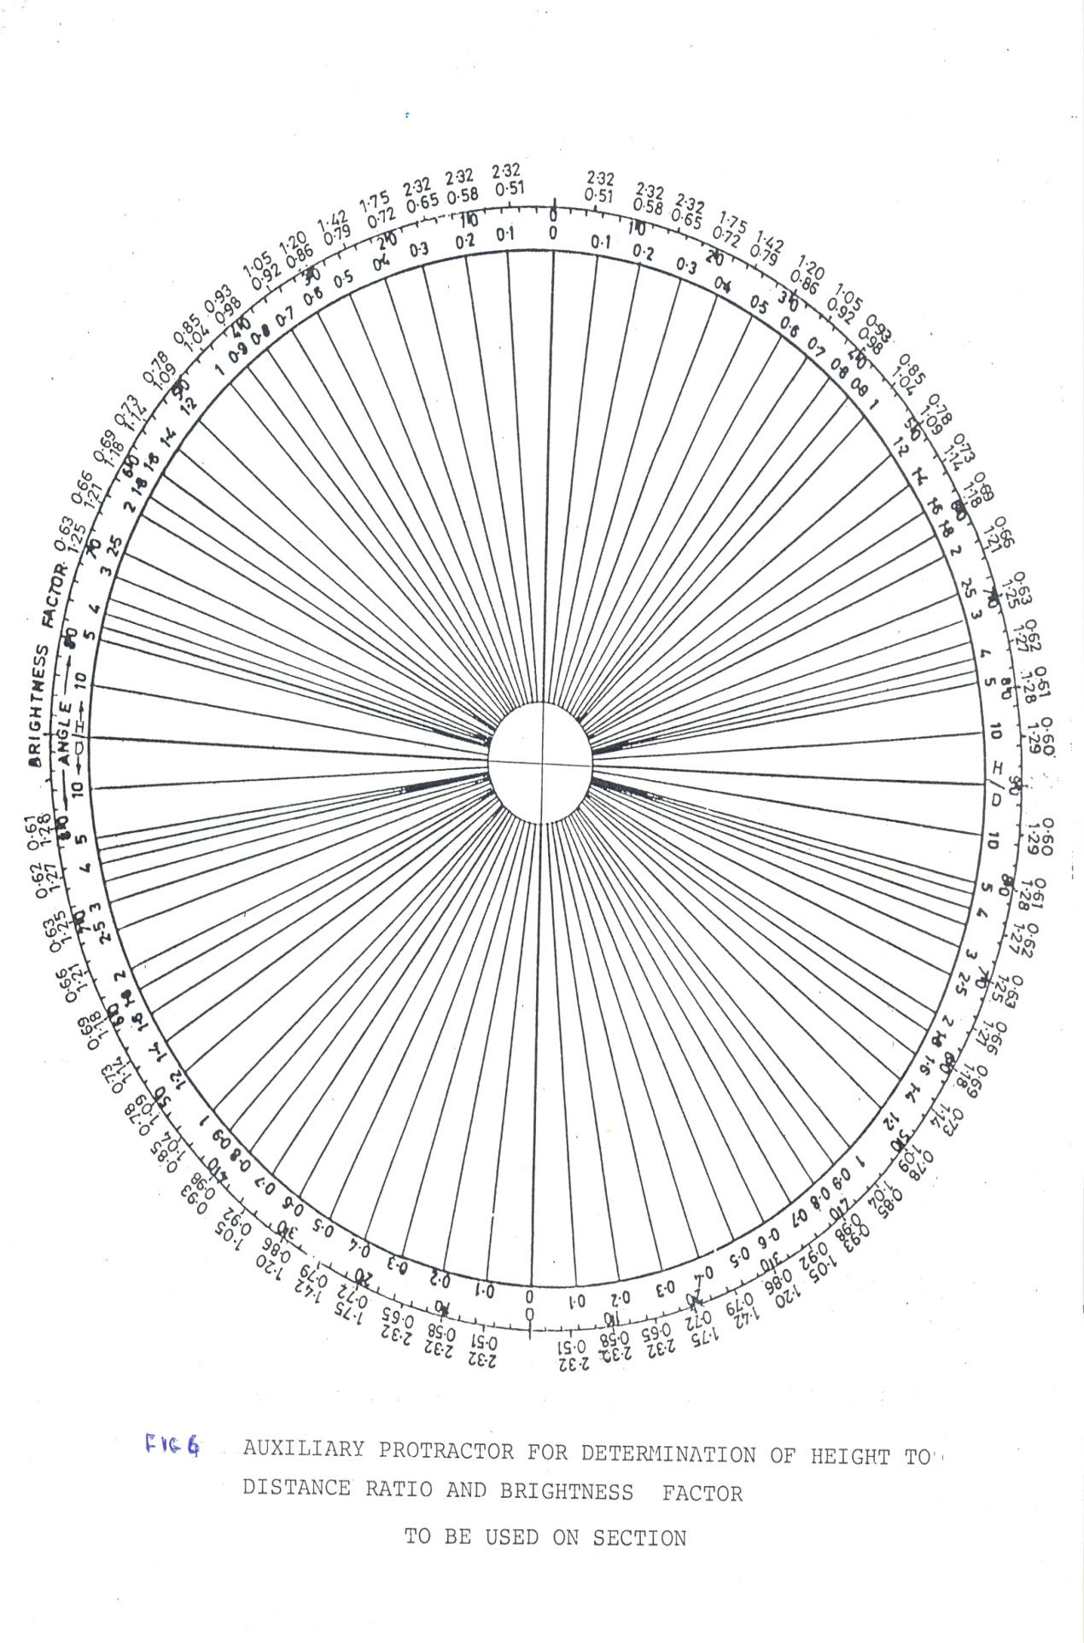

Table1. Luminous Efficiency of Light Sources

Light Source Luminous Efficiency Average Life
Lm / w Hours

GLS Incandescent lamps 8 – 18 1000
25 – 1000 w

Tungsten Halogen lamps 22 – 27 2000
500 –2000 w

Cool Daylight Fluorescent Tubes 61 5000
(diameter 38 mm) 20 - 80 w
Warm White Fluorescent Tubes 67 5000
(diameter 38 mm) 20 – 80 w
Slim Line Fluorescent Tubes 70 7000
(diameter 26 mm) 36 w
Compact Fluorescent Lamps 50 – 82 8000
(CFL) & LED lamps

* Recommended : Mirror Optic Luminaires / Efficient Semi-direct Luminaires
6. Conclusion

- Utilization of daylight in buildings based on latest IDMP data needs to be ensured.
- Latest energy efficient light sources should be utilized for energy efficiency in buildings.
- Selective artificial lighting units should be energized by photovoltaic conversion systems.
- Further researches need to be carried out for enhancing efficiency of solar cells in order to make them cost effective.

7. Acknowledgement

The authors are grateful to former CBRI scientists of Illumination Group, especially Mr. Shree Kumar and Mr. S. S. Aggarwal for useful interaction and valuable discussions on latest development in the field of day lighting and artificial lighting design.

References

1. CIE standard S 017/E { 2011} ILV International Lighting Vocabulary

2 (a). Saxena, B.K.. Aggarwal, S..S. , Shree Kumar {1999}, Methodology for estimation of daylight availability on horizontal and vertical surfaces for day lighting design of buildings, PRAKASH 99, pages 247-251. (b). Saxena, B.K.{1999}, Day lighting and IDMP data, Directory of Lighting Industry in India, PRAKASH 99, published by ISLE (Indian Society of lighting Engineers), pages.75-92
3. BIS National Building Code ( 2001), Bureau of Indian Standards, New Delhi
4. Saxena,B.K..Narasimhan,V.(1977),EnergyEconomic I Design for day-time lighting, ISI
Bulletin,Volume 9, No.6, pages 195 –198
5. Arndt, W. (1953), Proceedings of CIE Daylight Committee.
6. BIS SP 41 (S & T) – (1987), Handbook on Functional Requirements of Buildings, Bureau
of Indian Standards, New Delhi.
7. Valia, A. (2012), LED Lighting Systems, International Lighting Academy, Mumbai.

