Partial Replacement of Conventional Heat Energy by Solar Energy in the Production of Gypsum Plaster

Narendra Kumar*, S. K. Saini**, Sameer*

*CSIR-Central Building Research Institute, Roorkee
** Former Scientist, CSIR-Central Building Research Institute, Roorkee

Corresponding Author, Email: nkumar247@rediffmail.com

Abstract.

Gypsum is one of the important industrial minerals. It is hydrous calcium sulphate (CaSO₄.2H₂O) having a composition of 79% calcium sulphate and 21% water. Gypsum in its natural form finds applications in the manufacture of hydraulic cements, ammonium sulphate fertilizer, sulphuric acid and soil reclamation for agriculture purposes. When calcined into the form of plaster of Paris and enriched with additives like accelerators, retarders, fillers and binders, the use of gypsum are varied and extensive. The calcined gypsum or plaster of Paris is used in building, pottery, ceramic and surgical according to its grade plaster.

A batch type energy efficient gypsum calcinator has developed few years back in Central Building Research Institute with the primary aim of replacing the traditional open pan method with an energy efficient system using fossil fuel. The primary source of energy is the fossils fuels and mostly being used for the energy consumption today. The reserves of fossils fuels are limited and they will not sustain for a long time. The widespread use of fossil fuels increasing the environmental degradation day by day particularly global warming, urban air pollution etc. Hence the need was felt to explore the use of renewable energy sources to meet the growing demand of energy. For calcining the gypsum, the temperature required is around 160ºC inside the shell and this can be achieved by Solar energy. Solar energy is the most appropriate renewable energy that is collected from the radiations of Sun with the help of Solar thermal system. India is a sunny country with most parts receiving about 4 to 7 kilowatt hours of solar radiation per square meter per day with 250 - 300 sunny days in a year. This makes solar energy a very attractive option for generating both power and heat.

An experimental set-up of capacity 40 kg per batch for the calcination of gypsum has been designed and installed. The trials of the experimental set-up have been carried out using thermic oil heated by an alternate heating method.

Keywords: Gypsum, Calcination, decompose, solar radiation, thermic oil

1. Introduction

Gypsum is the sulphate of calcium (CaSO₄. 2H₂O). The available gypsum can be grouped into three main classes based on their mode of origin - quarry gypsum, marine gypsum and by product phospho gypsum. India is rich in the deposits of quarry gypsum and the mines are located mainly in Rajasthan, Gujarat, Jammu & Kashmir, Andhra Pradesh and Uttar Pradesh. About 90% of annual production of quarry gypsum is from Rajasthan alone. Marine gypsum is produced during separation of ordinary salt from seawater when the latter is evaporated in shallow pits. Huge quantity of phospho gypsum is produced from phosphoric acid plants as by-product of the wet process of phosphoric acid manufacture by acidulation of rock phosphate with sulphuric acid. The phospho gypsum, however, contains impurities like phosphates, fluorides and organic matter but after processing, the phospho gypsum is calcined into plaster of Paris and used for building and other purposes in the same way as the plaster produced from quarry gypsum or marine gypsum.

Gypsum in its natural form used in the manufacture of hydraulic cements, ammonium sulphate fertilizer, sulphuric acid and in soil reclamation. After calcination it converts into plaster of Paris and enriched with additives like accelerators, retarders, fillers and binders, the uses of gypsum are varied and extensive. The calcined gypsum used in building, moulding and casting plasters of many kinds; dental and surgical plasters; plaster for bedding plate glass while grinding and polishing; pottery mould plaster; dehydration of oil; filtering; and manufacture of many special products.

2. Manufacture of gypsum plaster

Gypsum as such does not posses proper setting and binding properties. Industrial importance of gypsum is attributed to its dehydrating ability on heating. Manufacture of gypsum plaster of different grades like surgical, building and pottery grades requires the gypsum to be calcined to hemi-hydrate commonly called plaster of Paris. On heating at 120-160ºC, gypsum releases one and a half molecule of water of crystallization forming hemihydrate.

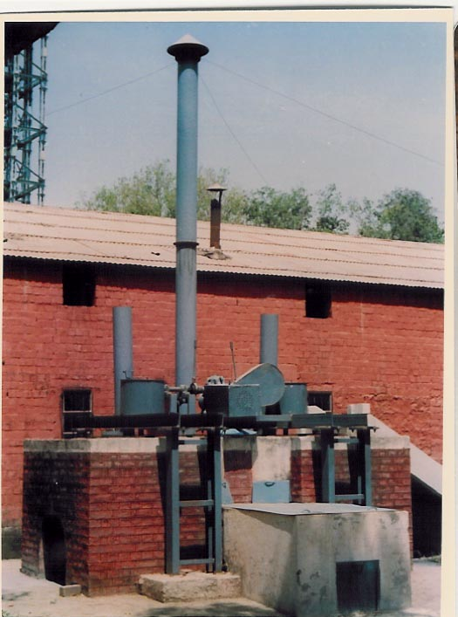
The calcination or conversion of gypsum (CaSO₄.2H₂O) to the hemihydrate (CaSO₄. 1/2H₂O) involves a reduction in water content from 20.9% to about 6.2%. This 14.7% water is lost in the form of steam, the escape of which from the powder gypsum gives an appearance similar to that of a boiling liquid. For producing gypsum hemihydrate (or plaster of Paris), gypsum is ground and heated to 120-160ºC. Because of the boiling liquid appearance at this temperature, the trade name of hemihydrate gypsum is first boil. The hemihydrate or the result of the first boil, known as ‘first settle plaster', sets rapidly when mixed with a suitable amount of water. When, however, gypsum is burnt at temperatures much in excess for 200ºC, the product is said to be 'overburnt' and the rate of setting is considerably delayed depending on the temperature employed. The need for careful control in the calcination of gypsum is therefore manifest; indeed, an unduly hurried calcination with bad distribution of heat may easily result in an unwelcome mixture of several calcined products plus some unaltered gypsum. Not only does the temperature require careful control, but also relative uniformity of temperature has to be achieved by constant mechanical churning of the gypsum charge during calcination. The different methods commonly employed for calcination of gypsum include: kiln or oven, open pan, gypsum bhatti, rotary kiln and kettle etc.
Figure 1. Energy Efficient Gypsum Calcinator

Amongst the above methods, open pan system was mostly used in India earlier and now gypsum bhatti for reasons of simplicity in design, operation and low initial cost of installation. However, these systems have several drawbacks; heat is wasted, dust losses and the plaster produced is not of uniform quality being sometimes under burnt or over burnt in different portions of the charge. As a result of growing awareness towards energy conservation in production units and to meet the requirements of the industry, a new system named as Energy Efficient Gypsum Calcinator was developed by CBRI which can be run using fire wood, coal, liquid fuel.

After successful in-house trials on the prototype plant at the Institute, the technology of the calcinator was licensed to several manufacturers. Commercial units of this calcinator are successfully producing plaster of Paris for industrial use. The innovative calcinator (Fig. 1) is basically a deep pan type calcinator with improved design of furnace for higher fuel efficiency and with the facility of power operated stirring system. It is free from all the drawbacks of open pan system and can be installed at low initial cost.

3. Thermal energy required for calcining gypsum

During storing, the powdered gypsum picks up some moisture because of its hygroscopic nature. The free moisture thus picked up may vary 3% to 7% but it may go up to 10% in certain cases. In addition to the free moisture, the gypsum (CaSO₄.2H₂O) contains two molecules of water in the combined form. For converting gypsum into plaster, gypsum losses 1.5 molecules of water besides the free moisture present in the gypsum. The heat consumed during calcination comprises of followings:

- Heat required to evaporate the free moisture content from the gypsum charge.
- Heat required for bringing gypsum charge to its decompose temperature.
- Heat required to decompose gypsum for conversion into gypsum plaster.
- Heat required for bringing temperature of gypsum to its calcination 130 to 160⁰C and maintain it to evaporate water molecules released in decomposition gypsum for conversion gypsum into gypsum plaster.

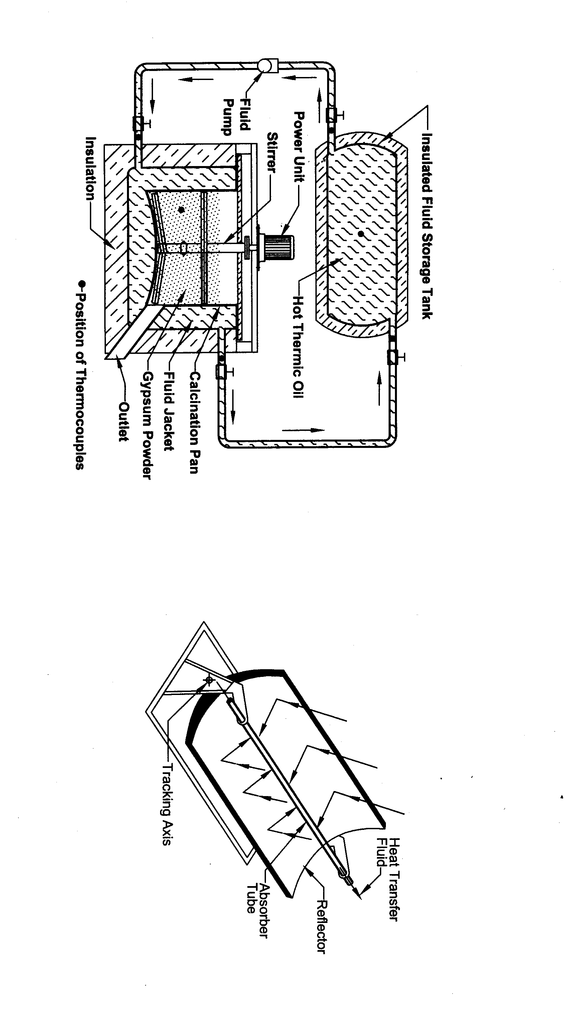
4. Solar heating system for calcination
Figure 2. Parabolic Trough Concentrator

For producing gypsum plaster (or plaster of Paris), gypsum is ground and heated to 120-160ºC for a certain period and at this temperature it releases one & half molecules of water of crystallization forming hemihydrate. Such solar heating system is required which can raise the temperature of gypsum powder to 120-160ºC by circulating the hot thermic oil (heated by Solar System) around the calcination pan. The different solar heating systems are available by which the temperature can be achieved for different applications.

The heart of a solar thermal system is a `solar collector'. As the name implies, it's main function is to collect solar thermal energy and transfer it to the oil to be heated. There are four different types of solar collectors i.e. flat plate collector (FPC), evacuated tube collector (ETC), CPC collector (stationary concentrator) and parabolic trough concentrator

The FPC, ETC & CPC collectors are suitable for applications that require a maximum temperature of about 80 - 85^{O}C which is not sufficient for the calcinations process. Parabolic Trough Concentrators are the most suitable for the application in gypsum calcination system as it may raise the temperature of thermic oil up to 350°C. A parabolic trough consists of a linear parabolic reflector that concentrates solar radiations on to a receiver positioned along the reflector's focal line. The receiver is a tube positioned directly at the focus of the parabolic mirror and filled with a working oil. The reflector follows the sun during the daylight hours by tracking along a single axis. The oil is heated to 150–350 °C as it flows through the receiver and is then used as a heat source for the required system (Fig. 2).

5. Experimental set-up of gypsum calcinator

An experimental set-up is designed and installed for the calcination of gypsum utilizing solar energy as partial replacement of heat energy required for calcination process. In the design system the heat energy is transferred to the gypsum powder by the hot thermic oil which is heated by solar energy system i.e. parabolic trough concentrators is the most suitable for the calcinations system which may raise the temperature of thermic oil up to 350^{O}C. The experimental set-up of calcinator having capacity 40 kg per batch consists of the calcinations pan, powered churning system, supporting structure and a hot thermic oil tank with hot oil circulation system (Fig. 3).
Fig. 3 Schematic Diagram of Experimental Set-up of gypsum Calcinator

5.1 Calcination pan

The cylindrical insulated calcination pan has the capacity of 40 kg per batch. The shape of the bottom of the pan is convex type and a cylindrical jacket is provided around the cylindrical shell as well as at the bottom of the pan for the circulation of hot thermic oil during calcination process. Provision has been made on the lower side & upper side of the pan for the inlet & outlet of the thermic oil respectively. The thermocouples have been provided on the inlet, outlet of the pan to monitor the temperature of the thermic oil and inside the pan at level to monitor the temperature of gypsum powder during calcination. An insulated top cover is also provided on to pan to minimize the thermal & dust losses.

5.2 Churning mechanism

The churning mechanism comprises of electric geared motor, stirrer shaft and churning blades. Two pairs of churning bladed have been provided on to the stirrer shaft and the lowest pair of churning blades is fixed with the bottom end of the stirrer shaft. A flange is fitted at one end of the stirrer for the mounting of stirrer with the geared motor. The churning system helps in proper agitation and intermixing of the gypsum charge in the pan during calcination.

  - Temperature sensing and monitoring

To calculate the heat transfer for the replacement of heat energy, the temperature of the thermic oil at inlet and outlet of the calcination pan was observed as well as the temperature of the charge during calcination was also observed with the help of thermocouples provided at different points and digital temperature indicator.

5.4 Operation of the gypsum calcinator

Due to non-availablity of parabolic trough concentrator, the thermic oil was heated by the alternate energy source i.e. electrical power. The heating element of 6 KW is fitted in the heating tank to heat the thermic oil. The heating of the thermic oil was started & the circulation of hot thermic oil was also started for initial heating of empty calcination pan. When the inside temperature of the pan is started increasing, the gypsum powder (passing through IS-60 Mesh Sieve) is loaded in the calcination pan in stages and the total charge of 50 Kg loaded within 30 minutes. The temperature of the thermic oil at inlet & outlet was recorded as well as temperature of the charge inside the pan was recorded at different interval during calcination process with the help of thermocouples provided and digital temperature indicator.

- Observations

The maximum temperature of the thermic oil was increased up to 219ºC and with the continued circulation, the temperature of the gypsum charge achieved up to max 124ºC in the pan during calcination. The heat required for producing 1 kg of gypsum plaster from gypsum having 10 % free moisture is 189.22 kCal. The total heat calculated on the basis of the temperature gain of the charge and it is 105.89 kCal / Kg of gypsum. Thus, the replacement of heat energy is about 56%. The saving in heat energy may be increased if the temperature of the thermic oil increased and with the result the increase in the temperature on the gypsum charge to be calcined.

- Acknowledgement

The paper is published with the permission of Director, Central Building Research Institute, Roorkee and forms the part of the R&D program of the institute.

- References

- Chopra, S.K. Taneja, C.A. and Kaushish, J.P. etc., ‘A Kettle for Improved
Calcination of Gypsum’ , Research and Industry, Vol. 16, No.2, pages. 123-124, 1971.
- Report on, ‘ Energy Efficient Gypsum Calcinator’ , sent to NRDC, New Delhi in June 1988 for NRDC Award Competition.
- Riddell, wallace, C, "Kettle Process of Calcination", Rock Products, Vol.48, NO.8, Aug. 1945, pages 88,89, and 152.
- Lewis R., "Improved Calcining Process for Gypsum", Zement-Kalk-Gips (ZKG), Vol.38, NO.5, May 1985, pages.250-255.
- Indian Mineral Year Book, Ministry of Steel and Mines, Vol. 2, 1986, pages 488-501.
- Kaushish J.P., Bhagwan Dass, Saini S.K., etcc., ‘ An Energy Efficient Gypsum Calcinator’. Invention Intelligence, Vol. 24 No.7 July 89, pages 321-327.

