Design and Thermal Performance Studies
of a Domestic Cooker – cum - Drier

J. S. Puri

Former Technical Officer, CSIR-Central Building Research Institute Roorkee
Corresponding Author, Email: purijs@rediffmail.com

Abstract

Major part of the energy used for cooking is met from fire wood, agricultural wastes, cow dung and cooking gas etc. Solar cookers have become much popular to some extent. But the target of their using, is not much achieved, despite efforts made by various agencies working in the areas. Similarly in case of drying, hardly anybody take the advantage of drier for drying the chillys, potato etc. People dry the material in open sky but suffers drawback on it, such as no control on drying rate, slow drying, no uniform drying, no protection from rains/dust storms. To make more popular utilization of solar energy particularly for cooking and drying is much needed. CBRI has designed and developed a solar cooker cum drier for domestic use for a small family for both cooking and drying. The cooker has been made with G. I. sheet of 24 SWG having 5cm insulation all around between inner and outer boxes with double glazing on its inclined front. Necessary opening has been provided to facilitate cooking & drying operation. The thermal performance study was carried out of both cooker and drier. In addition to this, study was also carried out for cooking various foods and drying of various fruits and vegetables both in winter and summer. The cooker cum drier has been found more effective and efficient. This paper gives more details about its design, construction and thermal performance.

- Introduction

More than fifty of energy consumption on domestic sector has been used for cooking purpose. This energy generally traps from agricultural wastes, cow dung and cooking gas etc. (1). Larger use of these sources causes ecological and population problems (2). In view of acute shortage and steel growing higher prices of fuel etc. there is a great need for utilizing solar energy for cooking and drying. Due to sufficient availability of this energy, it can be used as alternate source of energy. The different types of cookers and driers have been designed and developed by different agencies and institutions in India and abroad (3, 4, 5, 6). Solar radiation has important role in solar devices. In India solar radiation on horizontal surface is on an average 5.5 K.Watt/m²/day (7, 8). To make cooking & drying more popular and attractive CBRI has designed and developed a cooker cum drier for a small family. The performance study of cooker was cried out measuring plate temperature, inside air temperature; water temperature in winter as well as in summer in both the cookers (CBRI cooker and conventional cooker) made by means of thermal couples. The performance was also checked by cooking various foods in cooker. The performance study of drying was carried out by measuring inlet air temperature, plate temperature and outlet air temperature of CBRI drier and inside temperature, plate temperature and air temperature at the opening of conventional cooker both in winter and in summer. In additional to this various vegetables have been dried measuring initial weight, moisture and duration of period for drying.

- Design and construction details of cooker – cum – drier

A domestic cooker –cum-drier has been designed and developed particularly for a small family taking into consideration for cooking as well as drying. Earlier many driers have been designed and developed of larger capacity (9, 10, 11, 12, 13). In this cooker one can cook two items at a time Dal-rice etc. or can also dry small quantity of vegetable/fruits. This box type cooker cum drier has been made up with 24 SWG GI sheet. The size of inner box 50X35 cm with 7X23 cms height on its front and rear side of 60cm. the total area of inside box (base and walls), is 0.5m². The insulation of 5cms has been provided all around between two boxes. For drying purpose, seven nos. of holes with G.I. nipples 2.5cms dia. have been provide for inlet air and a Pipe of dia. 7.5 cms with 19cms. Height has been used as chimney for outlet hot air. A wire mesh tray of size 45X20cms with 5cm height has been used during drying. There is a door on its rear side size 45X20cms to facilitate cooking and drying operations. Inner box is painted with dull black paint and covered with 4mm air tight double glazing with slope 35º with horizontal. Castor wheels have been provided at the bottom of the unit for easy motion for tracking the sun during cooking or drying. The provision has also been made for closing and opening of inlet and outlet accordingly during cooking or drying.

- Performance studies of cooker cum drier

The performance study was carried out by measuring the temperature in both CBRI cookers and conventional cookers, on plates, inside sir, and in water by means of thermocouples (Cooper-constantan) with the help of digital temperature recorder in both winter and summer. During experimental study 500ml. Water was placed in each cooker. This is shown in Figure 1. For the comparison of thermal performance, the hourly temperature was measured from 9AM to 3PM. This is shown in table 1.
Table 1. Observed hourly variation of temperature during cooking in summer and winter (Load 500 ml water in each cooker)

Summer Winter
CBRI Cooker Conventional Cooker CBRI Cooker Conventional Cooker
Time Water Plate Inside air Water Plate Inside air Water Plate Inside air Water Plate Inside air
(hrs) Temp. temp. temp. Temp. temp. temp. Temp. temp. temp. Temp. temp. temp.
(ºC) (ºC ) (ºC) (ºC) (ºC ) (ºC) (ºC) (ºC ) (ºC) (ºC) (ºC ) (ºC)
9 21 44 43 20 40 35 11 14 15 9 13 12
10 54 81 67 64 93 82 27 46 41 35 60 52
11 75 96 81 88 110 110 50 70 61 67 86 80
12 83 102 83 88 130 112 65 77 67 81 92 85
13 83 101 83 87 125 103 73 81 71 87 86 90
14 83 100 86 85 118 96 57 51 46 61 52 47
15 83 95 82 85 112 95 51 39 37 55 40 43

We have also studied the performance of cooker by cooking various items such as rice-dal, rice-channa & rice-rajma etc. Figure 1. shows the cooker with two pots during cooking. The efficiency (14) of cooker has also been calculated and found approximately of the same order as in the case of conventional cooker. We have also compared the thermal performance of CBRI cooker-cum-drier with conventional cooker used as drying purpose. We have compared with conventional cooker because most of the people take the advantage of this cooker by drying the material by slightly opening the lid to escape the moist air. The temperature at inlet, plate and outlet were measured in CBRI drier whereas inside air temperature, plate temperature and air temperature at opening were measured in conventional unit from 9AM to 3PM both in winter and summer. The temperature comparison has been shown in table 2.
Table 2. Observed hourly variation of temperature during drying process in summer and winter (No Load)
Summer Winter
CBRI drier Conventional Unit CBRI drier Conventional Unit
Time Water Plate Inside air Water Plate Inside air Water Plate Inside air Water Plate Inside air
(hrs) Temp. temp. temp. Temp. temp. temp. Temp. temp. temp. Temp. temp. temp.
(ºC) (ºC ) (ºC) (ºC) (ºC ) (ºC) (ºC) (ºC ) (ºC) (ºC) (ºC ) (ºC)
9 31 61 53 45 67 71 12 15 15 12 11 11
10 32 78 57 50 93 84 20 33 30 37 53 49
11 32 85 57 52 106 90 19 46 39 48 77 72
12 34 84 55 55 137 112 20 50 43 57 87 83
13 32 82 53 54 131 102 25 50 43 58 88 81
14 31 80 52 60 122 95 15 25 24 29 35 35
15 31 72 50 60 92 85 15 21 20 22 27 28

The performance of drier has also been checked by drying potato chips in summer and tomato in winter. The hourly temperatures have been measured during two days for potato chips and 5 days for tomato, shown in table 3 & 4 respectively.

Table 3. Observed Hourly Variation of temperature during drying in summer (With Load 400 gm potato chips)
 | 1st Day 2nd Day
Time  (hrs) | Inlet air Plate Outlet air Inlet air Plate Outlet air  temp. (ºC) temp. (ºC) temp. (ºC) temp. (ºC) temp. (ºC) temp. (ºC)
9 29 29 35 25 29 32
10 26 31 40 25 33 39
11 29 37 43 23 47 45
12 30 38 41 28 55 48
13 26 33 49 32 58 50
14 23 33 38 25 54 48
15 22 29 36 23 47 44

Table 4. Table 4. Observed Hourly Variation of temperature during drying in winter (With Load 400gm tomato)
 | 1st Day |  |  |  | 2nd Day |  |  |  | 3nd Day |  |  |  | 4th Day |  |  |  | 5th Day
Time (hrs) |  | Inlet air Temp (ºC) | Plate Temp(ºC) | Outlet air Temp (ºC) |  | Inlet air temp (ºC) | Plate temp(ºC) | Outlet air temp (ºC) |  | Inlet air Temp (ºC) | Plate temp(ºC) | Outlet air Temp (ºC) |  | Inlet air Temp. (ºC) | Plate temp (ºC) | Outlet air Temp (ºC) |  | Inlet air Temp (ºC) | Plate temp (ºC) | Outlet air Temp (ºC)
9  10  11  12  13  14  15 |  | 11  13  13  21  19  14  13 | 9  16  25  34  34  20  17 | 12  24  27  34  33  20  17 |  | 10  12  16  12  14  13  12 | 9  19  16  30  33  19  16 | 10  23  30  32  35  19  16 |  | 10  12  12  16  18  12  12 | 8  15  26  31  30  18  16 | 12  22  27  32  32  18  15 |  | 11  17  20  27  28  19  16 | 8  21  23  29  30  18  15 | 12  12  12  12  14  12  11 |  | 10  12  12  12  14  12  11 | 8  21  27  30  32  19  16 | 9  26  26  31  33  19  15

During drying a wire mesh tray has been used, shown in Figure 1. Further, some more vegetables and fruits have also been dried in winter and summer measuring moisture content, weight of material, and duration of period (hours/days). This is shown in table 5. The efficiency of drier has also been calculated.

Table 5. Drying Details of Vegetables and Fruits
Vegetables and Weight of material Moisture content Duration of time of drying
Fruits (gms). %(Initial) (Days) (hrs)*
Initial Final
Onion 300 60 80 3 15*
Potato 400 70 82.5 2 10
Cauliflower 400 35 91.5 5 20
Tomato 400 30 92.5 5 20
Chilies 500 100 80 5 20
Banana 130 20 84.6 3 12
Guava 215 50 76.7 3 12
Grapes 165 60 63.6 7 8
* Solar radiation is available on cooker/drier surface, about 4 to 5 hrs daily. The rest of
time it is shaded by side standing ling trees.
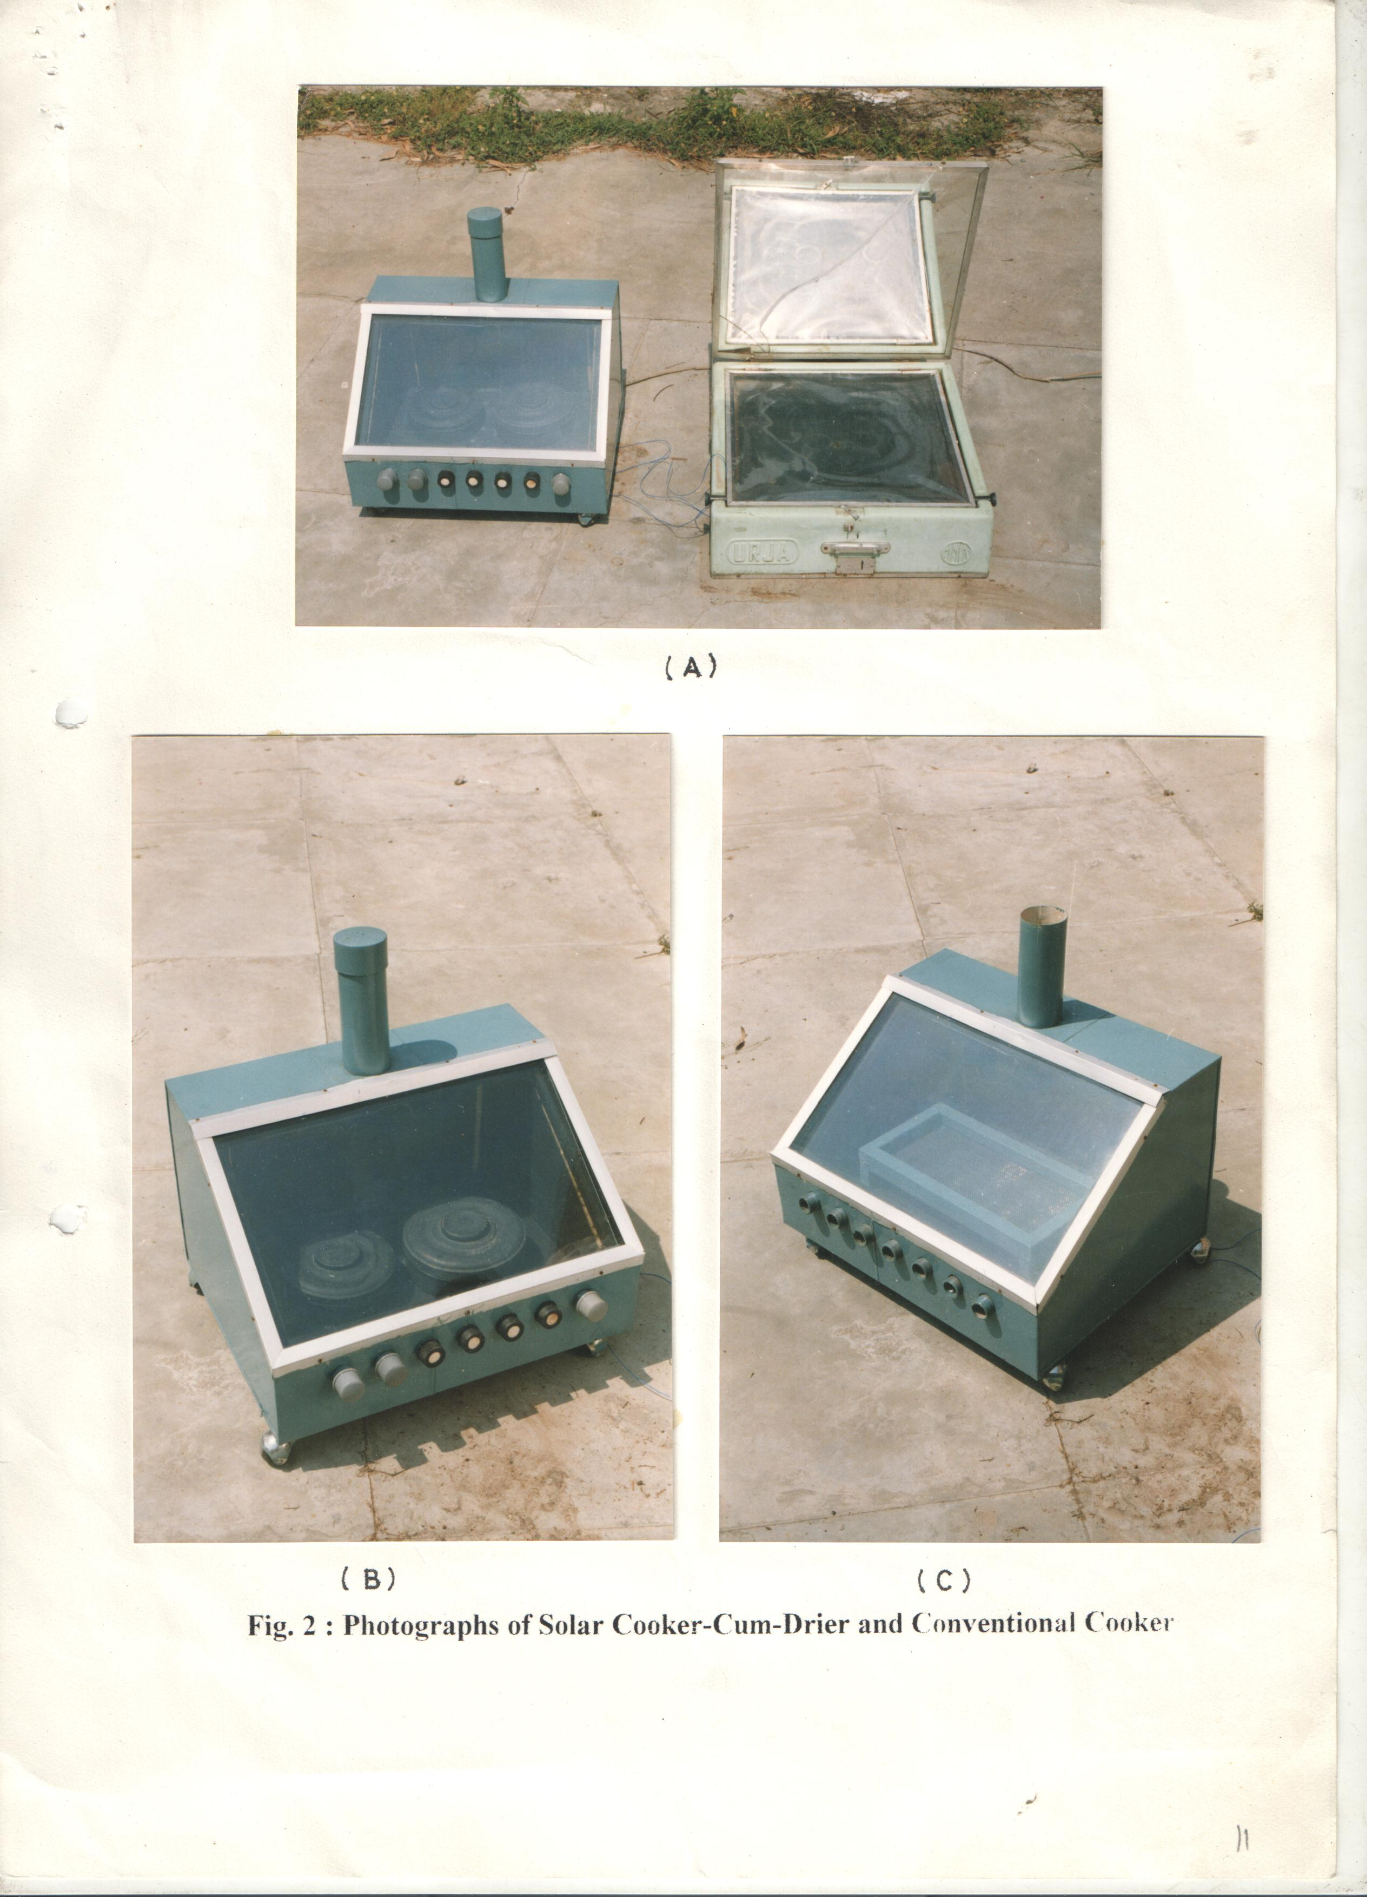
Figure 1: Solar Cooker-cum-Drier and Conventional Cooker

- Results & discussion

During the study in comparison of temperature of two cookers, it is observed that I summer, the max. Plate temperature 102ºC in CBRI cooker and 130ºC in conventional cooker was obtained. Similarly the max. Water temperature 83ºC and 88ºC and inside air temperature 86ºC and 112ºC were obtained in CBRI cooker and conventional cooker respectively. During winter observations, the max. plate temperature 81ºC and 92ºC, water temperature 73ºC & 87ºC and inside air temperature 71ºC and 90ºC in both CBRI cooker and conventional cooker respectively were obtained.

Higher temperature in all cases was observed in conventional cooker than the CBRI cooker because of additional provision of reflector in conventional cooker. The various foods have also been cooked such as rice dal, rice channa, rice rajma etc. It has been observed that rice could be prepared between 1 and ½ to 2 hours and hard dals etc. could be prepared between 2-3 hours. The study has also been carried out for drying during summer.

In CBRI drier it was observed that the maximum air temperature at inlet 34ºC and max. air temperature at outlet 57ºC through chimney and max. plate temperature 85ºC were obtained in typical summer and in case of conventional unit maximum air temperature at opening 60ºC, plate temperature 137ºC and inside air temperature 112ºC were obtained. During winter also we have obtained maximum inlet air temperature 25ºC, plate temperature 50ºC and outlet air temperature 43ºC in CBRI drier and in case of conventional unit maximum temperature at opening 58ºC, plate temperature 88ºC and inside air temperature 83ºC were obtained. In addition to this, the performance has also been checked by drying potato in summer and tomato in winter measuring inlet temperature and outlet temperature for consecutive two days and five days respectively.
Apart from this more vegetables fruits have been dried measuring hourly temperature initial moisture, initial and final weight and duration of period for drying the materials. The cost of cooker cum drier has been calculated and it comes out to Rs. 800/- whereas the cost of conventional cooker is Rs. 1700/-.

- Conclusion

The cooker designed by CBRI is more efficient and effective. In this cooker both the facilities of cooking & drying have been provide. It is very useful for a small family for cooking rice-dal or drying small quantities of vegetables or fruits. The efficiency of cooker is calculated and found almost the same as in case of conventional cooker even after elimination of reflector. To make more efficient, certain modifications in design and more investigations are required.

- Acknowledgement

This paper is a part of research activities of Central Building Research Institute, Roorkee and is published with the permission of Director. Author is thankful to Ishwar Chand and Dr. Manik Chandra for their faithful suggestions and Shri Har Sagar for the help during experimental measurements.

References

- Ganguly R. et al. (1987) “Solar option for Rural India” Proceeding of seminar on Rural Build and Environment, CBRI Roorkee.
- Murugesan, R./, et al., (1987), “Testing and performance analysis of an indirect type solar cookers”. National solar energy convention, New Delhi.
- Gupta, C.L., (1977), “The Indian Sun Scene” Sun World, Vol. 3.
- Hoda, M.M. (1977), “Solar cookers” Proceeding First International Conference Building Tech. London Vol.2, pages 817-823.
- Malhotra, K.S., et al., (1983) “Development of Solar cookers in India”. Sun world Vol. 6(6).
- Garg, H.P. and Thanu K.P. (1976) “Simple hot box type solar cooker” Research & Industry, 21 (3), 184-186.
- Mani. A. (ed) (1980), “Handbook of Solar Radiation data from India” Allied Publisher Pvt. Ltd., New Delhi.
- Garg. H. P. et al. (1969), “Design data for Direct Solar Utilization devices Part II-Solar Radiation” Indian Journal of Meteorology and Geophysics Vol. 20(3) pages 221-226.
- Pande, P.C. (1980) “Performance Studies on improved solar cabinet drier” National Solar Energy Convention pages 1-5 at Annamalai University, Annamalai Nagar.
- Garg. H. P. (1988), “Solar Drying” Summer School Energy Application at IIT New Delhi, pages-1-19.
- Low ward. T.A. (1966), “A Solar Cabinet Dries” Journal Solar Energy Vol. 10 (4), pages 158-164.
- Soda, M.S. et al (1982), “AN Experimental Solar Drier” National Solar Energy Convention at IIT New Delhi, pages 4.018-4.021.
- Sharma V. K., Colangelo, A & Spagna, GA (1995), “Experimental Investigation of Different Solar Dryers suitable for fruit and vegetables drying”, Renewable energy 6(4) pages 413-424.
- Jerman, B., (1981), “Light Weight Portable Solar Cooker” Proceedings of International Solar Energy Congress Brightan England.

