Solar energized Liquid Desiccant Air Conditioning – A review

Nagesh B. Balam and PK Bhargava

CSIR – Central Building Research Institute, Roorkee
Corresponding Author, Email: nagesh.balam@gmail.com

Abstract

A review on Liquid Desiccant based cooling technologies with special focus on advances in liquid desiccant materials and configurations of heat and mass exchangers have been discussed. Performance comparison and energy saving potential of a hybrid liquid desiccant cooling system based on vapour compression based sensible cooling and liquid desiccant based dehumidification in comparison to conventional vapour compression system has been reviewed. Hybrid liquid desiccant cooling system has enormous energy and cost saving potential especially in hot and humid regions like India. The ability of Liquid Desiccant cooling technology to be energized by Solar thermal makes it an attractive alternative to high electrical energy intensive conventional vapour compression based cooling for residential and commercial HVAC applications.

Keywords: Liquid Desiccant, Dehumidification, Vapour Compression, Solar Thermal.

1. Introduction

India is a tropical country and more than 80% of Indian Sub continental area falls under Warm humid or Composite Climatic zone [1]. These climatic zones are characterized by high annual average temperatures and high humidity. With rapid urbanization and industrialization in India, there is sharp rise in air conditioning load in Industrial, commercial as well as residential buildings.
The Air conditioning load could be broadly classified as sensible load and latent load. Conventional vapour compression Air conditioners (VAC) meet the total air conditioning load by cooling the air below the dew point temperature and thus condensing the moisture. These systems require evaporator temperatures to be maintained much lower than required to achieve sensible cooling alone. The dew point temperature is much below the set temperature level and hence process air requires further heating to bring its temperature to set temperature level. This requirement increases the capacity rating of the compressors and requires high electricity and consequently operates at reduced coefficient of performance (COP) [2].
There is a necessity to separate the latent cooling load and sensible cooling load and handle them separately so as to improve the COP of the air conditioners. The desiccant cycles can be used to reduce the moisture content of air by partially converting latent cooling load to sensible cooling load and then meeting the load by VAC’s. These systems with vapour compression cycle for meeting sensible cooling load and liquid – desiccant cycle for latent cooling load are called hybrid systems.
2. Liquid desiccant dehumidification and air conditioning

A desiccant material has a strong attraction for water vapour. Desiccants are commonly used in industrial applications where low dew-point air is needed. The strength of a desiccant can be measured by its equilibrium vapour pressure (i.e., pressure of water vapour that is in equilibrium with the desiccant). This equilibrium vapour pressure increases roughly exponentially with the temperature of the desiccant/water system. It also increases as the desiccant absorbs water (a dilute liquid desiccant will have a higher equilibrium vapour pressure than a concentrated liquid desiccant). When the absolute humidity of air that has come into equilibrium with a liquid desiccant of fixed concentration is plotted on a psychometric chart, the equilibrium line closely follows a line of constant relative humidity and the Fig1. illustrates this behaviour for solutions of lithium chloride.

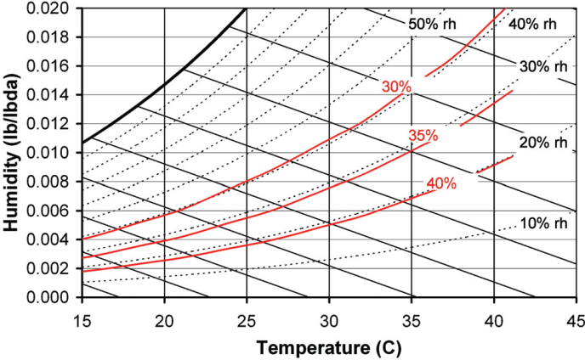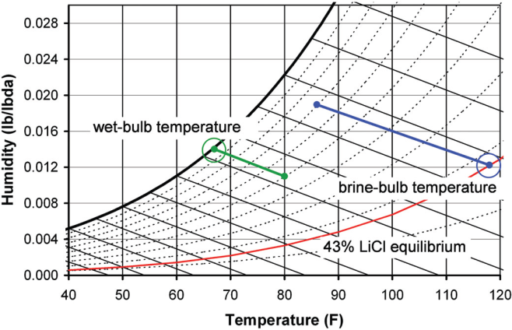
Figure 1. Psychrometric performance of LiCl at different concentrations
Adsk

Figure 2. Examples of Wet-bulb temperature and brine-bulb temperature

As shown in the Fig 2., the brine-bulb temperature for a 43% solution of lithium chloride and air at 30.0/25.6°C dry-bulb/wet-bulb will be 47.8°C. With an ambient wet-bulb temperature of 25.6°C, a typical cooling tower might supply water at29.4°C. It’s impractical to cool the ambient air using this cooling water in a conventional heat exchanger, because the cooling water is only one degree below the air temperature. However, a strong cooling effect could be achieved by wetting the surfaces of the heat exchanger with the 43% lithium chloride. Of course, one does not get this enhanced cooling for free. If the cooling process is to be continuous, energy must be expended to regenerate the desiccant back to its original concentration. If ambient air from the preceding example is brought into equilibrium with 43% lithium chloride at 85°F (29.4°C), the air will have a dew point of 33.5°F (0.8°C), a wet-bulb of 57.8°F (14.3°C), and its enthalpy will be reduced from 41.5 Btu/lb (96.3 kJ/kg) to 24.9 Btu/lb (57.8 kJ/kg). This large cooling effect, both in terms of latent cooling and total cooling, and low dew point—both of which are achieved without a compressor—demonstrate the potential for liquid desiccants to become an important part of HVAC systems. Liquid desiccants have been successfully used to produce dry air for a surprisingly long time. Dr. Russell Bichowsky, working for the Frigidaire Division of General Motors, first used solutions of lithium chloride to dry air in the 1930s. Also in the 1930s, the Niagara Blower Company introduced a liquid desiccant technology that used glycol solutions to prevent frost from forming on low-temperature evaporators. Both lithium chloride and glycol continue to be used today in liquid-desiccant dehumidifiers, but their use is limited primarily to industrial applications[3].

3. Hybrid configuration: desiccant de-humidification and vapour compression based cooling

An example of desiccant cooling application is represented in fig. 3 [4].

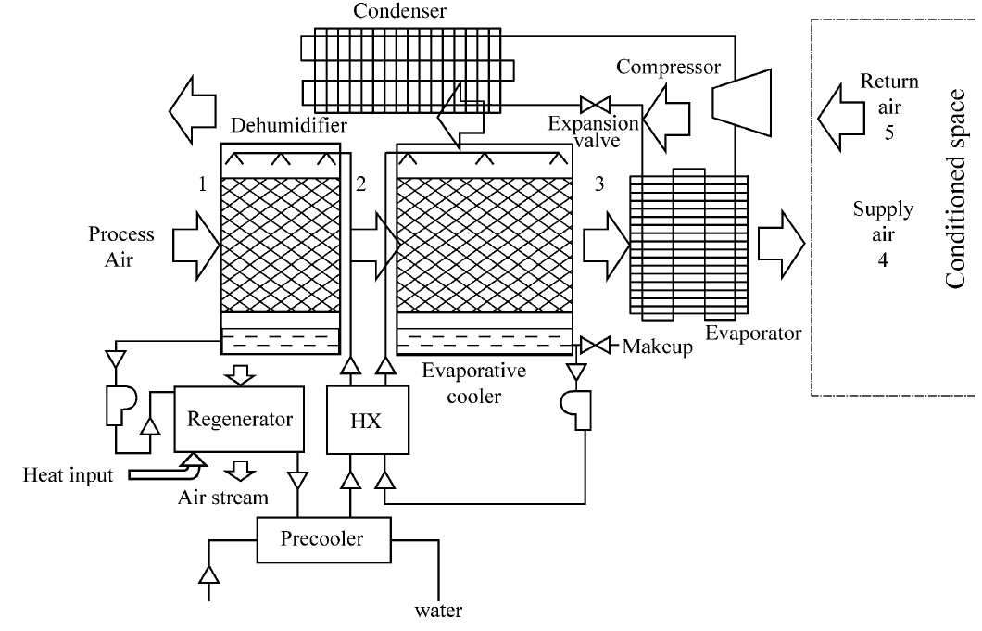
Figure 3.Schematic of Hybrid Liquid Desiccant aided Vapour compression air conditioning

Here, the cool strong desiccant solution is sprayed onto the top of the dehumidifier through spraying nozzles. By gravitation, it trickles through the structure of the dehumidifier where it gets contact with the process air stream blown perpendicularly to its trickling flow direction. Since, the cool and strong desiccant solution vapour pressure is less than that of the air vapour pressure, water vapour migrates from the air stream to the desiccant solution and condenses therein. Consequently, the heat of condensation and mixing are liberated causing an increase in the solution’s temperature. The process air stream is slightly cooled down due to its contact with the cold desiccant solution. The dehumidified and rather warm process air stream then passes successively through the evaporative cooler and the evaporator of the traditional refrigerant vapour compression air conditioner, before being delivered into the conditioned space. The diluted desiccant solution, exited from dehumidifier, is circulated through the regenerator where it is heated and the moisture absorbed in the dehumidifier is now lost to the scavenger air stream. In order for the system to keep functioning continuously and effectively, an equal amount of water vapour absorbed from the humid air and condensed to the desiccant solution in dehumidifier must be evaporated from the desiccant solution in the regenerator. The hot and strong desiccant solution is thereafter cooled down in the pre-cooler and then cooled further in the heat exchanger (HX) before being ready again to dehumidify the incoming process air.
The lowest limit temperature attainable by the evaporative cooler is the process air wet bulb temperature which decreases with the decrease of the relative humidity and increases with the elevation of the dry bulb temperature. The essential role of the desiccant solution in this example is to lower the relative humidity of the incoming air stream in order to enable the evaporative cooler to function more effectively.

Here, the desiccant assisted evaporative cooling is associated with the traditional vapour compression air conditioning to reduce its size and enhance its coefficient of performance. Because the latent load is handled independently by the desiccant dehumidifier, the need of cooling the ventilation air below its dew point is obviated. The temperature of evaporation can thus be lifted up to 15 °C from its generally practiced level of 5 °C for the traditional vapour compression system. The increase in evaporation temperature will entail the increase of the system’s coefficient of performance (COP).

This assemblage can be useful in humid climates where the wet bulb temperature is fairly high. In such climates, a significantly downsized vapour compression air conditioner can be supplemented with a desiccant assisted evaporative cooler in order to reach the desired indoor temperature, thus enabling costs and energy savings and improving the indoor air quality.

4. Liquid desiccant materials

Liquid desiccants such as Glycols and solutions of halide salts are routinely used in industrial de-humidifiers. Commonly used liquid desiccant materials include lithium chloride, lithium bromide, calcium chloride, triethylene glycol and mixture of salts etc. The choice of desiccant will have a profound effect on the design of desiccant de-humidifiers.

The desirable properties of liquid desiccants include large saturation absorption capacity, low regeneration temperature, Low Viscosity, Good heat transfer, non volatile, non – corrosive, odourless, non toxic, non flammable, stable and inexpensive. Surface Tension of liquid desiccants is an important parameter of liquid desiccants as it plays important role in static hold up and wetting of the surface of heat and mass exchanger of Liquid desiccant system.

Halide salts such as lithium chloride and lithium bromide are very strong desiccants. A saturated solution of lithium bromide can dry air to 6% relative humidity and lithium chloride to 15% but halide salts are corrosive in nature. Lithium Chloride has good desiccant characteristics and does not vapourize at ambient conditions but droplet filters are necessary to prevent any mixing of the liquid droplets with process air. Cost of halide salts are relatively high except calcium chloride whose cost is comparatively low compared to LiCl, LiBr and TEG. Another advantage of Calcium chloride is its low viscosity which reduces the pumping power. But the CaCl2 salt is highly corrosive in nature and can be used in non metallic systems only [5].

The least expensive alternative to lithium chloride is calcium chloride. Unfortunately, calcium chloride is a relatively weak desiccant. A 42% solution, which is about as strong as can be used without encountering crystallization, will dry air to about 35% rh. (For comparison, a 43% lithium chloride solution can dry air to a 15% rh.).

Glycols are the second class of liquid desiccants now used in industrial equipment. Both triethylene and propylene glycol have low toxicity, and their compatibility with most metals has led several researchers to use them in LDACs designed for HVAC applications. However, all glycols have one undesirable characteristic that they are volatile and any evaporation into the supply air makes it unacceptable for air conditioning for occupied buildings [6].

Salts of weak organic acids, such as potassium or sodium formate and acetate, have been explored as less corrosive alternatives to halide salts that are also not volatile. Although it is a significantly weaker desiccant than lithium bromide or lithium chloride, the ability to dry air below 30% relative humidity could make potassium formate a good alternative desiccant in some applications. Another less expensive alternative is potassium acetate. While potassium acetate could dry air to about 25%, its viscosity becomes very high. At 70% concentration and 27°C, a potassium acetate solution has a viscosity of about 28 cp. This is almost twice has high as a 43% lithium chloride solution at the same temperature. Water at 27°C has a viscosity of close to 1.0. [3].

Studies were also conducted on mixtures of calcium chloride and lithium chloride solutions to take the advantage of good desiccant properties of LiCl and low cost CaCl2 [7].

4.1 Advantages of using liquid desiccants include

- Lower air pressure drop in process air stream.
- Liquid desiccants are capable of providing equivalent dehumidification as solid desiccant systems with lower regeneration temperature(mostly 70 - 80°C) due to the internal cooling provided by cooling tower water or chilled water and allowing utilization of solar heat or waste heat.
- Pumping of liquid desiccants is possible makes it possible to connect several small desiccant dehumidifiers to a larger regeneration unit which is especially beneficial for large multi zonal commercial buildings.
- Liquid desiccants have high COP’s as highly efficient liquid-liquid exchangers could be employed.
- Simultaneous air dehumidification and desiccant regeneration is not necessary as it is possible to store dilute saturate liquid until regeneration heat is available.
- Liquid desiccants are highly beneficial for their ability to filter microbial contamination, bacteria, viruses, and moulds from process air stream.

5. Heat and mass exchangers for Liquid desiccant de-humidification

The Heat and mass exchanger of a desiccant dehumidification unit is where the liquid desiccant comes in direct contact with the process air.

The desirable characteristics for heat and Mass exchanger for high-performance liquid desiccant dehumidifiers

- High heat and mass transfer rates
- Low pressure drop in process air flow
- Small liquid-side resistance to moisture diffusion
- Large contact transfer surface area per unit volume
- Compatible desiccant/contact materials (non corrodible with high wetting coefficient)
- Zero carryover of liquid desiccant droplets into process air
- Use of common materials and inexpensive manufacturing techniques
- Classified various thermally activated Desiccant cooling technologies as shown in fig. 4

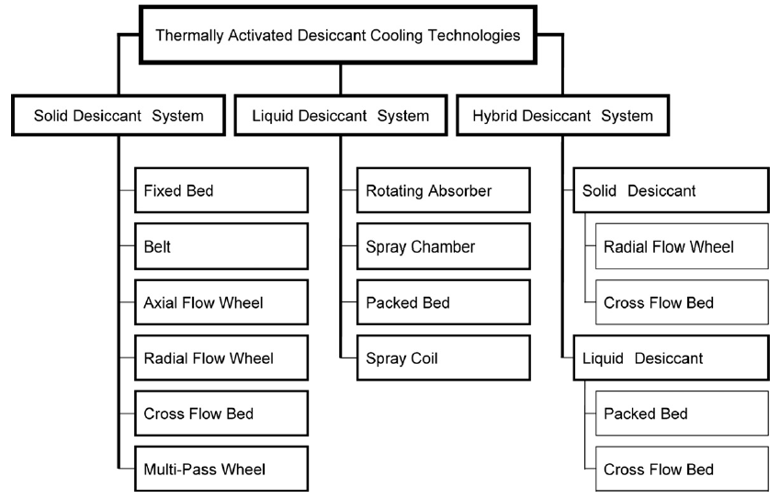

Figure 4. Heat and mass exchanger configurations for various desiccant cooling technologies

The packed-bed conditioner has been the focus of many R&D projects on Desiccant De-humidifiers. More recent R&D on packed-bed heat and mass exchangers includes the work of [9] in which the performance of packed-bed heat and mass exchangers flooded with lithium chloride solutions were experimentally measured. The researchers first implemented their conditioner and regenerator as internally cooled units using either copper tubes or polypropylene tubes as the contact surface. However, the copper tubes were too easily corroded by the desiccant, and the polypropylene tubes were too difficult for wetting.

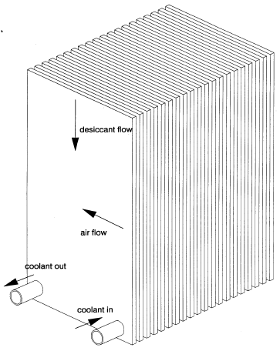
[10] modelled and experimentally measured the performance of packed-bed, lithium chloride heat, and mass exchangers that used a random, polypropylene packing with a volumetric surface area of 210 m² per m³. They reported that the lithium chloride solution did not uniformly wet the packing because of its high surface
tension.
High flooding rates are necessary to keep the desiccant cool and complete wetting. But High flooding rates may cause carryover of liquid desiccant droplets into air stream and also is responsible for pressure drop in air flow. Conditioners that are internally cooled do not have to operate at the high flooding rates of packed-bed units as the desiccant temperature is maintained close to coolant temperature [11]. A cross flow heat exchanger is shown inthe Fig. 5 which is internally cooled by coolant where the process air flow and desiccant flow contact at right angles. A coolant liquid provided from a cooling tower or chilled water enters through the pipe section throughout the heat exchanger and hence internally cooling desiccant.
Figure 5.Internally cooled
Cross flow heat exchanger

At low liquid desiccant temperature the vapour pressure also remains low and thus allowing more moisture absorption into the liquid desiccant.
6. Solar Hybrid Desiccant Cooling System

[12] has investigated the solar hybrid desiccant cooling system (SHDCS) shown in Fig. 7 for its applicability and performance in commercial premises with high latent cooling load in subtropical Hong Kong. Vapour compression chiller was used to provide chilled water to a supply air cooling coil. Desiccant wheel was adopted and its regenerating heat primarily came from the solar thermal gain of the evacuated tubes. The desiccant wheel dehumidified the fresh air to the required level and the supply air coil provided the sensible cooling. For commercial premises with high latent cooling load (60% RH) It is observed that SHDCS had more superior cooling and energy performances than the conventional centralized air-conditioning (AC) system in the subtropical Hong Kong. The annual primary energy consumption saving could be around 49.5% in comparison to conventional vapour compression systems.

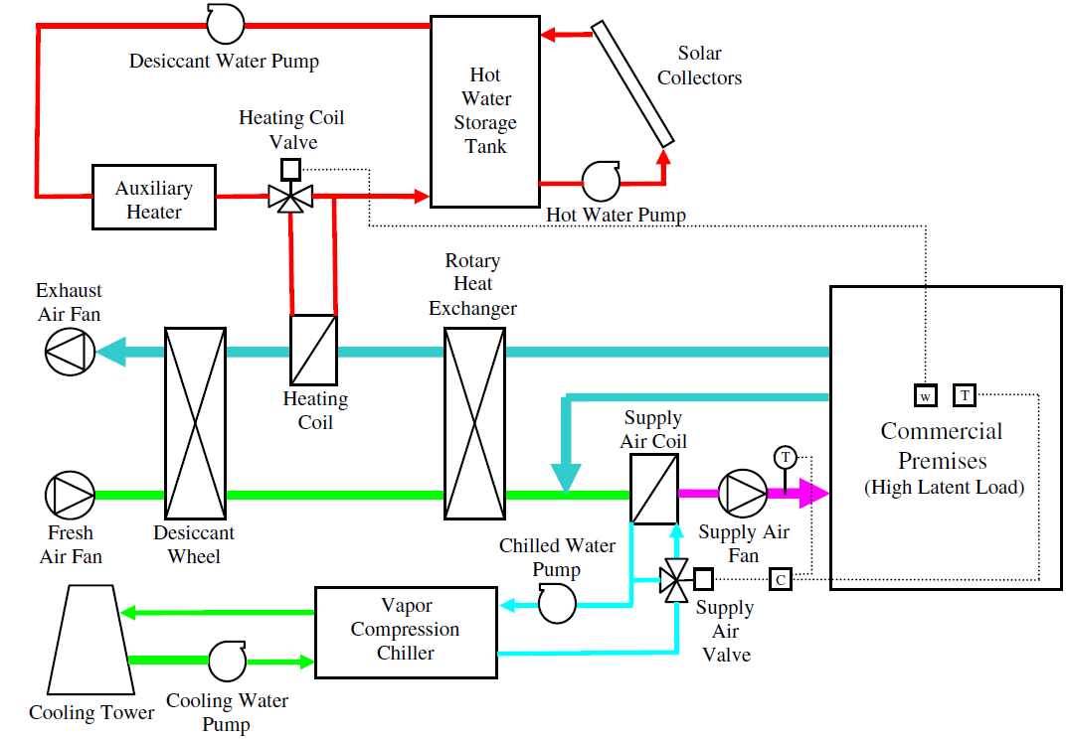
Figure 7. Solar Hybrid Desiccant Cooling system with solar heating for desiccant regeneration, Desiccant Dehumidification and compression based cooling
[13] simulated a hybrid desiccant cooling system comprising the conventional vapour compression air conditioning system coupled with a liquid desiccant dehumidifier which was regenerated by solar energy. The study suggested that, when the latent load constitutes 90% of the total cooling load, the system can generate up to 80% of energy savings. [14] conducted a comparative study of a standalone VAC, the desiccant-associated VAC, and the desiccant and evaporative cooling associated VAC as shown in following figure. The authors found an increase of cold production by 38.8–76% and that of COP by 20–30%. [15] have studied the performance of three possible hybrid system configurations in supermarket applications and have compared their performance with traditional VAC system. As reported, a total air conditioning saving ranging from 56.5% to 66% could be achieved for specified design conditions (ambient conditions: 30 °C, 16 g/kg.da; indoor conditions: 24 °C, 10.4 g/kg.da; room sensible heat ratio: 0.35). [16] have modelled the performance of a desiccant integrated hybrid VAC system. The waste heat rejected from a VAC cycle is utilized to activate a solid desiccant dehumidification cycle directly. The performance sensitivity of a first generation prototype hybrid VAC system to variable outdoor conditions has been studied and compared to the performance of conventional VAC systems. Results showed that the performance improvement over VAC systems could be 60% at the same level of dehumidification under ARI summer conditions. [17] have simulated the transient performance of a hybrid desiccant VAC system for the ambient conditions of Beirut. The annual energy consumption of the hybrid system in comparison with the conventional VAC system has been studied for the entire cooling season. A payback period less than five years was achieved.

[18] has reviewed various thermally activated cooling technologies and has tabulated a summary of the main features of up-to-date thermally activated cooling technologies which is shown in table 1. It is observed that of all the technologies liquid desiccant cooling technologies has lowest regeneration temperatures and has better COP value compared to other technologies.

- Conclusion

Liquid Desiccant dehumidification systems although limited to industrial applications, but could exhibit huge potential energy and economic savings for HVAC industry by

- Reducing the peak electricity demand created by compressor – based AC’s
- Improving the indoor air quality and reduce the indoor humidity levels that could be difficult to be controlled by conventional air conditioners.

Hybrid liquid desiccant cooling technology has demonstrated its superior performance for hot and humid climatic conditions and could save more that 50% operational energy saving compared to conventional vapour compression cooling technology. One of most important advantages of desiccant cooling systems undoubtedly lies in the possibility of using solar energy which can be effectively utilized to regenerate saturated liquid desiccants by using relatively low-cost solar thermal collectors. LDAC’s have low regeneration temperatures (60 - 90°C) and have high COP values (0.5 – 1.2) compared to other thermally activated cooling technologies.

Future research should include development of non corrosive desiccant materials having lesser regeneration temperatures, developing control strategies to prevent mixing of liquid desiccant droplets in the process air stream and design of small and compact systems for application in residential buildings.

References
- Ishwar Chand & Bhargava P.K (1999) “Climatic Data Handbook for Building Design in India”,Tata Mc Graw Hill Pvt. Ltd., New Delhi.
- Kaushik S.C, (1989), “Solar Refrigeration and Space-Conditioning”, Geoenviron Academia Press, Jodhpur, India
- Lowenstein A. (2008)“Review of Liquid Desiccant Technology for HVAC applications”, HVAC& R research, 14(6):819 - 839.
- Daou K., Wang R.Z. and Xia Z.Z., (2006), “Desiccant Cooling Air Conditioning: A Review,” Renewable and Sustainable Energy Reviews, Vol. 10, pp. 55-77
- Lowenstein, A. Slyzak, E. Kozubul, (2006) National Renewable Energy Laboratory, A Zero carry over liquid desiccant Air conditioner for Solar Applications. ASME International Solar Energy Conference (ISEC 2006) Denver, Colarodo.
- Elsarrag, E. (2006). Dehumidification of air by chemical liquid desiccant in a packed column and its heat and mass transfer effectiveness. HVAC&R Research 12(1):3–16.
- Ertas, A., E.E. Anderson, and I. Kiris. 1992. Properties of a new liquid desiccant solution—lithium chloride and calcium chloride mixtures. Solar Energy 49(2):205–212.
- Enteria N., Mizutani K., (2011) “The Role of the Thermally Activated Desiccant Cooling Technologies in the Issue of Energy and Environment”. Renewable and Sustainable Energy Reviews 15, 2095-2122.
- Gommed K., Grossman G., and Ziegler F., (2004) Experimental investigation of a LiClwater open absorption system for cooling and dehumidification. Transactions ASME,Journal of Solar Energy Engineering, 126, 710-715.
- Fumo, N., Goswami, D.Y., (2002). Study of an Aqueous Lithium Chloride Desiccant System: Air Dehumidification and Desiccant Regeneration. Solar Energy Journal 72, 4, 351-361.
- Pesaran, A. A.; Penney, T. R.; Czanderna, A. W. (1992). “Desiccant Cooling: State-of-the-Art Assessment”. 221 pp.; NREL Report No. TP-254-4147.
- Fong, K.F., Lee, C.K., Chow, T.T., Fong, A.M.L., (2011), Investigation on solar hybrid desiccant cooling system for commercial premises with high latent cooling load in subtropical Hong Kong. Applied Thermal Engineering, 31, pp. 3393-3401.
- Yadav YK.,(1995), Vapour-compression and liquid-desiccant hybrid solar space-conditioning system for energy conservation. Renew Energy; 7:719–23.
- Dai YJ, Wang RZ, Zhang HF, Yu JD., (2001), Use of desiccant cooling to improve the performance of vapour compression air conditioning. Appl Thermal Engg; 21:1185–205.
- Burns PR, Mitchell JW, Beckman WA., (1985), Hybrid desiccant cooling systems in supermarket applications. ASHRAE Transactions;91(Part 1B):457–68.
- Worek WM, Moon CJ., (1988), “Desiccant integrated hybrid vapor-compression cooling: performance sensitivity to outdoor conditions”. Heat Recovery Systems and CHP; 8(6):489–501.
- Ghali K., (2008), Energy savings potential of a hybrid desiccant dehumidification air conditioning system in Beirut. Energy Conversion and Management; 49(11):3387–90.
- Deng J., Wang R.Z., Han G.Y., (2011), A review of thermally activated cooling technologies for combined cooling, heating and power systems, Progress in Energy and Combustion Science 37; pp 172 – 203.

