Planning and Energy Conservation Strategies
in Small Settlements

S.K. Negi* and V.Srinivasan**

*CSIR-Central Building Research Institute, Roorkee
**CSIR-Structural Engineering Research Centre, CSIR Campus, Taramani, Chennai.
Corresponding Author, Email: e-mail:sknegicbri@rediffmail.com

Abstract.

The importance of energy efficient buildings has assumed great urgency today. In developing countries like India, rising population, increasing standards of living and rapid urbanization result in an increase in building construction activities. The need of energy is also increasing manifold, particularly with the coming up of MNCs & Real Estate developments. Design & planning of buildings and settlements can play a major role to curtail the energy demand and thus can help in achieving the global objective of sustainable development. In India the majority of the areas come under composite climate and our buildings are often designed without taking enough consideration of climate. The methodology adopted involves finding out the physical requirements for a settlement of 5000 population for which energy requirements are to be analyzed. In a study for Delhi region, the orientation of buildings if kept with longer axis as East –West i.e. major façade facing North & South and shorter facades on East & West, the building performs best for thermal comfort. If it is tilted 15 to 20 degree north then it also gets the advantage of air movements. Further having higher building blocks on south side rows, we get the advantage of the shadow on north side blocks by the movement of sun from east to west.

Keywords: energy conservation, orientation, simulation, shadow pattern, planning patterns, density of population

1. Introduction

Rapid urbanization, rising population, and increasing standards of living results in an increase in building construction activities. Globally, buildings are responsible for approximately 40 percent of the total world annual energy consumption. Most of this energy is used for the provision of lighting, heating, cooling and air conditioning. The demand for electrical energy by residential building in India is growing at a disproportionate and increasing rate. However, the design and construction of modern residential buildings, which are heavily reliant on electrical appliances for control of the internal built environment, are causing greater concern. As a result, local attention is focused on improving energy efficiency for residential buildings. Apart from general lack of norms and regulations, one reason that buildings are poorly adapted to the climate is lack of knowledge among building designers, whether an architect or engineer or town planner. In the field of passive solar architecture related to individual buildings many research works have been done. Some studies have been carried out on tree shade effects on residential energy use at California using different type of trees (e.g. shape, size) and location around buildings. Tree shade reduces summer air conditioning demand and increases winter heating load by intercepting solar energy that would otherwise heat the shade area. Similarly studies are available on shading of windows, their designs etc. In all studies the effects have been limited to single building only. Few buildings with passive features and other concepts of non-conventional sources of energy have been constructed at Delhi, Gurgaon & Hyderabad etc. to save the energy loads. In this background a project was under taken to achieve energy conservation through design and planning of small settlements. In this paper the impact of energy conservation has been discussed at a settlement level with different planning patterns through design of buildings, their orientation and distances among the buildings of different heights for shading effect.

2. Energy conservation in small settlement

2.1 Methodology

The methodology adopted involves finding out of energy requirements for different orientation of buildings and these are adopted in the layout planning for the physical requirements of a small settlement. The requirement includes the various types of residences, education facilities, recreation facilities and shopping facilities. Then area of the site has been estimated considering an assumed density of population. In this case a density of 125 persons has been taken for a population of 5000 persons only. This gives a housing density of 50 dwelling units / acre assuming 5 persons per family and total requirement of land comes out to be 40 acres or approximately 16 hectares only.

Requirements

1. No of houses @ 5 persons / family - 1000
2. Economically weaker sections^{i}/ Low income group^{ii} houses - 600
3. Middle income group^{iii} houses - 230
4. Higher income group^{iv} houses - 170
5. Primary school - 1
6. Nursery school - 2
7. Convenient shops - 20

The total requirement of houses comes out to be 1000 dwellings. The number of low category houses has been taken as 60 per cent of the total houses as majority of the population in India belongs to this section of population and government policy also advocates that in any urban housing scheme major share of houses should be assigned to low income group people. The other building requirements are also kept as per prevailing planning norms in India. Accordingly a plot of 400m x 400m has been theoretically selected for the study point of view. To calculate the energy requirements of a settlement the number of residences, their design, specifications, orientation and design of other buildings like shopping, schools etc. are all important.

2.2 Architectural design & specifications

To calculate the energy load of a building their architectural design and specifications are important consideration so the designs for various categories of houses, a primary school, a nursery school and a shopping center have been developed. The areas for LIG, MIG and HIG houses have been taken as 36.00 sq.m., 72.0 sq.m. and 108.0 sq.m. respectively. The areas for primary and nursery schools are 421.65 sq.m. and 90.74 sq.m. respectively. Shopping complex with 20 Nos. of shops has been designed with area of one shop as 12.00sq.m. The specifications for energy calculation point of view have been taken as follows.

- Brick work in cement mortar for 23cm thick brick walls and 11.5cm thick brick with 10mm thick cement plaster on both sides.
- 10 cm RCC roof with 10cm thick mud fuska including insulating layer of tar felt, & 5cm brick tiling.
- 4 cm thick cement concrete flooring on 7.5 cm lean concrete in two room set.
- 5 cm thick cement concrete flooring including 1.5 cm thick moisac finish and 7.5 cm thick lean concrete.
- Windows with plane glass of 3 mm thickness with wooden frame.

2.3 Energy aspects

The above designed buildings have been assessed for energy flow for 22nd June temperatures putting these buildings in eight cardinal directions and having two and four Storey developments by using TRNSYS software. The energy simulation curves have been prepared for Delhi Region. During temperature simulation process shading factor on the building surface is also required. For this purpose, software/program has been developed using FORTRAN programming language to calculate the shadows. It calculates the height of shadows on the opposite buildings placed at a given distance at different orientations of the building for different altitudes and azimuth of the sun at different hours of the day.

2.4 Settlement plans

Three plans have been developed, two with normal / traditional type of clusters & road patterns having 4 storeyed walkup apartments for LIG group and 2-4 storey apartments for MIG & HIG group. Here the buildings have been placed in all the directions as depicted in figure 1 & 2. The other layout has been developed considering orientation of all the buildings in E-W direction as longer side (facing north & south) because it consumes minimum energy. The depicted from the cooling load in table 1.

The cooling load histogram for LIG houses is shown in fig. 3. In this layout the height of blocks on the northern side rows have been reduced while of the blocks on the southern side has been increased to get the maximum advantage of the sun movement. It is reflected in the different design of residential clusters. Then these clusters have been grouped in a plot area of 400 m x 400m i.e. 16.00 hectare plot giving a density of 315 person / hectare or 126 persons / acre approximately. The development has been envisaged from 2 to 12 storeyed. The plantation of trees has been proposed on western side of clusters with a continuous belt of trees all round the boundary line of the site.

The energy conservation in a settlement is a function of many things because a settlement comprises of houses, community buildings and services. As the study was specifically to conserve energy through planning patterns and land uses, it is important to understand the concept of planning pattern and land uses taken in the study.

Table 1. Cooling Loads (kw) for Houses in Different Directions

Direction | LIG |  | MIG |  | HIG
Direction | two Storey | four Storey | two Storey | four Storey | two Storey | four Storey
N | 3.32 | 4.846 | 5.751 | 7.759 | 8.301 | 11.054
NE | 3.795 | 5.826 | 6.282 | 8.845 | 8.919 | 12.305
E | 3.686 | 5.618 | 6.088 | 8.434 | 8.598 | 11.652
SE | 3.73 | 5.7 | 6.238 | 8.753 | 8.874 | 12.217
S | 3.258 | 4.757 | 5.719 | 7.694 | 8.263 | 10.978
SW | 3.811 | 5.858 | 6.302 | 8.884 | 8.933 | 12.342
W | 3.687 | 5.62 | 6.089 | 8.437 | 8.6 | 11.656
NW | 3.772 | 5.785 | 6.209 | 8.855 | 8.916 | 12.32

Figure 1. Settlement layout plan for a neighborhood of 5,000 population, Alternative – I

Figure 2. Settlement layout plan for a neighborhood of 5,000 population, Alternative – II

Figure 3. Histogram for cooling load (kw) for LIG houses

2.5 Concept of planning patterns

Planning pattern at city level may be taken as an out come of major road patterns i.e. linear, grid, radial or a combination of these. At a small settlement level-planning pattern in general is the disposition of various buildings, in a locality in different fashion. It is shown in figure 4. This is the type of development in terms of height, number of storeyes and orientation of building blocks. The height or number of storeyes plays an important role in conserving energy because in a multi-storeyed building more number of floors are in shade. The top floor can be provided with proper insulation. Placing the buildings with respect to each other in a space in terms of distances and directions is also very important because of various patterns of shadows displayed on the opposite or side buildings. Orientation also plays a role as north & south surfaces get negligible quantity of sunrays.

The land use is a direct result of type of development or planning pattern. As we go higher we consume less space on ground and we reduces the land area for a particular land use like residential and get more open area as a more green/open land use for recreational activities i.e. parks, playgrounds, landscaping etc. for a better environment.

The distances and direction becomes significance because in a particular direction the building consumes less energy as compared to other direction. Further the distance & direction changes the shadow pattern of the blocks and the advantage of the shadows of higher buildings can be taken on the other buildings if higher blocks are placed in a fashion giving maximum shadow on the other blocks.

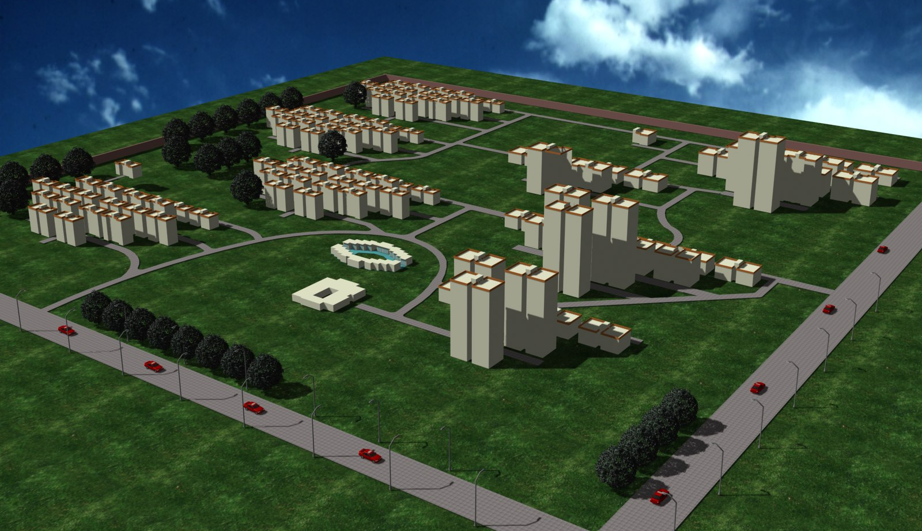

Figure 4. Site View of Small settlement planning Pattern

2.6 Discussions and findings

The results of the studies through temperature simulation curves drawn using TRNSYS for 22nd June indicate that orientation having longer sides on E-W direction is the best for energy considerations. So the orientation of the blocks of a building should be with E-W as longer side and facing north or south. The results for cooling load calculations for a LIG cluster planned in a traditional fashion of four storeyed development having 64 houses required a load of 40.78 KW while a cluster of similar houses planned in the proposed fashion requires a cooling load of 30.05 KW only i.e. a saving of 25% of cooling load. In these calculations the impact of shading has not been considered, if it is also taken in to account a saving of 35-40% of cooling load can be achieved easily. Shadow pattern studies show that maximum shadow on the buildings can be obtained on east & west surfaces placed against each other. This indicates that the surfaces of the building facing east and west should be put closer to each other to get the maximum advantage of the shadow. On north and south faces of the buildings there is hardly any shadow of opposite buildings. The shadows on south east & south west direction of blocks are generally thrown from the side blocks placed at an angular position on south side. Further the higher blocks of buildings / residences can be put on southern side of the other buildings so that advantage of the shadow of these blocks from movement of sun from east to west can be taken on the southern side by the blocks situated at angular position i.e. blocks which are on the E / W sides of the immediate north side blocks.

3. Conclusions

The importance of energy is well known. The scarcity of it is felt particularly due to the increasing population and more per capita consumption. Fast depleting energy resources are other matter of concern. By proper planning and design of settlements energy of the order of 40 percent or more can be saved easily using proper specifications and orienting the building blocks in suitable direction. Study for Delhi region shows that if residential blocks are placed in east –west direction with 15 to 20 degree tilt on north side, the advantage of sun and air movement taken together and providing some insulation in roof finish can save the energy bill upto 35- 40 percent. This saving can further be increased if southern side blocks in the layout are taken of more height than northern side blocks which may provide shadow on northern side low height blocks with movement of sun from east to west. Thus we can contribute in achieving the broad objective of global sustainability by way of planning and design of buildings and settlements.

4. Acknowledgements

The substance presented in this paper has been taken from in-house R&D project on ‘Energy conservation through planning pattern and land uses.

References

- Agarwal, S.S. Singh, R.D. and Chand Ishwar, Design and Study for Energy Efficient Building, Proceedings of the conference on Indian Habitat and Infrastructure – Need for Innovative Approach 25-26 Sept (2003), CBRI, Roorkee, pages 19-25.
- Hans Rosenlund, Climate Design of Buildings using Passive Techniques, Building issues, volume 10 (2000)
- Papadakis, G. Tsamis, P. & Kyritsis, S., An experimental investigation of the effect of shading with plants for solar control of buildings, Int. journal of Energy & Buildings, volume 33 (2001), pages 831-36.
- Radu Zmeureanu, Paul Fazio, Sebastiano Depani & Robert Calla, Development of an energy rating system for existing houses, Int. journal of Energy & Buildings, volume 29 (1999), pages 107-119.
- Ripudaman Singh, V.Srinivasan, Energy Efficient Design & Planning of Small Settlements as A Sustainable Building Approach, Proceedings of the International Conference on Sustainable Building (SB08), 21-25 Sept, Melbourne (2008).
- Simpson, J.R. and Mcpherson, E.G., Simulation of tree shades impacts on residential energy use for space conditioning in sacraments, Atmospheric Environment, volume 32(1998), pages 69-74.
- Simpson, James R., Improved estimates of tree-shade effects on residential energy use, Int. journal of Energy & Buildings, volume 34(2002), pages 1067-76.
- Teri, Energy efficient buildings in India (Mili Majumdar ed.), Tata energy research Institute (2001), New Delhi.
- Vildan, Ok., A procedure for calculating cooling load due to solar radiation: the shading effects from adjacent or nearby buildings, Int. journal of Energy and Buildings, volume 19 (1992), pages 11- 20.
- Yakakura, T., Kitade, S. & Goto, E., Cooling effect of greenery cover over a building, Int. journal of Energy Buildings, volume 31(2000), pages 1-6.

