Heritage Buildings
An Inspiration for Energy Efficient Modern Buildings

Neeta Mittal

CSIR- Central Building Research Institute, Roorkee
Corresponding Author, Email: neeta.mittal20@gmail.com

Abstract

India is known for rich Architectural and cultural heritage. Thermal performance and air quality inside the buildings can be improved substantially and energy can be saved through understanding the ancient design concept. Mugal architecture of India is known worldwide for the wonderful monuments.. Landscaping was an integral part of Indian palaces and monuments. Trees, green areas and water body around a building improve the physical comfort along with the visual pleasure. In monumental buildings passive techniques used for the comfort in different climatic region. Jali is the ornamental feature provided in most of the palaces in Rajasthan, Taj Mahal and Agra fort which increase the ventilation and comfort. Study of historical city of Jaipur shows that in desert areas where water is in short supply step wells are built which improve the microclimate of the place. Courtyard was also an important design element in old residential buildings in hot dry climate called Havelis. It was an element of passive cooling for regular fresh air supply. One of the modern buildings designed in Jaipur on this concept using these factors is also discussed. The paper highlights the ancient passive techniques to improve the thermal comfort and ventilation through examples of heritage buildings which may prove an inspiration for energy efficient modern buildings design.

Key words: Passive, Landscaping, Jali, Water, Step well, ventilation, thermal, microclimate.

- Introduction

Indian vernacular architecture reflects the environmental realities. The architectural quality makes a building a heritage building. Hindus & Mughals built magnificent monuments. Traditional architecture is the outcome of centuries of optimization of climate consideration, of material use, construction techniques. Landscaping elements water body and trees provided in monumental buildings, temples improves the microclimate of the place and increase the comfort level in the buildings.

Environmental degradation, technology advancement and development of urban centers have highly influenced energy consumption in buildings. Energy is the important component for economic development of the country. The modern equipment and materials used in construction and to maintain indoor thermal environment consumes significant amount of our national energy. In view of the shortage of energy it is very much essential to review the historical origin of Architecture &Technology to restore the comfort inside the building. Climate responsive architecture is the need of the day. Today most building structures are designed to separate man from the outside environment and require application of significant energy quantities to create an acceptable indoor environment. Energy consumption can be reduced in heating & cooling from 50-80% if the buildings are designed and planned considering the microclimate, topography of the place, and other external features. Modern buildings are being built with little consideration of the climate. An overview of vernacular architecture will help to understand the climatic or technological limitations of the past . Control Of the microclimate around the building was always important in indigenous design. This happened not only for the palaces but for simple dwellings as well.

- Passive techniques of heritage buildings design

Ancient buildings demonstrate the passive architecture of India. Without mechanical means these buildings are better than the newly designed buildings. Natural ventilation and advantages of solar direction was taken in those buildings. Materials are chosen for construction according to the climatic characteristics of the place. The Palaces in Rajasthan also demonstrates the natural ventilation techniques. Water body in temple premises, keeps the environment cool and improve the microclimatic conditions. Havelis of Rajasthan & Gujrat are good examples of passive architecture. The Mughals constructed excellent mausoleums, mosques, forts, gardens and cities. Taj mahal, Agra fort and, Fatehpur Sikri are few monumental buildings near Agra. Mugals laid out many beautiful gardens with water bodies in the centers in the neighborhood of Agra & Lucknow. These buildings are designed in such a way that all people are comfortable inside a building during the hot summer.

Indian architecture was greatly influenced by Persian styles. The Mughals constructed excellent mausoleums, mosques, forts, gardens and cities. Mughals built magnificent monuments. They also laid out many beautiful gardens with water bodies in the centers in the neighborhood of Agra and Lahore. Some gardens like Shalimar and Nishat gardens in Kashmir have survived to this day.

2.1 Landscaping

Mugal gardens are famous for planned landscaping. The general theme of a traditional Islamic garden is water and shade. Unlike English gardens, which are often designed for walking, Islamic gardens are intended for rest and contemplation. For this reason, these gardens usually include places for sitting with trees. Water greatly influence the microclimate of the place and improve the environment.

2.1.1 Water

Water is an architectural element which is extensively used in our ancient buildings and in garden of the Mugals. Water not only delighted the eye on a hot summer day but also provide the passive cooling. Water improves the physical comfort by the evaporative cooling of the surrounding air. Rate of heat loss from the moving air depends upon the area of water in contact with the air and careful zoning of the sheltered spaces so that strips of the water could be strategically placed around the structure [1].The beauty of Taj Mahal and Chota Immambada, Lucknow is enhanced by provision of water in front and built environment is comfortable in hot summer (Figure 1,2. ) [2].

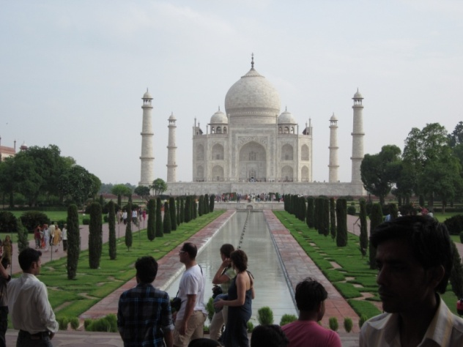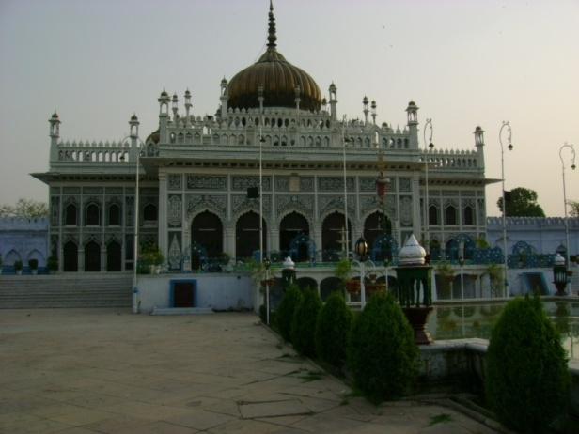

Figure1. Water body in front of Taj Mahal, Figure2. Chota Immambada ,Lucknow

In 1579, Guru Ramdas, the fourth Guru of the Sikhs founded the city of Amritsar in the Punjab. He first constructed a pool and named it Amrit Sar or 'Pool of Nectar' on a stretch of land gifted to him by Akbar. The golden temple is built in the water which reduce the outdoor air temperature through evaporation ( Figure 3.4. ) [2].

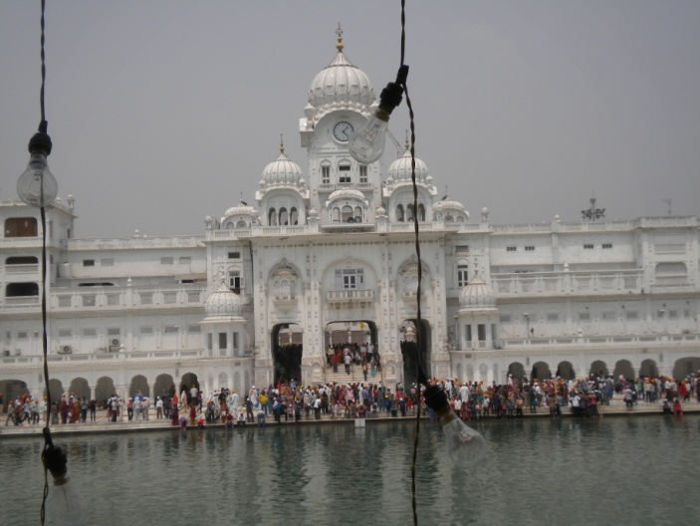

Figure 3. Golden temple Figure4. Golden temple gate, Amritsar

2.2 Baoli

This method was employed over 1,500 years ago by local Rajasthanis, who built "baoli" or stepwells -- bodies of water surrounded by a descending set of steps, helping to create a microclimate in the surrounding structure. Chand Baoli is a famous step-well situated in the village of Abhaneri near Jaipur. It was built in the 9th century and has 3500 narrow steps in 13 stories and is 100 feet deep (Figure 5)[3].
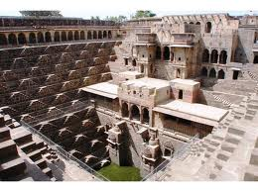
Figure 5. Chand Baoli -Step well in Jaipur

Among the various attractions at the Bada Imambada, the five storied baoli (step well), belonging to the pre-Nawabi era is the most captivating structure. Generally called as the Shahi-Hammam (royal bath), this well is connected with Gomti river. Only the first two-stories of the baoli are above water and the rest being perennially below water. Step wells reduces the temperature of surrounding areas.

2.3 Ventilation techniques in heritage buildings

2.3.1 Jali

In monumental buildings Jali is the ornamental feature provided in most of the palaces In Rajasthan, In Taj Mahal , Agra fort etc ( Figure 6.7) [2]. Fresh air enters in the building through jali with speed as well as stone jali protects the enclosure from direct solar radiation. Jali cast the decorative shadow in buildings which is also helpful in reducing the inside temperature.
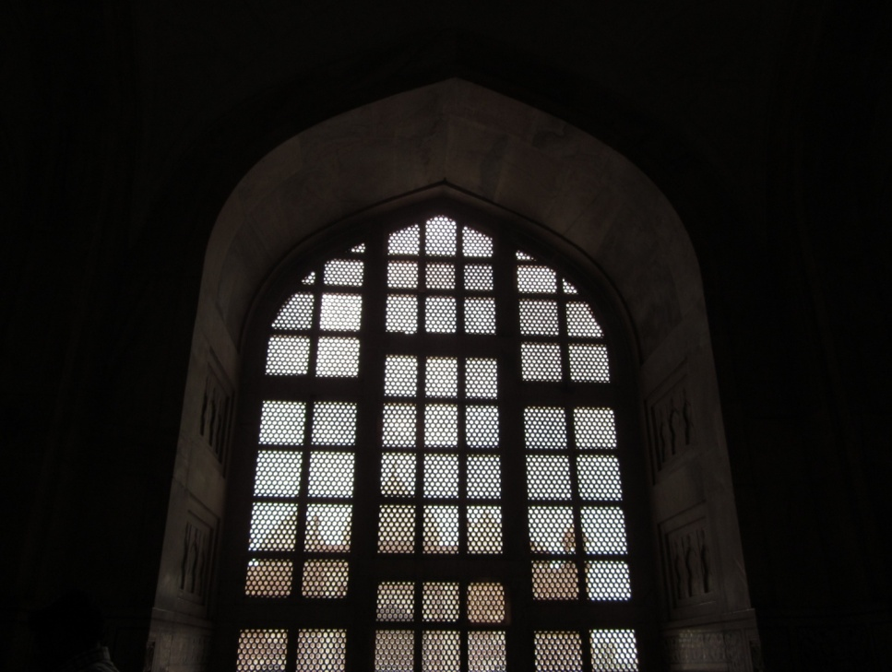
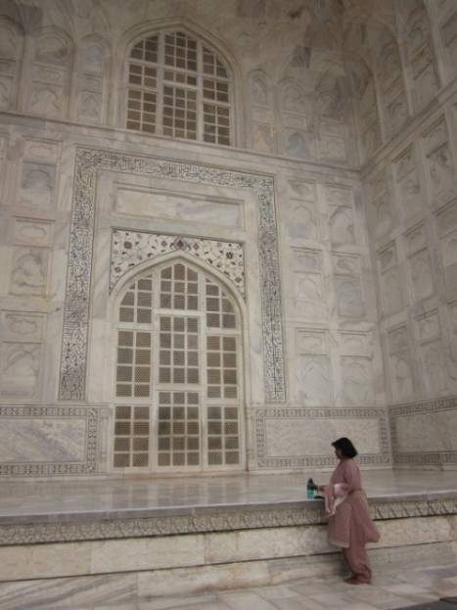

Figure 6. Inside view of Taj Mahal Jali Figure 7. Outside view of Jali-TajMahal

    - Ventilator

Natural ventilation is very important for comfort. Ventilation system provided in Bada Imambada Lucknow is the example to improve the natural air circulation ( Figure 8)[2] .

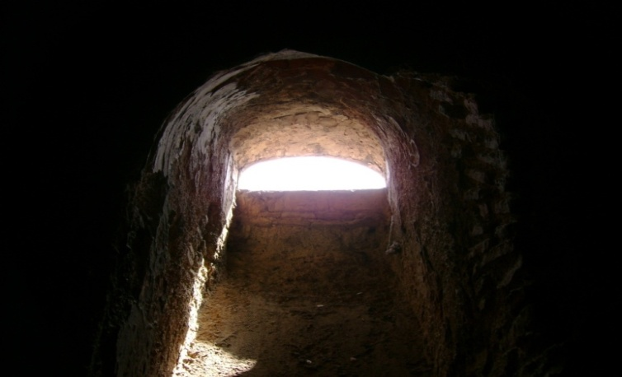

Figure 8. Bada Immambada , Lucknow

2.4 Courtyard

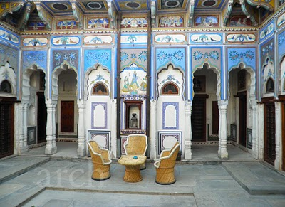
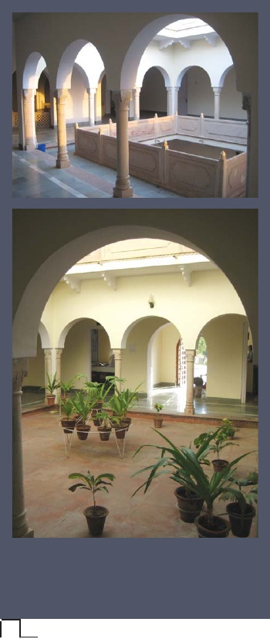
Courtyard was also an important design element in old residential buildings in hot dry climate including palaces. It was an element of passive cooling for regular fresh air supply and for day lighting. These interior courts - a common feature of Rajasthani architecture -optimize circulation of air during the 50°C summers ( Figure 9.10) [4].The rooms around courtyard are comfortable for use.

Figure 9. Haveli of Shekhawati Rajasthan Figure 10. Haveli- Rajasthan

Modern building -pearl academy of fashion Jaipur

Very few buildings in India are designed following the concepts of the ancient architecture. One of the building recognized globally for the passive design is Pearl Academy Jaipur built in the arid suburbs of Jaipur, Rajasthan by Architect Manmit Rastogi[5]. The Pearl Academy of Fashion combines modern exterior styling with ancient Rajasthani architecture -designed to keep temperatures down without artificial cooling systems.The passive features used are

- Double skin, derived from traditional "jaali" structure ( Figure 11)
Concrete screen runs the length of the building to provide a cooling outer skin.
- Traditional step wells often go many stories below ground level, here it is just four
meters down (Figure 12 )[5].
- Reversed earthen pot kept on the roof which act as insulator

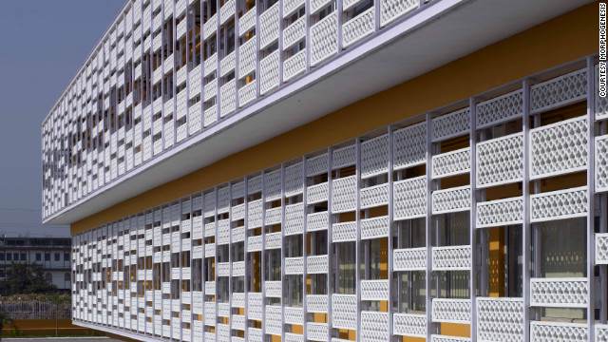
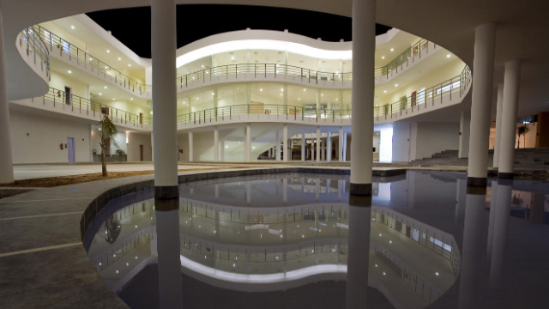
At the height of summer, in the sweltering industrial suburbs of Jaipur, Rajasthan in north-west India, the Pearl Academy of Fashion remains 20 degrees cooler inside than out -- by drawing on Rajasthan's ancient architecture.

Figure 11. Double skin Exterior- Concreta Jali Figure 12. Water Body in the centre

The central water body act as step-well and keeps the surrounding area cool.This modern building is inspired by the traditional passive techniques.

Conclusion

Energy is precious and to save this energy is a matter of prime concern. It is the time to learn and adopt the passive design techniques to maintain the comfortable environment inside without much use of active systems of cooling or heating. Ancient monumental buildings, palaces are still a place to relax without fan, coolers and air conditioners. There is a need to study the traditional buildings because they are time tested. it is important to investigate the effectiveness of the passive environment control system of Indian traditional architecture and identify its potential for contemporary application. Let us go back and review the science behind the architectural design of heritage buildings. Today green Building designalso provide the opportunity to adopt our age old passive techniques. Awareness should be created to design the modern buildings on the traditional building design concept.

5. References

Mittal Neeta,Energy Conservation Ancient Techniques for Effective Planning of Buildings, Seminar on Conservation of Energy in Buildings and Architecture, 15-16 Feb. 2002 Calcutta organized by Institute of Energy Environment and Waste Management
- Mittal Neeta-courtesy,Figure./ Photos ( 1, 2, 3, 4, 6, 7, 8 )
- en.wikipedia.org/wiki/Chand_Baori
- rangdecor.blogspot.com/.../havelis-.
Smiriti Saraswat,Understanding court yard design through Havelis of Rajasthan, 2011
- Ancient 'air-conditioning' cools building sustainably,From Nick Glass and George
Webster, CNN,March 8, 2012 -- Updated 1725 GMT (0125 HKT)

