Energy Efficiency through ICT Adoption for Sustainable Habitat

Amit Kush*, Amod Krishna** and P.K.Bhargava*

*CSIR-Central Building Research Institute, Roorkee
**Roorkee Institute of Technology, Roorkee
Corresponding Author, Email: amitkush@cbri.res.in

Abstract

India is the second most populated country in the world, accommodating over 120 crore people in diverse climatic zones. Owing to the rapid growth in infrastructure, especially in the commercial sector and the substantial rural to urban shift of the population, India’s building sector is expected to grow at a brisk pace. Commercial and residential sectors of buildings consume substantial quantum of energy throughout the lifecycle of buildings, contributing to around 6% of India’s total Green House Gases (GHG) emissions. Various initiatives have been introduced in the recent past, both at economy level and specifically for habitat sector that aim to increase energy efficiency and sustainability. The study focuses on exploring potential GHG reduction opportunities and energy efficiency opportunities enabled through Information and Communication Technology (ICT) solutions. On an average, it is estimated that the implementation of energy efficient options through ICT solutions would help in achieving around 30% electricity savings in new residential buildings and around 40% electricity savings in new commercial buildings. ICT based solutions for sustainable habitat in the areas of planning, energy efficiency, water and waste management, environmental pollution, building materials and technologies, roads and transportation, and impact of habitation on climate change can play a critical role in this transition towards higher energy efficiency, and low carbon emission habitats have been reported in this paper.

Keywords: GHG, ICT, environmental pollution, energy efficiency, carbon emission

1. Introduction

Several ICT based technologies have an important role to play in enhancing the efficient use of energy in buildings, with the green building technologies. Building management systems (BMS) to automatically manage and reduce energy consumption and control heating, ventilation and air conditioning systems, lighting systems play a crucial role. With climate change posing a global challenge, adopting ICT solutions in various industries would be a win-win way to cut India’s carbon foot print.

The study attempts to quantify the energy savings potential through the use of currently available ICT solutions and their contribution in reducing the green house gases (GHG) emissions in various sectors. ICT options for achieving increased energy efficiency are economically viable and available in the market. Report [1] says that total cost of ICT implementation in identified sectors – considering moderate penetration of ICT solutions in 2020 and 2030 – is estimated at INR 49,700 crore and INR 156,100 crore, respectively. These investments correspond to cost savings of around INR 7,300 crore per annum and INR29,200 crore per annum respectively. Identified ICT solutions can potentially lead to GHG emission savings of up to 450 million tonnes CO2 p.a. in 2030 – approximately 10% of estimated GHG emissions in 2030 for the sectors covered in the study, as well as energy cost savings of around INR 137,000 crore p.a. in 2030, which is approximately 2.5% of India’s current GDP. Road Transport and Power Sector have the maximum saving potential of 42%, 30% and 16% respectively.

Globally, transport is the second largest CO₂ emitting sector after electricity and heat production, while the building sector accounts for more than 40% of energy use. ICT driven applications across transportation have the potential to achieve a reduction in total global emissions by software systems to optimise transportation systems to reap big energy savings. Although efficient technologies are being developed worldwide and deployed in the sector on a continuous basis, the total energy consumption has still been rising.

2. Energy consumption and green house gas emission for sustainable habitat

Sustainable habitats aim to make cities sustainable through improvements in energy efficiency in buildings, shift to public transport for commuting and management of solid waste with focussed target of reduction in carbon emissions. Energy consumption and ICT enabled solutions in the areas of planning of habitats facilitate energy efficiency, water and waste management, better control on environmental pollution, and better use of resources for building materials and technologies, roads and transportation.

2.1 Buildings sector

Worldwide, the building sector accounts for more than 40% of energy use; although progressively efficient technologies are being developed and deployed.
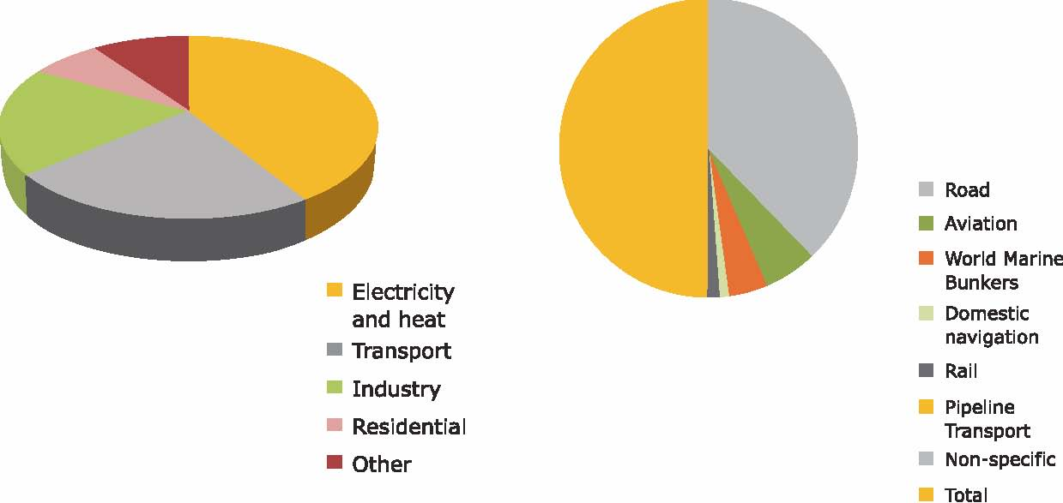

Figure 1. World CO₂ emissions by sector
Figure 2. Consumption of petroleum products in 2006 by the transport sector

According to a recent study [2], the worldwide energy consumption for buildings will grow by 45% from 2002 to 2025 – where buildings account for about 40% of energy demand out of which 33% is from commercial buildings. In many countries, specially developed countries, buildings are the largest contributors of CO₂ emissions.

2.2 Transport sector

The urban population of India, which constitutes 28% of the total population, is predominantly dependent on road transport. In India, around 80% of passenger and 60% of freight movement depends on road transport. The transport sector accounts for nearly one-quarter of global energy-related CO2 emissions and it can be inferred that road transport is responsible for the highest share of emissions globally (around two-thirds).

The transport sector is a major contributor to air pollution as well as CO2 emissions in densely populated urban India. Passenger mobility in urban India relies heavily on its roads, as rail-based and air-based transport services are available in only selected cities. Various energy sources used in this sector are coal, diesel, petroleum (gasoline) and electricity. Transportation through road, rail and air are responsible for CO2 emissions of around 80%, 13% and 6%, respectively [3].

2.3 Municipal solid waste

Municipal solid waste management continues to be one of the most unprofitable and neglected areas of urban development in India. However, considering the health, and environmental (including GHG emissions) implications of the sector on the population, it is imperative for the country to focus on the wide range of operations of solid waste management to ensure efficiency of collection and disposal. With regard to direct ICT implications on the sector, it is worthwhile to mention that more than 332,000 tonnes of e-waste was generated in India in 2007 and is likely to increase to 800,000 tonnes by 2012. The ICT equipment segment is fast growing with regard to its contribution to e-waste. In India, e-waste is mostly generated in large cities like Delhi, Mumbai and Bangalore. However, there is no large-scale organized e-waste recycling facility in India, which can accommodate this quantum of e-waste. Among the top 10 cities generating e-waste, Mumbai ranks first followed by Delhi, Bangalore, Chennai, Kolkata, Ahmedabad, Hyderabad, Pune, Surat and Nagpur. Mumbai generates 23,000 tonnes of e-waste every year while Bangalore’s innumerable IT (information technology) and related companies produce 11,000 tonnes of e-waste every year. ICT may prove to be cost effective proposition for waste disposal and adequate governance by using RF ID Tags connected with recycling, billing and incentive schemes.

3. ICT Solutions in buildings

ICT applications can contribute to the reduction of the carbon footprint for buildings, both during construction and during operation stages. The construction process is a highly energy and GHG intensive process owing to the high degree of embodied energy of materials used in construction (e.g. steel and concrete). Further, ICT solutions can also deliver energy savings by way of simulation, modeling, analysis, monitoring and visualization at design stage and building management at operation stage.

Incorporation of ICT solutions in new buildings to achieve energy efficiency are easier but in existing buildings to incorporate identified ICT solutions are difficult and expensive.

3.1 Design phase

Software tools can be deployed for purposes such as temperature modeling and fluid dynamic modeling, and can be used to plan buildings that are able to extract the maximum benefit from their surroundings. They help builders to determine the most optimal and efficient design of a building, bearing in mind the various factors that contribute to efficiency in terms of health and comfort, building costs, energy performance, etc. The analysis and simulation software and design tools such as Trnsys, EnergyPlus and eQUEST/DOE-2 etc. can help designers in selecting building materials, construction methods, building orientation and equipment types to optimize energy consumption. They also aid designers and builders in system sizing and cost optimization.

3.2 Operation phase: building management systems (BMS)

During the operation phase of buildings, ICT solutions like BMS can be used to automatically control and adjust heating, cooling, lighting and energy use, and regulate the buildings’ behaviour and performance to changes in the external environment and needs of the users. These systems constitute the most promising technology for enabling energy savings by optimizing operation and output of equipment and reducing excess energy consumption. BMS typically is a computer system that can control connected loads of a building according to the pre-set requirements of the building as well as by way of acting on information received from its sensors. Its inputs, such as temperature sensors and outputs, such as on/ off signals are connected to control centres around the building. A modem may also be connected to the system to allow for remote access. BMS can also help in monitoring in real-time, as well as recording and preserving past records of data, which can help in diagnosis of failure. A BMS typically is guided by the information through the sensors to get the status of temperature, heat, light level, movement of occupants, smoke and gas, air quality, open window and glass break etc.

3.3 Remote management systems

Remote management systems remotely control digital devices, such as computers, security systems and appliances like ACs, heat pumps, and lighting. Remote management systems when integrated with the smart grids will allow consumers and utility companies to more closely monitor power grid activity and appliance power usage. For example, it can allow users to set appliances to run at a certain time of day (off-peak). With the implementation of remote management systems, around 10% of energy consumption can be reduced. By using Smart Occupancy Controls, Intelligent Building Controls and Intelligent Street Lighting Management, Illumination Level Detection, and Time Scheduling, it is possible to set the utility features and services adroitly. By adopting such techniques, we can accomplish significant impact on energy utilization without sacrificing services and may substantially reduce GHG emissions from buildings.

3.4 ICT solutions in transport

Road, rail and air are responsible for 80%, 13% and 6%, respectively, of total transport GHG emissions. Although, as a long-term strategy, reducing GHG emissions will eventually require decarbonizing the transport sector, however, for the short-term, relatively economical reductions can be achieved through the implementation of ICT solutions. One of the solutions for GHG emission reduction from the transport sector is to augment public transport so that road space can be used more efficiently to carry passengers at greater speed. ICT can play a vital role in promoting the cause of public transportation by enhancing road movement efficiency. ICT solutions can provide relatively economical answer for the sustainable development of this sector.

Mobility management systems encompassing a broad range of wireless and wired ICT solutions have the potential to significantly enhance the effectiveness and efficiency of surface transportation systems through advanced applications in information systems, communication channels and sensors. Designed to provide continuous stream of information, utilities like intelligent traffic management systems (ITMS) can stabilize traffic flow by providing real-time data on incident locations, travel times, congested corridors and transit vehicle information at multi-modal centres. ITMS encompasses a wide range of ICT enabled tools to enable authorities, operators and individual travelers to make better informed and more coordinated decisions. These systems vary in technologies applied, from basic management systems, such as car navigation, traffic signal control systems, variable message signs, automatic number plate recognition or speed cameras to monitoring applications, such as security CCTV systems. More advanced applications may integrate live data and feedback from a number of other sources, such as parking guidance and information systems including weather information systems. Although reducing congestion and increasing the carrying capacity by mobility management initiatives may induce additional traffic, in many circumstances, overall traffic emissions are likely to reduce due to optimization of operating speeds.

Features that are part of a basic intelligent public transport system include vehicle tracking systems, real time passenger information system (GSM/GPRS, GPS), central control station (cluster of servers), communication sub systems (GPRS, display units, GPS vehicle mounted unit), travel demand management, and incident and emergency management system. The key ICT solutions are GSM/GPRS, geographical positioning system, DGPS, dead reckoning, track circuits, odometers and different combinations of these technologies, electronic display systems and vehicle mounted units, among others.

3.5 Data centres

The continued development and adoption of more efficient ICT, which includes PCs and peripherals, data center servers and cooling technologies, telecommunications devices and infrastructure, is expected to improve energy efficiency of products produced within the ICT sector. Globally, these improvements are projected to reduce the in-use energy consumption of ICT products by 895 billion kWh in 2015. "Continuing developments and adoption of energy saving technologies, specific to computers and peripherals amounts to well over 30% in energy reduction by 2015, compared to 2010 consumption," said Carr[4]. "This includes the increasing sales of these products globally."

To effectively manage the operation-phase energy consumption of data centres, one needs to focus on both the IT and Infrastructure energy consumption of data centres, given the fact that less than half of the total electricity consumed by a facility actually goes towards powering IT equipment, such as servers and networking devices, the rest being consumed by environmental control systems and power delivery components. These environmental control systems include cooling system components, such as chillers, computer room air conditioning (CRAC) units, direct expansion (DX) air handler units, pumps, cooling towers, lighting, fire protection system, etc. Power delivery systems include UPS’, switch gears, generators, power distribution units (PDUs), batteries and distribution losses external to the IT equipment.

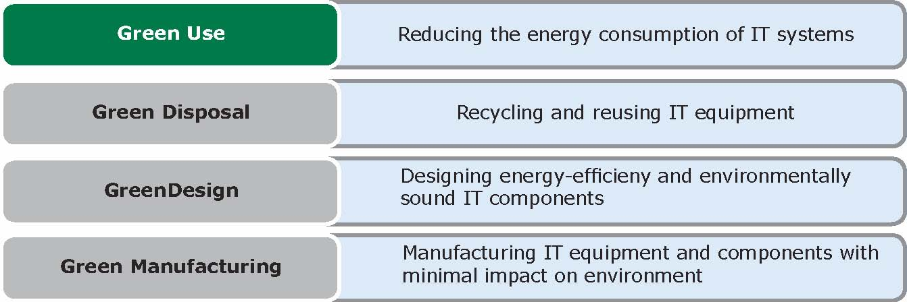

Fig. A green IT strategy typically entails progress and improvement in the following aspects:
The EPA estimates that servers and storage hardware account for almost 50% of total power usage of data centres and measures aimed at increasing their energy efficiency can result in considerable savings in space, power and cooling requirements.

4. Barriers to improved energy efficiency through ICT adoption

- Lack of awareness
- Lack of skilled man power
- High Cost of ICT Solutions
- Unavailability of benchmarks
- Lack of incentives for builders to consider ICT for energy efficiency
- Demand side constraints of urban transport sector
- Demand side constraints of municipal waste management
- Lack of standardization
- Limited alternatives on the supply sides

5. Conclusion

Energy efficient, eco friendly buildings for people and the earth promising low carbon footprint may be accomplished by adopting ICT based solutions through coordinated efforts of government, industries and research with adequate mixing of plans, policies and funding. Effects of CO₂ reduction through the suggested methods may be whopping; up to 93% in certain areas (e.g. through e-learning where the participant is not commuting regularly) by optimizing the usage of ICT equipment, office/home space, movement of human beings and resource consumption.
References

- Bedi Rahul,( Aug 26, 2011), “ Shaping sustainability in business via ICT tools” The author is Director, Corporate Affairs at Intel South Asia.
- Source: ASHRAE, US Department of Energy- Building Technologies Program
- ICTs contribution to India’s National Action Plan on Climate Change (NAPCC), A report by CII-ICT Centre of Excellence for Sustainable Development, 2010 and Digital Energy Solution Consortium.

Shelley Carr, (Tue, Aug 28, 2012 ), Information & Communications Technologies Boost Energy Efficiency: SBI Bulletin Press Release: SBI – AM EDT

