Value Added Insulating Materials from Wastes

S. P. Agrawal and B. M. Suman

CSIR-Central Building Research Institute, Roorkee-247 667 (U.K.)
Corresponding Author, Email: subodhagrawal@cbri.res.in

Abstract

Heating and cooling of residential buildings are prime requirements in built environment for comfort of residents/ occupants. Heating and cooling accounts for 50 -70% of the energy, used in an average house. The best way to achieve the comfort zone temperature inside the building is to put the barriers in the path of the heat is being transferred inside the building by any mode i.e. conduction, convection, and radiation. Amongst all the methods, most convenient and easy method to prevent incoming heat in a building is to provide the barrier as thermal insulating materials, which impart resistance to flow of heat by conduction. Heat conduction is the major source of heating of a building and contribute maximum. In this paper a few insulating materials using agro-industrial wastes have been developed at CSIR-Central Building Research Institute, Roorkee, which are eco-friendly as green materials are described in brief.

Key Words: Thermal, Insulation, Insulation Materials, Alternative Insulation Materials

1. Introduction

The built environment is heated in different ways by external sources which include conduction, convection, and radiation. These are the three modes of heat transfer and each contribute significantly in raising the inside temperature of the built spaces which lead to discomfort. The factors affecting the inside temperature of a building includes;

- Influence of solar radiation on optimum plain shape and orientation.
- Air-temperature cycles.
- Placing and orientation of windows.
- Solar shading

Heating and cooling of residential buildings are prime requirements in built environment for comfort of residents/ occupants. Heating and cooling account for 50-70% of the energy used in an average house. Inadequate insulation and air leakage are leading causes of energy waste in most homes. Insulation saves money and our nation’s limited energy resources, makes our house more comfortable by helping to maintain a uniform temperature throughout the house, and makes walls, ceilings, and floors warmer in the winter and cooler in the summer. The amount of conserved energy depends on several factors which include local climate, size, shape, and construction of the house, living habits, type and efficiency of heating and cooling systems, and the type of energy used. Heat flows naturally from warmer to a cooler space. In winter, the heat moves directly from all heated living spaces to the outdoors and to adjacent unheated attics etc. During the summer, heat moves from outdoors to the house interior. To maintain comfort, the heat lost in winter must be replaced by heating system and the heat gained in summer must be removed by used cooling devices. Insulating ceilings, walls, and floors decrease the heating or cooling load by providing an effective resistance to the flow of heat.

Heat loss during winter and heat gained during summer by a house are shown in figure 1 and figure 2 respectively.
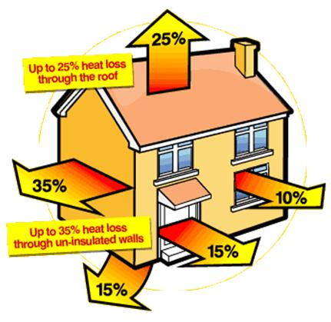

Figure 1: Heat Loss from a house during winter
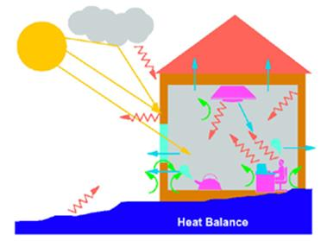

Figure 2: Heat gained by a house during summer

The best way to achieve the comfort zone temperature inside the building is to put the barriers in the path of the heat is being transferred inside the buildings by any mode i.e. conduction, convection, and radiation. Materials used as barriers for conduction are named as insulation materials, for convection the materials used as barriers are named as convective heat barriers, and the materials used for radiant heat are named as radiant heat barriers. Batts, blankets, loose fills, and low density foams all work by limiting air movement. The still air is an effective insulator because it eliminates convection and has low conduction. Reflective insulation works by reducing the amount of energy (heat) that travels in the form of radiation by reflecting the radiant heat. Amongst all the methods, most convenient and easy method to prevent incoming heat in a building is to provide the barrier as thermal insulating materials, which impart resistance to flow of heat by conduction. Heat conduction is the major source of heating of a building and contribute maximum. In this paper a few insulating materials using agro-industrial wastes have been developed in CSIR-Central Building Research Institute, Roorkee, which are eco-friendly as green materials are described in brief.
2. Thermal insulation board (bio-degradable) from forest wastes (leaves)

A product, a thermal Insulation board is developed using dried leaves of forest waste which is suitable for acoustic cum thermal insulation purposes in rural houses. This board can also be sandwiched between two laminating surfacing materials which can be used as paneling material with better resistance to heat as well as acoustic purposes in buildings. The leaves are cut into small pieces manually using scissors, soaked in 2.5 to 5.0 % solution of water based binder (resin) for 8 h and then the soaked leaves are heat pressed in a hot press to convert them into flat sheets after removing the excess resin solution. The typical sheets are shown in Figure 3

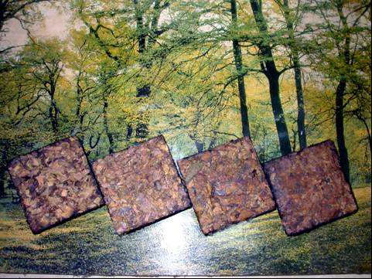
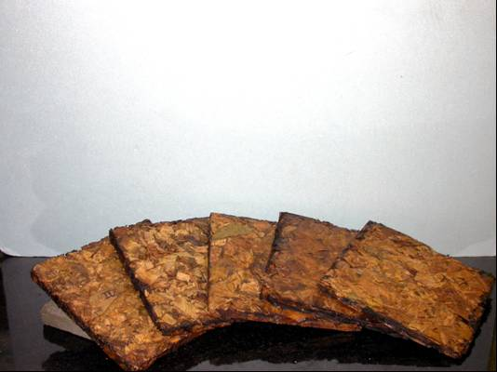

Figure 3: Low Density Sheets made from Leaves of Forest waste
The developed product is characterized in the laboratory and the characterization values are given in table-1.

Table 1. Characterization Values of Insulation Board from Forest waste (Leaves)

No. | Property | Value (Unit)-average
1. | Dimensions | L-150; W-150; T-6 to 10 in mm
2. | Average Weight | 200 g (approx.)
3. | Density | 234.35 kg/m³
4. | Initial Moisture (Temp. 28ºC, RH 42%) | 12.28 % (by weight)
5. | Bond Strength (between particles) | 1.83 N/cm²
6. | Bio-degradability | 6 – 12 months (being assessed)
7. | Thermal Conductivity at 32.6ºC[1] | 0.131 W/mK
8. | Bio-degradability | 4-8 months
9. | Estimated unit cost | Rs. 1.00

The mechanical strength (bending strength) of this developed board is low and for efficient and effective use, the same should be sandwiched between two hard surfacing materials such as MDF board, plywood, Hard Board etc.

3. Lightweight sandwich panels

The cellulosic refuse of paper industries are rich in small fibres and can be used to make value added product, which can be used for acoustics, thermal insulation and false ceiling purposes in buildings. The laboratory scale developed technology yielded a light weight sandwich panel which is very much suitable for above mentioned purposes. These developed panels have their end applications in partitioning, paneling, thermal insulation and false ceiling with its unique aesthetics. The technology as well as product has been patented. The estimated economic viable capacity is 2 tones per day and most suitable for paper industries as a down stream process. Panels with different surface textures are shown in Figure 4.

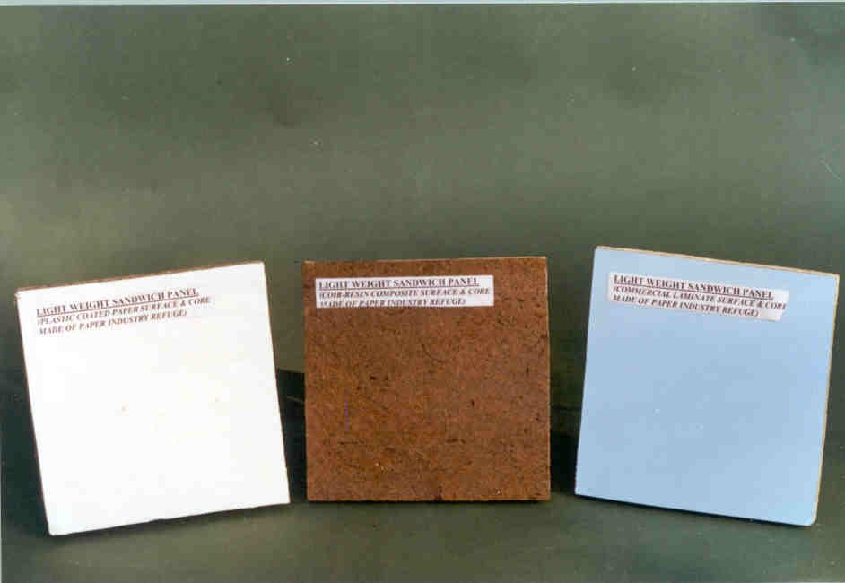

Figure 4. Light Weight Sandwich Panels with Different Surface Textures

4. Coir-CNSL thermal insulation sheets

This is a composite material which utilizes the coconut fibres as reinforcing material and CNSL as the natural binder. The density of the board is kept very low i.e. around 350-450 kg/m³. The product can be given suitable shape to be fitted with equipment or surface to be insulated. The thermal conductivity is 0.0745 kcal/hr m² °C. A prototype flat sheet made in the laboratory is shown in Figure-5.

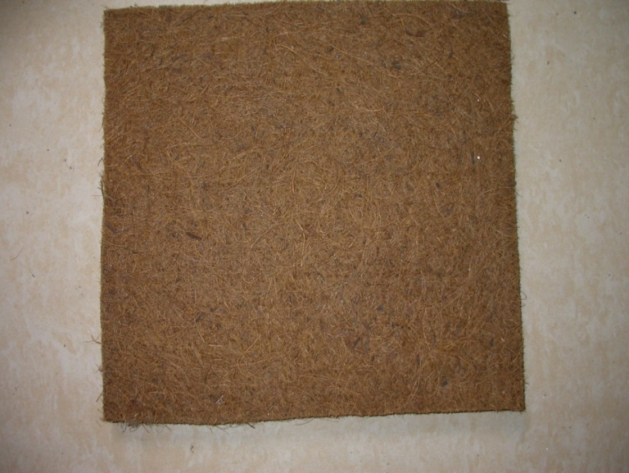

Figure 5. Light Weight Coir-CNSL Thermal Insulation Sheet
5. Low density thermal insulation board from paper industry waste

At present the cellulosic refuge from digester, recovery unit and ETP units of paper industries is used as fuel within the industry or by outsiders (brick kilns etc.). A portion of this waste is also used for making hardboard (gatta) by mixing some fresh pulp into it. This waste is used to produce a value added product without mixing any fresh pulp. Paper industries are generating waste around 10-15% of their production capacity. This low density board technology is patented (patent no. 190173). A typical prototype of low density board is shown in Figure 6. Properties of the board are given in Table 2.

Table 2. Characterization Values of Low Density Board from Paper Industry Waste

No. | Property | Value (Unit)-average
1. | Density | 537.2 kg/m³
2. | Initial Moisture (Temp. 24ºC, RH 38%) | 4.46 % (wt)
3. | Bending Strength | 7.80 N/cm²
4. | Water Absorption after 2 h soaking in water | 70.74 % (wt)
5. | Thermal Conductivity at 32.6ºC | 0.078 W/mK

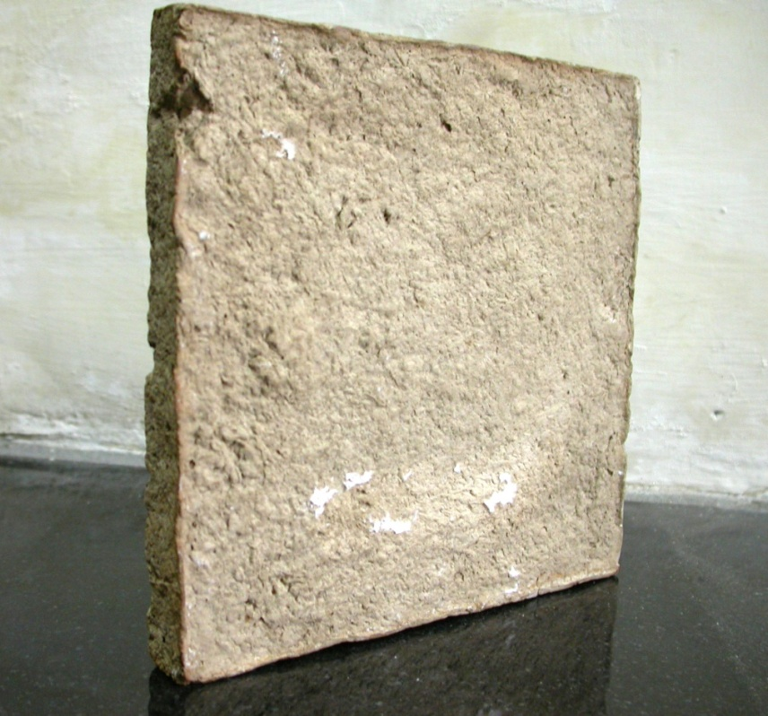

Figure 6. Prototype of Low Density Board from Paper Industry Waste
6. Conclusion

Number of waste products and renewable materials are available which can be converted into a value added products. These developed products can be used for thermal insulation purposes in buildings as barrier for conductive heat transfer. These developed products are cost effective, renewable, alternatives to conventional materials, and recyclable. Only there is a need to produce them commercially and to make their availability in the market. These technologies are available for transfer at laboratory level.

References

- IS: 3346-1980, “Method for the determination of thermal conductivity of thermal insulation materials (Two-slab, Guarded hot plate method).
- Thermal Properties of Materials, Homsey, R. I., ENG 2000 series Chapter 9.
- Principal Methods of Thermal Conductivity Measurement, a publication of TA Instruments, Argentina.
- http://en.wikipedia.org/wiki/Thermal_insulation
- http://www.excellence-in-insulation.eu/site/fileadmin/user_upload/PDF/Thermal _ insulation materials_made_of_rigid_polyurethane_foam.pdf

