Energy and Environmental Concerns in Building Materials

Manjit Singh

Former Scientist, CSIR-Central Building Research Institute, Roorkee
Corresponding Author, Email: manjit_csr@rediffmail.com

Abstract

Production of traditional building materials such as cement, steel, brick, lime and pozzolana consume enormous energy in the form of coal, oil, electricity, steam, etc. The energy requirement varies extensively depending upon the level of automation involved in the manufacturing of the building materials. The knowledge of energy requirement in the production of building materials using various materials including hazardous industrial wastes lays the foundation for fresh research and development in the production technology so that further energy may be curtailed to economize the process. Saving of energy is significant in the case of green house gases emission (GHG) into the atmosphere and reducing cost of materials. Energy consumption in the production of basic building materials (such as cement, steel, aluminum, gypsum, etc.) and different types of materials used for construction has been discussed. The energy consumed in different types of masonry mortars based on industrial wastes and gypsum plaster and gypsum products has been detailed. The use of geopolymers from natural clay and other resources and making calcium bricks at lower energy compared to burnt clay bricks are presented in the paper.

1. Introduction

In recent years, awareness of environmental aspects has grown in the building and construction sector. Manufacturing processes of building materials contribute greenhouse gases (GHG) like CO₂ to the atmosphere. There is a great concern and necessity in reducing the GHG emission into the environment in order to control adverse ecological effect. Energy requirements for production and processing of different building materials and the CO₂ emissions and the implications on environment have been studied by Buchanan and Honey[1], Suzuki et al.[2], and Debnath, et al.[3], etc. These studies belong to New Zealand, Japan and India. Indian construction industry is one of the largest in terms of employing manpower and quantity of materials produced (cement, brick, steel, timber and other materials). Construction sector in India is responsible for major input of energy resulting in the largest share of CO₂ emissions (22%) into the atmosphere. Demand and supply gap for residential buildings is increasing every year (20 million units in 1980 to 40 million units in 2000. Cement (>290 million tones per annum), steel (>15 million tones per annum) and bricks (> 90 billion per annum) are the largest and bulk consumption commodities in the Indian construction industry. This paper deals with detailed embodied energy in alternative building materials and techniques and compares the embodied energy in buildings built with traditional and the new building techniques. Energy saving through use of some industrial wastes are highlighted.
2. Background

Energy and CO₂ implications of building construction in New Zealand has been examined by Buchanan and Honey. The study indicates that significant decrease in GHG gases like CO₂ emissions may result from a shift in construction from steel, concrete and aluminium to greater use of timber in construction. Suzuki et. al threw light on energy consumption and CO₂ emission due to housing construction in Japan. Total energy required and CO₂ emissions/m² of area of different types of constructions have been compared. Energy consumption for the construction of steel and reinforced concrete (RC) multi-storeyed family houses has been found to be 8-12 GJ/m², whereas, for timber single family houses it is 3 GJ/m². They conclude that wooden houses score over other types of constructions in terms of energy requirements and GHG gases like CO₂ emissions. Studied to estimate the energy requirements for different types of residential buildings are reported in India[4]. Energy in buildings can be grouped into two types: 1) energy for the maintenance / servicing of a building during its useful life, and 2) energy capital that goes into production of a building (embodied energy) using various building materials. Examples of buildings using alternative building technologies can be found in India and elsewhere.

Embodied energy can be divided into: 1) energy consumed in the production of basic building materials, 2) energy needed for transportation of the building materials, and 3) energy required for assembling the various materials to form the building. This paper presents these aspects of embodied energy.

It is hoped that the information provided in this paper could help in selecting energy efficient building technologies and building systems based on embodied energy as well as various types of useful industrial wastes thereby reducing cost of materials and also GHG gas like CO₂ emission into atmosphere.

3. Energy in building materials

3.1 Basic building materials

Portland cement represents one of the major materials consumed in bulk quantities for building construction. Energy of cement arises from the use of coal in the rotary kilns and energy needed for crushing and grinding of the clinker. In India, cement is manufactured by employing both the wet (old cement plants) and dry (new plants) process. Wet process used in old cement plants loads to an energy consumption of 7.5 MJ/kg of cement, whereas modern plants employing pre calcination and dry process consume 4.2 MJ/kg of cement. The value of 5.85 MJ/kg of cement given in Table 1 represents the average value of 7.5 and 4.2 MJ. The average value of 5.85 MJ/kg of cement has been used in the computation of energy in various components and systems.

Hydrated lime consumes 3-6 MJ of thermal energy/kg, which is about the same as that for cement. High-energy consumption for lime can be attributed to low thermal efficiency of small scale kilns employed for lime burning in India. LP cements are effective alternative to Portland cement, mainly for secondary applications such as masonry mortar, plastering, base/sub-base for flooring, roads, etc. A typical LP cement will consist of 30% lime, 60% pozzolana and 10% calcined gypsum, all three being inter-ground in a ball-mill. Such cement possesses an energy content of 2.5 MJ/kg.
Aluminium and steel are the two high-energy metals commonly used in building construction. Even though aluminium is much lighter than steel, consumes six to seven times more than the energy of steel per unit weight. The use of aluminium doors and windows can contribute significantly to the energy input into a buildings. The use of these metals should be kept minimum in the buildings. Glass is another energy intensive material used in buildings. Its energy consumption is next to steel, but its density is much lower than steel.

3.1.1 Masonry building materials

Masonry walls is the major energy consuming components of the building, particularly in case of load bearing masonry structures. Varieties of materials are used for the construction of masonry walls. The building blocks viz. stone burnt clay brick, soil-cement block, hollow concrete block and steam cured mud block were examined in detail.

3.1.2 Stone block
Natural building stones have been extensively used for the building construction in India and elsewhere. In India, stone blocks are generally produced by splitting the hard natural stone into convenient sizes. Stone blocks of size approximately about 180 mm x 180 mm x 180 mm are generally used in the Indian construction practices.

3.1.3 Soil-cement blocks

These are produced by pressing a wetted soil-cement mixture into a solid block using a machine (manually operated or mechanized) and then cured. Soil-cement blocks produced by employing manually operated machines have become popular in India and elsewhere[5-6]. Detailed information on the production, properties and masonry using soil-cement blocks can be obtained from the references[7-8]. Energy content of the blocks is mainly dependent upon the cement content. Soil-cement blocks used for the load bearing masonry buildings generally contain cement content of about 6-8% and posses energy content of 2.6-3.56 MJ per block of size 230 mm x 190 mm x 100 mm.

3.1.4 Hollow concrete blocks

These are light weight low density blocks very commonly used for the construction of non-load bearing filler walls in multi-storeyed buildings in India. They are also used for the construction of load bearing masonry walls to a limited extent. The basic composition of the blocks consists of cement, sand and coarse aggregates (~6 mm size). The energy content of the block will mainly depend upon the cement percentage. Energy spent for crushing of coarse aggregate will also contribute to the block energy. The cement percentage generally varies between 7 and 10% by weight. Quality of the block, particularly compressive strength is the deciding factor for cement percentage. Energy content of the hollow concrete block of size 400 mm x 200 mm xx 200 mm may be in the range of 12.3-15.0 MJ.

3.2 Energy in transportation of building materials

Transportation of materials is a major factor in the cost and energy of a building. Bulk of the building materials in urban and semi-urban centres are transported using trucks in India. The transportation distance may vary depending upon the location of construction activity. In urban areas, the materials travel anywhere between 10 and 100 km in the Indian sub-continent. Materials such as sand aggregates are transported from a distance of 80-100 km in the like cities. Similarly, cement and steel travel even longer distances, of the order of 500 km or more. Large quantities of cement and steel is handled through rail transport. Fancy building materials such as marble, paints, etc. are sometimes transported from great distances (over 1600 km) in India.Natural sand and crushed stone aggregate consume about 2.0 MJ/m² for every one km of transportation distance. Similarly bricks require about 2.5 MJm² per km travel. Assuming steel and cement are also transported using trucks, diesel energy of 2 MJ/tonne/km is spent during transportation.

3.3 Energy in mortars

Mortar is a mixture of cementitious material and sand. It is used for the construction of masonry as well as plastering. Cement mortar, cement-soil mortar, cement-pozzolana mortar are used for masonry construction and plastering. Cement mortar is a common choice for masonry and rendering works. Cement-soil mortar has been used for the construction of SMB masonry. Cement-pozzolana and LP mortars can also be used for masonry construction and other applications ⁹. Total energy content of these four types of mortars is given in Table 1.

Table 1. Energy in Mortars

Type of mortar | Proportion of materials  Cement Sand Soil | Energy m³(MJ)
Cement mortar | 1 0 6  1 0 8 | 1270  1050
Cement pozzolana mortar | 0.8:0.2 0 6  0.8:0.2 0 8 | 925  750
Cement-soil mortar | 1 2 6  1 2 8 | 860  790
LP mortar | 1(1:2) 0 3 | 740

Energy content: Cement -5-8 MJ/kg, Sand-175 MJ/m³, Pozzolana-1.75 MJ/m³

The use of industrial wastes may save considerable energy when used as part replacement of the blended cements i.e. PPC, PSC, masonry cement, burnt bricks, etc. Table 2 lists energy saving through use of industrial wastes. Energy content of brick masonry is the highest with a value of 2141 MJ³. Soil-cement block masonry consumes only about one-third of brick masonry energy. Hollow concrete block masonry requires about 38-45% of the brick masonry energy. Steam cured mud block masonry consumes about two-thirds of that needed for brick masonry. Soil-cement block masonry is the most energy efficient among the alternatives listed in the table.

4. Energy performance of gypsum based building materials

Gypsum has many uses, but the most important by far in the manufacture of gypsum building plaster and plaster board and as a retarder in Portland and the blended cements which account for the greater chunk of the gypsum produced. For use in plaster industry, the gypsum is calcined to produce hemihydrate or anhydrite plaster forms. Ground gypsum is used as a soil conditioner, particularly on green legumes to provide good calcium and sulphur deficiencies in soil, to mitigate soil alkalinity and to flocculate soil particles thereby improving drainage. Gypsum has important application in reclaiming barren land which has been flooded by the sea waters, by displacing sodium ions from clay minerals and thus, allowing these ions to be removed by percolation of ground water. Gypsum is also used as the filler in many industries and several relevant standards (Indian) have been laid for their proper applications.
Table 2. Energy Saving through Use of Industrial Wastes

Sl.  No. | Building material | Composition | Material compared | Energy saving (%)
1. | Portland pozzolana cement | 75% OPC  25% Flyash | 100% OPC | 20
2. | Portland blast furnace slag cement | 60% OPC  40% BF Slag | 100% OPC | 30
3. | Masonry cement | 50% OPC  50% Tailings/waste  Chalk | 100% Masonry cement  (50%OPC + 50% Limestone) | 20
4. | Lime-pozzolana mixture | 25% Lime  75% Flyash | 25% Acetylene gas lime  75% Calcined brick | 25
5. | Calcium silicate brick | 90% FA Tailings  10% Lime(waste source) | Burnt clay brick | 30
6. | Burnt brick | 75% clay 125% Flyash | Burnt clay brick | 15

The importance of industrial application of gypsum is due to its conversion into variety of calcined products i.e. hemihydrate plasters (alpha & beta) and different type of anhydrite plasters ranging from soluble to insoluble anhydrite or dead burnt gypsum. All type of these plasters when mixed with water, set and hardened to the dihydrate gypsum of variable properties and form basis of the gypsum products. Off course different type of admixtures like retarders, activators, polymers, plasticizers, super-plascitizers, flocculating agents, fibres, etc. are added to the gypsum plaster to formulate insitu or preformed building products. Extensive R &D efforts have been made across the world to synthesize variety of plasters, binders, boards, tiles, blocks and many other useful building products. Based on these researches, valuable cost effective gypsum building products covering vast technological aspects have been launched in the market to fulfill needs of the people for ecstasy, aesthetic, comforts and safety.

4.1 Manufacture and setting of plaster of Paris of different grades

Gypsum is used as the raw material for most of the gypsum based products used in building construction such as plaster of Paris, building plaster, gypsum sheathing board, gypsum backing board, gypsum partition blocks, gypsum wallboard, anhydrite or Keene’s cement etc. Although gypsum has its greatest use in the building industry and civil construction works in most of the developed countries like Germany, Canada, France, Australia, USA, China, etc. its use is not yet popular in India in spite of extensive availability as mentioned above. Except gypsum plaster, the production and use of other gypsum products in the country is small. The process of Production of gypsum plaster involves calcination of raw gypsum at an optimum temperature to drive off three quarters of water of crystallization at temperature around 120-150⁰C. Commercially it can be manufactured by pan calcination, kettle calcination, rotary calcinations, fluidized calcination and using vertical shaft kiln. The manufacture of plaster of Paris therefore requires best energy of the order 0.83 x 10⁶ BTU/T or 0.21x10⁶ kcal which is only one seventh of the energy needed for producing an equivalent amount of Portland cement. CBRI has developed and installed an energy efficient gypsum calcinator comprising of a two separate furnaces for two pans of 500 kg each. The plant has a capacity of 8TPD. Its thermal efficiency is 70% as against 12 % for the open pan calcination. The technology has been commercialized and also bagged NRDC award [10].

Enormous R & D work has been accomplished at Central Building Research Institute (CBRI), Roorkee on the mineral and by-product gypsum (phospho, Fluoro, Dye industry waste, boro gypsum) for scientific studies and industrial applications since more than three decades. The results obtained on the investigations carried out, have been utilized for developing technical know-how of certain industrial products and building materials [11-14].

The performance data of making various calcined phases are given Table 3.

Table 3. Performance Data for Calcined Gypsum (per metric tonne)

Phosphogypsum
Utilities | Plaster of Paris | Wall Plaster | Anhydrite II
Fuel | 1.4x10⁶ BTU/  0.35x10⁶ Kcal | 1.6x10⁶ BTU/  0.4x10⁶ Kcal | 2.0-2.2x10⁶ BTU/  0.5-0.55x10⁶ Kcal
Electricity | 30 kWh | 35 kWh | 45 kWh
Natural Gypsum

Fuel | 0.83x10⁶ BTU/  0.21x10⁶ Kcal | 1.2x10⁶ BTU/  0.3x10⁶ Kcal | 1.6-1.8 x10⁶ BTU/  0.4-0.45x10⁶ Kcal
Electricity for calcinations | 15 kWh | 17 kWh | 30 kWh
Plaster board | 8-11 (MJ) | --- | ---

4.2 Properties of plasters

There are mainly two types of plaster namely α- and β hemihydrate generally used in construction. The two varieties are identical in chemical composition but their physical properties vary widely. The quality of a plaster is determined by its physical properties like normal consistency i.e. water/plaster ratio, compressive strength, modulus of rupture, impact strength, porosity etc. depending upon the actual use of the material. α-hemihydrate is denser, has lower water/plaster ratio, higher fluctural strength, higher compressive strength and lower porosity when compared to β-hemihydrate. The anhydrite plaster made at higher temperatures (>700⁰C) attains quite high strength and durability. The raw gypsum and the calcined gypsum/plaster are shown in Fig.1.

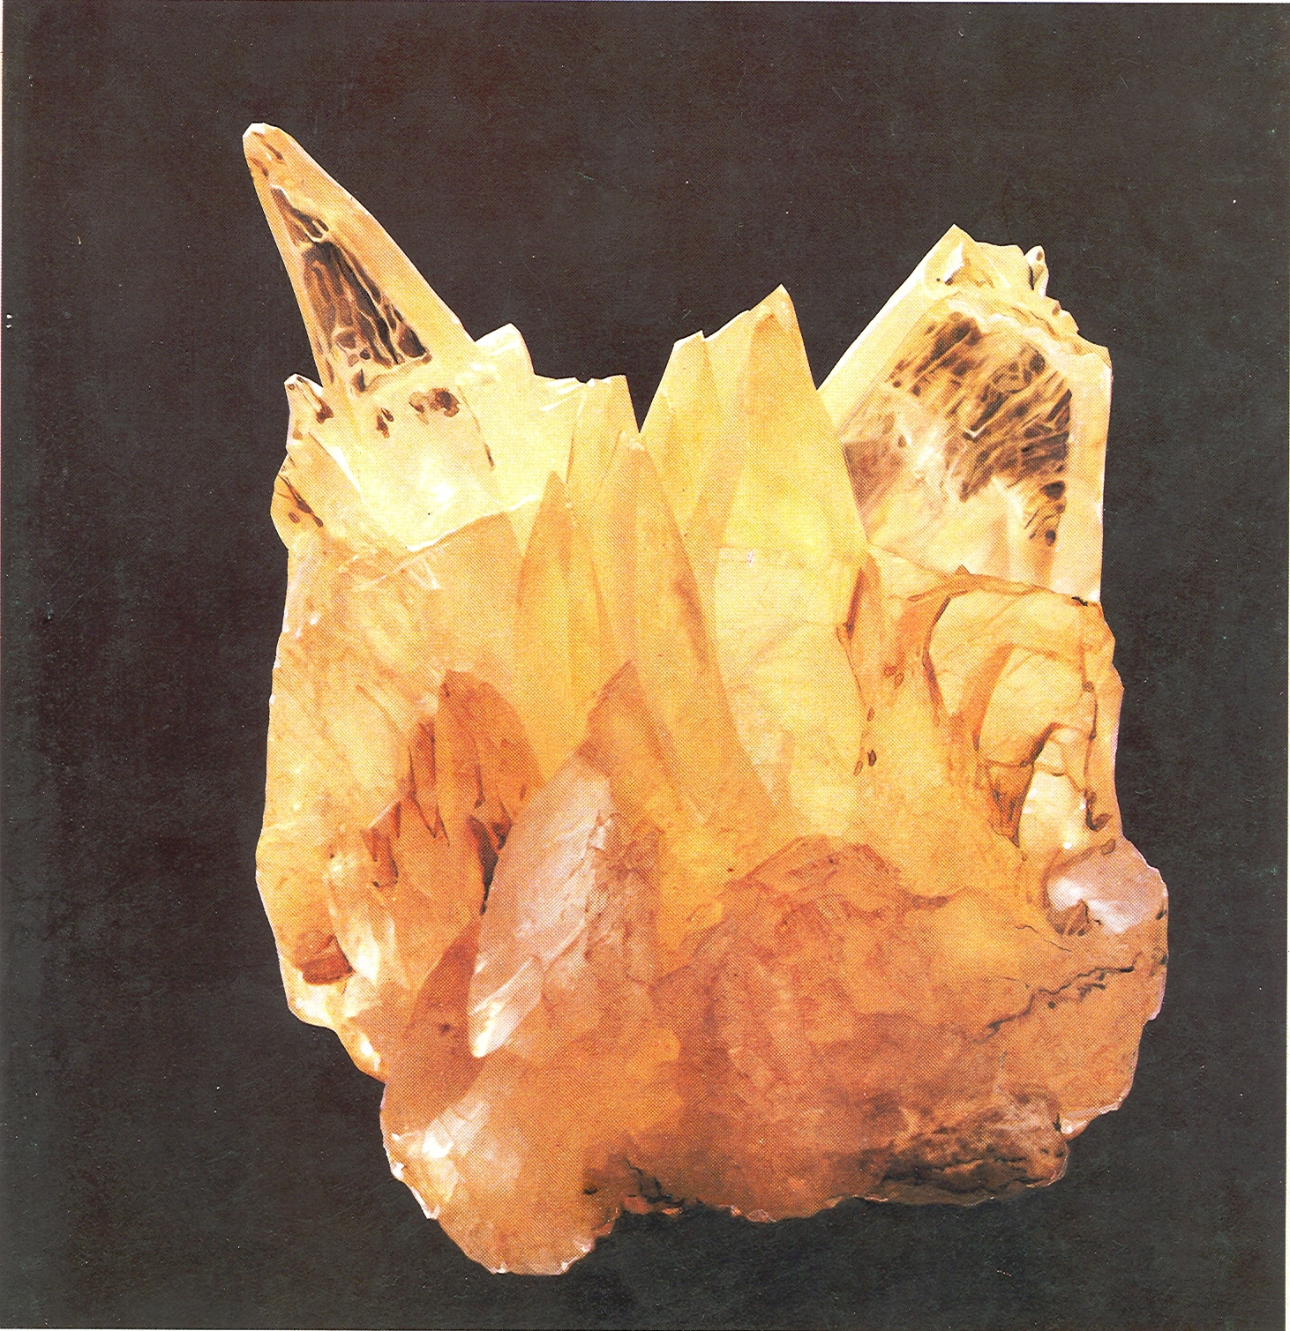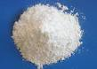

Figure1. (a) Gypsum Crystal (b) Calcined Gypsum/Plaster

4.3 Plaster boards and blocks

Plaster of Paris of uniform particle size usually of the cheaper variety namely β –hemihydrate is mixed with water (70-80%) to form slurry and moulded in the form of boards, hollow blocks etc. These component can be artistically finished, with design impressions or can be coated with wall papers for a modern aesthetic look and can be utilized for non-load bearing partitions ceilings, etc. They have better properties than the conventional partition boards such as ply wood, asbestos sheet, gypboards, due to their thermal insulation, acoustic properties and cheapness. CBRI has developed gypsum boards, blocks, water resisting binders, tiles both from natural and waste phospho and other variety of gypsum. Several assignments have been done for the industry based on phospho, fluoro, dye industry gypsum, etc.

4.4 Gypsum anhydrite cement

Anhydrite cement is the anhydrous calcium sulphate produced by calcining gypsum at high temperature (700-1000⁰C)[15]. It is also called Keene cement. Anhydrite plaster is ground to a fineness of 350-400 m²/kg (Blaine’s) and blended with different chemical activators for setting & strength development in the plaster. Anhydrite cement sets to a hard mass (20-360 Min.) and gives sufficient strength (30-35 MPa) which is comparable to that of Portland cement.Plastering work (Finish and Undercoat, Mix.1:2, Anhydrite:Sand)) with this cement gives a smooth finish and perfectly white appearance. Building bricks and flooring tiles have been produced from the phospho and fluoro anhydrite and patent has been claimed by CBRI [16]. Anhydrite cement can replace Portland cement in most of the indoor constructions as well as outdoor purposes. The anhydrite binders based on water resistant formulations may be fit for exposed situation[17].

- Geopolymer cement

Geopolymer cement is the new state of art cement discovered by Davidovits, a French scientist.The word ‘geopolymer’ was coined to describe the new material. ‘Geo’ meaning earth combined with ‘polymer’ meaning many molecules. Geopolymer cement can be made without limestone. The key ingreidients are mineral kaolinite, blast furnace slag, fly ash, etc.It is the result of geosynthesis, a reaction that chemically integrates minerals, that involves silicon-aluminium at a high pH in the presence of soluble alkali metal silicates. The silica, aluminium and oxygen atoms react to form moleculesthat are chemically, structurally comparable to those binding natural rock. Geopolymers cements are inorganic hydraulic cements that are based on polymerization of minerals ¹⁸. Geopolymers have many advantages such as flexibility of raw materials, energy saving and environment protection, simple separation techniques, good volume stability, quick gain of strength, excellent durability, higher fire resistance , low thermal conductivity, etc.

6. Energy conservation in the manufacture of bricks

In a traditional building, the bricks occupy a major portion of the total building materials. It has been realized that clay bricks alone can not meet the heavy demand for building bricks and hence the potential for alternative material such as calcium silicate bricks (sand lime) has been recognized. The CBRI, has done extensive work for development and production of calcium silicate type of bricks and has developed a small capacity rotary press for demonstration and experimental work¹⁸. It has been found that by experiments that sand lime bricks are quite comparable with those of clay bricks in respect of energy consumption and also total energy consumed in manufacturing process is less than that of clay bricks.

The sand lime bricks are produced by thoroughly mixing the sand and hydrated lime in the ratio 90:10 by weight with small quantity of water to make semi dry mixture. The mixture is filled in the moulds of the press where a pressure of 200-300 kg/cm² is applied to the mixture followed by removal of bricks from the moulds and then autoclaving them in saturated steam pressure at 14 kg/cm² for a period of 4-5 hours. While the clay bricks are manufactured by four major operations : preparation of raw materials, mixing, shaping/extrusion and firing/burning. By comparing the two case, it has been found that saving in total energy in the manufacture of sand lime bricks is about 30%.

- Concluding remarks

- Soil-cement block is the most energy efficient among the alternative material for walling, consuming only one-fourth of the energy of common burnt clay brick. Concrete blocks and steam cured blocks also consume much less energy during manufacturing process when compared to burnt clay brick. LP mortars have lowest energy content when compared with other mortars like cement mortar, cement-pozzolana mortar, etc.

- The hemihydrate plaster based building products like boards, blocks, binders consume less energy than the anhydrite plaster based building materials. As compared to OPC, gypsum (natural/waste) based building materials comparatively consume less energy and will help in protecting the environment.

- The production of geopolymer from slag or fly ash and its use in concrete may reduce enormous energy compared to OPC.

- About 30% energy can be saved in the manufacture of calcium silicate bricks vis-a vis burnt clay bricks.

References

- Buchanan, A.H., Honey, B.G.. Energy and carbon dioxide implications of buildingconstruction. Energy and Buildings 20 (1994) pages 205-217.
- Suzuki M., Oka T., Okada K., The estimation of energy consumption and CO₂ emission due to housing construction in Japan. Energy and Buildings 22(1995) pages 165-169.
3. Debnath, A., Singh, S.V, Singh, Y.P., Comparative assessment of energy requirements for different types of residential buildings in India, Energy and Buildings 23(1995) pages 141-146.
4. Energy Directory of Building Materials, Development Alternatives, New Delhi, India
- K.S, Jagdish. The Progress of Stabilized Soil Construction in India, in Proceedings of National Seminar on Application of Stabilized Mud Blocks in Housing and Buildings, Bangalore, India, Nov. 1988, pages 17-43.
6. Mukerji, Soil Block Presses, Report on Global Survey, German Appropriate Technology Exchange, Dag-Hammerxjold-Weg 1, 6236.
- B.V. Venkataraman Reddy, K.S. Jagdish, Properties of Soil Cement Block Masonry, Masonry International 3 (2) (1989) 80-84/
- B.V. Venkataraman Reddy, K.S. Jagdish, Influence of Soil composition on the strength and durability of soil-cement blocks. The Indian Concrete Journal 69 (9)(1995) 517-524.
- K.M Rao, B.C. Venkatarama Reddy, K.S. Jagdish, Influence of flexural bond strength on the compressive strength of masonry, in : proceedings of the National Conference on Civil Engineering Materials and Strucures. Osmania University, Hyderabad, India, January 1995.
10 Singh, M.; Rai, M.: Autoclaved Gypsum Plaster from Selenite and By-product
Phosphogypsum, J Chem.Tech.Biotechnol, 43 (1988), pages 1-12.
11. Singh, M.; Garg M.: Investigation of Waste Gypsum Sludge for Building Materials,
Zement-Kal-Gips, 53 (2000) 6, pages 362-364.
12. Singh, M.: Utilization of By-product Phosphogypsum for Building Materials, Build.
Res.Note No.9, CBRI Publication, Roorkee, India, March, 1988.
13. Singh, M.; Garg, M.: Phosphogypsum-Fly ash Cementitious Binder-Its Hydration and
Strength Development, Cement concrete Research (USA), 25(1995) 4, pages 725-758.
14. Singh, Manjit; Trends in Global Gypsum Industry, Indian Concrete Journal, Vol.35,
No.10, 2011, pages 49-60.
15. Singh, Manjit; Durable Cost Effective Building Materials from Waste
Fluorogypsum, New Building Materials & Construction World, Vol. 17, March
2012, pages 202-217.
16. Singh, Manjit and Garg Mridul, Indian Patent No. 696/Del/2000 – A Novel High
Strength Plaster Composition and Flooring Tiles Made There from.
17. Singhvi, M.K., Mission Geopolymer and India Vision 2020: A perspective,
International Seminar & Exhibition- Cost Effectiveness in Cement Manufacture and
Construction Technological and Management Options, 11-12 January, 2005,
Mumbai, India, Vol. II, pages 58-62
18. Rai Mohan and Gupta, R.L., Energy Conservation in the Manufacture of Sand Lime
Bricks, National Seminar on Autoclaved Calcium Silicate Products, New Delhi,
January 8, 1990. Pages C-9-C-13.

