Additives Filled Rigid Polyurethane Foam - A Fire Retardant and Energy Efficient Building Material

Harpal Singh

CSIR-Central Building Research Institute, Roorkee
Corresponding Author, Email: harpalcbri@yahoo.com

Abstract.

Rigid polyurethane foam (RPUF) has many advantages over other insulating materials as lowest thermal conductivity, high mechanical and chemical properties at both high and low temperatures and the ability to form sandwich structures with various facer materials. Buildings around the globe consume more than 40% of the total energy generated and are a major contributor to the increased level of greenhouse gases. Effective insulation is therefore a significant contributor towards sustainable construction. Studies showed that buildings insulated with RPUF typically use 30% less energy for heating and cooling compared to other insulation materials. However, RPUF is highly flammable and generates smoke containing CO and HCN. Chemically modified RPUF is a perfect fire retardant and energy efficient material for building applications. A fire retardant composition was prepared from phosphorus-nitrogen (P-N) based additives. The fire retardancy of rigid polyurethane foam (RPUF) was studied by impregnating it with various concentrations of P-N based additives composition. Optimum impregnation time, retention and density of RPUF samples with P-N composition were also studied. The morphology and fire performance of RPUF and RPUF-P-N samples were investigated using scanning electron microscopy (SEM) and BS: 4735 respectively. The results showed that phosphorus-nitrogen additives composition enhances the fire retardancy of RPUF samples.

Keywords: Rigid polyurethane foam, fire retardant, energy efficient, thermal insulation, impregnation, morphology, mass loss, burning rate.

  - Introduction

Rigid polyurethane foam (RPUF) is high molecular weight polymer based on the polyaddition of polyfunctional hydroxyl-group containing compound and polyisocyanate in the presence of catalyst, surfactant, chain extender and blowing agents. Compared with other insulating materials such as fiberglass, wood wool, mineral wool, rock wool, polyethylene foam, polystyrene foam and phenolic foam, RPUF is highly competitive as shown in Table 1. There are many product-related advantages as lowest thermal conductivity, high mechanical and chemical properties at both high and low temperatures, the ability to form sandwich structures with various facer materials, and the new generation of RPUF is CFC-free and recyclable [1]. Buildings around the globe consume more than 40% of the total energy generated and are a major contributor to the increased level of greenhouse gases. The greatest energy demand in a building is for conditioning the interior by heating or cooling. Buildings gain or lose heat through conduction, radiation and convection. Most of the energy in a building is lost through the building envelope which contributes to over 60% of the total heat gain/loss. Effective insulation is therefore a significant contributor towards sustainable construction. The utilization of thermal insulation in the building envelope can substantially reduce the building thermal load and consequently its energy consumption. The performance of the thermal insulation material is mainly determined by its thermal conductivity (shown in Table 2), which is dependent on the density, porosity, moisture content and means temperature difference of the material [2]. The right insulation material plays an important role in achieving energy efficiency. Studies showed that buildings insulated with RPUF typically use 30% less energy for heating and cooling compared to buildings insulated with traditional fibrous insulation material. RPUF has high thermal insulation value due to its highly cellular closed cell structure with low moisture permeability [3-4]. However, RPUF is highly flammable due to its chemical nature, high air permeability and high inner surface area of the foam structure to mass ratio. During RPUF burning diisocyanate converts into yellow smoke containing HCN, and rest of the other groups convert to white smoke containing CO₂ and CO. HCN and CO are the prominent toxicant gases which on inhalation lead to death [5-8]. Various fire retardants such as phosphorus-halogen mixture, ammonium polyphosphate (APP) and organophosphorus compounds either alone or in combination with nitrogen or silicone have been used to impart fire retardancy to RPUF [9-11]. Modesti et al. were recently reported the successful incorporation of various combinations of halogen free fire retardants such as APP with melamine, expandable graphite with triethyl phosphate and red phosphorus, and expanded graphite with melamine into the RPUF formulations [12-15]. As phosphorus and other halogen free fire retardants containing RPUF give off non-toxic combustion products, thus they are preferred over halogen containing fire retardants [16-17]. On exposure to heat, phosphorus compound decomposes at lower temperature than polyurethane foams to produce phosphoric or polyphosphoric acids. These acids catalyse the char formation in the condensed phase. This phosphorus rich char prevents heat transfer by reducing the production of combustible gases [18-20]. The main objective of this study is the preparation of phosphorus-nitrogen additives based composition and to investigate the effect on the fire retardancy of RPUF impregnated with P-N composition. Earlier such fire retardant compositions have been studied in cellulosic paper and wood [21] but never in RPUF to the best of our knowledge. RPUF impregnated with P-N composition was prepared in our own laboratory and the results are reported [22]. RPUF samples of similar density were impregnated with different concentrations of P-N composition. The density of RPUF samples impregnated with P-N was measured as per ASTM D1622. The morphology and fire performance of RPUF and RPUF-P-N samples were investigated using scanning electron microscopy (SEM) and BS: 4735 respectively.

Table 1. Material thickness at equal thermal insulation value

Insulation material | Thickness (mm)
Rigid polyurethane foam  Expanded polystyrene  Mineral wool  Cork  Wood fiber  Softwood  Light weight concrete  Dense bricks | 50  80  90  100  130  200  760  1720
Table 2. Comparison of thermal conductivity of common insulation materials

Insulation material | Thermal conductivity (W/mK)
Dense bricks | 1.31-1.60
Light weight concrete | 0.14-0.18
Soft wood | 0.13-0.17
Wood fiber | 0.11-0.15
Cork | 0.055-0.070
Mineral wool | 0.036-0.042
Expanded polystyrene | 0.029-0.035
Rigid polyurethane foam | 0.023-0.026

- Method

  - Preparation of P-N additives composition

An aldehyde solution mixed with distilled water was charged in a 1000 ml three-neck round bottom flask equipped with thermometer, stirrer and reflux condenser. The medium of the solution was adjusted to alkaline by adding a few drops of an alkali solution. The solution was then heated over water bath until it attains the temperature of 80-90⁰C. A mixture of nitrogen additives was then added incrementally with constant stirring over 20 min. Upon the completion of the addition, the reaction mixture was allowed to reflux for 10 min. The resulting solution was cooled to ambient temperature by putting the flask under cold-water stream. Phosphorus additive was then added slowly with constant stirring. During the addition of phosphorus additive, the whole assembly was continuously kept under cold-water stream to avoid the heat up of flask due to the heat generated by the reaction of phosphorus additive and mixture solution. The final product was a colorless viscous liquid mixture of phosphorus-nitrogen additives. This viscous mixture was designated as P-N additives. The basic formulation used for the P-N additives preparation is presented in Table 3.

Table 3. Basic Chemical Formulation of P-N Additives Composition

Chemical | Quantity per mole
Phosphorus additive | 1.0
Nitrogen additive-1 | 0.25
Nitrogen additive-2 | 1.0
Aldehyde solution | 3.0
Water | 8.0

  - Sample preparation

RPUF samples of 49.19-kg/m³ densities were used for impregnation with P-N additives composition. P-N additives composition concentration, impregnation time, retention and density are considered to be the most important parameters during the preparation of RPUF samples. A P-N additive is water based composition, thus its various concentrations ranging from 10-100% were prepared by mixing it with water. Optimum impregnation is the time at which RPUF samples retain the maximum quantity of P-N additives with optimum time period. Optimum impregnation time was investigated by impregnating the RPUF samples with 100% P-N additives solution concentration from 10–60 min. with an increment of 10 min. at the ambient conditions. Retention is the quantity of P-N additives solution concentration absorbed by the RPUF samples and subsequently retained in it. Retention of RPUF samples was investigated by impregnating the 30 samples for optimum time with 10-100% P-N additives concentrations with an increment of 10%. The effects of P-N additives concentration and impregnation time on retention were studied by impregnating the 180 RPUF samples into the P-N additives solution concentration ranging from 10–100% and every three samples were removed from the solution at an interval of 10 min. The effect on the density of RPUF samples was observed by impregnating the samples for optimum time with 10-100% P-N additives concentrations with an increment of 10%. After complete impregnation, RPUF samples were removed from their respective P-N additives solution concentration and allowed to dry for 24 hours at room temperature. P-N additives solution concentration and optimum impregnation time of RPUF samples (RPUF-P-N) are shown in Table 4. In the sample code, P-N denotes the phosphorus-nitrogen additives composition concentrations used for impregnation. RPUF samples impregnated with P-N additives are shown in Figure 1(a). RPUF and RPUF-P-N samples with maximum retention were prepared for SEM. The flammability characteristics of RPUF and RPUF-P-N samples of dimensions 150×50×13 mm were investigated by impregnating the three samples with each P-N additives composition concentrations ranging from 0-100% with an increment of 10%. After impregnation the RPUF samples were removed from the solution and dried for 24 hours at room temperature. Dried RPUF samples were marked across their width by a line (gauge mark) 25 mm from one end.

Impregnated with P-N additives based composition

Sample codes  (RPUF-P-N) | P-N Concentration  (%) | Water  (%) | Impregnation time  (min)
RPUF-0.0 | 0.0 | 0.0 | 0.0
RPUF-P-N | 10 | 90 | 20
RPUF-P-N | 20 | 80 | 20
RPUF-P-N | 30 | 70 | 20
RPUF-P-N | 40 | 60 | 20
RPUF-P-N | 50 | 50 | 20
RPUF-P-N | 60 | 40 | 20
RPUF-P-N | 70 | 30 | 20
RPUF-P-N | 80 | 20 | 20
RPUF-P-N | 90 | 10 | 20
RPUF-P-N | 100 | 0.0 | 20

  - Measurements

P-N additives impregnation extent to the RPUF samples mainly depends upon the concentration, impregnation time and retention. These three parameters are linked to each other in which impregnation time depends upon the maximum retention, and retention depends on both concentration and impregnation time. Optimum impregnation time was measured on the basis of maximum P-N additives retention attained by the RPUF samples with respect to time. Further, optimum impregnation time on the basis of maximum retention of every three RPUF-P-N samples was calculated and averaged. Retention on each P-N additives concentrations were also calculated and averaged. The density of conventional RPUF and RPUF-P-N samples was measured according to ASTM D1622. The size (length×width×thickness) of the specimen was 30×30×30 mm respectively. RPUF and RPUF-P-N specimens were conditioned at 25⁰C and 55% relative humidity for 48 hours prior to their density measurement. The density of five specimens per sample were measured and averaged. The morphology of RPUF and RPUF-P-N samples was observed with LEO (438 VP, UK) scanning electron microscopy (SEM). The samples were cryogenically fractured and gold coated to render them conductive prior putting under scanning observation. During scanning 15 KV accelerating voltage was used. The SEM was used to observe the P-N additives deposition on the cell walls, surfaces and the difference in the shape and size of the cells between RPUF and RPUF-P-N samples. To define the cell size, measured cell sizes were averaged except the sizes for the largest and smallest cells. Flammability characteristics of RPUF and RPUF-P-N samples were evaluated according to BS: 4735. The specimens were weighed before placing horizontally on support gauge inside the non-combustible chamber. The farthest end away from gauge mark of the specimen was exposed for 60s to 10 mm diameter wing top fitted LPG burner of 38 mm non-luminous flame height. Exposed RPUF-P-N samples are shown in Figure 1 (b). After complete fire exposure extent burnt, burning rate, percent mass loss (PML) and extinction time of three specimens per sample were measured and averaged for analysis.

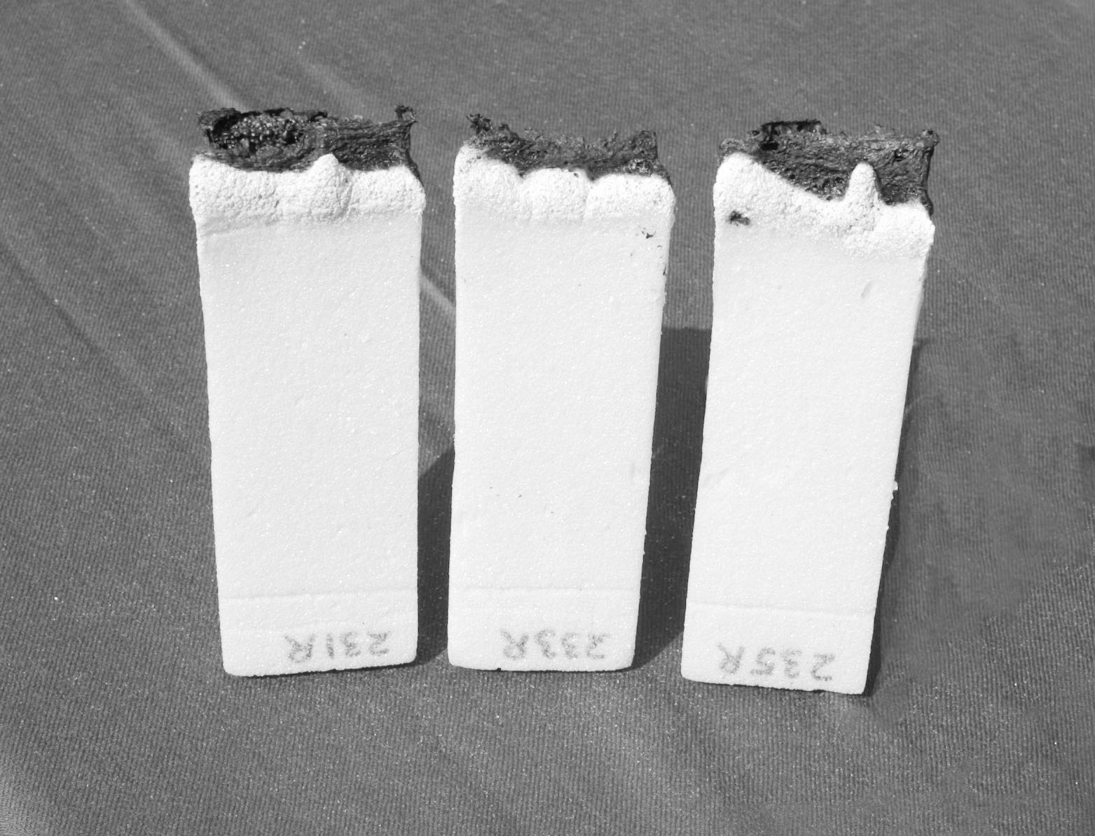
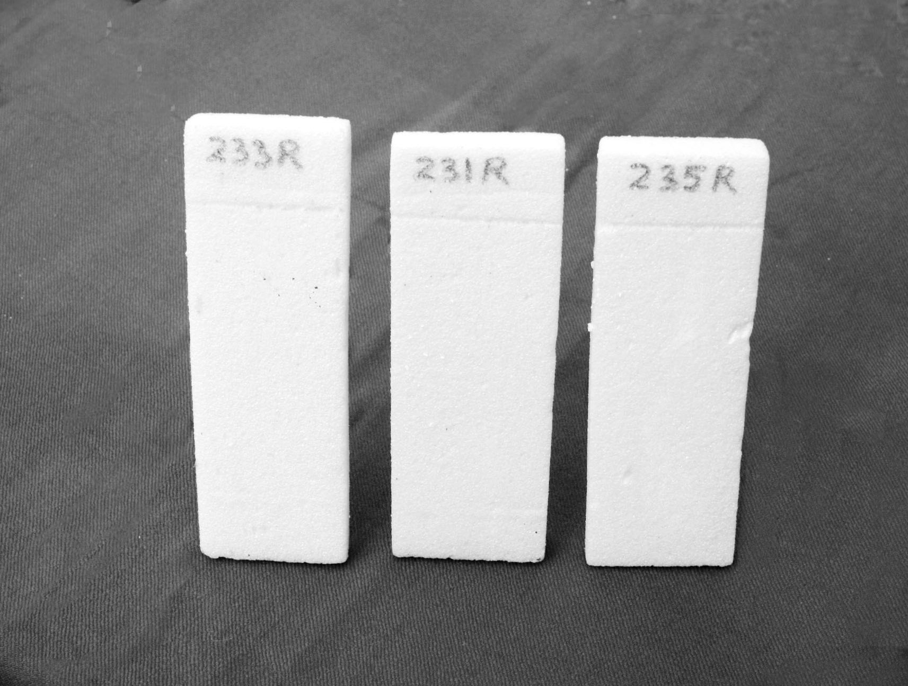
(a) (b)

Figure 1. RPUF-P-N samples: (a) before flammability test and (b) after flammability test

- Results and discussion

  - P-N additives composition

Chemical reactions involved in the preparation of P-N additives composition were already studied. It was found that one mole of nitrogen additive in alkaline medium reacts with one mole of aldehyde to form monomethylol product. Similarly to nitrogen additive-1, nitrogen additive-2 in alkaline medium reacts with aldehyde to yield monomethylolated product. When the amount of aldehyde is increased to two moles, the dimethylolated product is formed. The rate of dimethylolated product formation is very slow at room temperature. When the temperature is raised in the range of 80-90⁰C, the end product was dimethylol and no monomethylol product was formed. Thus the major intermediates in the P-N additives composition are N, N’-dimethylolated nitrogen additive-1 and N, N’-dimethylolated nitrogen additive-2. These dimethylolated products react with phosphorus additive to give 6-membered ring compound which acts as fire retardant by polymerization [21].

3.2 Concentration, Impregnation, Retention and Density

The add-on of phosphorus-nitrogen (P-N) additives composition to the RPUF samples was mainly measured from P-N concentration, impregnation time and retention. Results presented in Figure 2 show that the retention of RPUF samples was ranged from 1.98 to 64.29% when they were impregnated with 10 to 100% P-N additives concentration for 10 to 60 min. respectively. After 20 min. impregnation the retention of RPUF samples were ranged from 1.98 to 62.98% with 10 to 100% P-N additives concentration respectively and further up to 60 min. impregnation only 1.09% average increase in the retention was observed. This may be possible due to the fact that the vacant cell space was fully occupied by P-N additive composition after 20 min. of impregnation, and no enough space was left for further impregnation at the same rate. Thus after 20 min. and up to 60 min., no appreciable increase in the retention was observed. Therefore, 20 min. is considered as the optimum impregnation time of RPUF samples. The retention and density of RPUF and RPUF-P-N samples impregnated for optimum time are shown in Figure 3. As shown in Figure 3, the density increases as the retention of RPUF-P-N samples increases. When retention of RPUF samples increases from 2.49 to 62.98%, the density increases from 50.42 to 80.17 kg/m³ respectively. Thus the impregnation of RPUF samples with P-N additives composition increases their densities up to 62.98%.
Figure2. Effect of P-N concentration and impregnation time on retention of RPUF-P-N Samples

Figure 3. Effect of P-N concentration on the retention and density of RPUF-P-N samples

- Morphology

The cross-sectional surfaces of RPUF and RPUF-P-N samples were observed at the similar magnification under SEM. Micrographs of the RPUF and RPUF-P-N samples are shown in Figure 4 (a, b). As shown in Figure 4 (a), RPUF sample has the polyhedral and spherical cell structure of 357 μm average cell size. Figure 4 (b) shows the deposition of P-N additives on the cell surfaces in addition to the polyhedral and spherical cell structure of RPUF. The average cell size of RPUF-P-N sample was reduced to 285 μm. This suggests that the decrease in the cell size may be due to the deposition of P-N additives on the cell walls also. The P-N additives deposition on the RPUF skeleton is further confirmed by the fact that polyurethane phase is optically transparent [23]. Thus P-N additives were deposited on the cell surfaces and walls of impregnated RPUF sample.

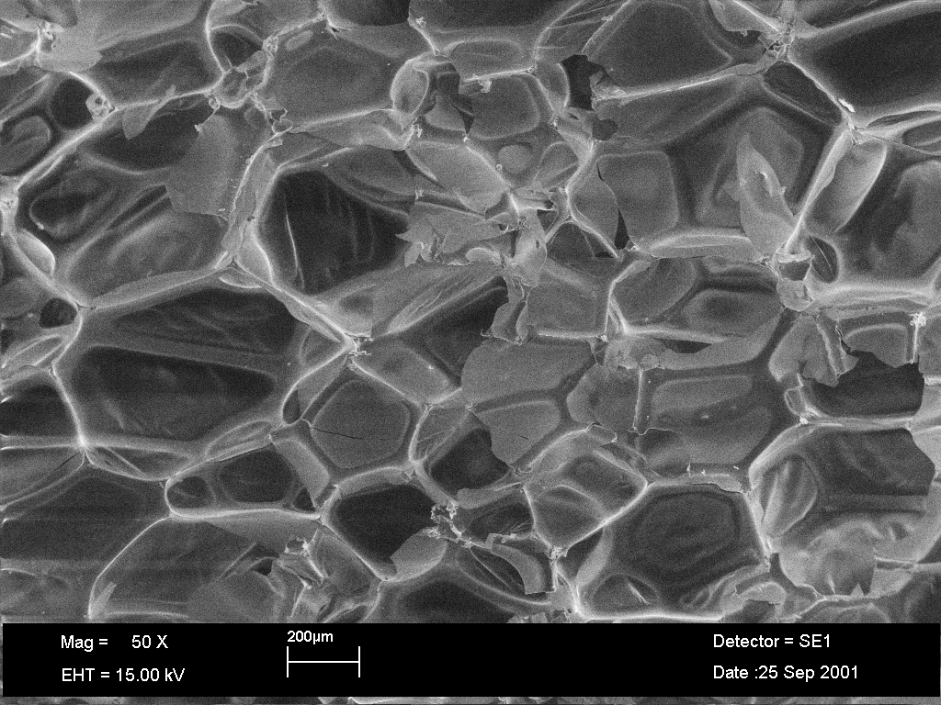
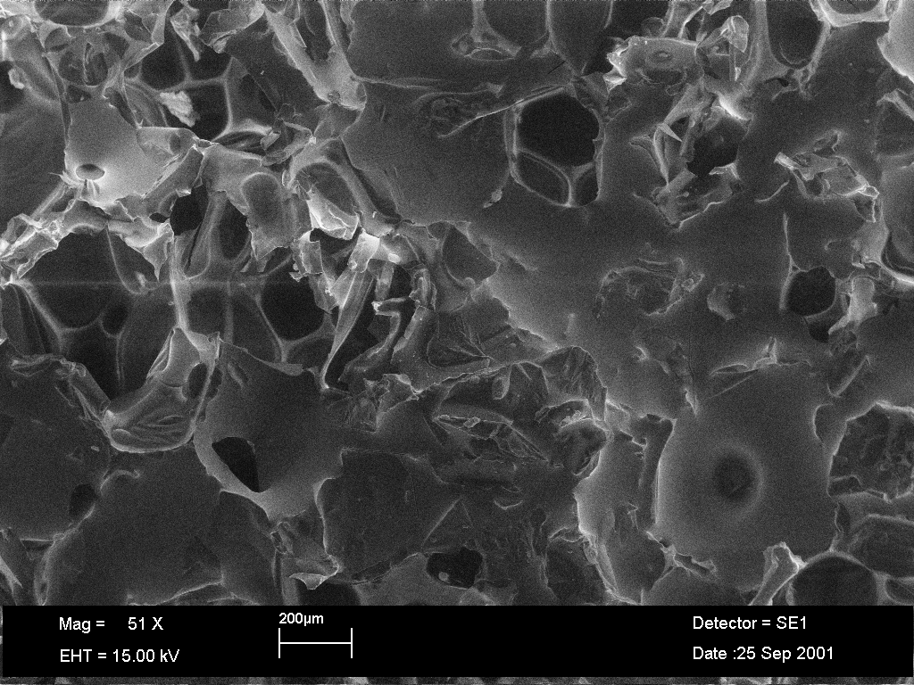
(a)
(b)

Figure 4. Micrographs of RPUF samples: (a) Control RPUF and (b) RPUF-P-N impregnated

- Fire performance

Fire performance of RPUF and RPUF-P-N samples and their comparison is mainly measured from extent burnt, burning rate, percent mass loss (PML) and extinction time obtained during the fire test. All these parameters are expressed in terms of average values. The variations of extent burnt and burning rate, PML and extinction time of RPUF and RPUF-P-N samples with respect to P-N concentrations are shown in Figures 5 and 6 respectively. Figure 5 presents the results as expected with an increasing concentration of P-N from 0 to 100%, the extent burnt and burning rate were decreased from 125 to 27 mm and 2.23 to 0.44 mm/s respectively. However, exponential difference was observed between RPUF and RPUF samples impregnated with minimum (10%) P-N concentration in their extent burnt and burning rate which were 125 mm, 2.23 mm/s and 45 mm, 1.07 mm/s respectively. The rates of decrease of extent burnt and burning rate are almost linear with the increase of P-N concentration. However, when P-N concentration increases over 90% up to 100%, there is an increase of 16.39% in the retention of RPUF-P-N, whereas, extent burnt and burning rate are decreased only by 4 mm and 0.05 mm/s respectively. Thus there is no appreciable decrease in the rate of extent burnt and burning rate, at the increasing rate of P-N concentration. As shown in Figure 6, the increasing concentration of P-N from 0 to 100% reduces the PML from 100 to 8.82%, but extinction time increases slightly from 56s to 60s respectively. RPUF and RPUF samples impregnated with minimum (10%) P-N concentration show great difference in their PML and extinction time which are 100%, 56s and 16.92%, 40s respectively. The rate of PML reduction is almost linear to 90% P-N concentration and above this PML reduces slightly as the concentration increases to 100%. RPUF samples in flammability test are consumed up to gauge mark (125 mm) in 56s. For comparison, 56s is considered as extinction time of RPUF. The extinction time of RPUF sample reduces to 42s with minimum P-N concentration, however, increases to 61s with maximum concentration. This slightly different flame extinction behavior of RPUF-P-N samples can be explained by considering the fire retardant action of phosphorus-nitrogen additive.
Figure 5.Extent burnt and burning rate of RPUF and RPUF-P-N samples

Figure 6. PML and extinction time of RPUF and RPUF-P-N samples

During flammability test the presence of phosphorus-nitrogen additive accelerates the decomposition of foam at lower temperature which leads to an increase in the amount of high temperature stable char residue [7-9]. Flame extinction time is increased slightly with the increase of P-N concentration and the combined effect of these two resulted into the formation of large amount of stable char residue. The stabilized char residue acts as protective thermal barrier which does not allow further flame spread. This may leads to reduced burning rate which resulted into enhanced fire retardancy. Thus depending upon the decrease 24.8% in extent burnt, 21.9% in burning rate and 89.7% in PML and, 46.59% increase in the density of RPUF-P-N samples, P-N additives concentration of 90% can be considered as optimum.

- Conclusion

In order to understand the effect of P-N composition on the structure and flammability characteristics of RPUF, large number of RPUF samples impregnated with various concentrations of P-N were investigated using SEM, and BS: 4735. Fire retardant chemical composition was prepared from phosphorus-nitrogen additives. P-N additives composition was a colorless viscous liquid miscible with water. P-N concentrations were decreased with the increasing water content. Retention and density of RPUF-P-N samples were increased with the increased concentration of P-N for optimum impregnation time of 20 min. Retention and density of RPUF samples with optimum impregnation time were increased up to 62.98% and 80.17 kg/m³ respectively. The results of morphology showed that the cell size of impregnated RPUF samples was decreased from 357 to 285 μm. The cell size was decreased by the increased thickness of cell wall which may be due to the deposition of P-N on the cell walls and surfaces. The results of extent burnt, burning rate and PML under flammability test indicate that an optimum 90% P-N concentration is adequate to render RPUF fire retardant. RPUF samples containing 46.59% P-N retention exhibit 46.6% increase in the density, however, remarkable decrease in extent burnt (66.25%), burning rate (90.19%) and PML (91.18%) were observed under flammability test. Thus phosphorus-nitrogen additives impregnation enhances the fire retardancy of RPUF which can be used for buildings insulation with added advantage of total safety from fire.

- Acknowledgement

The author is grateful to the Director, CSIR-Central Building Research Institute, Roorkee for his encouragement and kind support.

References

- Emmanuel, I. (2012), “Polyurethane insulation for building envelope”, Polyurethanes today, PUAI, Volume 6, Issue 2, Pages 20-23.
- Adel A. A, Ismail M. B. (2005), “Comparison of Thermal Conductivity Measurements of Building Insulation Materials under Various Operating Temperatures”, Journal of building physics, Volume 29, No. 2, pages 171-184.
- Oertel, G. (1985), Polyurethane Handbook, Hanser Publisher, New York.
- Szycher, M. (1999), Handbook of Polyurethanes, CRC Press, Washington DC.
- Lefebvre, J., Bastin, B., Bras, M. L., Duquesne, S., Paleja, R., Delobel, R. (2005), “Thermal stability and fire properties of conventional flexible polyurethane foam formulations”, Polymer Degradation and Stability, Volume 88, Pages 28-34.
- Tang, Z., Valer, M., Anderson, J. M., Miller, J. W., Listemann, M. L., McDaniel, P. L., Morita, D. K., Furlan, W. R. (2002), “Thermal degradation behavior of rigid polyurethane foams prepared with different fire retardant concentrations and blowing agents”, Polymer, Volume 43, Pages 6471-6479.
- Levchik, S. V., Weil, E. D. (2004), “Thermal decomposition, combustion and fire-retardancy of polyurethanes-a review of the recent literature”, Polymer International, Volume 53, Pages 1585-1610.
- Pielichowski, K., Kulesza, K., Pearce, E. M. (2003), “Thermal Degradation Studies on Rigid Polyurethane Foams Blown with Pentane”, Journal of Applied Polymer Science, Volume 88, Pages 2319-2330.
- Leu, T. S., Wang, C. S. (2004), “Synthesis and Characterization of a Novel Nitrogen- Containing Flame Retardant”, Journal of Applied Polymer Science, Volume 92, Pages 410-417.
- Yang, C. P., Hsiao, S. H. (1988), “Flameproofed polyesters prepared by direct polycondensation of aromatic dicarboxylic acids and brominated biphenyls with tosyl chloride and N, N-dimethylformamide in pyridine”, Journal of Applied Polymer Science, Volume 36, Pages 1221-1232.
- Duquesne, S., Bras, M. L., Bourbigot, S., Delobel, R., Camino, G., Eling, B., Lindsay, C., Roels, T., Vezin, H. (2001), “Mechanism of Fire Retardancy of Polyurethanes Using Ammonium Polyphosphate”, Journal of Applied Polymer Science, Volume 82, Pages 3262-3274.
- Modesti, M., Lorenzetti, A., Simioni, F., Checchin, M. (2001), “Influence of different flame retardants on fire behavior of modified PIR/PUR polymers”, Polymer Degradation and Stability, Volume 74, Pages 475-479.
- Modesti, M., Lorenzetti, A. (2002), “Halogen-free flame retardants for polymeric foams”, Polymer Degradation and Stability, Volume 78, Pages 167-173.
- Modesti, M., Lorenzetti, A. (2002), “Flame retardancy of polyisocyanurate–polyurethane foams: use of different charring agents”, Polymer Degradation and Stability, Volume 78, Pages 341-347.
- Modesti, M., Lorenzetti, A. (2003), “Improvement on fire behavior of water blown PIR–PUR foams: use of an halogen-free flame retardant”, European Polymer Journal, Volume 39, Pages 263-268.
- Horrocks, A. R., Zhang, J., Hall, M. E. (1994), “Flammability of polyacrylonitrile and its copolymers II. Thermal behavior and mechanism of degradation”, Polymer International, Volume 33, Pages 303-314.
- Wang, C. S., Lin, C. H. (1999), “Synthesis and properties of phosphorus containing PEN and PBN copolyesters”, Polymer, Volume 40, Pages 747-757.
- Liu, Y. L., Hsine, G. H., Chiu, Y. S., Jeng, R. J., Ma, C. (1996), “Synthesis and flame retardant properties of phosphorus-containing polymers based on poly(4-hydroxystyrene)”, Journal of Applied Polymer Science, Volume 59, Pages 1619-1625.
- Camino, G., Costa, L., Luda di Cortemiglia, M. P. (1991), “Overview of fire retardant mechanisms”, Polymer Degradation and Stability, Volume 33, Pages 131-154.
- Grassie, N., Zulfiqar, M. (1979), In Developments in Polymer Stabilization; Scott, G., Ed.; Kluwer Academic Publishers: Dordrecht.
- Juneja, S. C. (1972), “Stable and Leach Resistant Fire Retardants for Wood”, Forest Products Journal, Volume 22, Pages 17.
- Singh, H., Sharma, T. P., Jain, A. K. (2007), “Reactivity of the Raw Materials and Their Effects on the Structure and Properties of Rigid Polyurethane Foams”, Journal of Applied Polymer Science, Volume 106, Pages 1014-1023.
- Kageoka, M, Tairaka, Y., Kodama, K. (1997), “Effects of Melamine Particle Size on Flexible Polyurethane Foam Properties”, Journal of Cellular Plastics, Volume 33, Pages 219-237.

